
Improving Growth Corridor in Mindanao Road Sector Project
(Loan No. 3631-PHI)

Web-Based MYPS User Manual
Deliverable #48
(Version 3.0)



28 April 2026

DOCUMENT CONTROL SHEET
Contracting Authority: |  |  | DEPARTMENT OF PUBLIC WORKS AND HIGHWAYS – DPWH
The Promoter: |  |  | ASIAN DEVELOPMENT BANK
Contract Name: |  |  | Improving Growth Corridors in Mindanao Road Sector Project (Loan No. 3631-PHI), Consulting Services for ICD-1: Multi-Year Planning
Contract Number: |  |  | 22CS2101
Report title: |  |  | Web-Based MYPS User Manual - Deliverable #48
REV. | DATE | AUTHOR |  | PARTICIPANTS | COMMENTS
 | 16 Dec 2025 | GE |  | RP, ED, CL

Consultant | EPTISA | Madrid Head Office: C. de Emilio Muñoz, 35, San Blas-Canillejas, 28037 Madrid, Spain  Philippines Office: Unit 604, Taipan Place, Ortigas Center, Pasig City, 1605 Metro Manila, Philippines
Project Director | Name  Telephone  Email | ANTONIO ALFEREZ BURILLO  +632-881-74200  aalferez@eptisa.com
Team Leader | Name  Telephone  Email | ROGER PFEIFFER (RP)  +63 965-491-6853‬‬‬‬‬‬‬‬‬‬‬‬‬‬‬‬‬‬‬‬‬‬‬‬‬‬‬‬‬‬‬‬‬‬‬‬‬‬‬‬‬  rp@pfeiffer-online.org
Verification and Approval:
 | APPROVED:  From the Team Leader | APPROVED:  From the Consulting Firm
 | Roger Roland Pfieffer,  Project Team Leader  ICD-1 Project | Antonio Alferez Burillo,  Project Director  Eptisa Servicios de Ingenieria S.L. in the Philippines
Signature | 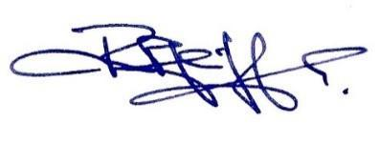 | 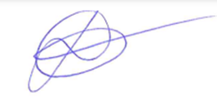
Date | 01/12/2025 | 02/12/2025
TABLE OF CONTENTS

1 Introduction for Users 13
Purpose of the User Manual 13
Scope (What This Manual Covers and Does Not Cover) 14
Intended Audience and Roles (PS/IMS, ROs/DEOs, RPO/UPMO, IMS/IT, View-only) 15
Key Concepts: Programs, Projects, Funding, Revisions, GIS (user-level view of the Data Model) 16
Where to Find Technical and Operational Details (D45–D47, Operations Guide D21) 17
2 Getting Started with MYPS Web 19
Accessing MYPS Web (URL, browser support, SSO/login) 19
First Login and User Profile (roles, offices, contact details) 19
Home and Dashboard (UI-UX-001/002 overview) 20
Screen Index by Function (mapping of UI-UX-001…UI-UX-0142 to manual sections) 21
Login Page (UI-UX-001) 31
Dashboard (UI-UX-002) 33
Global Search (UI-UX-003) 36
Corrected Search Categories and Behavior 36
Program (UI-UX-004) 39
Add Program (UI-UX-005) 42
Filter Program (UI-UX-006) 47
Delete Program (UI-UX-007) 49
Program Stages (UI-UX-008) 52
Program Details RBP (UI-UX-009) 55
Program Details BP (UI-UX-0010) 59
Proceed to Next Stage NEP (UI-UX-0011) 62
Program Details NEP (UI-UX-0012) 65
Proceed to Next Stage NEP-E (UI-UX-0013) 68
Programs Details NEP-E (UI-UX-0014) 70
Proceed to Next Stage HGAB (UI-UX-0015) 73
Programs Details HGAB (UI-UX-0016) 76
Proceed to Next Stage HGAB – I (UI-UX-0017) 80
Programs Details HGAB – I (UI-UX-0018) 83
Proceed to Next Stage GAA (UI-UX-0019) 86
Programs Details GAA (UI-UX-0020) 89
Proceed to Next Stage GAA-R (UI-UX-0021) 92
Programs Details GAA-R (UI-UX-0022) 95
Publish Program to other Applications (UI-UX-0023) 99
Publication Eligibility Checklist 99
Add Existing Project (UI-UX-0024) 103
Batch Delete Projects (UI-UX-0025) 107
Confirm Batch Delete (UI-UX-0026) 110
Restrict Publish (UI-UX-0027) 113
Allow Publishing (UI-UX-0028) 116
Import Projects (UI-UX-0029) 119
Export Projects (UI-UX-0030) 124
Generate Report / View AIP Report (UI-UX-0031) 128
Project (UI-UX-0032) 134
Project Stages (UI-UX-0033) 139
Add Project Details (UI-UX-0034) 142
Save New Project (UI-UX-0035) 149
View Edit Project Details (UI-UX-0036) 152
Import Lump Sum Project (UI-UX-0037) 159
Eligibility and File Type 159
Funding Profiles (UI-UX-0038) 162
Funding Profile Validation Rules 162
Component Cost (UI-UX-0039) 167
Common Component Cost Validation Messages 167
Add Project Component Costs (UI-UX-0040) 172
Major Items of Work (UI-UX-0041) 176
Major Item and Work Location Dependency 176
Add Major Items of Work (UI-UX-0042) 181
Major Items of Work, Infra Type, Accessibility Facility (UI-UX-0043) 184
Major Items of Work Infra Type, Bridges (UI-UX-0044) 188
Major Items of Work, Infra Type, Consultancy (UI-UX-0045) 192
Major Items of Work, Infra Type, Flood Control Structures (UI-UX-0046) 196
Major Items of Work, Infra Type, Hospitals (UI-UX-0047) 200
Major Items of Work Infra Type, Local Bridges (UI-UX-0048) 204
Major Items of Work, Infra Type, Local Flood Control Structures (UI-UX-0049) 209
Major Items of Work, Infra Type, Local Roads (UI-UX-0050) 213
Major Items of Work, Infra Type, Multi-Purpose Buildings (UI-UX-0051) 218
Major Items of Work, Infra Type, Non-Infra (UI-UX-0052) 222
Major Items of Work, Infra Type, Other of Buildings (UI-UX-0053) 226
Major Items of Work, Infra Type, Rain Water Collector (UI-UX-0054) 230
Major Items of Work, Infra Type, Roads (UI-UX-0055) 235
Major Items of Work, Infra Type, School Buildings (UI-UX-0056) 240
Major Items of Work, Infra Type, Septage and Sewage Plant (UI-UX-0057) 244
Major Items of Work, Infra Type, Water Supply Systems (UI-UX-0058) 248
Major Items of Work, Infra Type, Waterway (UI-UX-0059) 253
Supporting Documents (UI-UX-0060) 257
Add Documents (UI-UX-0061) 260
Update Project (UI-UX-0062) 264
Transaction Logs (UI-UX-0063) 267
3 Revisions & Modifications (User Procedures) 270
Project Details Revision (UI-UX-0064) 270
Revision Entry Point and Submission Requirements 270
Additional Funding (UI-UX-0065) 273
Revision Additional Funding - Additional (buffer) funds from other agencies (UI-UX-0066) 276
Attach the Approved Revision Document - Additional (buffer) funds from other agencies (UI-UX-0067) 284
Adjustment (UI-UX-0068) 288
Revision Adjustment – Component incorrectly set up - to be deleted (UI-UX-0069) 292
Attach the Approved Revision Document - Component incorrectly set up - to be deleted (UI-UX-0070) 300
Change in Authority to Implement (UI-UX-0071) 304
Change in Funding (UI-UX-0072) 307
Change of Creditor (UI-UX-0073) 310
Expired Funding (UI-UX-0074) 312
For Savings – Partial Unutilized Balance (UI-UX-0075) 315
Mode of Implementation (UI-UX-0076) 318
Modification (UI-UX-0077) 320
Revision Modification Category A - Typographical Error – Project Description needs items removed due to typo error (UI-UX-0078) 326
Attach the Approved Revision Document - Category A - Typographical Error – Project Description needs items removed due to typo error (UI-UX-0079) 334
Multi-Year Costing Changes (UI-UX-0080) 338
Non-Implementable (UI-UX-0081) 340
Termination (UI-UX-0082) 344
Modification / Revision Approval (UI-UX-0083) 347
Role-Based Approval Routing 347
Revision List (UI-UX-0084) 355
4 Project Groups 357
Project Groups (UI-UX-0085) 358
Exact Project ID Requirement 358
Add New Project Groups (UI-UX-0086) 362
Project Groups Details (UI-UX-0087) 365
Add Project to Group (UI-UX-0088) 370
Delete Project Groups (UI-UX-0089) 374
5 Settings Code Tables 377
Code Tables Project Details Category Management (UI-UX-0090) 378
Code Tables Project Details Thrust Management (UI-UX-0091) 383
Code Tables Project Details Agency Management (UI-UX-0092) 389
Code Tables Project Details Origin Management (UI-UX-0093) 394
Code Tables Component Cost Type Management (UI-UX-0094) 399
Code Tables Major Work Category Management (UI-UX-0095) 405
Code Tables Type of Work Management (UI-UX-0096) 410
Code Tables Major Items Infrastructure Types (UI-UX-0097) 416
Code Tables Funding Profile Agreement (UI-UX-0098) 422
Code Tables Funding Profile Source (UI-UX-0099) 428
Code Tables Revisions Categories (UI-UX-0100) 433
Code Tables Revisions Headers (UI-UX-0101) 439
Code Tables Revisions Documents (UI-UX-0102) 444
Code Tables Revisions Reasons (UI-UX-0103) 450
Code Tables Revisions Statuses (UI-UX-0104) 457
Code Tables Revisions Rules (UI-UX-0105) 463
Code Tables Revisions Validated Dates (UI-UX-0106) 470
Code Tables Program Stage (UI-UX-0107) 476
Code Tables Program Type (UI-UX-0108) 482
Code Tables Program Status (UI-UX-0109) 488
Code Tables Admin Areas Regions (UI-UX-0110) 494
Code Tables Admin Areas Provinces (UI-UX-0111) 500
Code Tables Admin Areas Cities / Municipalities (UI-UX-0112) 506
Code Tables Admin Areas Legislative Districts (UI-UX-0113) 513
Code Tables Admin Areas DEOs (UI-UX-0114) 520
6 Settings User Management Overview 527
User Management App Modules (UI-UX-0115) 527
App Modules Check Read-Only Controllers (UI-UX-0116) 533
App Modules Check Read-Only Views (UI-UX-0117) 537
User Management Users Modules (UI-UX-0118) 541
User Management Add User (UI-UX-0119) 546
User Management Filter User (UI-UX-0120) 551
User Management Update User (UI-UX-0121) 554
User Management Delete User (UI-UX-0122) 557
User Management User Group (UI-UX-0123) 560
User Group Modules (UI-UX-0124) 563
Add New User Group (UI-UX-0125) 566
Filter User Groups (UI-UX-0126) 568
Update User Group (UI-UX-0127) 570
7 Settings Infrastructure Administration Overview 575
Infrastructure Administration Roads (UI-UX-0128) 575
Module Name and Infrastructure ID Rules 575
Infrastructure Administration Add New Future Road (UI-UX-0129) 579
Infrastructure Administration Filter Roads (UI-UX-0130) 582
Infrastructure Administration Import Road Network (UI-UX-0131) 585
Infrastructure Administration Edit Future Roads (UI-UX-0132) 588
Infrastructure Administration Delete Future Roads (UI-UX-0133) 590
Infrastructure Administration Add Road Section (UI-UX-0134) 592
Infrastructure Administration Road Section (UI-UX-0135) 594
Infrastructure Administration Filter Road Sections (UI-UX-0136) 597
Infrastructure Administration Edit Future Road Section (UI-UX-0137) 600
Infrastructure Administration Delete Road Section (UI-UX-0138) 602
Infrastructure Administration Edit Future Bridge (UI-UX-0139) 604
Infrastructure Administration Bridge (UI-UX-0140) 607
Infrastructure Administration Edit Future Bridge (UI-UX-0141) 609
Infrastructure Administration Delete Bridge (UI-UX-0142) 612
Appendix: Issue Reporting Checklist 614
Appendix: Consolidated Validation Messages 614
Appendix: Controlled Terminology 615

ABBREVIATIONS
Abbreviation | Full Description
AIP | Annual Investment Plan
API | Application Programming Interface
AWS | Amazon Web Services
CI/CD | Continuous Integration / Continuous Deployment
CTA | Component Technology Architecture
DMA | Design Management Application
DDL | Data Definition Language
DSS | Decision Support System
EAS | Enterprise Application Server
ERD | Entity–Relationship Diagram
GAA | General Appropriations Act
GKE | Google Kubernetes Engine
GIS | Geographic Information System
HGAB | House-Approved General Appropriations Bill
IROWMA | Infrastructure Right-of-Way Management Application
MYPS | Multi-Year Planning and Scheduling
NEP | National Expenditure Program
OAT | Operational Acceptance Testing
OAuth 2.0 | Open Authorization 2.0 (industry-standard authorization framework)
PCMA | Project and Contract Management Application
PDM | Physical Data Model
PIP | Public Investment Program
PDSA | Plan-Do-Study-Act cycle (not directly used but relevant to iterative design)
PIP | Public Investment Program
PPMPA | Project Procurement Management Plan Application
PREXC | Program Expenditure Classification
PXS | Placeholder for proprietary XML schema
RBAC | Role-Based Access Control
RBIA | Road and Bridge Inventory Application
REST | Representational State Transfer (style for Web APIs)
SAML | Security Assertion Markup Language
SPA | Single-Page Application
SQL | Structured Query Language
SSO | Single Sign-On
TLS | Transport Layer Security
TOR | Terms of Reference
UAT | User Acceptance Testing
UBP | Unified Budget Proposal
UDIP | UPMO Development Investment Program
UEFI  LDAP | Unified Extensible Firmware Interface  Lightweight Directory Access Protocol

GLOSSARY OF TERMS
The terms used in this document are defined in this glossary. This list will be updated and expanded as required to ensure a common understanding.
- AIP Annual Investment Plan: DPWH’s yearly program of prioritized projects for budget allocation and printing.
- Angular: A TypeScript-based, opinionated front-end web framework maintained by Google.
- API – Application Programming Interface: A defined set of methods and data formats that allows software components or systems to communicate. In MYPS Web, APIs expose Programs, Projects, Funding, Options, and GIS features as HTTP/HTTPS endpoints.
- Clarification Notes: End-user Q&A document capturing unresolved questions about existing MYPS behavior and requirements.
- CTA: Component Technology Architecture (used generically for microservices/containers).
- DMA: Design Management Application: DPWH system for managing design activities and approvals.
- EAS: Enterprise Application Server (version 6.3.1 in current MYPS deployment).
- ER Diagram: Entity–Relationship Diagram: Visual representation of database tables and their relationships.
- ESRI Shapefile: A popular geospatial vector data format for GIS features (points, lines, polygons).
- GAA General Appropriations Act: Philippine annual law authorizing government spending.
- GKE Google Kubernetes Engine: Managed Kubernetes service on Google Cloud Platform.
- GIS Geographic Information System: Software for capturing, analyzing, and visualizing spatial data.
- HGAB House-Approved General Appropriations Bill: Philippine budget prior to bicameral conference.
- IROWMA Infrastructure Right-of-Way Management Application: DPWH system handling land acquisition processes.
- JMeter / Locust: Open-source tools for load and stress-testing web applications and APIs.
- MYPS: Multi-Year Planning and Scheduling: DPWH’s core application for programming infrastructure projects.
- NEP: National Expenditure Program: Executive branch’s proposed annual budget in the Philippines.
- PCMA Project and Contract Management Application: DPWH system for managing project contracts and awards.
- PDM Physical Data Model: The database schema diagram for the current MYPS implementation.
- PDSA: Plan-Do-Study-Act cycle (not directly used but relevant to iterative design).
- PIP Public Investment Program: National-level multi-year infrastructure program; also a MYPS module in Version 7.0 Lite.
- PPMPA Project Procurement Management Plan Application: DPWH system for procurement planning.
- PREXC Program Expenditure Classification: DPWH reporting requirement for obligations before project implementation.
- PXS: Placeholder for proprietary XML schema (used generically in integration specs).
- RBIA Road and Bridge Inventory Application: DPWH system for managing asset inventories.
- RESTful API: API design style using HTTP verbs and stateless, resource-oriented endpoints.
- SPA – Single-Page Application: A Web application pattern where a single HTML page is loaded once and content is updated dynamically via JavaScript and APIs. MYPS Web’s front end is implemented as an SPA.
- SSO – Single Sign-On: An authentication approach that allows users to access multiple systems with a single set of credentials. MYPS Web integrates with DPWH SSO/identity infrastructure.
- STDWithin: Spatial SQL function to test proximity between geometries within a given distance.
- TLS 1.2+ : Minimum Transport Layer Security protocol version mandated for encrypting data-in-transit.
- TOR – Terms of Reference: The formal project document defining the scope, objectives, deliverables, timelines, and constraints for the Web-based MYPS modernization effort.
- UAT – User Acceptance Testing: Formal testing performed by business users (e.g., PS/IMS) to confirm that the system meets agreed requirements before go-live.
- UBP Unified Budget Proposal: MYPS module for UPMO cluster annual budget workflows (Version 7.0 Lite reference).
- UDIP UPMO Development Investment Program: A MYPS program stage in Version 7.0 Lite for UPMO clusters.
- UEFI: Unified Extensible Firmware Interface (included here as an analogy for structured initialization, though not directly used).
- Vue: A lightweight, progressive JavaScript
- LDAP: The Lightweight Directory Access Protocol, is a mature, flexible, and well supported standards-based mechanism for interacting with directory servers.

Introduction for Users
The Web-based Multi-Year Planning System (MYPS) is the primary tool of DPWH for programming, reviewing, and monitoring infrastructure investments across multiple years, budget cycles, and offices. It replaces the legacy VB desktop client with a browser-based, role-aware application that sits on top of a modern Web UI/UX and a redesigned data model, while preserving the planning logic and workflows defined in MYPS 7.0 and the 2018 design volumes.
This User Manual is the task-focused companion to the more technical documents (D44–D47, D21). It explains how to use MYPS Web, screen by screen and task by task, from an end-user perspective.

Purpose of the User Manual
The purpose of this manual is to provide clear, step-by-step guidance for performing everyday planning, budgeting, and monitoring activities in Web-based MYPS. It is written for business users rather than developers or system administrators.
In particular, this manual aims to:
- Help users transition from the VB desktop client to the Web interface, by mapping familiar concepts (Programs, Projects, funding, revisions) to the new screens, navigation and workflows.
- Describe how to complete tasks (e.g., create a Program, encode Project details, manage Funding Profiles, run reports, publish to PCMA) using the new UI/UX patterns and screen archetypes documented in D45 and validated in D46.
- Embed practical tips, examples, and “what to do if…” guidance, based on test procedures (D46), operational experience (D21), and field feedback.
This is not a technical design document. Where necessary, it references D44–D47 and D21 for deeper architectural, operational, or configuration details.

Scope (What This Manual Covers and Does Not Cover)
In scope
This manual covers the tasks that a typical MYPS Web user needs to perform through the browser:
- Access and navigation – logging in, understanding the dashboard, using menus, search, and filters (UI-UX-001/002 and related screens).
- Program and project management – creating, editing, and reviewing programs and projects; viewing lifecycle stages and revisions; and managing Funding Profiles, Component Costs, and Major Items of Work.
- Revisions and modifications – recording and tracking change types, such as Multiple Modes, VO, and declustering, according to the clarified rules in D45 and D44.
- Publishing to PCMA and other systems – initiating and monitoring publish operations from the Web UI, and understanding user-visible statuses and error messages.
- GIS-enabled tasks – selecting infrastructure from the RBIA inventory and visualizing project work locations.
- Reports and exports – running standard reports, applying filters and parameters, and exporting data for review and consolidation.
Where applicable, procedures explicitly note differences from the 2018 desktop UI, such as when a function previously available from a menu is now accessed through a toolbar action or context panel.
Out of scope
This manual does not cover:
- Internal technical design, architecture, or Entity–Relationship Diagram (ERD) details (see D45 and D47).
- Detailed test cases, acceptance forms, and UAT procedures (see D46).
- Day-to-day operations and administration tasks, such as backups, patching, disaster recovery drills, and monitoring configuration (see D21 and D47).
- Formal project governance, TOR, or contractual aspects of the modernization (see TOR and D44).
Where a topic falls outside this scope, the manual points to the appropriate deliverable.

Intended Audience and Roles (PS/IMS, ROs/DEOs, RPO/UPMO, IMS/IT, View-only)
Web-based MYPS is used by multiple roles across DPWH. The manual is structured so that each role can quickly find the procedures relevant to their responsibilities:
- Planning Service (Central Office)
  - Owns the MYPS planning process and most Program-level workflows, including approval stages, NEP/HGAB/ERRATA cycles, and national consolidation.
  - Uses this manual to drive standardized encoding, review, and publishing practices across the organisation.
- Regional Offices (ROs) and District Engineering Offices (DEOs)
  - Encode and update Project-level data, locations, funding, and major work items; respond to clarifications from PS/IMS.
  - Use this manual to follow the correct sequencing of tasks per budget cycle and to understand how their data flows into Programs and national views.
- Regional Project Offices (RPO) / Unified Project Management Offices (UPMO)
  - Manage specific program clusters or corridors, often with more complex multi-year projects and groupings.
  - Use this manual to understand multi-year, grouping, and revision features in the Web UI, and how these align with UDIP/UBP workflows.
- IMS/IT and System Administrators
  - While D21 and D47 are their primary references, IMS/IT staff use this manual to understand what end users are trying to do so they can provide better support, replicate issues, and validate fixes.
- View-only / Read-only Users
  - Users who need to view Programs, Projects, maps, and reports but are not authorized to make changes.
  - The manual indicates which procedures apply to viewers and what they should expect to see in the interface.
Throughout the manual, icons or labels may indicate role-specific steps (e.g., “Planner only”, “Reviewer”, “Admin”), reflecting the RBAC model summarized in D45 and D47.

Key Concepts: Programs, Projects, Funding, Revisions, GIS (user-level view of the Data Model)
The Data Model in D45 reorganizes data to better support Web workloads, GIS integration, and traceability, but the business concepts remain familiar to users of MYPS 7.0. This subsection explains those concepts in user language, not in table names.
- Program
  - A Program is a multi-year planning container that groups related Projects under a strategy, corridor, or funding line (e.g., growth corridor program).
  - Each Program has a lifecycle (Draft → For Review → Approved → Published) and may have multiple revisions over time, particularly across NEP, HGAB, and GAA stages.
- Project
  - A Project is an individual infrastructure investment (e.g., road section improvement, bridge construction, flood control structure) under a Program.
  - In MYPS Web, the Project screens capture administrative, technical, and locational details, and connect to funding, components, and major work items.
- Funding
  - Funding represents annual or multi-year budget allocations to Projects under different sources and profiles (e.g., GAA, loans, grants).
  - The Web UI uses dedicated Funding Profiles and component cost screens to ensure that totals remain consistent with Program and Project budgets and with what is published to PCMA.
- Revisions
  - Revisions capture changes to Programs and Projects over time – for example, new implementation modes, Variation Orders (VO), scope declustering, or corrections.
  - The new data model also stores the revision history, allowing the Web UI to show a clear history of what changed, when, and why.

- GIS and Location
  - GIS features link Programs and Projects to actual assets and locations (roads, bridges, flood-control segments, administrative boundaries).
  - In the Web version, users can select infrastructure from RBIA, draw new features (e.g., future roads), and validate that project extents are consistent with the network and administrative areas. These operations are backed by the GIS APIs, spatial functions, and new ERD tables described in D45 and D47.
When this manual mentions these concepts, it focuses on what you see and do in the screens. Technical details such as table names, primary keys, and indexes live in the application and system design documents.

Where to Find Technical and Operational Details (D45–D47, Operations Guide D21)
This User Manual sits within a broader set of deliverables. When you need more context than this manual provides, refer to:
- D44 – Recommendation Report on Web-Based MYPS Design
  - Explains why the system was modernized, the limitations of the earlier Web/VB design, and the high-level recommendations for architecture, UI/UX, and integration.
- D45 – Application Design Document (Web-based MYPS)
  - Describes the solution architecture, new ERD, Web UI/UX patterns, and integration contracts in technical detail.
  - Use D45 if you need to understand how screens in this manual map to APIs, entities, and data flows.
- D46 – Acceptance Test Plan & Operational Acceptance Environment (UAT with PS/IMS)
  - Contains formal test cases and procedures for each UI-UX screen and core process.
  - Use D46 when you need to see how tasks in this manual were formally tested and what “pass” looks like.

- D47 – System Documentation for Web-based MYPS
  - Provides the system-level view: environments, deployment, configuration, data layer, interfaces, monitoring, backup/restore, and security administration.
  - Use D47 when troubleshooting system behavior or coordinating with IMS/IT.
- D21 – Operations Guide (Web-based MYPS)
  - Defines how MYPS is operated: routines, incident/problem/change management, DR playbooks, and operational readiness for releases.
  - Use D21 when you need to understand on-call procedures, service levels, or how changes are introduced into production.
Together, these documents provide a complete view:
- D44–D45 explain what MYPS Web is and why it is designed that way.
- D46–D47 show how it is tested and how it runs as a system.
- D21 explains how it is operated and supported.
- This User Manual (D48) explains how you, as an end user, work with it every day.

Getting Started with MYPS Web
MYPS Web is accessed through a browser rather than a locally installed VB client. Users sign in using DPWH’s identity provider (SSO/Active Directory) and work within a modern, tabbed, search-driven interface that sits on top of the new ERD and REST APIs defined in D45 and validated in D46.
This section explains how to access the system, understand the home/dashboard screens, and use common navigation, search, and list/grid patterns that appear across all modules.

Accessing MYPS Web (URL, browser support, SSO/login)
Access URL
- MYPS Web is accessed via an HTTPS URL provided by PS/IMS or IMS/IT (for example,
https://myps.eptisa-dev.com
- Different environments (DEV/TEST/UAT/PROD) use distinct hostnames; the URL you use depends on your role and the current budget cycle activities.
Login
Web-based MYPS uses DPWH’s central identity provider:
- Navigate to the MYPS Web URL.
- You will be redirected to the DPWH login page to enter your network username and password.
- After successful authentication, MYPS Web creates a user session and loads the Dashboard (UI-UX-002).
Compared with the VB desktop client, there is no local installation and no separate MYPS-specific credentials; identity and basic access control come from DPWH’s Active Directory infrastructure, with detailed roles and permissions managed inside MYPS (see D45, Section 6 and D47, Section 9).

First Login and User Profile (roles, offices, contact details)
On first login, MYPS Web:
- Resolves your user account from the identity provider.
- Maps you to one or more roles (Planner, Reviewer, Viewer, Admin, etc.) and offices (RO, DEO, RPO, UPMO, Central Office) according to the RBAC configuration maintained by IMS/IT and PS/IMS.
You can verify this mapping via the User Profile panel (often accessed via your username in the top-right corner):
- Displayed role(s): the functional roles that drive what you can see and do (e.g., “RO Planner”, “PS-IMS Reviewer”).
- Assigned office(s): your primary operating unit (e.g., Region III, DEO XYZ) and any additional offices you are allowed to act for.
If the displayed role or office is incorrect, do not proceed with encoding data. Instead:
- Record a screenshot of the profile.
- Contact your local MYPS or PS/IMS to request a role/office correction, following the joiner/mover/leaver process described in the Operations Guide (D21, Section 4).

Home and Dashboard (UI-UX-001/002 overview)
After a successful login through the Login Page (UI-UX-001), users are redirected to the Dashboard screen (UI-UX-002). The Dashboard serves as the main landing page of MYPS Web and replaces the legacy “main menu” window used in the VB desktop client. Instead of opening separate desktop windows, users now begin from a role-aware Web dashboard that consolidates account information, available actions, navigation links, and workload summaries in one screen.
The Dashboard is designed to show only the modules and shortcuts that the signed-in user is allowed to access. This supports the MYPS role-based access model, where available features may differ for PS/IMS users, ROs/DEOs, RPO/UPMO users, planners, reviewers, administrators, and view-only users. D45 also identifies UI-UX-002 as the Dashboard screen whose purpose is to present user information, account status, and role-based quick actions.
Typical Dashboard elements include:
- User Info block – Shows the user’s basic account details, such as username, assigned role, and contact information where available.
- Account Status block – Shows whether the user account is active, locked, expired, or otherwise restricted.
- Quick Actions – Provides shortcuts to common tasks such as creating a new Program, creating a new Project, or importing data, depending on the user’s permissions.
- Side Navigation menu – Provides access to major MYPS modules such as Dashboard, Program, Project, Revision, Project Groups, Code Tables, User Management, and Infrastructure Management.

Screen Index by Function (mapping of UI-UX-001…UI-UX-0142 to manual sections)
This manual references screens using the UI-UX IDs defined in D45 (Section 5.3.3) and exercised in D46’s test cases.
The table below provides a screen index by function, so users can quickly see:
- What each UI-UX ID represents,
- Which functional area it belongs to,
- What its primary purpose is in day-to-day use.
You can use this index together with the Table of Contents to locate the relevant step-by-step procedures in later chapters.
UI-UX ID | Screen Name | Functional Area / Module | Primary Purpose (User Perspective)
UI-UX-001 | Login | Global | Sign in with DPWH credentials and establish a secure MYPS Web session.
UI-UX-002 | Dashboard | Global | View overall status, quick counts, and shortcuts based on your role and office.
UI-UX-003 | Global Search | Global | Locate any MYPS entity using keyword search across modules.
UI-UX-004 | Program | Programs | Search, filter, and open Programs; create new Program headers.
UI-UX-005 | Add Program | Programs | Wizard/form to capture core attributes for a new Program.
UI-UX-006 | Filter Program | Programs | Apply filters to narrow down displayed Programs by year, stage, or other attributes.
UI-UX-007 | Delete Program | Programs | Remove a Program, respecting workflow and permissions rules.
UI-UX-008 | Program Details | Programs | View detailed information of a Program including stages, funding, and related projects.
UI-UX-009 | Program Details RBP | Programs
  View Program details specific to Regional Budget Proposal context.
UI-UX-0010 | Program Details BP | Programs | View Program details specific to Budget Proposal context.
UI-UX-0011 | Proceed to Next Stage NEP | Programs | Advance Program to the National Expenditure Program stage.
UI-UX-0012 | Program Details NEP | Programs
  View Program information in the NEP stage including approvals and linked projects.
UI-UX-0013 | Proceed to Next Stage NEP-E | Programs | Advance Program from NEP to NEP-Expenditure stage.
UI-UX-0014 | Program Details NEP-E | Programs
  View detailed Program information for NEP-Expenditure stage.
UI-UX-0015 | Proceed to Next Stage HGAB | Programs
  Move Program to House General Appropriations Bill stage.
UI-UX-0016 | Program Details HGAB | Programs | View Program data at HGAB stage including project alignment and funding.
UI-UX-0017 | Proceed to Next Stage HGAB-I | Programs
  Move Program to HGAB-Infrastructure stage.
UI-UX-0018 | Program Details HGAB-I | Programs | View Program details in HGAB-Infrastructure stage.
UI-UX-0019 | Proceed to Next Stage GAA | Programs
  Advance Program to General Appropriations Act approval stage.
UI-UX-0020 | Program Details GAA | Programs
  View Program information in GAA stage including approved allocations and linked projects.
UI-UX-0021 | Proceed to Next Stage GAA-R | Programs | Advance Program to post-GAA revision/rollback stage.
UI-UX-0022 | Program Details GAA-R | Programs | View detailed Program data in GAA revision stage.
UI-UX-0023 | Publish Program Existing Project | Programs | Publish an existing Program and its linked Projects to downstream applications, subject to validation and permissions.
UI-UX-0024 | Add Existing Project | Projects | Attach an existing Project to a Program or Program stage.
UI-UX-0025 | Batch Delete Projects | Projects
  Delete multiple Projects at once, subject to workflow and permissions.
UI-UX-0026 | Confirm Batch Delete | Projects | Confirm and finalize deletion of selected batch of Projects.
UI-UX-0027 | Restrict Publish | Programs | Temporarily restrict Program/Project data from being published.
UI-UX-0028 | Allow Publishing | Programs
  Re-enable publishing for Program/Project data.
UI-UX-0029 | Import Projects | Projects
  Import Projects in bulk from an Excel template.
UI-UX-0030 | Export Projects | Projects | Export Project records or filtered Project lists to an external file, such as Excel, for review, reporting, or offline reference.
UI-UX-0031 | View AIP Report | Reports | View the Annual Infrastructure Program report for a Program or set of Projects.
UI-UX-0032 | Project | Projects | Create or access Project records for planning and tracking.
UI-UX-0033 | View Project Details | Projects | Inspect Project information including components, funding, and major work items.
UI-UX-0034 | Add Project Details | Projects | Enter detailed attributes for a new Project including stage, location, and implementing office.
UI-UX-0035 | Save New Project | Projects
  Save newly created project into MYPS database
UI-UX-0036 | View Edit Project Details | Projects
  Open existing Project details for review or update, respecting workflow rules.
UI-UX-0037 | Import Lump Sum | Projects | Upload Lump Sum project components or costs from an approved Excel template to MYPS.
UI-UX-0038 | Funding Profiles |  | View or manage funding allocations, sources, and agreements for a project.
  Projects
UI-UX-0039 | Component Cost
  Projects
  View costs associated with each project component to track budget allocation and expenditure.
UI-UX-0040 | Add Project Component Cost | Projects | Enter new cost data for a project component, including unit costs and quantity.
UI-UX-0041 | Major Items of Work |  | Review and manage the key deliverables or work items associated with a project.
  Projects
UI-UX-0042 | Add Major Items of Work | Projects | Capture additional major work items for a project, specifying scope, type, and targets.
UI-UX-0043 | Major Items of Work, Infra Type, Accessibility Facility | Projects
  Track major work items specifically for accessibility-related infrastructure components.
UI-UX-0044 | Major Items of Work, Infra Type, Bridges | Projects | Track bridge-related major work items, including design, construction, and rehabilitation.
UI-UX-0045 | Major Items of Work, Infra Type, Consultancy | Projects | Track major consultancy-type work items linked to project components.
UI-UX-0046 | Major Items of Work, Infra Type, Flood Control Structures | Projects | Track flood control infrastructure projects and their major work items.
UI-UX-0047 | Major Items of Work, Infra Type, Hospitals | Projects | Track hospital-related major infrastructure items within a project.
UI-UX-0048 | Major Items of Work, Infra Type, Local Bridges |  | Track local bridge-related major work items, including local government-funded components.
  Projects
UI-UX-0049 | Major Items of Work, Infra Type, Local Flood Control Structures | Projects | Track local flood control infrastructure items and their major work tasks.
UI-UX-0050 | Major Items of Work, Infra Type, Local Roads | Projects | Track local road construction and rehabilitation items and their major work details.
UI-UX-0051 | Major Items of Work, Infra Type, Multi-Purpose Buildings | Projects | Enter, view, or edit major work items for multi-purpose building components within a project.
UI-UX-0052 | Major Items of Work, Infra Type, Non-Infra | Projects | Manage non-infrastructure major items of work for a project.
UI-UX-0053 | Major Items of Work, Infra Type, Other of Buildings | Projects | Capture major work items related to other building types under a project.
UI-UX-0054 | Major Items of Work, Infra Type, Rain Water Collector | Projects
  Manage and record rainwater collection work items for project components.
UI-UX-0055 | Major Items of Work, Infra Type, Roads | Projects | Record and maintain road-related major items of work within a project.
UI-UX-0056 | Major Items of Work, Infra Type, School Buildings | Projects | Enter major items of work for school building components in projects.
UI-UX-0057 | Major Items of Work, Infra Type, Septage and Sewage Plant | Projects | Manage septage and sewage plant-related work items within projects.
UI-UX-0058 | Major Items of Work, Infra Type, Water Supply Systems | Projects | Enter or review water supply system components and associated work items.
UI-UX-0059 | Major Items of Work, Infra Type, Waterway | Projects
  Manage work items specific to waterway-related project components.
UI-UX-0060 | Supporting Documents | Projects | View, attach, or manage supporting documents relevant to project work items or revisions.
UI-UX-0061 | Add Documents | Projects | Upload new documents to associate with a project or project component.
UI-UX-0062 | Update Project | Projects
  Make modifications to an existing project, including updates to components, costs, or work items.
UI-UX-0063 | Transaction Logs | Projects | Track changes and revisions made to project data, including historical updates and audit trail.
UI-UX-0064 | View Project Details Revision | Revision Modifications | View the selected Project’s revision details, location, current status, revision options, and related project information before initiating or reviewing a revision.
UI-UX-0065 | Additional Funding | Revision Modifications | Select and start an Additional Funding revision for a Project that requires added budget allocation.
UI-UX-0066 | Revision Additional Funding - Additional (buffer) funds from other agencies | Revision Modifications | Submit an Additional Funding revision request when buffer funds from other agencies need to be added to the Project.
UI-UX-0067 | Attach the Approved Revision Document - Additional (buffer) funds from other agencies | Revision Modifications
  Upload the approved supporting document and approval date for the additional buffer funds revision request.
UI-UX-0068 | Adjustment | Revision Modifications | Select and start an Adjustment revision for correcting Project details, component setup, targets, dates, locations, or other allowable MYPS data corrections.
UI-UX-0069 | Revision Adjustment – Component incorrectly set up - to be deleted | Revision Modifications | Submit an Adjustment request to delete a Project component that was incorrectly created or configured in MYPS.
UI-UX-0070 | Attach the Approved Revision Document - Component incorrectly set up - to be deleted | Revision Modifications | Upload the approved supporting document and approval date for an Adjustment request involving deletion of an incorrectly created or configured Project component.
UI-UX-0071 | Change in Authority to Implement | Revision Modifications | Initiate or process a revision that changes the authorized Implementing Office or authority responsible for implementing the Project.
UI-UX-0072 | Change in Funding | Revision Modifications | Record and process changes to the Project’s funding source, funding allocation, or funding arrangement.
UI-UX-0073 | Change of Creditor | Revision Modifications
  Update the creditor, financing agency, or funding partner associated with the Project.
UI-UX-0074 | Expired Funding | Revision Modifications | Record and process Project funding that has expired or is no longer available for obligation or use.
UI-UX-0075 | For Savings – Partial Unutilized Balance | Revision Modifications
  Identify and record the partial unutilized balance of Project funds as savings, subject to applicable approval and workflow rules.
UI-UX-0076 | Mode of Implementation | Revision Modifications | Update the Project’s implementation method, such as by contract, by administration, or another approved implementation mode.
UI-UX-0077 | Modification | Revision Modifications | Start a formal Project Modification request involving approved changes to Project details, scope, targets, stationing, location, category, or other controlled Project attributes.
UI-UX-0078 | Revision Modification Category A - Typographical Error – Project Description needs items removed due to typo error | Revision Modifications | Submit a Category A Modification request to correct a Project Description by removing text caused by a typographical error.
UI-UX-0079 | Attach the Approved Revision Document - Category A - Typographical Error – Project Description needs items removed due to typo error | Revision Modifications | Upload the approved supporting document and approval date for the Category A typographical error correction request.
UI-UX-0080 | Multi – Year Costing Changes | Revision Modifications
  Record and process changes affecting the Project’s multi-year cost distribution, funding year split, or programmed cost schedule.
UI-UX-0081 | Non - Implementable | Revision Modifications
  Mark or process a Project or component as non-implementable due to approved reasons, such as reversion, abandonment for savings, or delisting.
UI-UX-0082 | Termination | Revision Modifications
  Process the termination of a Project or component and record the related status, justification, and approval details.
UI-UX-0083 | Modification / Revision Approval | Revision Modifications | Review, approve, return, or finalize submitted modification/revision requests based on the authorized approval workflow.
UI-UX-0084 | Revision List | Revision Modifications | View, search, filter, and monitor submitted revision requests, including their status, project reference, category, reason, and approval progress.
UI-UX-0085 | Project Groups | Project Grouping | View, search, filter, and manage the list of Project Groups created to organize related Projects under one group.
UI-UX-0086 | Add New Project Groups | Project Grouping
  Create a new Project Group by entering the group name, description, user group, and other required information.
UI-UX-0087 | Project Groups Details | Project Grouping
  View or edit the details of an existing Project Group, including its name, description, assigned user group, created information, and linked Projects.
UI-UX-0088 | Add Project to Group | Project Grouping | Attach or link one or more existing Projects to a selected Project Group for easier organization, tracking, and reporting.
UI-UX-0089 | Delete Project Groups | Project Grouping | Remove or archive an existing Project Group, subject to user permissions, workflow rules, and whether the group is eligible for deletion.
UI-UX-0090 | Category Management | Code Tables | Maintain the list of Project categories used in MYPS for classifying Programs and Projects.
UI-UX-0091 | Thrust Management | Code Tables | Maintain the Thrust or PAP-related options used to classify Projects according to approved planning and programming categories.
UI-UX-0092 | Agency Management | Code Tables | Maintain the list of agencies or offices that may be associated with Projects, funding, implementation, or reporting.
UI-UX-0093 | Origin Management | Code Tables | Maintain the list of Project origins used to identify where or how a Project was initiated or proposed.
UI-UX-0094 | Cost Type Management | Code Tables
  Maintain the available cost type options used in Project component costing and funding-related records.
UI-UX-0095 | Major Work Category Management | Code Tables | Maintain the standard categories used to group major items of work for Project components.
UI-UX-0096 | Type of Work Management | Code Tables
  Maintain the selectable types of work used when defining Project components, major items of work, and infrastructure-related activities.
UI-UX-0097 | Major Items Infrastructure Types | Code Tables | Maintain the list of infrastructure type options used when defining Major Items of Work for Project components.
UI-UX-0098 | Funding Profile Agreement | Code Tables | Maintain funding agreement options used in Project funding profiles and financing records.
UI-UX-0099 | Funding Profile Source | Code Tables | Maintain the list of funding sources used when encoding or updating Project funding profiles.
UI-UX-00100 | Revisions Categories | Code Tables | Maintain the revision category options used to classify Project revision or modification requests.
UI-UX-00101 | Revisions Headers | Code Tables | Maintain standard revision header records used to organize revision information and workflow references.
UI-UX-00102 | Revisions Documents | Code Tables | Maintain document type options required or allowed for revision and modification submissions.
UI-UX-00103 | Revisions Reasons | Code Tables | Maintain the list of selectable reasons for revision or modification requests.
UI-UX-00104 | Revisions Statuses | Code Tables | Maintain the status options used to track revision workflow progress, such as draft, submitted, approved, or returned.
UI-UX-00105 | Revisions Rules | Code Tables | Maintain the rules that control which fields, actions, or validations apply to each revision category or reason.
UI-UX-00106 | Revisions Validated Dates | Code Tables | Maintain validated date references used in revision processing, approval, and compliance tracking.
UI-UX-00107 | Program Stage | Code Tables | Maintain the Program stage options used in the MYPS planning and budget workflow.
UI-UX-00108 | Program Type | Code Tables | Maintain Program type options used to classify Programs according to planning, funding, or implementation purpose.
UI-UX-00109 | Program Status | Code Tables | Maintain Program status options used to indicate the current workflow condition of a Program.
UI-UX-00110 | Admin Areas Regions | Code Tables | Maintain the list of administrative Regions used in Program, Project, and location records.
UI-UX-00111 | Admin Areas Provinces | Code Tables | Maintain the list of Provinces linked to Regions for administrative and Project location selection.
UI-UX-00112 | Admin Areas Cities / Municipalities | Code Tables | Maintain the list of Cities and Municipalities used in Project location and administrative area records.
UI-UX-00113 | Admin Areas Legislative Districts | Code Tables | Maintain legislative district records used for Project location, reporting, and administrative classification.
UI-UX-00114 | Admin Areas DEOs | Code Tables | Maintain District Engineering Office records used for Project assignment, filtering, and reporting.
UI-UX-00115 | User Management App Modules | User Management / Security | View and maintain application modules used for assigning system access and permissions.
UI-UX-00116 | App Modules Check Read-Only Controllers | User Management / Security | Review or configure which controllers are limited to read-only access for selected roles or modules.
UI-UX-00117 | App Modules Check Read-Only Views | User Management / Security | Review or configure which views or screens are available as read-only for selected users, roles, or modules.
UI-UX-00118 | User Management Users Modules | User Management / Security | Manage the relationship between users and the modules they are allowed to access.
UI-UX-00119 | User Management Add Users | User Management / Security | Create a new MYPS user account or user profile with assigned access details.
UI-UX-00120 | User Management Filter Users | User Management / Security | Search, filter, and locate user accounts based on name, role, office, status, or other criteria.
UI-UX-00121 | User Management Update Users | User Management / Security | Edit an existing user’s profile, office assignment, status, role, or module access.
UI-UX-00122 | User Management Delete Users | User Management / Security | Remove, deactivate, or archive a user account subject to security rules and administrator permissions.
UI-UX-00123 | User Management User Group | User Management / Security | View and manage user groups used for role-based access and permission assignment.
UI-UX-00124 | User Group Modules | User Management / Security | Assign, review, or update module access for a selected user group.
UI-UX-00125 | Add New User Group | User Management / Security | Create a new user group for organizing users with similar access rights or responsibilities.
UI-UX-00126 | Filter User Group | User Management / Security | Search and filter user groups to quickly locate existing access groups.
UI-UX-00127 | Update User Group | User Management / Security | Edit an existing user group’s name, description, access rights, or module assignments.
UI-UX-00128 | Infrastructure Administration – Roads | Infrastructure Admin / GIS | View and manage road records used for linking Projects to road network information.
UI-UX-00129 | Infrastructure Administration – Roads | Infrastructure Admin / GIS | Access road administration records for reviewing available roads and related infrastructure data.
UI-UX-00130 | Infrastructure Administration – Filter Roads | Infrastructure Admin / GIS | Search and filter road records by road name, ID, region, DEO, or other available criteria.
UI-UX-00131 | Infrastructure Administration – Import Road Network | Infrastructure Admin / GIS | Import road network records into MYPS from an approved road network source or file.
UI-UX-00132 | Infrastructure Administration – Edit Future Roads | Infrastructure Admin / GIS | Update details of future road records before they become official road network assets.
UI-UX-00133 | Infrastructure Administration – Delete Future Roads | Infrastructure Admin / GIS | Delete or archive future road records subject to validation, usage status, and user permissions.
UI-UX-00134 | Infrastructure Administration – Add Road Section | Infrastructure Admin / GIS | Create a new road section record under an existing road or future road.
UI-UX-00135 | Infrastructure Administration – Road Section | Infrastructure Admin / GIS | View and manage road section details used for Project location and infrastructure reference.
UI-UX-00136 | Infrastructure Administration – Filter Road Section | Infrastructure Admin / GIS | Search and filter road section records by road, section ID, region, DEO, or other available criteria.
UI-UX-00137 | Infrastructure Administration – Edit Future Road Section | Infrastructure Admin / GIS | Update details of a future road section record, including location, limits, or related road information.
UI-UX-00138 | Infrastructure Administration – Delete Road Section | Infrastructure Admin / GIS | Delete a selected road section after reviewing its details and confirming the deletion action.
UI-UX-00139 | Infrastructure Administration – Edit Future Bridge | Infrastructure Admin / GIS | Modify an existing future bridge record, including bridge ID, bridge name, chainage, length, and carriageway information.
UI-UX-00140 | Infrastructure Administration – Bridge | Infrastructure Admin / GIS | View and manage bridge records linked to road sections, including search, review, edit, and delete actions.
UI-UX-00141 | Infrastructure Administration – Edit Future Bridge | Infrastructure Admin / GIS | Update bridge information from the bridge management screen, subject to user permissions and validation rules.
UI-UX-00142 | Infrastructure Administration – Delete Bridge | Infrastructure Admin / GIS | Delete a selected bridge record after confirmation, subject to permissions and dependency checks.

Login Page (UI-UX-001)
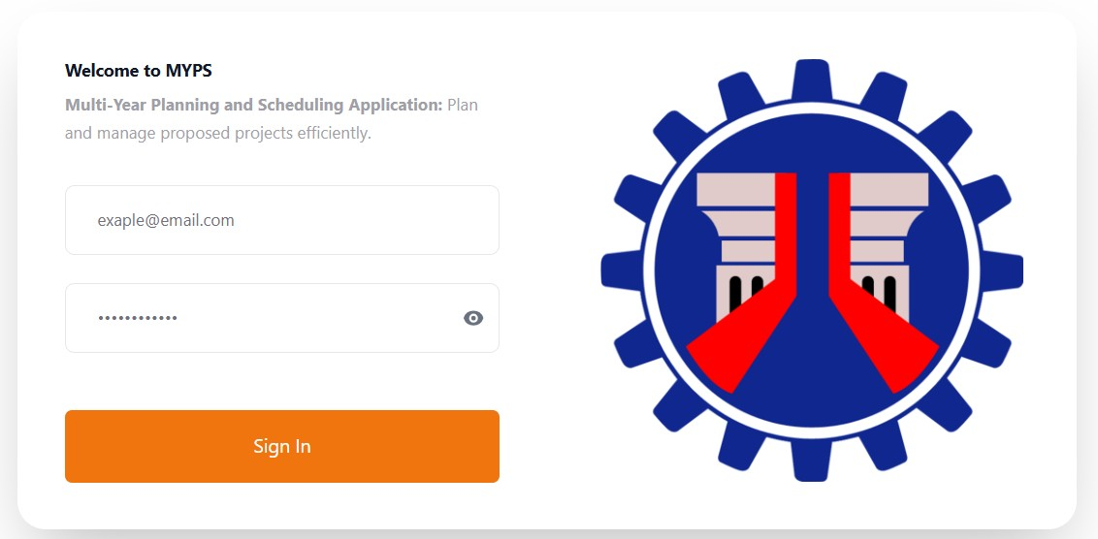
Purpose
The Login Page allows authorized users to access the MYPS Web application by entering their MYPS or DPWH account credentials.

Who uses this
The Login Page is used by all authorized MYPS users, including:
- DEO
- RO
- AUC / PS ADMIN

Prerequisites
Before logging in ensure that:
- You have an active MYPS/DPWH account.
- You know your username and password.

Field Reference
No. | Fields/Blocks/Objects | Description | Values / Actions
UI-UX-001-01 | USERNAME | DPWH network/MYPS account name used to sign in. | Required; 3–50 characters; alphanumeric with optional period (.), underscore (_), or hyphen (-); no spaces; case-insensitive. Example: jimeneznr
UI-UX-001-02 | PASSWORD | Secret credential for the above account. | Required; 8–64 characters; case-sensitive; masked input; expires per policy. Must not be shared; lockouts apply after repeated failed attempts.
UI-UX-001-03 | SIGN IN BUTTON | Button to submit login credentials for authentication. | Button labeled "Sign In". If credentials are valid, the application will redirect the user to the dashboard.

Step-by-Step: Sign In
- Open the Login page
Launch your browser and go to the MYPS Web URL provided by your office.
- Enter your Username
Click the USERNAME field and type your account name.
- Enter your Password
Click the PASSWORD field and type your password.
- Submit Select the Sign In button (or press Enter). Wait for authentication to complete. If successful, you will be redirected to your MYPS dashboard.

On Success
- Verify your displayed name and role at the top bar.
- If the role or office is incorrect, contact your MYPS administrator.

Common Outcomes & What to Do
Message / Situation | What it Means | What You Should Do
Your session has expired. Please sign in to continue. | The current session is no longer valid or authentication failed. | Sign in again using your user ID and password.

Dashboard (UI-UX-002)
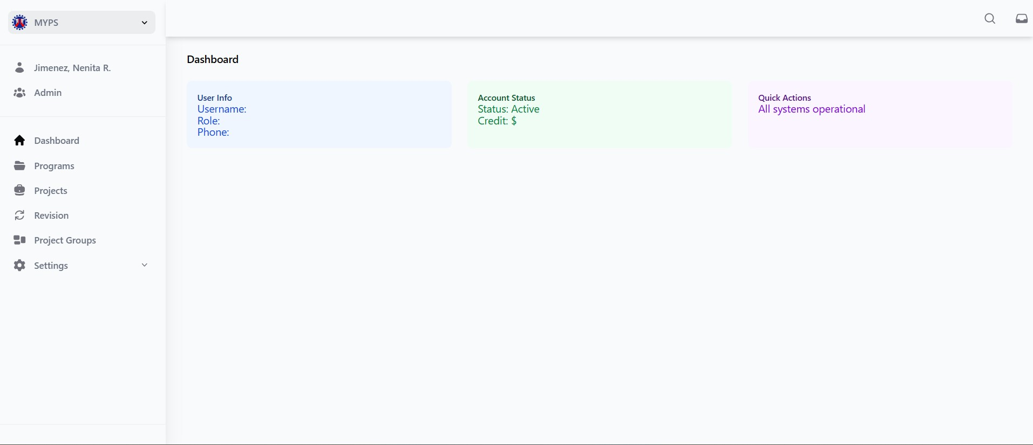
Purpose
The Dashboard is the main landing page after a successful login.

Who uses this
This screen is available to authorized MYPS users with access to the module.

Prerequisites
Before using this screen, ensure that:
You have successfully signed in to the MYPS Web application.
Your account is active and assigned to the correct role and office/unit.
You have access to the modules needed for your work.
Network or VPN access is available, if required by your office.

Field Reference
No. | Fields/Blocks/Objects | Description | Values / Actions
UI-UX-002-01 | SIDE NAVIGATION / DASHBOARD | Persistent left-side navigation panel for accessing the Dashboard. | Clickable to navigate to Dashboard section.
UI-UX-002-02 | SIDE NAVIGATION / PROGRAM | Navigational item for accessing the Program section. | Clickable to navigate to Program section where users can manage, edit, and review programs.
UI-UX-002-03 | SIDE NAVIGATION / PROJECT | Navigational item for accessing the Project section. | Clickable to navigate to Project section where users can manage and review projects.
UI-UX-002-04 | SIDE NAVIGATION / REVISION | Navigational item for accessing the Revision section. | Clickable to navigate to Revision section where users can view or modify project revisions.
UI-UX-002-05 | SIDE NAVIGATION / PROJECT GROUPS | Navigational item for accessing Project Groups section. | Clickable to navigate to Project Groups section for organizing projects.
UI-UX-002-06 | SIDE NAVIGATION / SETTINGS CODE TABLE | Navigational item for accessing the settings - Code Tables section. | Clickable to navigate to Code Tables settings section.
UI-UX-002-07 | SIDE NAVIGATION / SETTINGS USER MANAGEMENT | Navigational item for accessing Settings - User Management section. | Clickable to navigate to User Management settings section.
UI-UX-002-08 | SIDE NAVIGATION / SETTINGS INFRA MANAGEMENT | Navigational item for accessing Settings - Infra Management section. | Clickable to navigate to Infra Management settings section.

Step-by-step: Use the Dashboard
- Open the Dashboard
After signing in successfully, wait for the Dashboard page to load.
- Review your user information
- Check your account status
- Review available Quick Actions
- Open a task using Quick Actions
- Use the Side Navigation menu
- Open the Program section
Click SIDE NAVIGATION / PROGRAM to go to the Program module for managing and reviewing programs.
- Open the Project section
Click SIDE NAVIGATION / PROJECT to go to the Project module for managing and reviewing projects.
- Open the Revision section
Click SIDE NAVIGATION / REVISION to go to the Revision module for viewing or updating project revisions, if permitted.
- Open the Project Groups section
Click SIDE NAVIGATION / PROJECT GROUPS to manage or review project groups.
- Open settings sections if permitted
If your role allows access, click any of the following:
  - SETTINGS CODE TABLE
  - SETTINGS USER MANAGEMENT
  - SETTINGS INFRA MANAGEMENT
- Continue to the required MYPS task
Once the selected module opens, proceed with the next step of your work.

On success
- The Dashboard loads correctly after login.
- Your account information is displayed properly.
- The navigation links and quick actions respond correctly when selected.
- You can open the MYPS section needed for your task.

Common Outcomes & What to Do
Message / Situation | What It Means | What To Do
Module is not visible | The module may not be assigned to your role. | Confirm your permissions with your MYPS administrator or focal person.

Global Search (UI-UX-003)

Corrected Search Categories and Behavior
Use the Search By dropdown to choose one of the supported categories: Project ID, Alternate ID, Description, UACS, Program Name, Roads, Road Section, or Bridge. The Value field remains disabled until a category is selected. Search is case-insensitive and supports partial values where the application supports them.
Category group | Result columns / behavior
Project ID, Alternate ID, Description, UACS | Project Id, Description, Program Name, Stage Name, Region. Each result has a View link when available.
Program Name | Program Id, Name, Stage Name, Year Start, Status. Each result has a View link when available.
Roads | Road Id, Road Name, Region, Length. View links are not yet available.
Road Section | Road Section Id, Road Name, Region, Road Length. View links are not yet available.
Bridge | Bridge Id, Bridge Name, Region, Length. View links are not yet available.
If exactly 50 rows are displayed, refine the search by adding more characters or selecting a more specific category.
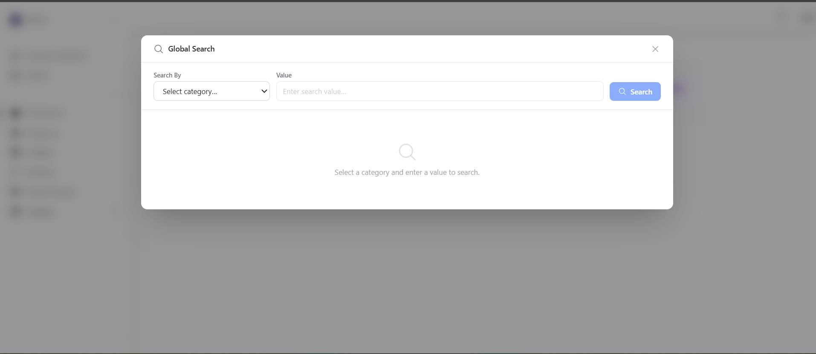
Purpose
Global Search allows users to search by Project ID, Alternate ID, Description, UACS, Program Name, Roads, Road Section, or Bridge. It helps users quickly locate data based on known identifiers or keywords.
Who uses this
This screen is available to authorized MYPS users with access to the module.
Prerequisites
Before using this screen, ensure that:
- You are logged in to the MYPS Web application.
- You have an active MYPS/DPWH account.
- You know the keyword, identifier, or name for the data you want to search.
- You are familiar with the category options available for searching.
Field reference
No. | Fields/Blocks/Objects | Description | Values / Actions
UI-UX-003-01 | SELECT CATEGORY | Dropdown field used to choose the category or module to search within (e.g., Program Name, Project ID, Roads and Bridges). | Dropdown; select a category from available options. Required before search.
UI-UX-003-02 | INPUT VALUE | Open text field where the user enters the keyword or identifier to search based on the selected category. | Text input; placeholder “Enter search value…”. User types the value to search (e.g., program name, project ID, road name).
UI-UX-003-03 | CLICK SEARCH |  | Button “Search”; click to execute the search. System returns results based on category and value.
  Action button to run the search based on the selected category and entered value.

Step-by-Step Procedure
- Step-by-step: Use Global Search
- Open Global Search
Click the magnifying-glass icon in the top navigation bar to open Global Search.
- Select a search category
In the Search By dropdown field, select the category you wish to search.
Examples of categories:
  - Alternate ID
  - Bridge
  - Description
  - Program Name
  - Project ID
  - Road Section
  - Roads
  - UACS
- Enter the search value
In the Value input box, type the keyword, identifier, or name related to the selected category.
Example search values:
  - Project ID (“BP01091013VS")
  - Program Name ("GAA-R 2020 - DO_OO1 TARLAC-PANGASINAN-LA UNION EXPRESSWAY PROJECT (TPLEX)")
- Run the search
Click the Search button to initiate the search.
- Review the results
After the search is complete, review the results displayed. The system will return matching records based on the category and value entered.
- Refine the search if necessary
If the search results are not what you expected, adjust the category or value and click Search again.
- Close the Global Search window
When you are finished with the search, you can close the window by clicking the X icon at the top-right corner.
On success
- The system returns matching search results based on the selected category and entered value.
- The relevant records are displayed in the results area.
- You can proceed to review or interact with the results.
Common Outcomes & What to Do
Message / Situation | What It Means | What To Do
No Results found | No matching records were found based on the search criteria. | Review your search terms, adjust the category or value, and try again.

Program (UI-UX-004)
Program Stage and Action Availability Matrix
The actions available on the Program screen may vary depending on the user’s assigned role, permissions, selected program stage, program status, validation results, and record lock condition. Use the matrix below as a general guide.
Action | Typical Availability / Condition
Add Program | Available to users with permission to create program records.
View Program Details | Available to users with permission to view program records. This action opens the selected program’s detail screen.
Delete Program | Available only when the user has deleted permission and the selected program is not restricted, locked, approved for publishing, or linked to dependent records.
Add Project / Add Existing Project | Available when the selected program stage and status allow project maintenance, and the user has permission to add or link project records.
Batch Actions | Available when batch operations, such as batch delete, restrict publishing, or allow publishing, are valid for the selected program and stage.
Generate Report / View AIP Report | Available only for supported program stages, report types, and user permissions.
Publish Program | Available only when the selected program is in an approved, publish-eligible stage and all required project validations have passed.
If an action is not visible or is disabled, the user may not have the required permission, or the selected program may be in a restricted stage, status, validation state, or lock condition. Users should confirm their role access and the current program status before escalating the issue to the MYPS administrator.
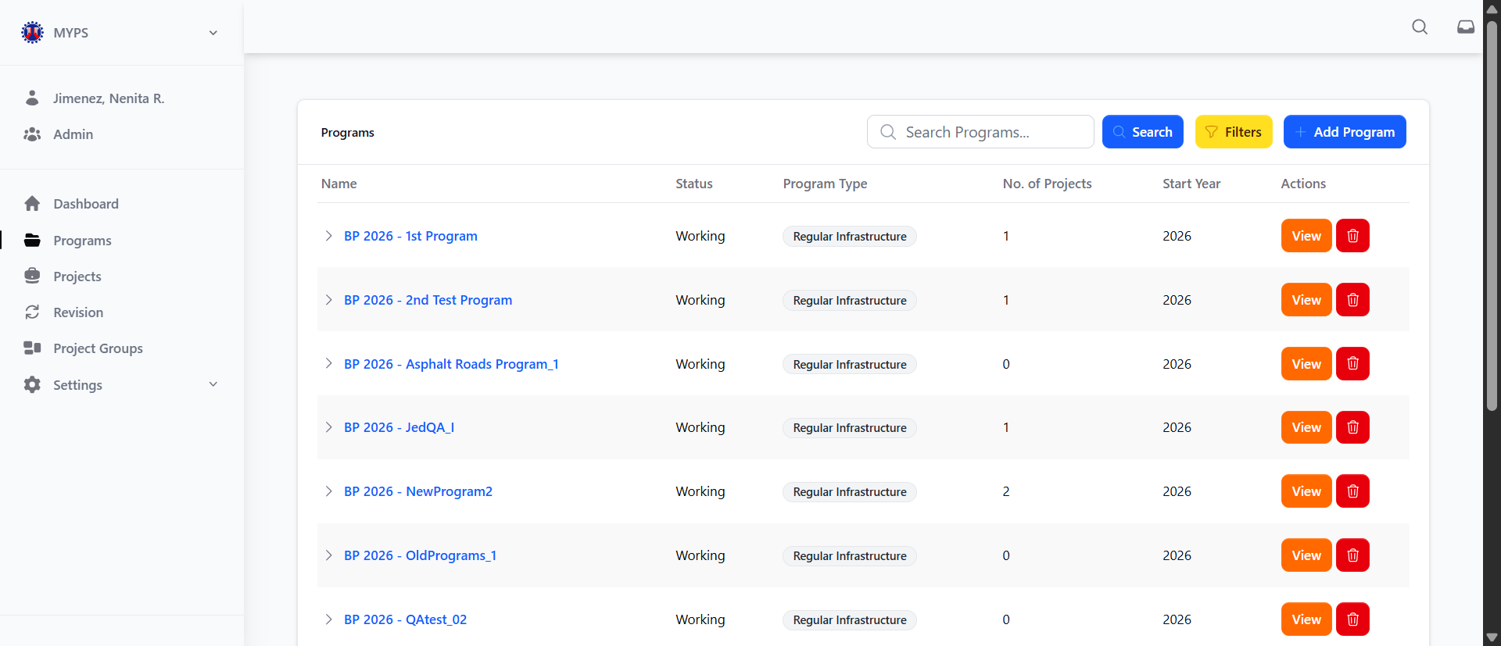
Purpose
The Program feature allows authorized users to manage, view, and edit information about various programs. This includes defining program names, statuses, types, and associated projects, as well as performing actions like adding, viewing, and deleting programs.
Who Uses This
This screen is available to authorized MYPS users with access to the module.
Prerequisites
- You must be logged into your MYPS account.
- You must have appropriate permissions to view and edit programs.
Field Reference
No. | Fields/Blocks/Objects | Description | Values / Actions
UI-UX-004-01 | PROJECT NAME | The official title of the project or initiative under the program. | Alphabetical text; Official title of the project or initiative under the program.
UI-UX-004-02 | STATUS | Current status of the program. | Working, Approved, etc.
UI-UX-004-03 | PROGRAM TYPE | Specifies the classification of the program (e.g., Infrastructure, Social, Environmental). | Drop-down list for selecting program type (e.g., Infrastructure, Social, Environmental).
UI-UX-004-04 | NO. OF PROJECTS | The number of projects under the current program. | Numeric value (e.g., 5 projects).
UI-UX-004-05 | START YEAR | The year in which the program starts. | Numeric value in YYYY format.
UI-UX-004-06 | SEARCH PROGRAM | Search field to filter the programs based on their name or program code. | Text input; placeholder: "Search Programs..."; alphanumeric characters, max 100 chars.
UI-UX-004-07 | FILTERS | Provides options to filter the displayed programs based on different parameters. | Filter criteria for program selection; options such as status, region, or program type.
UI-UX-004-08 | ADD PROGRAMS | Button to allow users to add new programs to the system. | Primary action; opens the form to add new programs.
UI-UX-004-09 | ACTION/VIEW | Button to view more details about the program. | Button labeled "View"; when clicked, it opens detailed information about the program.
UI-UX-004-10 | ACTION/DELETE | Button to delete or remove a program from the list. | Button labeled "Delete"; action is triggered after confirming the deletion of the program.

Step-by-Step: Using the Program Screen
- View Program List
- The Programs screen will show a list of all existing programs.
- Each program displays the Program Name, Status, Program Type, No. of Projects, and Start Year.
- Search for a Program
- Use the Search field to find a specific program by its name or program code.
- Type in a keyword and click Search to filter the list of programs.
- Apply Filters
- Click on Filters to filter the displayed programs by Start Year, Program Group, Program Stage.
- This helps narrow down the list based on specific criteria.
- Add a New Program
- To add a new program, click the Add Programs button.
- A form will open where you can enter the Program Name in the Sub Name and Select Start Year, Program Type, Program Stage, User Groups, and Data Security Access.
- View Program Details
- To view more details about a specific program, click the View button under the Actions column next to the program.
- This will open the program's detailed view.
- Delete a Program
- If you need to remove a program, click the Delete button under the Actions column.
- You will be asked to confirm the deletion before the program is removed from the list.
Common Outcomes & What to Do
“Program updated successfully” | The program details were successfully updated. | Verify that the program information reflects the changes.
“Required field missing” | One or more required fields are empty. | Ensure all required fields (Program Name, Status, etc.) are filled before saving.

Add Program (UI-UX-005)
Required Fields, Conditional Fields, and Special Cases
Required fields include Start Year, Program Type, Program Stage, User Groups, and Data Security Access. Sub Name is optional unless the current business rule or naming convention requires it.
Skip Reason: If the selected stage requires skipping an intermediate stage, enter the required skip explanation before submitting.
Trust Fund (TF) behavior: When Program Type is set to TF and this behavior is enabled in the application, the system automatically sets the stage to the final stage and generates the name using the TF{Year} format.
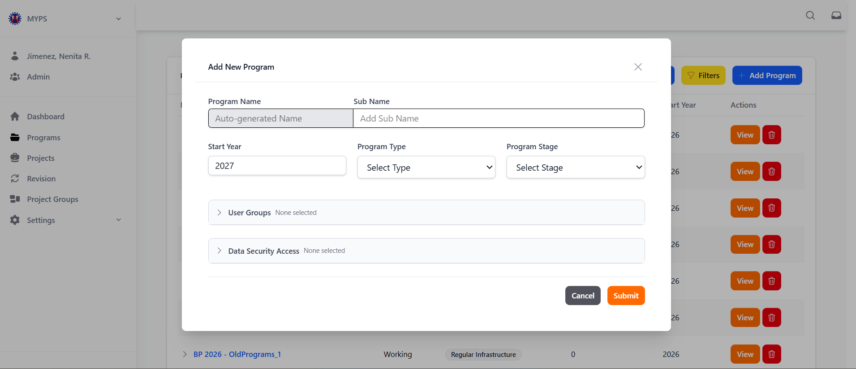
Purpose
The Delete Program screen allows authorized users to remove a selected program after confirming the program name and typing DELETE.
Who uses this
This screen is available to authorized MYPS users with access to the module.
Prerequisites
- You must be logged into the MYPS system with the appropriate permissions to add a program.
- Ensure you have all the necessary program details (e.g., program name, type, start year, user group, and security access).
Field Reference
No. | Fields/Blocks/Objects | Description | Values / Actions
UI-UX-005-01 | PROGRAM NAME | Auto-generated name for the new program. Users cannot edit this field. | Users cannot edit this field as the name is auto-generated.
UI-UX-005-02 | SUB NAME | Optional sub-program name or label for categorization. | Text Input; placeholder “Add Sub Name not required”; Alphanumeric + punctuation; 5–200 chars; Must be unique; Optional text input/label.
UI-UX-005-03 | START YEAR | Year when the program initiates. | 4-digit numeric (YYYY); range 1990–2100; required.
UI-UX-005-04 | PROGRAM TYPE * | Defines the nature of the program. | Selection of Current Program Type via Drop Down: Regular Infrastructure, External Infrastructure, Trust Fund, Automatic Appropriation.
UI-UX-005-05 | USER GROUP | Indicates the user group for the program. | Selection of User Group via Drop Down: DPD, PD, Admin, AGS, RPC, DPC, etc.
UI-UX-005-06 | PROGRAM STAGE * | States the stage which a program is at. | Selection of Current Program Type via Drop Down: RDIP, PIP, BP, NEP, HGAB, GAA, TF.
UI-UX-005-07 | DATA SECURITY ACCESS | Allows specifying which organizations or offices can access the data. | Selection of Organizations/Offices via Check Box: Central Offices, Regional Offices, Project Management Offices, Bureaus.
UI-UX-005-08 | SEARCH ORGANIZATIONS | Search bar to find specific offices or organizations for Data Security Access. | Text input; placeholder “Search organizations…”; Allowed: letters, numbers, spaces, “-”, “_”, “/”; max 100 chars.
UI-UX-005-09 | SELECT ALL / CLEAR ALL | Buttons to select or deselect all organizations in the list. | Buttons to “select” or “deselect all” items. Adds/removes checks on the check boxes.
UI-UX-005-10 | CANCEL BUTTON | Cancels the creation of the new program and closes the form. | Button “Cancel”; Action leads to closing the form.
UI-UX-005-11 | SUBMIT BUTTON | Saves and submits the new program. | Button “Submit”; Action leads to saving the program.
Step-by-Step: Adding a New Program
- Open the Add Program Modal
From the Program management screen, click the Add Program button to open the modal window where you can create a new program.
- Program Name
The Program Name field is auto-generated and cannot be edited.
- This name will be based on a predefined format from the system.
- Sub Name
Enter an optional Sub Name for the program if needed.
- Example: "Bridge Maintenance Program".
- Note: This field is optional and not required.
- Start Year
Select the Start Year of the program from the dropdown.
- Choose a 4-digit year within the range of 1990–2100.
- Example: 2026.
- Program Type
Select the Program Type from the dropdown menu.
- Options include: Regular Infrastructure, External Infrastructure, Trust Fund, Automatic Appropriation.
- Choose the most relevant type for the program.
- User Group
Select the appropriate User Group for the program.
- Options include: DPD, PP, Admin, AGS, RCP, DPC, etc.
- This defines who can access and manage the program.
- Program Stage
Select the Program Stage from the available options in the dropdown.
- Options include: RDIP, PIP, BP, NEP, HGAB, GAA, TF.
- This indicates the current stage of the program.
- Data Security Access
Select the organizations or offices that will have access to the program’s data.
- You can search for specific organizations using the Search Organizations bar.
- Check the appropriate checkboxes for the selected organizations.
- Use Select All or Clear All for bulk actions.
- Cancel or Submit
- If you wish to cancel the operation, click the CANCEL BUTTON to close the modal without saving.
- To save and submit the new program, click the SUBMIT BUTTON. The program will be created and added to the system.

Common Outcomes & What to Do
Message / Situation | What it Means | What You Should Do
“Name: The Name field is required” | The Name field has been left empty or is invalid | Enter a valid name in the "Name" field to proceed. Ensure that it meets any required formatting or character limitations.

Filter Program (UI-UX-006)
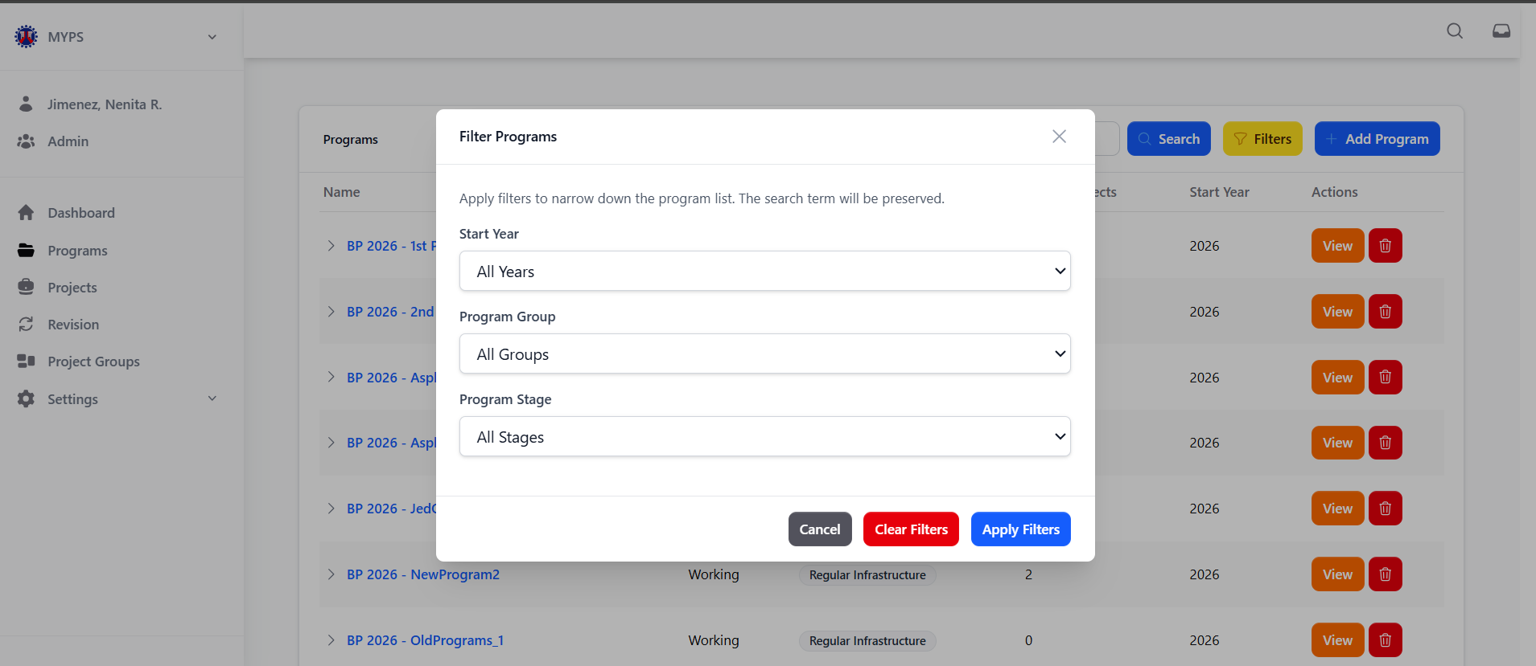
Purpose
The Filter Program feature allows users to apply specific filters to narrow down the list of programs displayed on the Programs screen. This helps users easily find programs based on their starting year, program group, and program stage.
Who Uses This
This screen is available to authorized MYPS users with access to the module.
Prerequisites
You must be logged into your MYPS account.
You must have access to the Programs section of the system.
Field Reference
No. | Fields/Blocks/Objects | Description | Values / Actions
UI-UX-006-01 | START YEAR | Filter programs by their starting year. | Dropdown list for selecting a specific start year or selecting "All Years".
UI-UX-006-02 | PROGRAM GROUP | Filter programs based on the group they belong to. | Dropdown list for selecting the program group (e.g.,"Admin”, “AUC”, “RPC”, “DPC”, “DPD Admin”, “SD”).
UI-UX-006-03 | PROGRAM STAGE | Filter programs by their current stage (e.g., BP, NEP, GAA). | Dropdown list for selecting the program stage (e.g., "All Stages", "BP", "NEP", etc.).
UI-UX-006-04 | CANCEL | Cancel the filter action and close the filter panel. | Button labeled "Cancel"; closes the filter panel without applying any changes.
UI-UX-006-05 | CLEAR FILTERS | Clears all selected filters and restores the unfiltered view. | Button labeled "Clear Filters"; clears all applied filters.
UI-UX-006-06 | APPLY FILTERS | Apply the selected filters and display the filtered results. | Button labeled "Apply Filters"; applies the selected filters to the program list.

Step-by-Step: Using the Filter Program
- Open the Filter Dialog
- Click the Filter button on the Programs page to open the filter dialog box.
- Select Start Year
- In the Start Year dropdown, select a specific year or choose "All Years" to include all years in your search
- Select Program Group
- In the Program Group dropdown, select the program group (e.g., "Admin”, “AUC”, “RPC”, “DPC”, “DPD Admin”, “SD”) to filter the programs by their associated group.
- Select Program Stage
- In the Program Stage dropdown, select a program stage (e.g., "All Stages", "BP", "NEP", "HGAB") to filter the programs by their current stage.
- Apply Filters
- Once you've selected the desired filter criteria, click the Apply Filters button to filter the program list according to the selected criteria.
- Clear Filters (if necessary)
- If you wish to remove all applied filters and reset the view, click the Clear Filters button.
- Cancel Filter Action
- If you decide not to apply any filters, click the Cancel button to close the filter dialog without making any changes.
Common Outcomes & What to Do
Message/Situation | What it Means | What You Should Do
“Filters applied successfully” | The filters were applied and the program list has been updated. | Review the filtered programs and ensure they match the selected criteria.
“No programs match the selected filters” | The filter criteria you’ve applied don’t match any programs. | Review and adjust your filter criteria or remove some filters to expand the results.

Delete Program (UI-UX-007)
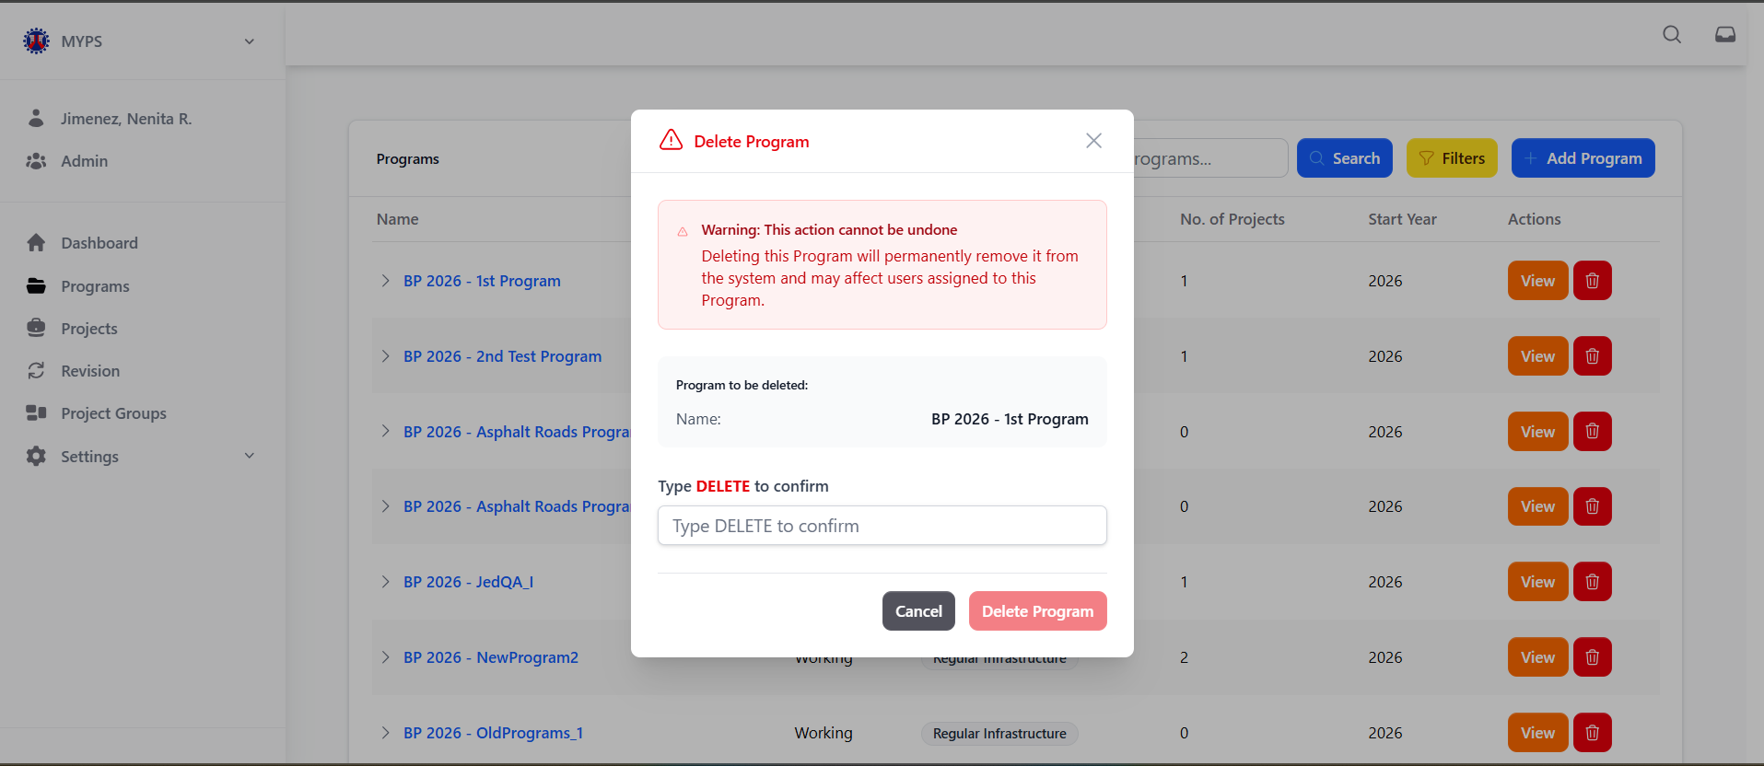
Purpose
The Delete Program screen allows authorized users to delete a selected program after confirming the program name and entering the required confirmation keyword. This screen helps prevent accidental deletion by requiring the user to review the selected program and type DELETE before the deletion is completed.
Who uses this
This screen is available to authorized MYPS users who have permission to delete program records.

Prerequisites
Before using this screen, ensure that:
- You are logged in to the MYPS Web application.
- You have permission to delete programs.
- The program to be deleted has been correctly identified.
- The program is not linked to dependent records, such as projects or assigned users.
- You understand that the deletion action cannot be undone.
Field Reference
No. | Fields/Blocks/Objects | Description | Values / Actions
UI-UX-007- 01 | WARNING MESSAGE BLOCK | Displays a critical warning to the current user that the deletion may affect other users. | Text message; Warning message: “Warning: This action cannot be undone.”; States effects of the deletion.
UI-UX-007- 02 | PROGRAM TO BE DELETED | Specifies which program is being deleted. | Text message; Text: “Program to be deleted:”.
UI-UX-007- 03 | PROGRAM NAME FIELD | Shows the name of the program selected for deletion. | Text message; States the name of the program to be deleted.
UI-UX-007- 04 | CONFIRMATION INSTRUCTION TEXT | Instructs the user to type a specific word to confirm deletion. | Text message; Instruction text: “Type DELETE to confirm.”
UI-UX-007- 05 | CONFIRMATION INPUT FIELD | Text field where the user types the confirmation keyword to proceed. | Text input; Instruction text: “Type DELETE to confirm.”; Delete to confirm (keyword confirmation).
UI-UX-007- 06 | CANCEL BUTTON | Button to abort or close the deletion. | Button “Cancel”; Action leads to closing the form and aborts deletion.
UI-UX-007- 07 | DELETE BUTTON | Confirms the deletion of the selected program. | Button “Delete”; Confirms deletion.

Step-by-Step: Delete a Program
- Open the Delete Program dialog
From the Program management screen, locate the program you want to delete, then click the Delete button or trash icon beside the selected program.
- Review the warning message
Carefully read the warning message displayed in the dialog. The warning informs you that the deletion action cannot be undone.
- Verify the program name
Check the Program Name field and confirm that it shows the correct program to be deleted.
Example: GAA 2025 SSP
- Enter the confirmation keyword
In the confirmation input field, type DELETE exactly as shown in the instruction text.
- Cancel or proceed
Click Cancel if you do not want to continue. The dialog will close and no changes will be made.
Click Delete if you are sure that the selected program should be deleted.
- Confirm the result
After the deletion is completed, the system returns to the Program management screen or refreshes the program list. Verify that the deleted program no longer appears in the list.
On success
The selected program is deleted from the system, and the Program management screen is updated to reflect the change.
Common Outcomes & What to Do
Message / Situation | What it means | What you should do
Program deleted successfully. | The selected program was deleted successfully. | Confirm that the program no longer appears in the Program list.
Error: Cannot delete program. | The program may be linked to dependent records, such as projects or assigned users. | Review the program’s related records or contact the MYPS administrator.
Confirmation keyword is missing. | The required confirmation text was not entered. | Type DELETE in the confirmation input field and try again.

Program Stages (UI-UX-008)
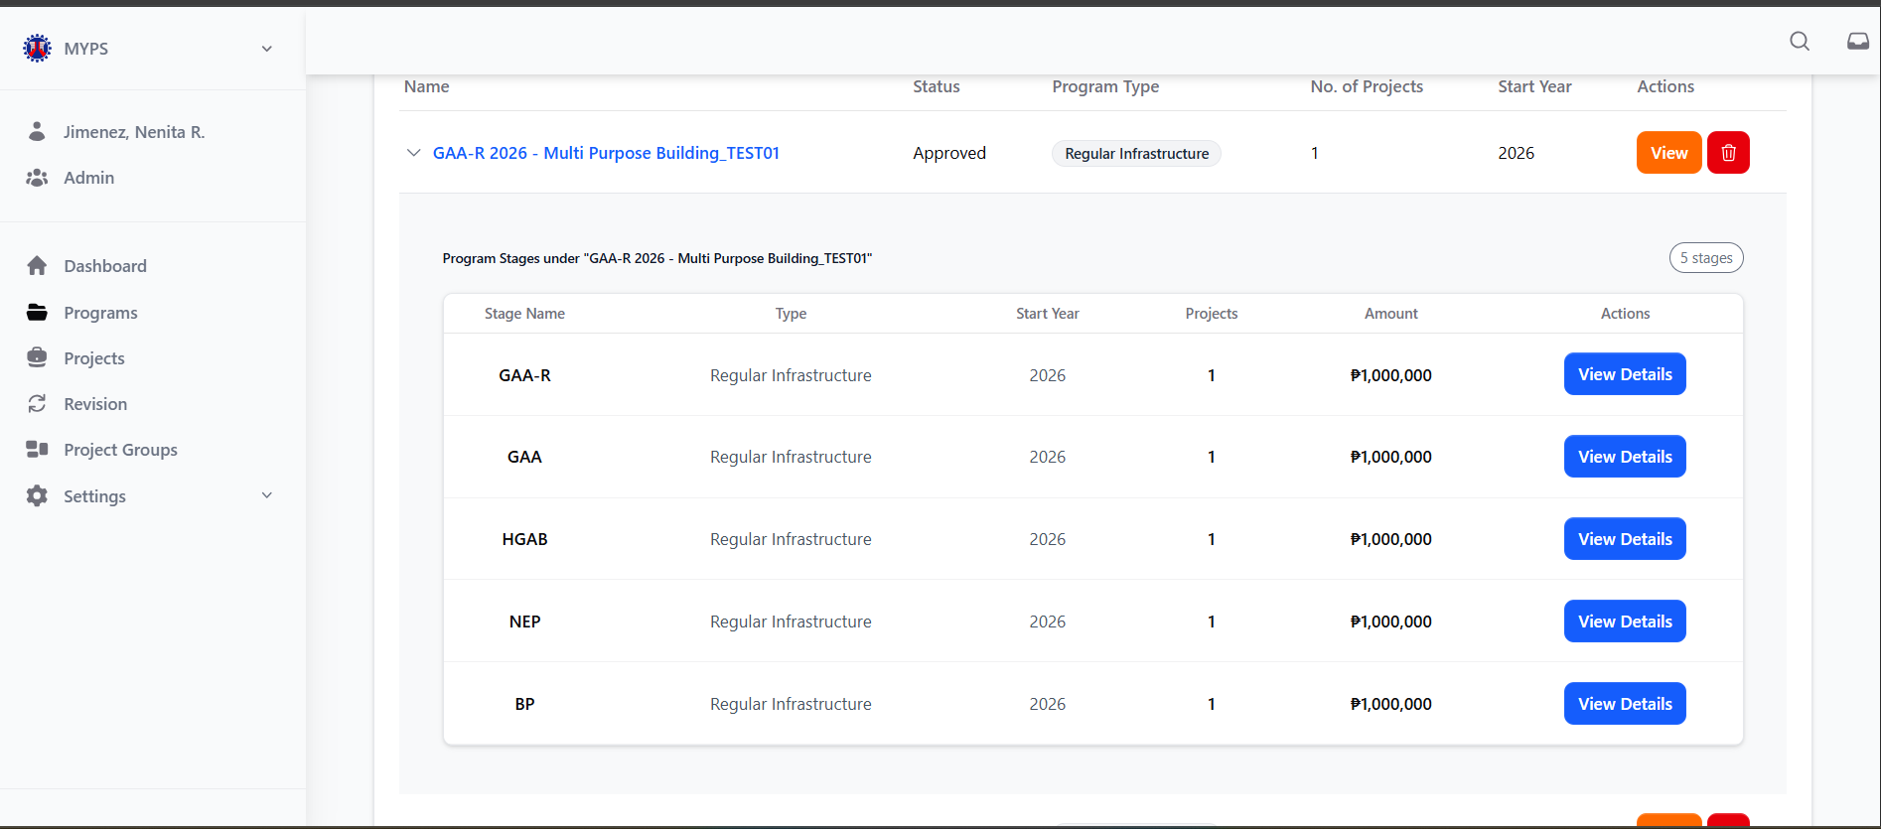
Purpose
The Program Stages screen allows users to review detailed information for a selected program, including its stages, Stage Name, Type, Start Year, Projects, Amount. It helps authorized users monitor, review, and manage the details of the program's various stages.
Who Uses This
This screen is available to authorized MYPS users with access to the module.
Prerequisites
Before using this screen:
- You must be logged in to the MYPS Web application.
- A program must be selected from the list of programs.
- Your account must have permission to view program details.
Field reference
No. | Field/Block/Objects | Description | Allowed values / Actions
UI-UX-008-01 | STAGE NAME | Displays the stage name of the program. | Dropdown options: BP, NEP, HGAB, GAA, etc.
UI-UX-008-02 | TYPE | Specifies the classification or category of the program. | Text input for project classification (e.g., Infrastructure, Environmental).
UI-UX-008-03 | START YEAR | The year the program is scheduled to start. | Numeric value (YYYY), e.g., "2025"
UI-UX-008-04 | PROJECTS | Number of projects associated with each stage of the program. | Numeric value (e.g., 3 projects).
UI-UX-008-05 | AMOUNT | Displays the cost or budget allocated for each stage or project. | Currency value (e.g., ₱15,000,000,000).
UI-UX-008-06 | ACTIONS/VIEW DETAILS | Button to view the details of the specific project or program. | Button labeled "View Details"; when clicked, the user can view detailed information for the program or project.

Step-by-Step: Viewing Program Stages
1. Open the Program Stages Screen
- Launch the MYPS Web application and log in.
- Navigate to the Programs section from the main menu.
- Select a program from the available list.
2. View Program Information
Once the program is selected, the following fields are displayed:
- Stage Name: The name of each stage in the program (e.g., BP, NEP).
- Type: The classification of the program (e.g., "Infrastructure").
- Start Year: The year the program is scheduled to start (e.g., 2025).
- Projects: The number of projects within the program stage (e.g., "3 projects").
- Amount: The total allocated cost for the program stage (e.g., ₱15,000,000,000).
3. View Detailed Information
To view more detailed information about a specific project or program stage, click the View Details button located next to the respective stage.
- Clicking this button will open a detailed view of the selected stage, showing additional information such as project breakdown, funding details, and more.
4. Access and Manage Projects
The Projects field shows the number of projects tied to each stage. To manage or view details of a specific project, select it from the associated projects table, which may have options like Add Project or Add Existing Project.
On success
- Program and stage details are displayed correctly.
- Clicking View Details opens additional information for the program or stage.
- Updates, if made, are successfully saved.
Common Outcomes & What to Do
Message / Situation | What It Means | What To Do
Program details not loading | The program data could not be retrieved. | Refresh the page or contact support if the issue persists.
Unauthorized to update | Your role does not permit edits. | Contact MYPS administrator for permissions.

Program Details RBP (UI-UX-009)
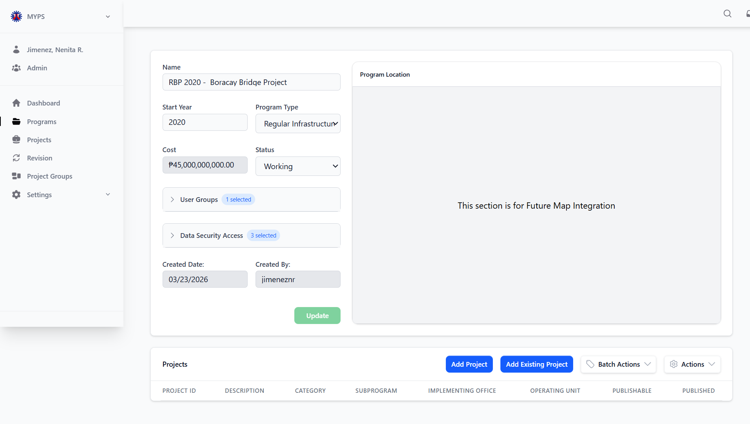
Purpose
This screen allows authorized users to view and review the details of an existing Regional Budget Proposal (RBP) program in MYPS Web. It presents the program header information, security and access settings, program location area, and the list of projects currently included in the selected program.
Who uses this
This screen is available to authorized MYPS users with access to the module.
Prerequisites
Before using this screen, ensure that:
- Before using this screen, ensure that:
- You are logged in to MYPS Web.
- You have permission to access Program records.
- The selected Program already exists in MYPS.
- The Program record is an RBP Program.
- Your assigned role allows viewing or updating Program details
Field Reference
No. | Field / Block / Object | Description | Values/Actions
UI-UX-009-01 | NAME | Name of the selected RBP Program. | Text field. Displays the Program name. Editable only if the user has permission and the workflow status allows editing. Example: RBP 2020 - Boracay Bridge Project.
UI-UX-009-02 | START YEAR | Budget or planning start year of the Program. | Numeric year value in YYYY format. Example: 2020.
UI-UX-009-03 | PROGRAM TYPE | Type classification of the selected Program. | Dropdown or selected value. Example: Regular Infrastructure.
UI-UX-009-04 | COST | Total cost recorded for the Program. | Currency field. Usually system-calculated from linked projects or approved Program cost. Example: ₱45,000,000,000.00.
UI-UX-009-05 | STATUS | Current workflow or approval status of the Program. | Dropdown or selected value, depending on permissions. Example shown: Working.
UI-UX-009-06 | USER GROUPS | User groups assigned to the selected Program. | Expandable section. Displays selected user groups. May allow selection, update, or review depending on user role.
UI-UX-009-07 | DATA SECURITY ACCESS | Security access settings for the selected Program. | Expandable section. Displays assigned offices or organizations with access to the Program record.
UI-UX-009-08 | CREATED DATE | Date when the Program record was created. | Display value; read-only. Example: 03/23/2026.
UI-UX-009-09 | CREATED BY | User who created the Program record. | Display value; read-only. Example: jimeneznr.
UI-UX-009-10 | UPDATE | Saves allowed changes to the Program record. | Click to save updates to editable fields. Button may be disabled if no changes are made or if the user has read-only access.
UI-UX-009-11 | PROGRAM LOCATION | Panel for map or location display associated with the Program. | Display panel. Current screen may show placeholder text such as “This section is for Future Map Integration.”
UI-UX-009-12 | PROJECTS GRID | List of projects currently included in the selected Program. | Grid view showing project records and related columns such as Project ID, Description, Category, Subprogram, Implementing Office, Operating Unit, Publishable, and Published.
UI-UX-009-13 | ADD PROJECT | Creates a new project under the selected Program. | Click to open the Add Project workflow, if permitted.
UI-UX-009-14 | ADD EXISTING PROJECT | Adds an existing project to the selected Program. | Click to open the add-existing-project process.
UI-UX-009-15 | BATCH ACTIONS | Applies batch operations to selected project records. | Click to open available batch actions, such as batch update, delete, restrict publishing, or allow publishing, depending on status and permissions.
UI-UX-009-16 | ACTIONS | Provides additional Program-level or project-list actions. | Click to open available actions, such as export, import, generate report, or other role-based actions.

Step-by-step: View RBP Program details
- Open the Programs module
From the left navigation menu, click Programs.
- Find the RBP Program
Use the Program list, search field, or filters to locate the required RBP Program.
- Open the Program details screen
Click View or the applicable row action beside the selected Program.
- Review the Program header
Check the displayed Name, Start Year, Program Type, Cost, and Status.
Confirm that the opened record is the correct RBP Program.
- Review User Groups
Expand User Groups to see which groups are assigned to the Program.
If your role allows editing, update the assigned groups as needed.
- Review Data Security Access
Expand Data Security Access to verify which offices or organizations have access to the Program.
Confirm that the security access is appropriate before making or approving changes.
- Review Created Date and Created By
Check the read-only audit fields to identify when the Program was created and who created it.
- Review the Program Location panel
Check the Program Location area.
If map integration is not yet active, the panel may display a placeholder message for future map integration.
- Review the Projects grid
Scroll to the Projects section and review the list of projects linked to the RBP Program.
- Add a new project, if needed
Click Add Project to create a new project under this Program, if your role allows it.
- Add an existing project, if needed
Click Add Existing Project to search for and link an existing project to the Program.
- Use Batch Actions, if needed
Select applicable project records and click Batch Actions to perform allowed bulk operations.
- Use additional Actions, if needed
Click Actions to open other available Program or project-list actions.
- Save allowed updates
If you changed editable fields, click Update.
Wait for the system confirmation before leaving the screen.
On success
The selected RBP Program details are displayed correctly.
The Program header information matches the intended record.
User Groups and Data Security Access are visible for review.
Linked projects appear in the Projects grid.
Any allowed updates are saved successfully after clicking Update.
Common outcomes & what to do
Message / Situation | What it means | What you should do
Program details open in read-only mode | Your role may only allow viewing, or the Program status may restrict editing. | Review the information only. Contact your MYPS administrator if you believe edit access is required.
Update button is disabled | No changes were made, required fields are incomplete, or your access is read-only. | Confirm that you changed an editable field and that all required values are valid.
User Groups cannot be expanded or changed | Your role may not have permission to manage access settings. | Contact the Program owner or MYPS administrator.
Data Security Access appears incorrect | The Program may be visible to the wrong office or missing required access. | Do not proceed with sensitive changes. Report the issue to the Program administrator.

Program Details BP (UI-UX-0010)
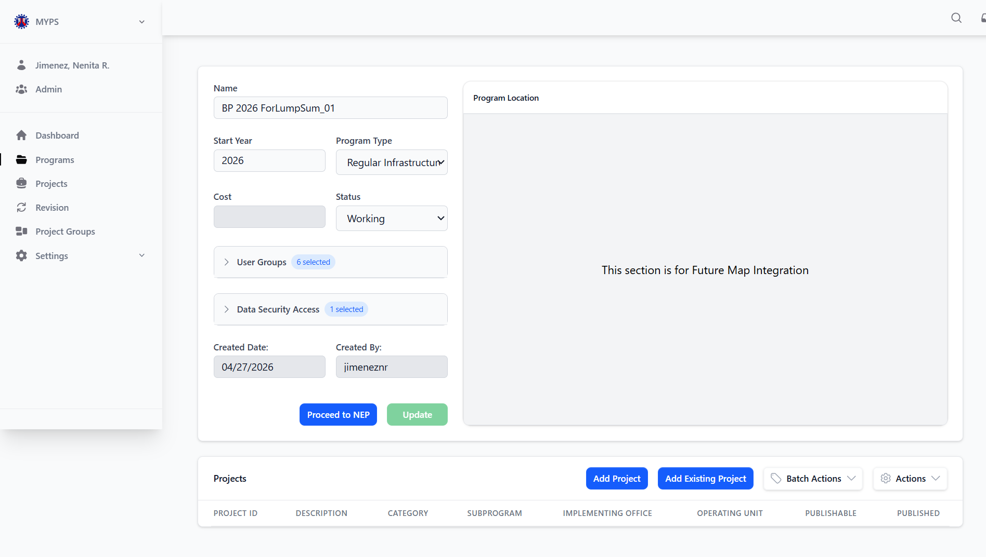
Purpose
The Program Details BP screen allows users to view detailed information for a selected Budget Proposal (BP) program. It provides program-specific data including stages, cost, user access, and status to support monitoring, review, and updates.
Who uses this
This screen is available to authorized MYPS users with access to the module.
Prerequisites
Before using this screen:
- You must be logged in to MYPS Web.
- You must have selected a program from the list of BPs.
- You must have the necessary role to view or update program details.
Field reference
No. | Fields/Blocks/Objects | Description | Values / Actions
UI-UX-0010-01 | PROGRAM NAME | The name of the program being viewed | Alphanumeric text (e.g., "BP 2025 - Budget Proposal for X")
UI-UX-0010-02 | PROGRAM TYPE | Specifies the type of the program | Dropdown: Regular Infrastructure, Special Projects, etc.
UI-UX-0010-03 | START YEAR | The year the program is scheduled to start | Numeric value (YYYY); e.g., "2025"
UI-UX-0010-04 | COST | The cost allocated for the program | Numeric value (e.g., "₱20,000,000")
UI-UX-0010-05 | STATUS | Current status of the program | Dropdown: Working, Pending, Approved, etc.
UI-UX-0010-06 | USER GROUPS | Groups authorized to access or work with the program | Text or multiple selections from user groups
UI-UX-0010-07 | DATA SECURITY ACCESS | Defines the level of access for different user roles | Text input or dropdown specifying the security levels
UI-UX-0010-08 | CREATED BY | The user who created the program | Alphanumeric (user's name, e.g., "admin")
UI-UX-0010-09 | CREATED DATE | The date the program was created | Date format (mm/dd/yyyy)
UI-UX-0010-10 | UPDATE BUTTON | Button to update the details of the program | Button labeled "Update" to submit changes
UI-UX-0010-11 | PROCEED TO NEP BUTTON | Button to proceed to the National Expenditure Program. | Button labeled "Proceed to NEP"

Step-by-step: View Program Details BP
- Open the Program List
Navigate to the Programs section in MYPS Web.
- Select the program
Click on the specific BP program you wish to view.
- Review program information
Check Program Name, Program Type, Start Year, Cost, and Status fields.
- Verify access and security
Review User Groups and Data Security Access to confirm authorized access.
- Check creation details
Confirm Created by and Created Date for reference.
- Update program details (if authorized) Edit the permitted fields, then click Update to save the changes.
- Review associated projects
Scroll to the projects table. Use Add Project or Add Existing Project buttons if you have permission to manage projects.
On success
- Program details display correctly.
- Users can update information if authorized.
- Associated projects are visible and can be managed
Common Outcomes & What to Do
Message / Situation | What It Means | What To Do
Fields are read-only | User does not have edit permissions. | Confirm role and permissions with MYPS administrator.

Proceed to Next Stage NEP (UI-UX-0011)
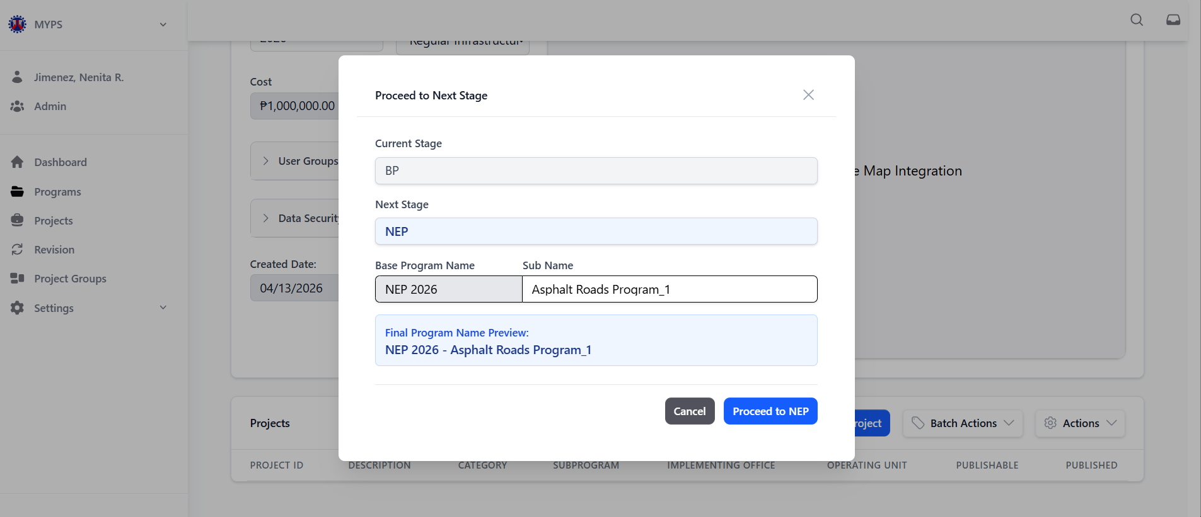
Purpose
The Proceed to Next Stage NEP feature allows authorized users to transition a program from one stage to the next, specifically moving a program to the NEP (National Expenditure Program) stage. This action involves confirming the program’s next stage, adjusting its name if necessary, and proceeding with the transition.
Who Uses This
This screen is available to authorized MYPS users with access to the module.
Prerequisites
- You must be logged into your MYPS account.
- You must have permissions to transition programs between stages.
- The program must have completed its current stage before proceeding to the next.
Field reference
No. | Fields/Blocks/Objects | Description | Values / Actions
UI-UX-0011-01 | CURRENT STAGE | Displays the current stage of the program. | Text; read-only; shows the current program stage (e.g., BP, NEP).
UI-UX-0011-02 | NEXT STAGE | Displays the next stage the program will transition to. | Text; read-only; shows the automatic next stage (e.g., NEP).
UI-UX-0011-03 | BASE PROGRAM NAME | Editable field to change the name of the base program. | Text input; 4-digit numeric (e.g., "NEP 2026").
UI-UX-0011-04 | SUB NAME | Optional field for adding additional names for clarification (e.g., revision, version). | Text input; alphanumeric + punctuation.
UI-UX-0011-05 | PROGRAM NAME PREVIEW | Displays a preview of the full program name before finalizing the transition. | Text shows the preview name (e.g., "NEP 2025 - CONCRETING OF TUGAS-MALIGAY ROAD PATIKUL SULU").
UI-UX-0011-06 | CANCEL | Closes the modal without proceeding to the next stage. | Button labeled "Cancel"; action leads to closing the form.
UI-UX-0011-07 | PROCEED TO NEP | Confirms the action and proceeds the program to the NEP stage. | Button labeled "Proceed to NEP"; action confirms the transition to the next stage.

Step-by-Step: Proceed to Next Stage (NEP)
- Select the Program for Transition
  - Locate the program you want to transition and click the Proceed to Next Stage button.
- Check the Current Stage
  - The Current Stage field will show the current status of the program (e.g., BP). Ensure the program is ready to proceed to the next stage.
- Review the Next Stage
  - The Next Stage field will automatically display NEP, indicating the stage the program is moving into.
- Modify the Base Program Name (if needed)
  - If necessary, edit the Base Program Name field to reflect the correct name (e.g., NEP 2026).
  - This is an editable field where you can update the name of the program.
- Add a Sub Name (Optional)
  - In the Sub Name field, you can add additional details, such as version or clarification notes (e.g., "2026 Version 1").
- Preview the Final Program Name
  - The Program Name Preview will display the final name after all edits. Review the name to ensure accuracy (e.g., "NEP 2025 – CONCRETING OF TUGAS-MALIGAY ROAD PATIKUL, SULU").
- Proceed to Next Stage
  - Once you’ve verified the program name and details, click the Proceed to NEP button to finalize the transition and move the program to the NEP stage.
- Cancel the Action (if needed)
  - If you decide not to proceed with the transition, click the Cancel button. This will close the modal without making any changes.

Common Outcomes & What to Do
Message/Situation | What it Means | What You Should Do
“Program transitioned to NEP successfully” | The program has been successfully moved to the NEP stage. | Verify the program status to ensure it now shows the NEP stage.
“Required field missing” | One or more required fields (e.g., Base Program Name) are empty. | Fill in all required fields before proceeding.

Program Details NEP (UI-UX-0012)
Purpose
The View Program Details NEP feature allows authorized users to view and edit detailed information about programs that have transitioned to the NEP (National Expenditure Program) stage. This includes the program’s name, type, status, associated projects, and other relevant information.
Who Uses This
This screen is available to authorized MYPS users with access to the module.
Prerequisites
- You must be logged into your MYPS account.
- The program you wish to view must be in the NEP stage.

Field Reference
No. | Field/Block/Object | Description | Values / Actions
UI-UX-0012-01 | PROGRAM NAME | Dropdown to select the program under which the project falls. | Dropdown options (e.g., "NEP 2025")
UI-UX-0012-02 | PROGRAM TYPE | Defines the type of program. | Dropdown: Regular Infrastructure, External Infrastructure, etc.
UI-UX-0012-03 | START YEAR | The starting year for the program. | Numeric input (YYYY), e.g., "2025"
UI-UX-0012-04 | PROGRAM STATUS | Displays the current status of the program. | Dropdown: Active, Completed, Working, Approved, etc.
UI-UX-0012-05 | COST | Displays the cost allocated or estimated for the program. | Numeric value (e.g., ₱15,000,000,000)
UI-UX-0012-06 | USER GROUPS | Groups with access to the program. | Text input or selection of multiple user groups (e.g., Admin, Planner)
UI-UX-0012-07 | DATA SECURITY ACCESS | User groups or offices that have data security access. | Text input or list of selected groups
UI-UX-0012-08 | CREATED DATE | Date when the program was created. | Date input (MM/DD/YYYY)
UI-UX-0012-09 | CREATED BY | User who created the program. | Text input (e.g., "admin")
UI-UX-0012-10 | PROCEED TO NEP-E | Button to proceed to the next NEP stage. | Button labeled "Proceed to NEP-E"
UI-UX-0012-11 | PROCEED TO HGAB | Button to proceed to the HGAB stage. | Button labeled "Proceed to HGAB"
UI-UX-0012-12 | UPDATE | Button to save changes made to the program details. | Button labeled "Update"

Step-by-Step: View Program Details NEP
1. Select Program
- On the Programs page, locate a program that has reached the NEP stage.
- Click on the program name to open the View Program Details NEP page.
2. Review Program Details
- Verify the program’s Name, Program Type, Start Year, Program Status, Cost, User Groups, Data Security Access, Created Date, and Created By fields.
- Ensure the Program Status is accurately listed (Working, Approved, etc.).
3. Proceed to NEP or HGAB
- If the program is ready to transition to the next NEP stage, click Proceed to NEP-E.
- To move the program to the HGAB stage, click Proceed to HGAB.
4. Update Program Details
- Edit any fields that require updates, such as Program Name, Status, or Cost.
- Click Update to save changes.
5. Cancel Changes
- If you decide not to make changes, close the page or navigate away without clicking Update. No changes will be saved.
Common Outcomes & What to Do
Message/Situation | What it Means | What You Should Do
“Program updated successfully” | The program details were successfully updated. | Verify that the updated program details reflect the changes.

Proceed to Next Stage NEP-E (UI-UX-0013)
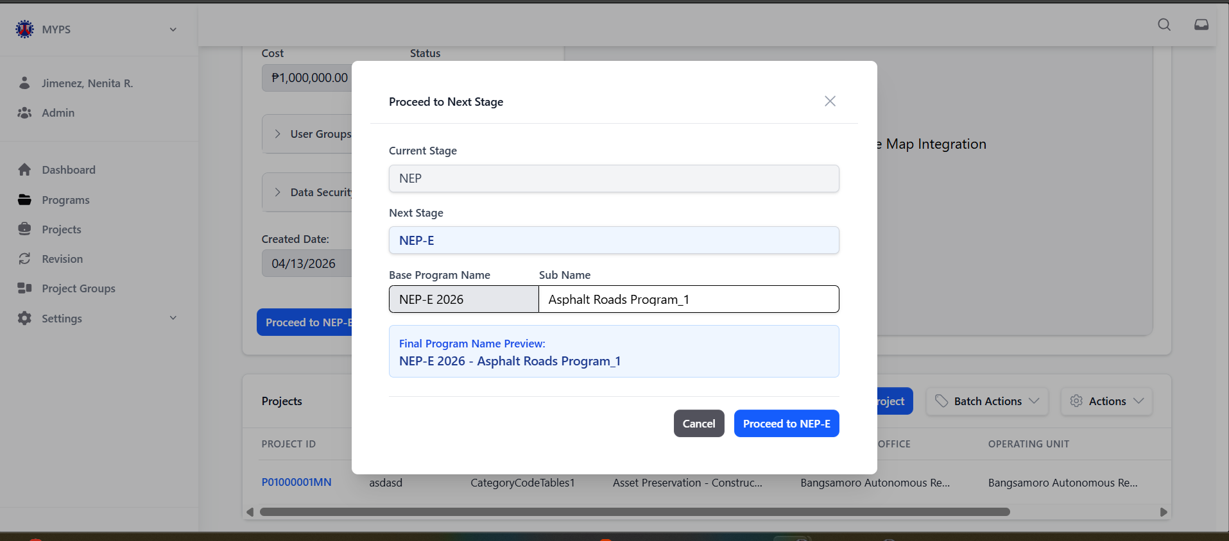
Purpose
The Proceed to Next Stage NEP-E feature allows authorized users to transition a program from the NEP (National Expenditure Program) stage to the NEP-E (Expanded NEP) stage. Users can confirm the next stage, adjust the program name if necessary, and proceed with the transition.
Who Uses This
This screen is available to authorized MYPS users with access to the module.
Prerequisites
- You must be logged into your MYPS account.
- You must have permission to transition programs between stages.
- The program must be in the NEP stage to proceed to NEP-E.
Field Reference
No. | Field/Block/Object | Description | Values / Actions
UI-UX-0013-01 | CURRENT STAGE | Displays the current stage of the program. | Read-only; e.g., NEP
UI-UX-0013-02 | NEXT STAGE | Shows the next stage for transition. | Read-only; e.g., NEP-E
UI-UX-0013-03 | BASE PROGRAM NAME | Editable field to update the base program name. | Alphanumeric text; e.g., "NEP-E 2026"
UI-UX-0013-04 | SUB NAME | Optional field for additional program name details. | Text input (optional)
UI-UX-0013-05 | PROGRAM NAME PREVIEW | Shows the full program name after updates. | Read-only; auto-generated preview
UI-UX-0013-06 | CANCEL | Closes the modal without applying changes. | Button labeled "Cancel"
UI-UX-0013-07 | PROCEED TO NEP-E | Confirms the action and transitions the program. | Button labeled "Proceed to NEP-E"

Step-by-Step: Proceed to Next Stage NEP-E
1. Open the Modal
- Navigate to the View Program Details NEP page.
- Click the Proceed to NEP-E button.
2. Confirm Current Stage
- Verify that the Current Stage field shows NEP.
3. Verify or Edit Program Name
- Update the Base Program Name if necessary (e.g., "NEP-E 2026").
- Optionally, add details in the Sub Name field.
- Check the Program Name Preview to confirm the final name.
4. Confirm or Cancel
- Click Proceed to NEP-E to transition the program to the NEP-E stage.
- Or click Cancel to exit the modal without applying changes.

Common Outcomes & What to Do
Message / Situation | What it Means | What You Should Do
"Invalid Stage" | Program is not currently in NEP stage. | Verify the program’s current stage before proceeding.
"Insufficient Permissions" | Your account cannot perform the transition. | Request stage transition permissions from an admin.

Programs Details NEP-E (UI-UX-0014)
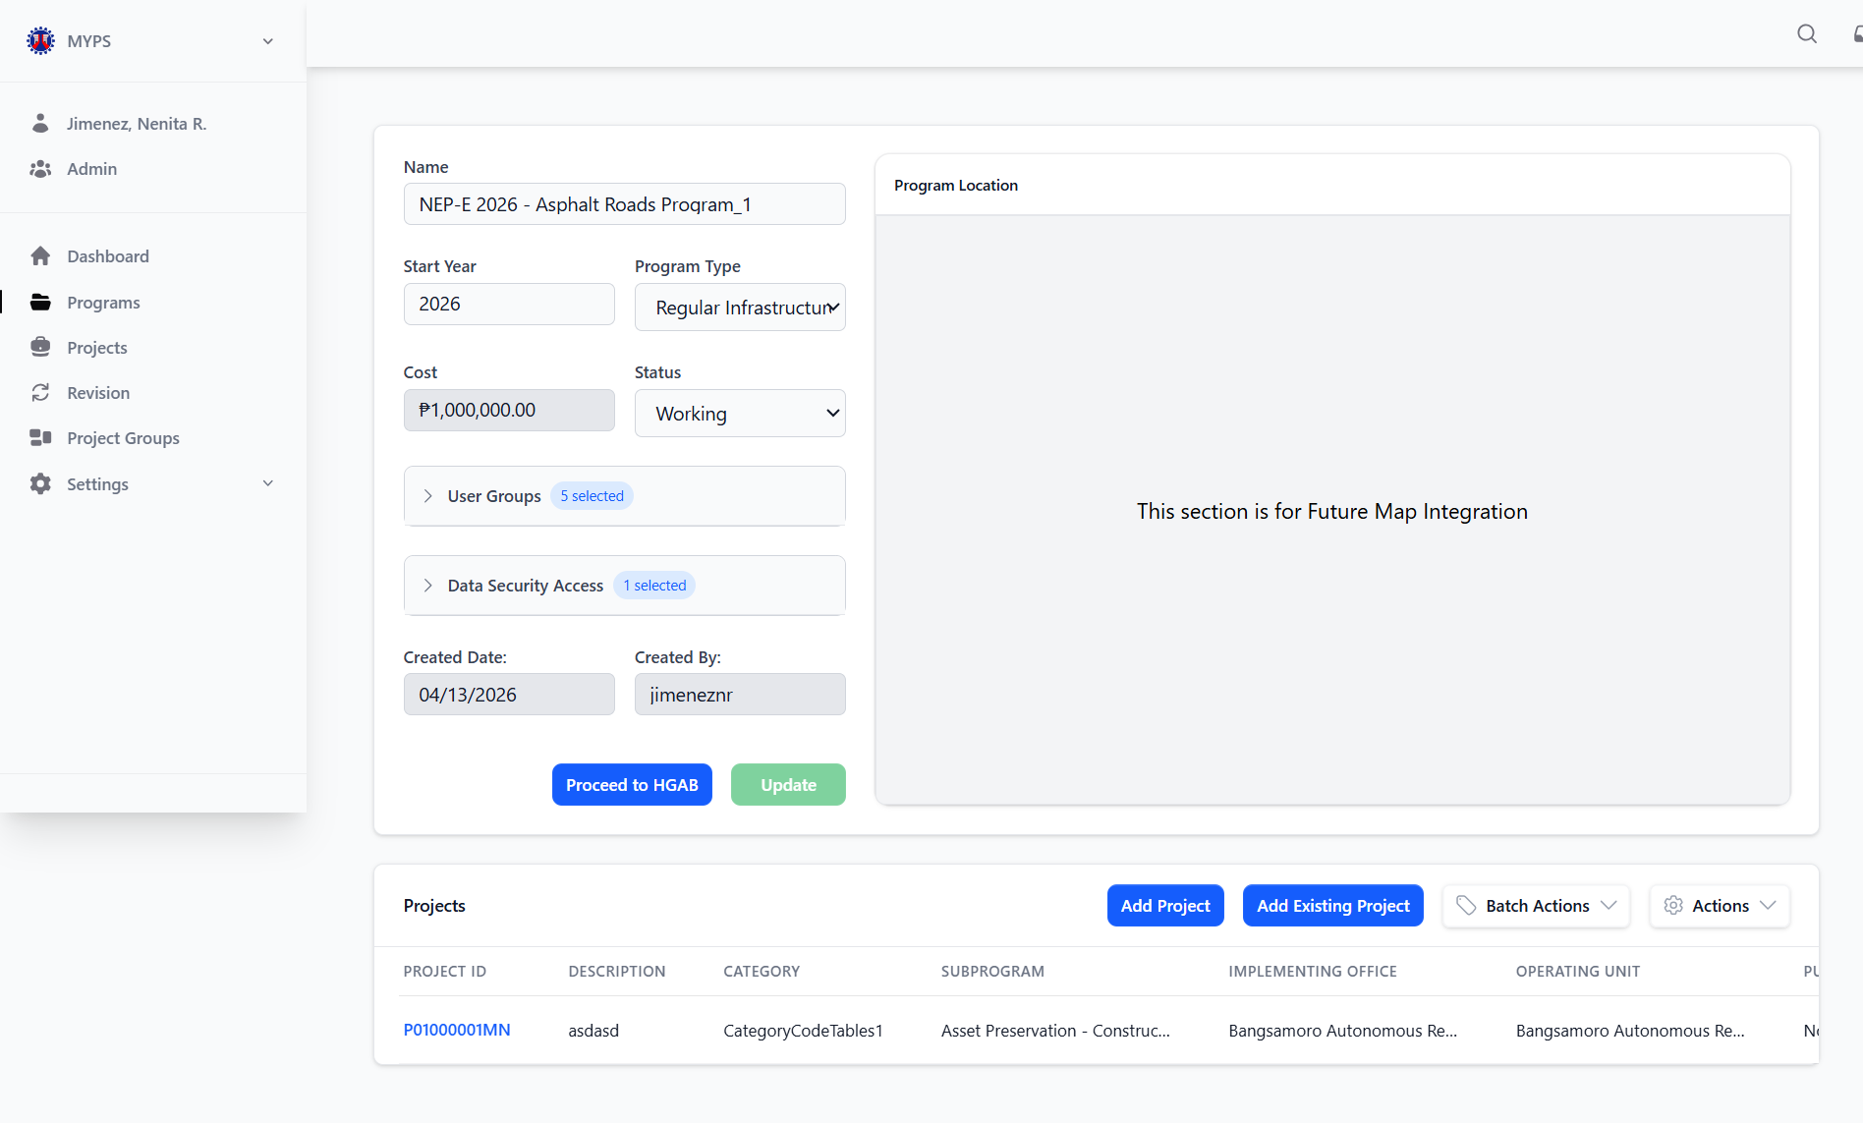
Purpose
The View Program Details NEP-E feature allows authorized users to access detailed information about programs that have reached the NEP-E (Expanded National Expenditure Program) stage. This includes the program's name, type, status, associated projects, cost, and other relevant details.

Who Uses This
This screen is available to authorized MYPS users with access to the module.
Prerequisites
- You must be logged into your MYPS account.
- The program must be in the NEP-E stage to view its details.
- You need appropriate permissions to access program information
Field Reference
No. | Fields/Blocks/Objects | Description | Values / Actions
UI-UX-0014-01 | PROGRAM NAME | Dropdown to select the program under which the project falls. | Dropdown field for selecting a program from existing options (e.g., "NEP-E 2025").
UI-UX-0014-02 | PROGRAM TYPE | Defines the type of program (e.g., Regular Infrastructure, External Infrastructure). | Dropdown list for selecting program type (e.g., "Regular Infrastructure").
UI-UX-0014-03 | START YEAR | The starting year for the program. | Numeric input field for year (e.g., 2025).
UI-UX-0014-04 | PROGRAM STATUS | Displays the current status of the program (e.g., Active, Completed). | Dropdown field to select the program's current status (e.g., "Active", "Completed").
UI-UX-0014-05 | COST | Displays the cost allocated or estimated for the program. | Numeric value representing the program's cost (e.g., ₱15,000,000,000).
UI-UX-0014-06 | USER GROUPS | Displays the groups that have access to the program. | Text input or list of selected user groups (e.g., Admin, Planner).
UI-UX-0014-07 | DATA SECURITY ACCESS | Displays the user groups or offices that have data security access for the program. | Text input or list of selected user groups/offices (e.g., Central Office).
UI-UX-0014-08 | CREATED DATE | Displays the date when the program was created. | Date input field (MM/DD/YYYY format).
UI-UX-0014-09 | CREATED BY | Displays the name of the person who created the program. | Text input for creator’s name (e.g., "admin").
UI-UX-0014-10 | PROCEED TO HGAB | Button to transition the program to the HGAB stage. | Button labeled "Proceed to HGAB"; leads to the HGAB stage of the program.
UI-UX-0014-11 | UPDATE | Button to save changes and update the program details. | Button labeled "Update"; applies changes made to the program details.

Step-by-Step: View Program Details NEP-E
- Select Program to View
  - Locate the program that has moved to the NEP-E stage and click on the program name to view its details.
- Review Program Information
  - The Program Name, Program Type, Start Year, Status, Cost, and other relevant details will be displayed for review.
- Review User Groups and Data Security Access
  - The User Groups section will show which groups have access to the program.
  - The Data Security Access section will display the groups or offices with data access rights.
- Review Creation Details
  - The Created Date and Created By fields will show when and by whom the program was created.
- Proceed to HGAB Stage
  - If the program is ready to proceed, click the Proceed to HGAB button to move the program to the next stage.
- Update Program Details
  - If you need to update any program information, make the necessary changes and click the Update button to save them.

Common Outcomes & What to Do
Message/Situation | What it Means | What You Should Do
“Program details updated successfully” | The program details were successfully updated. | Verify that the updated program information reflects the changes made.
“Required field missing” | A required field (e.g., Program Name) is missing. | Ensure all required fields are filled before proceeding.
“Permission error” | You do not have permission to view or update the program. | Contact your MYPS administrator to request the necessary permissions.

Proceed to Next Stage HGAB (UI-UX-0015)
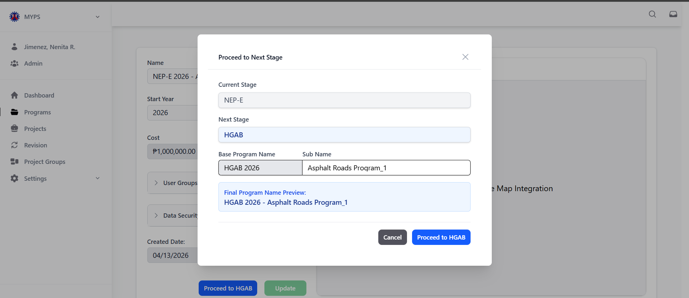
Purpose
The Proceed to Next Stage HGAB feature allows authorized users to transition a program from the NEP-E (Expanded National Expenditure Program) stage to the HGAB (House-Approved General Appropriations Bill) stage. This action involves confirming the transition, adjusting the program name if necessary, and proceeding with the next stage.
Who Uses This
This screen is available to authorized MYPS users with access to the module.
Prerequisites
- You must be logged into your MYPS account.
- You must have permission to transition programs between stages.
- The program must be in the NEP-E stage to proceed to the HGAB stage.
Field Reference
No. | Fields/Blocks/Objects | Description | Values / Actions
UI-UX-0015-01 | CURRENT STAGE | Displays the current stage of the program (e.g., NEP-E). | Text; read-only; shows the current program stage (e.g., NEP-E).
UI-UX-0015-02 | NEXT STAGE | Displays the next stage the program will transition to (e.g., HGAB). | Text; read-only; shows the next stage (e.g., "HGAB").
UI-UX-0015-03 | BASE PROGRAM NAME | Editable field to change the name of the base program. | Text input; 4-digit numeric (e.g., "HGAB 2026").
UI-UX-0015-04 | SUB NAME | Optional field for adding additional names for clarification (e.g., revision, version). | Text input; alphanumeric + punctuation.
UI-UX-0015-05 | PROGRAM NAME PREVIEW | Displays a preview of the full program name before finalizing the transition. | Text; shows the preview of the full name (e.g., "HGAB 2027 - Flood prevention program for NCR").
UI-UX-0015-06 | CANCEL | Closes the modal without proceeding to the next stage. | Button labeled "Cancel"; action to close the modal without any changes.
UI-UX-0015-07 | PROCEED TO HGAB | Confirms and moves the program to the HGAB stage. | Button labeled "Proceed to HGAB"; action to confirm and move the program to the HGAB stage.

Step-by-Step: Proceed to Next Stage HGAB
- Login and Access the Program
  - Log in to your MYPS account.
  - Navigate to the Programs section under the Side Navigation menu.
- Select Program to Transition
  - In the Programs section, find the program that is currently in the NEP-E stage.
  - Click on the program name or click the Proceed to Next Stage button to open the modal for transitioning the program.
- Review Current Stage
  - The Current Stage field will display NEP-E. Ensure the program is in the correct stage before proceeding.
- Review Next Stage
  - The Next Stage field will automatically display HGAB, indicating the next stage the program will transition to. Verify that this is correct.
- Modify Base Program Name (if necessary)
  - In the Base Program Name field, edit the program’s base name if needed (e.g., "HGAB 2026").
  - Ensure the name follows the naming convention.
- Enter Sub Name (Optional)
  - In the Sub Name field, you can add additional details or clarifications such as a version or a specific project classification (e.g., "Version 1").
- Preview the Final Program Name
  - The Program Name Preview field will display the full program name based on your input (e.g., "HGAB 2027 – Flood prevention program for NCR").
  - Review the preview to ensure accuracy before proceeding.
- Proceed to HGAB
  - Once all information is verified, click the Proceed to HGAB button to confirm the transition and move the program to the HGAB stage.
- Cancel the Transition (if needed)
  - If you decide not to proceed with the transition, click the Cancel button. This will close the modal without making any changes.
Common Outcomes & What to Do
Message/Situation | What it Means | What You Should Do
“Program transitioned to HGAB successfully” | The program has been successfully moved to the HGAB stage. | Verify that the program status is now set to HGAB and review its details.
“Required field missing” | A required field (e.g., Program Name) is missing. | Ensure all required fields are filled before proceeding.

Programs Details HGAB (UI-UX-0016)
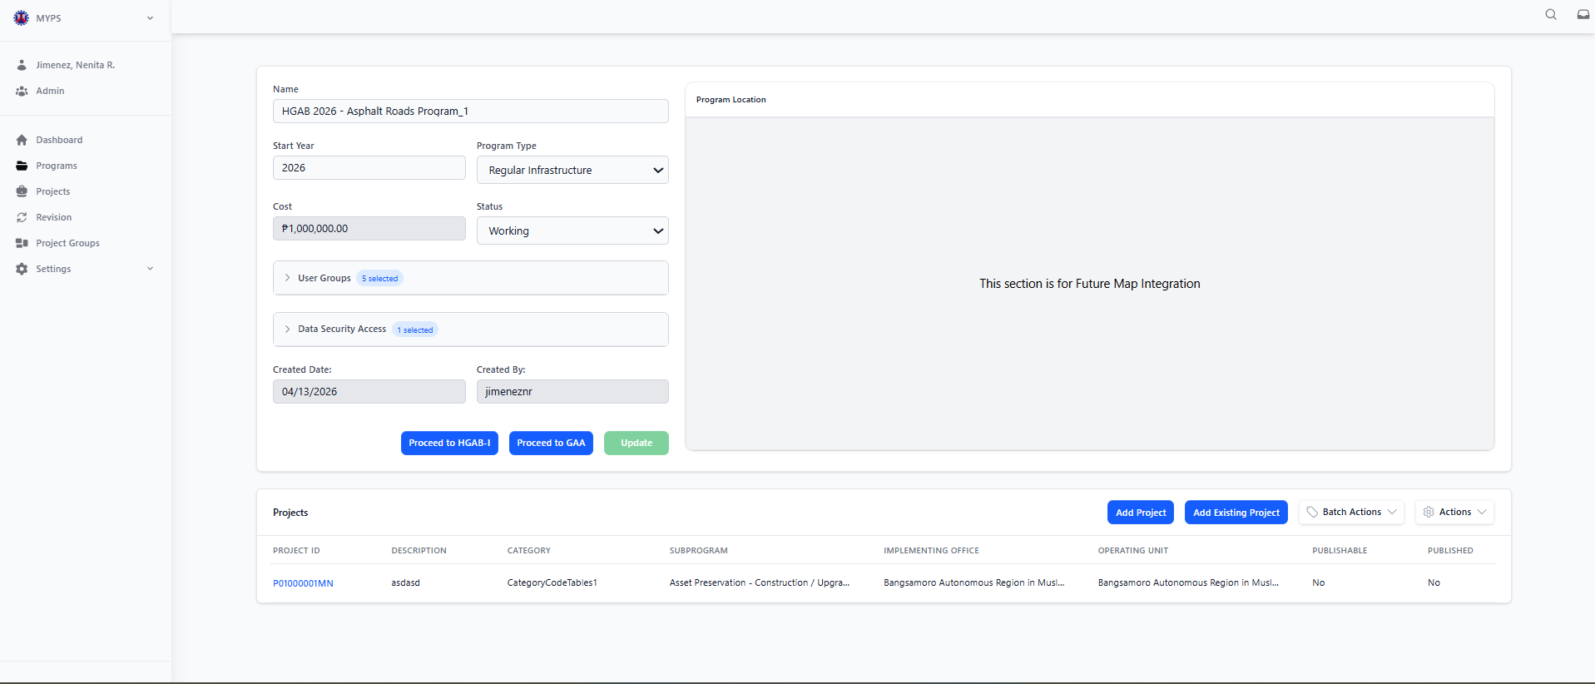
Purpose
The View Program Details HGAB feature enables authorized users to view detailed information about programs that have transitioned to the HGAB (House-Approved General Appropriations Bill) stage. This includes the program's name, type, status, associated projects, cost, and other relevant details.
Who Uses This
This screen is available to authorized MYPS users with access to the module.
Prerequisites
- You must be logged into your MYPS account.
- You must have the necessary permissions to view program details.
- The program must have transitioned to the HGAB stage.

Field Reference
No. | Fields/Blocks/Objects | Description | Values / Actions
UI-UX-0016-01 | PROGRAM NAME | Dropdown to select the program under which the project falls. | Dropdown field for selecting a program from existing options (e.g., "NEP 2025").
UI-UX-0016-02 | PROGRAM TYPE | Defines the type of program (e.g., Regular Infrastructure, External Infrastructure). | Dropdown field to select the program type (e.g., "Regular Infrastructure").
UI-UX-0016-03 | START YEAR | The starting year for the program. | Numeric input field for year (e.g., 2025).
UI-UX-0016-04 | PROGRAM STATUS | Displays the current status of the program (e.g., Active, Completed). | Dropdown field to select the program's current status (e.g., "Active," "Completed").
UI-UX-0016-05 | COST | Displays the cost allocated or estimated for the program. | Numeric value, representing the program's cost (e.g., ₱15,000,000,000).
UI-UX-0016-06 | USER GROUPS | Display the groups that have access to the program. | Text input or a list of selected user groups (e.g., Admin, Planner, Reviewer).
UI-UX-0016-07 | DATA SECURITY ACCESS | Display the user groups or offices that have data security access for the program. | Text input or list of selected user groups with security access.
UI-UX-0016-08 | CREATED DATE | Displays the date when the program was created. | Date input field (MM/DD/YYYY format).
UI-UX-0016-09 | CREATED BY | Displays the name of the person who created the program. | Text input for the creator's name (e.g., "admin").
UI-UX-0016-10 | PROCEED TO HGAB-I | Button to proceed to the HGAB-I stage of the program. | Button labeled "Proceed to HGAB-I"; leads to the HGAB-I stage of the program.
UI-UX-0016-11 | PROCEED TO GAA | Button to proceed to the GAA stage of the program. | Button labeled "Proceed to GAA"; leads to the GAA stage of the program.
UI-UX-0016-12 | UPDATE | Button to save changes and update the program details. | Button labeled "Update"; applies any changes made to the program details.

Step-by-Step: View Program Details HGAB
- Login and Access the Program Section
  - Log in to your MYPS account.
  - Navigate to the Programs section under the Side Navigation menu.
- Select Program to View
  - On the Programs page, locate the program that is currently in the HGAB stage.
  - Click on the program name or click the View button to open its details.
- Review Program Information
  - The Program Name, Program Type, Start Year, Status, Cost, and other details will be displayed for review.
  - Ensure that the Program Status is listed as Working, Approved, or other relevant statuses.
- Review User Groups and Data Security Access
  - The User Groups section will show which groups have access to the program.
  - The Data Security Access section will display which user groups or offices have access to the program's data.
- Review Creation Details
  - The Created Date and Created By fields will display when the program was created and by whom.
- Proceed to Next Stage
  - If the program is ready to proceed, click the Proceed to HGAB-I button to transition the program to the HGAB-I stage.
  - Alternatively, click the Proceed to GAA button to move the program to the GAA stage.
- Update Program Details
  - If any changes need to be made, modify the necessary fields (e.g., Program Name, Status, Cost).
  - Click the Update button to save the changes.

Common Outcomes & What to Do
Message/Situation | What it Means | What You Should Do
“Program updated successfully” | The program details were successfully updated. | Verify the updated program information reflects the changes made.
“Required field missing” | A required field (e.g., Program Name) is missing. | Ensure all required fields are filled before proceeding.

Proceed to Next Stage HGAB – I (UI-UX-0017)
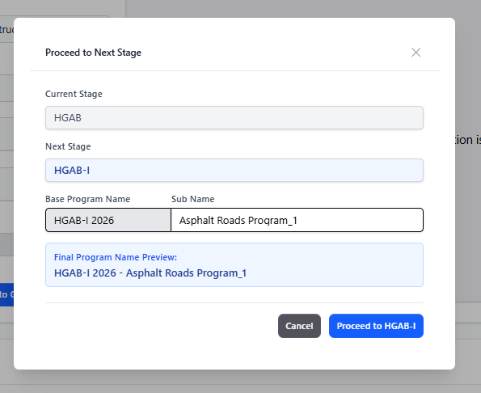

Purpose
The Proceed to Next Stage HGAB-I feature enables authorized users to transition a program from the HGAB (House-Approved General Appropriations Bill) stage to the HGAB-I stage. This action involves confirming the program's next stage, adjusting the program name if necessary, and proceeding with the transition.

Who Uses This
This screen is available to authorized MYPS users with access to the module.

Prerequisites
- You must be logged into your MYPS account.
- You must have permission to transition programs between stages.
- The program must be in the HGAB stage to proceed to the HGAB-I stage.

Field Reference
No. | Fields/Blocks/Objects | Description | Values / Actions
UI-UX-0017-01 | CURRENT STAGE | Displays the current stage of the program (e.g., HGAB). | Text field; read-only, shows the current program stage (e.g., "HGAB").
UI-UX-0017-02 | NEXT STAGE | Displays the next stage the program will transition to (e.g., HGAB-I). | Text field; read-only, shows the next stage (e.g., "HGAB-I").
UI-UX-0017-03 | BASE PROGRAM NAME | Editable field to change the name of the base program (e.g., HGAB-I 2026). | Text input; 4-digit numeric (e.g., "HGAB-I 2026").
UI-UX-0017-04 | SUB NAME | Optional field for adding additional names or clarifications (e.g., version). | Text input; alphanumeric + punctuation (e.g., "Version 1").
UI-UX-0017-05 | PROGRAM NAME PREVIEW | Displays a preview of the full program name. | Text; shows the preview name of the program (e.g., "HGAB 2027 – Flood prevention program for NCR").
UI-UX-0017-06 | CANCEL | Closes the modal without proceeding to the next stage. | Button labeled "Cancel"; closes the modal without making any changes.
UI-UX-0017-07 | PROCEED TO HGAB-I | Confirms the action and moves the program to the HGAB-I stage. | Button labeled "Proceed to HGAB-I"; confirms the transition to the HGAB-I stage.

Step-by-Step: Proceed to Next Stage HGAB-I
- Select Program to Transition
  - In the Programs section, locate the program that is currently in the HGAB stage.
  - Click on the program name or the Proceed to Next Stage button to open the modal for transitioning the program.
- Review Current Stage
  - The Current Stage field will automatically display HGAB. Verify that the program is in the correct stage before proceeding.
- Review Next Stage
  - The Next Stage field will show HGAB-I, indicating the next stage the program will transition to.
  - Ensure this is the correct next stage.
- Modify Base Program Name (if necessary)
  - In the Base Program Name field, edit the program’s base name if needed (e.g., HGAB-I 2026).
  - Ensure that the base name follows the appropriate naming conventions.
- Enter Sub Name (Optional)
  - In the Sub Name field, you can add additional details or clarifications such as version numbers (e.g., "Version 1").
  - This field is optional.
- Preview the Final Program Name
  - The Program Name Preview will display the full program name based on your input (e.g., "HGAB 2027 – Flood prevention program for NCR").
  - Review the preview to ensure the program name is correct.
- Proceed to HGAB-I
  - After confirming the details, click the Proceed to HGAB-I button to confirm the transition and move the program to the HGAB-I stage.
- Cancel the Transition (if needed)
  - If you decide not to proceed, click the Cancel button to close the modal without making any changes.

Common Outcomes & What to Do
Message/Situation | What it Means | What You Should Do
“Program transitioned to HGAB-I successfully” | The program has been successfully moved to the HGAB-I stage. | Verify the program status is now set to HGAB-I and review its details.
“Required field missing” | A required field (e.g., Program Name) is missing. | Ensure all required fields are filled before proceeding.

Programs Details HGAB – I (UI-UX-0018)
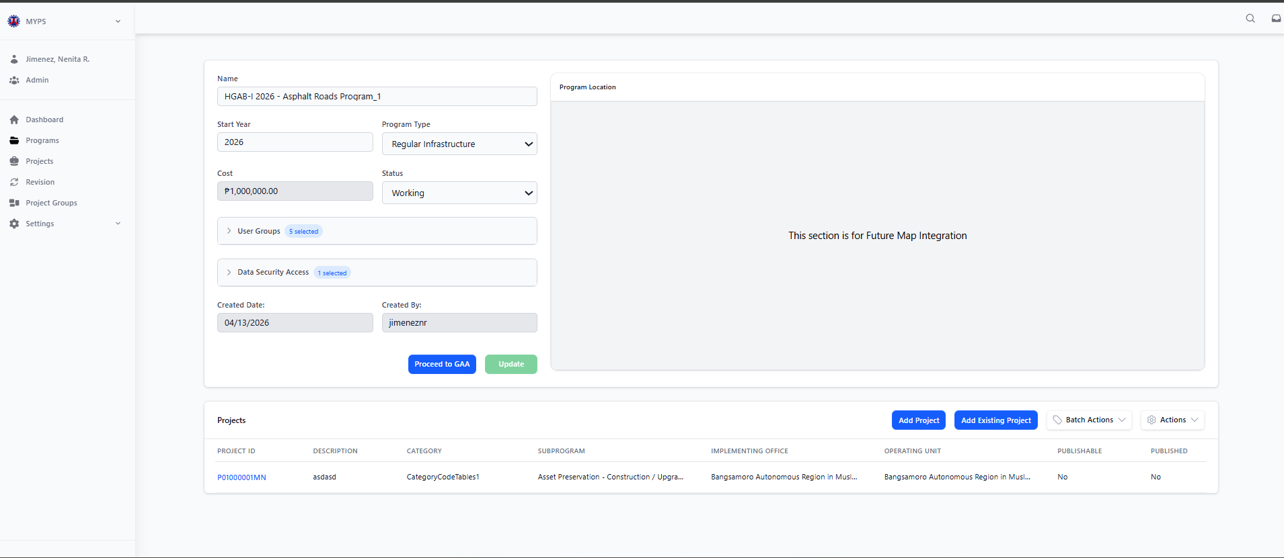
Purpose
The View Program Details HGAB-I feature allows authorized users to access and view detailed information about programs that have transitioned to the HGAB-I (House-Approved General Appropriations Bill – Intermediate) stage. This includes the program's name, type, status, associated projects, cost, and other relevant details.
Who Uses This
This screen is available to authorized MYPS users with access to the module.
Prerequisites
- You must be logged into your MYPS account.
- The program must have transitioned to the HGAB-I stage.
Field Reference
No. | Fields/Blocks/Objects | Description | Values / Actions
UI-UX-0018-01 | PROGRAM NAME | Dropdown to select the program under which the project falls. | Dropdown field for selecting a program from existing options (e.g., "NEP 2025").
UI-UX-0018-02 | PROGRAM TYPE | Defines the type of program (e.g., Regular Infrastructure, External Infrastructure). | Dropdown field to select the program type (e.g., "Regular Infrastructure").
UI-UX-0018-03 | START YEAR | The starting year for the program. | Numeric input field for year (e.g., 2025).
UI-UX-0018-04 | PROGRAM STATUS | Displays the current status of the program (e.g., Active, Completed). | Dropdown field to select the program's current status (e.g., "Active," "Completed").
UI-UX-0018-05 | COST | Displays the cost allocated or estimated for the program. | Numeric value, representing the program's cost (e.g., ₱15,000,000,000).
UI-UX-0018-06 | USER GROUPS | Display the groups that have access to the program. | Text input or a list of selected user groups (e.g., Admin, Planner, Reviewer).
UI-UX-0018-07 | DATA SECURITY ACCESS | Display the user groups or offices that have data security access for the program. | Text input or list of selected user groups with security access.
UI-UX-0018-08 | CREATED DATE | Displays the date when the program was created. | Date input field (MM/DD/YYYY format).
UI-UX-0018-09 | CREATED BY | Displays the name of the person who created the program. | Text input for the creator's name (e.g., "admin").
UI-UX-0018-10 | PROCEED TO GAA | Button to proceed to the GAA stage of the program. | Button labeled "Proceed to GAA"; leads to the GAA stage of the program.
UI-UX-0018-11 | UPDATE | Button to save changes and update the program details. | Button labeled "Update"; applies any changes made to the program details.

Step-by-Step: View Program Details HGAB-I
- Select Program to View
  - On the Programs page, find the program that is currently in the HGAB-I stage.
  - Click the program name or the View button to open its details.
- Review Program Information
  - The Program Name, Program Type, Start Year, Status, Cost, and other details will be displayed for review.
  - Ensure that the Program Status is correctly listed as Active, Completed, or another relevant status.
- Review User Groups and Data Security Access
  - The User Groups section will show the groups with access to the program.
  - The Data Security Access section will display which groups or offices have access to the program's data.
- Review Creation Details
  - The Created Date and Created By fields will display when the program was created and by whom.
- Proceed to HGAB-I
  - If the program is ready to move to the HGAB-I stage, click the Proceed to HGAB-I button.
- Proceed to GAA
  - If the program is ready for the GAA stage, click the Proceed to GAA button to move the program to the GAA stage.
- Update Program Details
  - If any changes need to be made, update the necessary fields and click Update to save the changes.

Common Outcomes & What to Do
Message/Situation | What it Means | What You Should Do
“Program updated successfully” | The program details were successfully updated. | Verify the updated program information reflects the changes made.
“Required field missing” | A required field (e.g., Program Name) is missing. | Ensure all required fields are filled before proceeding.
“Error processing program” | There was an issue processing the program details. | Review the entries and try again. If the issue persists, contact support.

Proceed to Next Stage GAA (UI-UX-0019)
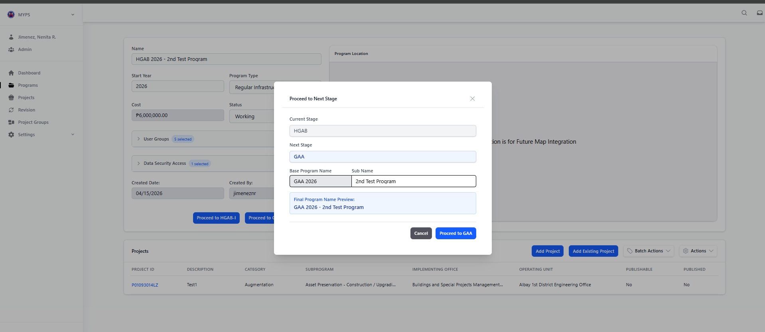
Purpose
The Proceed to Next Stage GAA feature allows authorized users to transition a program from the HGAB-I (House-Approved General Appropriations Bill - Intermediate) stage to the GAA (General Appropriations Act) stage. This action involves confirming the program's next stage, adjusting the program name if necessary, and proceeding with the transition.
Who Uses This
This screen is available to authorized MYPS users with access to the module.
Prerequisites
You must be logged into your MYPS account.
You must have permission to transition programs between stages.
The program must be in the HGAB-I stage to proceed to the GAA stage.
Field Reference
No. | Fields/Blocks/Objects | Description | Values / Actions
UI-UX-0019-01 | CURRENT STAGE | Displays the current stage of the program. | Text; read-only; shows the current program stage (e.g., BP, NEP).
UI-UX-0019-02 | NEXT STAGE | Displays the next stage the program will transition to. | Text; read-only; shows the automatic next stage (e.g., GAA).
UI-UX-0019-03 | BASE PROGRAM NAME | Editable field to change the name of the base program. | Text input; 4-digit numeric (e.g., "GAA 2025").
UI-UX-0019-04 | SUB NAME | Optional field for adding additional names for clarification (e.g., revision, version). | Text input; alphanumeric + punctuation.
UI-UX-0019-05 | PROGRAM NAME PREVIEW | Displays a preview of the full program name before finalizing the transition. | Text; shows the preview name (e.g., "GAA 2025 - DO_OO2").
UI-UX-0019-06 | CANCEL | Closes the modal without proceeding to the next stage. | Button labeled "Cancel"; action leads to closing the form.
UI-UX-0019-07 | PROCEED TO GAA | Confirms the action and proceeds the program to the GAA stage. | Button labeled "Proceed to GAA"; action confirms the transition to the next stage.

Step-by-Step: Proceed to Next Stage GAA
- Select Program to Transition
In the Programs section, locate the program that is currently in the HGAB-I stage.
Click on the program name or the Proceed to Next Stage button to open the modal for transitioning the program.
- Review Current Stage
The Current Stage field will display HGAB-I. Verify that the program is in the correct stage before proceeding.
- Review Next Stage
The Next Stage field will automatically display GAA, indicating the next stage the program will transition to.
Confirm that this is the correct next stage.
- Modify Base Program Name (if necessary)
In the Base Program Name field, you can modify the program’s base name if needed (e.g., GAA 2025).
Ensure that the name follows the correct naming conventions.
- Enter Sub Name (Optional)
In the Sub Name field, you can add additional details or clarifications such as version (e.g., "Version 2").
This field is optional.
- Preview the Final Program Name
The Program Name Preview will show the full program name based on your entries (e.g., "GAA 2027 – Flood prevention program for NCR").
Review the preview to ensure the program name is correct.
- Proceed to GAA
After verifying the program details, click the Proceed to GAA button to confirm the transition and move the program to the GAA stage.
Cancel the Transition (if needed)
If you decide not to proceed with the transition, click the Cancel button. This will close the modal without making any changes.
Common Outcomes & What to Do
Message/Situation | What it Means | What You Should Do
"Program moved to GAA stage successfully" | The program has successfully transitioned to the GAA stage. | Verify the transition by checking that the program now shows the GAA stage in the program details.

Programs Details GAA (UI-UX-0020)
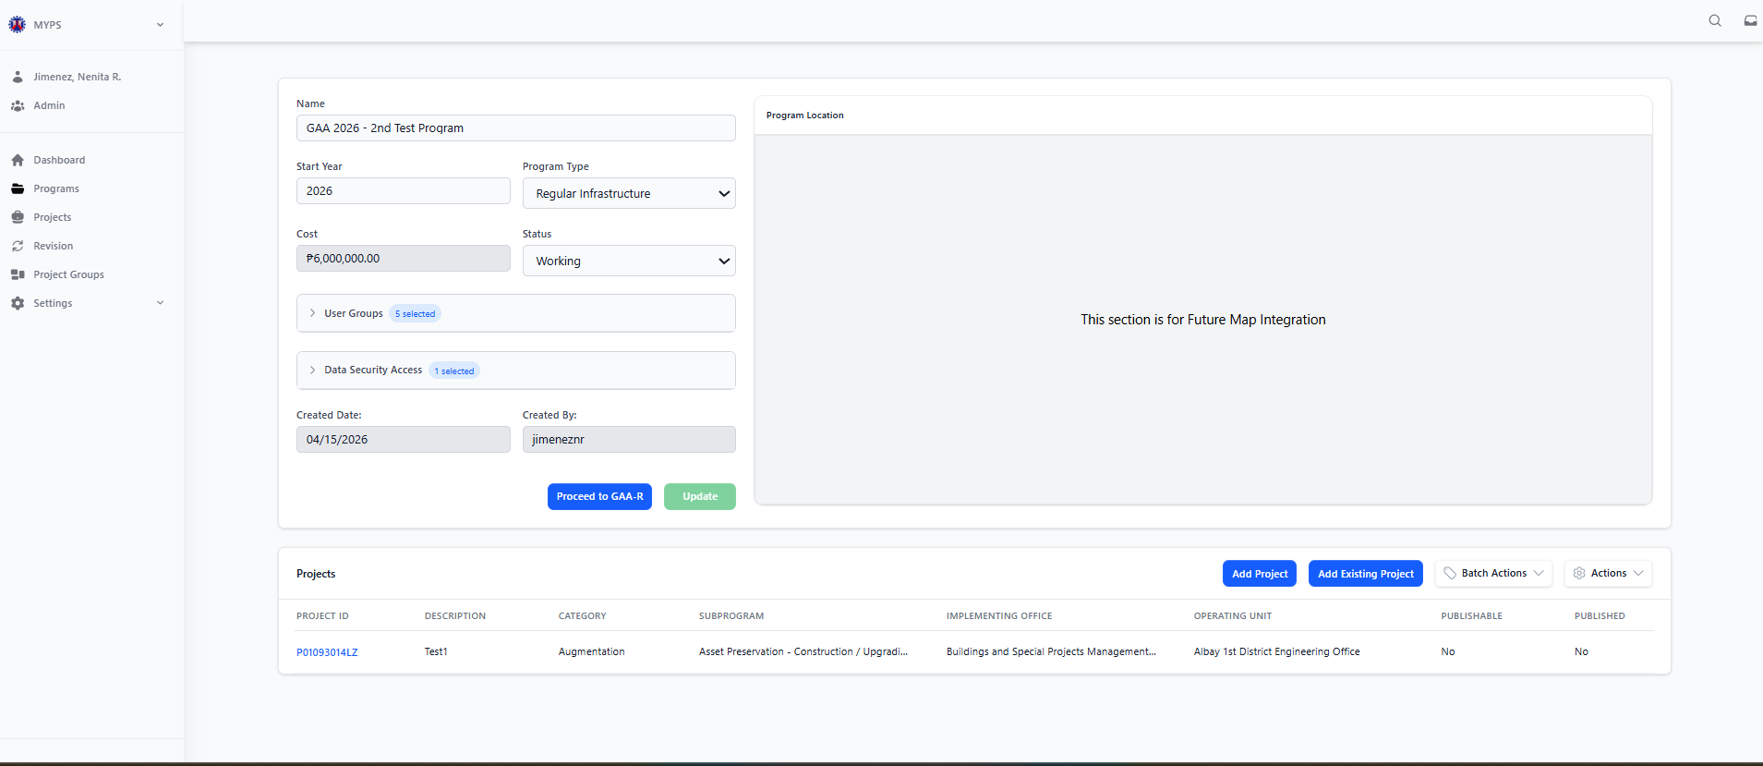
Purpose
The View Program Details GAA feature allows authorized users to access and view detailed information about programs that have transitioned to the GAA (General Appropriations Act) stage. This includes the program's name, type, status, associated projects, cost, and other relevant data.
Who Uses This
This screen is available to authorized MYPS users with access to the module.
Prerequisites
- You must be logged into your MYPS account.
- The program must have transitioned to the GAA stage.
Field Reference
No. | Fields/Blocks/Objects | Description | Values / Actions
UI-UX-0020-01 | PROGRAM NAME | Dropdown to select the program under which the project falls. | Dropdown field for selecting a program from existing options (e.g., "NEP 2025").
UI-UX-0020-02 | PROGRAM TYPE | Defines the type of program (e.g., Regular Infrastructure, External Infrastructure). | Dropdown field for selecting the program type (e.g., "Regular Infrastructure").
UI-UX-0020-03 | START YEAR | The starting year for the program. | Numeric input field for year (e.g., 2025).
UI-UX-0020-04 | PROGRAM STATUS | Displays the current status of the program (e.g., Active, Completed). | Dropdown field to select the program's current status (e.g., "Active," "Completed").
UI-UX-0020-05 | COST | Displays the cost allocated or estimated for the program. | Numeric value, representing the program's cost (e.g., ₱15,000,000,000).
UI-UX-0020-06 | USER GROUPS | Display the groups that have access to the program. | Text input or a list of selected user groups (e.g., Admin, Planner, Reviewer).
UI-UX-0020-07 | DATA SECURITY ACCESS | Display the user groups or offices that have data security access for the program. | Text input or list of selected user groups with security access.
UI-UX-0020-08 | CREATED DATE | Displays the date when the program was created. | Date input field (MM/DD/YYYY format).
UI-UX-0020-09 | CREATED BY | Displays the name of the person who created the program. | Text input for the creator's name (e.g., "admin").
UI-UX-0020-10 | PROCEED TO GAA-R | Button to proceed to the GAA-R stage of the program. | Button labeled "Proceed to GAA-R"; leads to the GAA-R stage of the program.
UI-UX-0020-11 | UPDATE | Button to save changes and update the program details. | Button labeled "Update"; applies any changes made to the program details.

Step-by-Step: View Program Details GAA
- Select Program to View
- In the Programs section, find the program that is currently in the GAA stage.
- Click on the program name or the View button to open its details.
- Review Program Information
- The Program Name, Program Type, Start Year, Status, Cost, and other details will be displayed for review.
- Ensure that the Program Status is listed as Working, Approved, or other relevant statuses.
- Review User Groups and Data Security Access
The User Groups section will show the groups that have access to the program.
The Data Security Access section will display which user groups or offices have access to the program's data.
- Review Creation Details
The Created Date and Created By fields will display when the program was created and by whom.
- Proceed to GAA-R
If the program is ready to proceed to the GAA-R stage, click the Proceed to GAA-R button.
- Update Program Details
If any changes need to be made, update the necessary fields and click Update to save the changes.
Common Outcomes & What to Do
Message/Situation | What it Means | What You Should Do
“Program updated successfully” | The program details were successfully updated. | Verify the updated program information reflects the changes made.
“Required field missing” | A required field (e.g., Program Name) is missing. | Ensure all required fields are filled before proceeding.

Proceed to Next Stage GAA-R (UI-UX-0021)
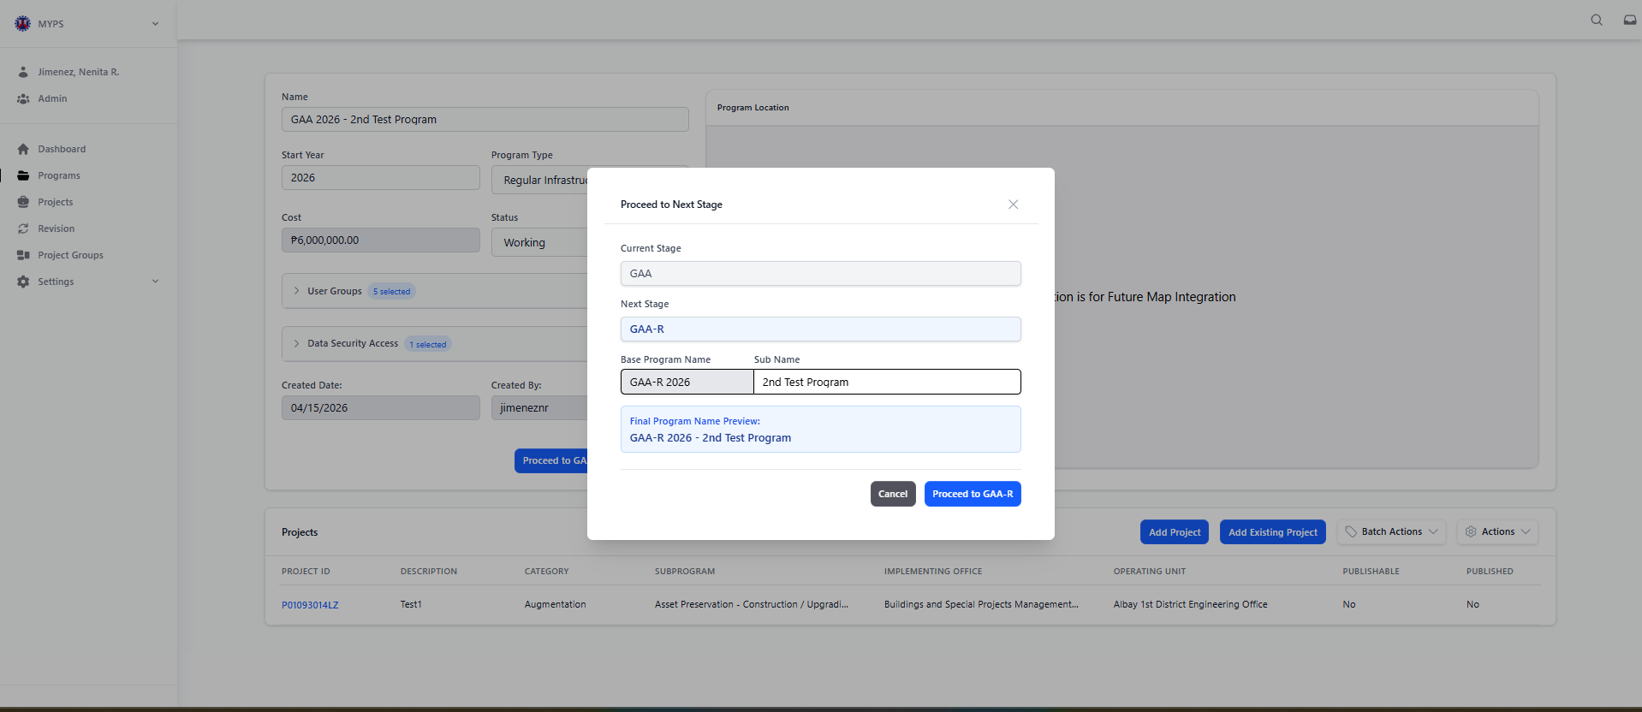
Purpose
The Proceed to Next Stage GAA-R feature allows authorized users to transition a program from the GAA (General Appropriations Act) stage to the GAA-R (General Appropriations Act Revised) stage. This action involves confirming the next stage, adjusting the program name if needed, and completing the transition.
Who Uses This
This screen is available to authorized MYPS users with access to the module.
Prerequisites
- You must be logged into your MYPS account.
- You must have permission to transition programs between stages.
- The program must be in the GAA stage to proceed to the GAA-R stage.
Field Reference
No. | Fields/Blocks/Objects | Description | Values / Actions
UI-UX-0021-01 | CURRENT STAGE | Displays the current stage of the program. | Text; read-only; shows the current program stage (e.g., GAA).
UI-UX-0021-02 | NEXT STAGE | Displays the next stage the program will transition to. | Text; read-only; shows the next program stage (e.g., GAA-R).
UI-UX-0021-03 | BASE PROGRAM NAME | Editable field to change the name of the base program. | Text input; 4-digit numeric (e.g., "GAA-R 2025").
UI-UX-0021-04 | SUB NAME | Optional field for adding additional names for clarification (e.g., revision, version). | Text input; alphanumeric + punctuation.
UI-UX-0021-05 | PROGRAM NAME PREVIEW | Displays a preview of the full program name before finalizing the transition. | Text; shows the preview name (e.g., "GAA-R 2025 - DO_OO2").
UI-UX-0021-06 | CANCEL | Closes the modal without proceeding to the next stage. | Button labeled "Cancel"; action closes the form.
UI-UX-0021-07 | PROCEED TO GAA-R | Confirms the action and proceeds the program to the GAA-R stage. | Button labeled "Proceed to GAA-R"; action confirms the transition.

Step-by-Step: Proceed to Next Stage GAA-R
- Select Program to Transition
- In the Programs section, find the program that is currently in the GAA stage.
- Click on the program name or the Proceed to Next Stage button to open the modal for transitioning the program.
- Review Current Stage
- The Current Stage field will display GAA. Verify that the program is in the correct stage before proceeding.
- Review Next Stage
The Next Stage field will automatically display GAA-R, indicating the next stage the program will transition to.
Ensure this is the correct next stage.
- Modify Base Program Name (if necessary)
- In the Base Program Name field, you can modify the program’s base name if needed (e.g., GAA-R 2025).
- Ensure the name follows the appropriate naming conventions.
- Enter Sub Name (Optional)
- In the Sub Name field, you can add additional details or clarifications such as version numbers (e.g., "Version 2").
- This field is optional.
- Preview the Final Program Name
- The Program Name Preview will display the full program name based on your entries (e.g., "GAA-R 2025 – Flood prevention program for NCR").
- Review the preview to ensure the program name is correct.
- Proceed to GAA-R
- After verifying the program details, click the Proceed to GAA-R button to confirm the transition and move the program to the GAA-R stage.
- Cancel the Transition (if needed)
- If you decide not to proceed with the transition, click the Cancel button. This will close the modal without making any changes.
Common Outcomes & What to Do
Message/Situation | What it Means | What You Should Do
“Program transitioned to GAA-R successfully” | The program has been successfully moved to the GAA-R stage. | Verify the program status is now set to GAA-R and review its details.
“Required field missing” | A required field (e.g., Program Name) is missing. | Ensure all required fields are filled before proceeding.

Programs Details GAA-R (UI-UX-0022)
Purpose
The View Programs Details GAA-R screen allows authorized users to view and review the details of a program under the GAA-R stage in MYPS. It also allows permitted users to update program information and publish the program when required.
Who uses this
This screen is available to authorized MYPS users with access to the module.
Prerequisites
Before using this screen, ensure that:
- You have successfully signed in to the MYPS Web application.
- Your account is active and assigned to the correct role and office/unit.
- You have permission to access the Programs module.
- The target GAA-R program already exists in MYPS.
- Network or VPN access is available, if required by your office.

Field Reference
No. | Fields/Blocks/Objects | Description | Values / Actions
UI-UX-0022-01 | PROGRAM NAME | Dropdown to select the program under which the project falls. | Dropdown field for selecting a program from existing options (e.g., "NEP 2025").
UI-UX-0022-02 | PROGRAM TYPE | Defines the type of program (e.g., Regular Infrastructure, External Infrastructure). | Dropdown field for selecting the program type (e.g., "Regular Infrastructure").
UI-UX-0022-03 | START YEAR | The starting year for the program. | Numeric input field for year (e.g., 2025).
UI-UX-0022-04 | PROGRAM STATUS | Displays the current status of the program (e.g., Active, Completed). | Dropdown field to select the program's current status (e.g., "Active," "Completed").
UI-UX-0022-05 | COST | Displays the cost allocated or estimated for the program. | Numeric value, representing the program's cost (e.g., ₱15,000,000,000).
UI-UX-0022-06 | USER GROUPS | Display the groups that have access to the program. | Text input or a list of selected user groups (e.g., Admin, Planner, Reviewer).
UI-UX-0022-07 | DATA SECURITY ACCESS | Display the user groups or offices that have data security access for the program. | Text input or list of selected user groups with security access.
UI-UX-0022-08 | CREATED DATE | Displays the date when the program was created. | Date input field (MM/DD/YYYY format).
UI-UX-0022-09 | CREATED BY | Displays the name of the person who created the program. | Text input for the creator's name (e.g., "admin").
UI-UX-0022-10 | UPDATE | Button to save changes and update the program details. | Button labeled "Update"; applies any changes made to the program details.
UI-UX-0022-11 | PUBLISH PROGRAM | Button to publish the program. | Button labeled "Publish Program"; action publishes the program.

Step-by-step: View and use GAA-R Program Details
- Open the Programs module
From the left-side navigation menu, select Programs.
- Locate the target GAA-R program
Search for or select the required program under the GAA-R stage.
- Open the program details screen
Click the selected program to open the View Programs Details GAA-R screen.
- Review the program name
Check the PROGRAM NAME field and confirm that the correct program is selected.
- Review the program type
Check the PROGRAM TYPE field and confirm that the displayed type is correct.
- Review the start year
Check the START YEAR field and confirm that the correct year is shown.
- Review the program status
Check the PROGRAM STATUS field and confirm that the displayed status matches the current GAA-R workflow stage.
- Review the cost
Check the COST field and confirm that the displayed amount is correct.
- Review user access settings
Check the USER GROUPS field and confirm that the correct access groups are assigned to the program.
- Review data security settings
Check the DATA SECURITY ACCESS field and confirm that the correct groups or offices have data access.
- Review creation details
Check the CREATED DATE and CREATED BY fields to confirm the record history.
- Update the program details, if permitted
If your role allows editing, make the required changes to the editable fields.
- Save the changes
Click UPDATE to save any permitted changes made to the program details.
- Publish the program, if permitted
If your role and workflow allow publication, click PUBLISH PROGRAM.
- Continue to the next MYPS task
After reviewing, updating, or publishing the program, proceed to the next required MYPS activity.
On success
- The GAA-R Program Details screen loads correctly.
- The selected program information is displayed properly.
- Any permitted updates are saved successfully after selecting Update.
- The program is published successfully when Publish Program is used by an authorized user.
- The user can continue to the next required MYPS task.
Common Outcomes & What to Do
Message / Situation | What It Means | What To Do
Program details screen does not load | The page may not have loaded correctly or there may be a temporary system issue. | Refresh the page and try again. If the issue continues, report it to support.
Program fields are visible but cannot be edited | Your role may not allow editing, or the record may be locked due to program stage or status. | Confirm your permissions and the program status. Contact your MYPS administrator if editing access is expected.

Publish Program to other Applications (UI-UX-0023)

Publication Eligibility Checklist
Check | Requirement
Stage | The program must be in a publish-eligible final or post-final stage configured for the application, such as GAA or GAA-R. Confirm the currently enabled production rule.
Status | The program must be Approved or otherwise marked as eligible for publication.
Role | The user must have permission to publish programs to PCMA or connected applications.
Project readiness | Projects that should be included must be marked publishable and must pass validation.
Downstream effect | Publishing makes the program and eligible projects available to PCMA or connected applications after validation.
Before clicking Publish to PCMA, review the project list and publishable status. Do not proceed if the displayed program or stage is not the intended record.
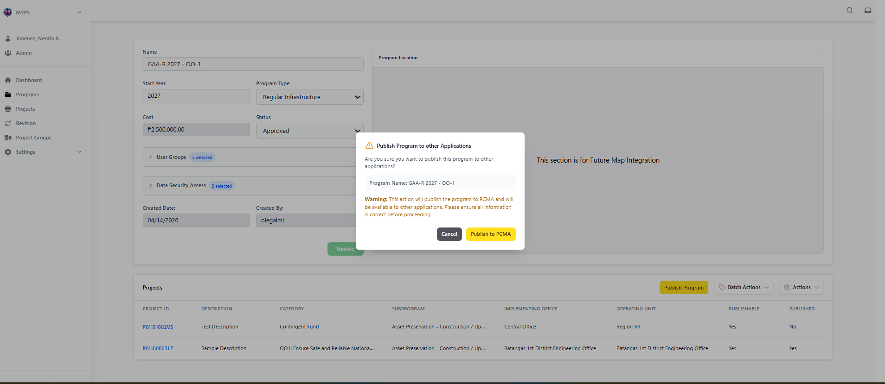
Purpose
This screen allows authorized users to publish an approved MYPS Program to other connected DPWH applications, particularly PCMA. Publishing makes the selected program and its project records available for downstream use, subject to system validation, user permissions, and program status. This action should only be performed after the user has reviewed the program details, project list, publishability status, and related information for accuracy.

Who uses this
This screen is available to authorized MYPS users with access to the module.
Prerequisites
Before using this screen, ensure that:
- You are signed in to MYPS Web.
- You have permission to view and publish programs.
- The selected program already exists in MYPS.
- The program is in a valid stage/status for publishing.
- Program and project details have been reviewed.
- Projects listed under the program are confirmed as ready for publication, where applicable.
Field reference
No. | Fields / Blocks / Objects | Description | Values / Actions
UI-UX-0023-01 | PUBLISH CONFIRMATION MESSAGE | Displays the confirmation prompt asking whether the user wants to publish the program to other applications. | Message such as: Are you sure you want to publish this program to other applications?
UI-UX-0023-02 | PROGRAM NAME | Displays the name of the selected program being published. | Read-only display value. Example: GAA-R 2025 - Sample Future Program.
UI-UX-0023-03 | WARNING MESSAGE | Displays a warning about the effect of publishing the program. | Indicates that the action will publish the program to PCMA and make it available to other applications. User must verify that all information is correct before proceeding.
UI-UX-0023-04 | CANCEL BUTTON | Allows the user to close the publish confirmation modal without publishing. | Button labeled Cancel; closes the modal and returns the user to the Program Details page.
UI-UX-0023-05 | PUBLISH TO PCMA BUTTON | Confirms the publication action. | Button labeled Publish to PCMA; initiates publication of the selected program to PCMA and other connected applications, if applicable.

Step-by-step: Publish a Program to other Applications
1. Open the Programs module
Sign in to MYPS Web. From the left navigation menu, go to Programs.
2. Open the program record
Locate the program that needs to be published. Open the Program Details page for the selected program.
3. Review program information
Before publishing, review the visible program details, including:
- Program Name
- Start Year
- Program Type
- Cost
- Status
- User Groups
- Data Security Access
- Created Date and Created By
- Program Location, if available
Confirm that the program details are correct and complete.
4. Review the project list
Check the projects listed under the program. Review the project ID, description, category, operating office, and publishable status.
Make sure the projects that should be published are correctly included in the program.
5. Select the publish action
Click Publish Program from the Program Details page. The Publish Program to other Applications confirmation modal will appear.
6. Confirm the Program Name
In the modal, review the Program Name field. Confirm that it matches the program you intend to publish.
Do not proceed if the displayed program name is incorrect.
7. Read the warning message
Read the warning message carefully. The system informs the user that the selected program will be published to PCMA and made available to other connected applications.
Proceed only if the program data has been reviewed and is ready for publication.
8. Cancel if needed
If you are not ready to publish, click Cancel. The modal will close without publishing the program.
9. Publish to PCMA
If all details are correct, click Publish to PCMA. Wait for the system to process the request.
10. Confirm publishing result
After publishing, check for a success message, updated publication status, or any system feedback. If an error appears, review the message and follow the recommended action.

On success
- The selected program is submitted for publication.
- The program is published to PCMA, if validation is successful.
- The program and related project data become available to connected applications, where applicable.
- Publication status or system feedback is updated.
- The action may be recorded in the system audit or transaction logs.

Common Outcomes & What to Do
Message / Situation | What It Means | What To Do
Program published successfully | The program was successfully published to PCMA or connected applications. | Review the updated status and confirm that the program appears correctly in the downstream application, if required.
Program is not eligible for publishing | The program status, stage, or validation condition does not allow publishing. | Review the program status and complete required validations before trying again.

Add Existing Project (UI-UX-0024)
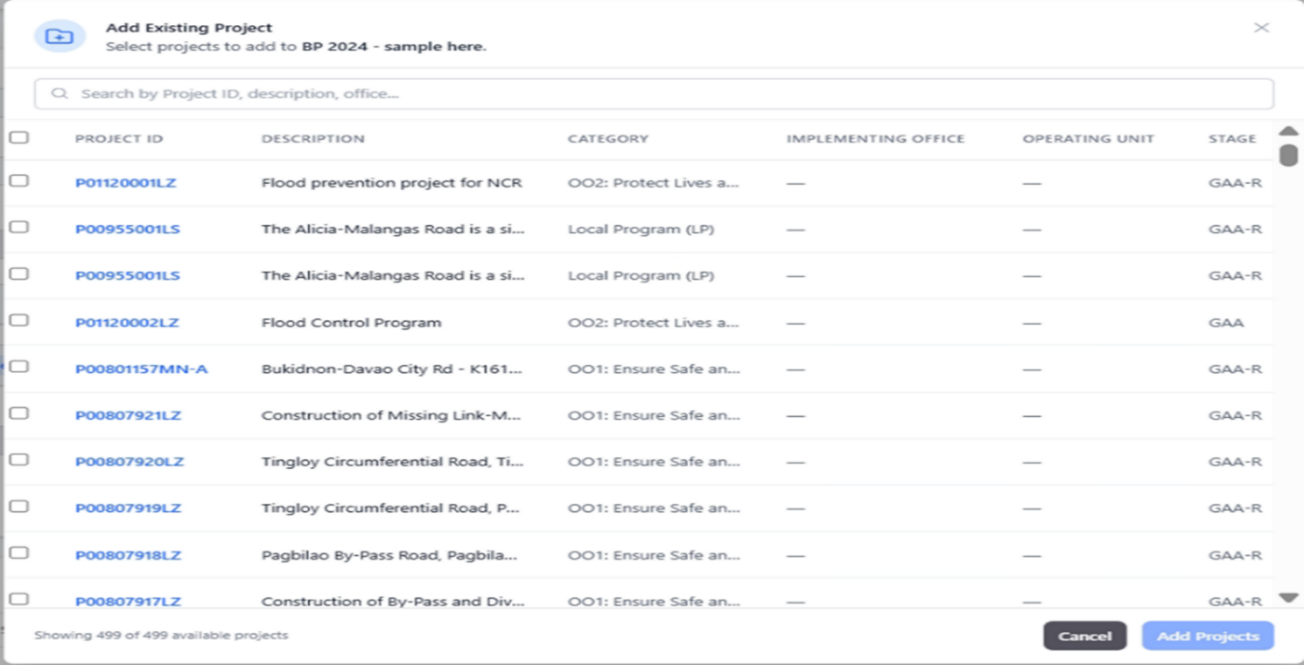
Purpose
The Add Existing Project feature allows authorized users to add a previously existing project to the current program. This helps streamline the management of multiple projects by associating them with the correct program, making it easier to track and manage related tasks.

Who Uses This
This screen is available to authorized MYPS users with access to the module.
Prerequisites
- You must be logged into your MYPS account.
- The program to which the project will be added must be selected and accessible.
Field Reference
No. | Fields/Blocks/Objects | Description | Values / Actions
UI-UX-0024-01 | PROGRAM NAME | Dropdown to select the program under which the project falls. | Dropdown field for selecting a program from existing options (e.g., "NEP 2025").
UI-UX-0024-02 | PROJECT ID | Displays the unique identifier of the project. | Read-only text field showing the project ID.
UI-UX-0024-03 | DESCRIPTION | Provides a brief description of the project. | Text input field for entering the project description (e.g., "Flood prevention program for NCR").
UI-UX-0024-04 | CATEGORY | Displays the category of the project (e.g., Local Program, National Program). | Dropdown field for selecting the category (e.g., "Local Program").
UI-UX-0024-05 | SUBPROGRAM | Displays the subprogram associated with the project (e.g., Asset Preservation, Network Development). | Dropdown field for selecting the subprogram (e.g., "Asset Preservation").
UI-UX-0024-06 | IMPLEMENTING OFFICE | Displays the office or department responsible for implementing the project. | Text input or dropdown to select the implementing office (e.g., "Quezon 1st District Engineering Office").
UI-UX-0024-07 | OPERATING UNIT | Displays the unit responsible for operating the project. | Text input or dropdown to select the operating unit (e.g., "Zamboanga del Norte District Engineering Office").
UI-UX-0024-08 | PUBLISHABLE | Displays whether the project is publishable (e.g., Yes, No). | Read-only text field showing the publishable status ("No" in the example above).
UI-UX-0024-09 | SEARCH | Allows users to search for existing projects based on project ID, description, office, or other criteria. | Text input field to search by project ID, description, etc.
UI-UX-0024-10 | ADD PROJECT | Button to add the selected existing project to the current program. | Button labeled "Add Project"; action adds the selected project to the program.
UI-UX-0024-11 | CANCEL | Closes the modal without adding the project. | Button labeled "Cancel"; closes the modal without saving or adding the project.

Step-by-Step: Add Existing Project
- Select the Program
  - In the Programs section, find the program to which you want to add the project (e.g., "GAA 2025 OO-1").
  - Click the Add Project button next to the program name to open the modal for adding existing projects.
- Search for the Project
  - In the Search field, you can search for projects by Project ID, Description, or other criteria.
  - Use the dropdown filters for Program Name, Subprogram, and Implementing Office to narrow down the search.
- Select the Project
  - From the list of available projects, select the project you want to add by checking the checkbox next to it.
  - Verify the Project ID, Description, Category, Implementing Office, and Operating Unit.
- Review Project Details
  - Review the details of the selected project, including the Subprogram and Publishable status.
  - Ensure that the project is ready to be added to the program.
- Add the Project
  - Click the Add Project button to add the selected project to the current program.
- Cancel the Action (if needed)
  - If you decide not to add the project, click the Cancel button to close the modal without adding the project.
Common Outcomes & What to Do
Message/Situation | What it Means | What You Should Do
“Project added successfully” | The project has been successfully added to the program. | Verify the project appears in the Program Details section and check that the details are correct.
“Required field missing” | A required field (e.g., Program Name) is missing. | Ensure all required fields are filled before proceeding with the action.

Batch Delete Projects (UI-UX-0025)
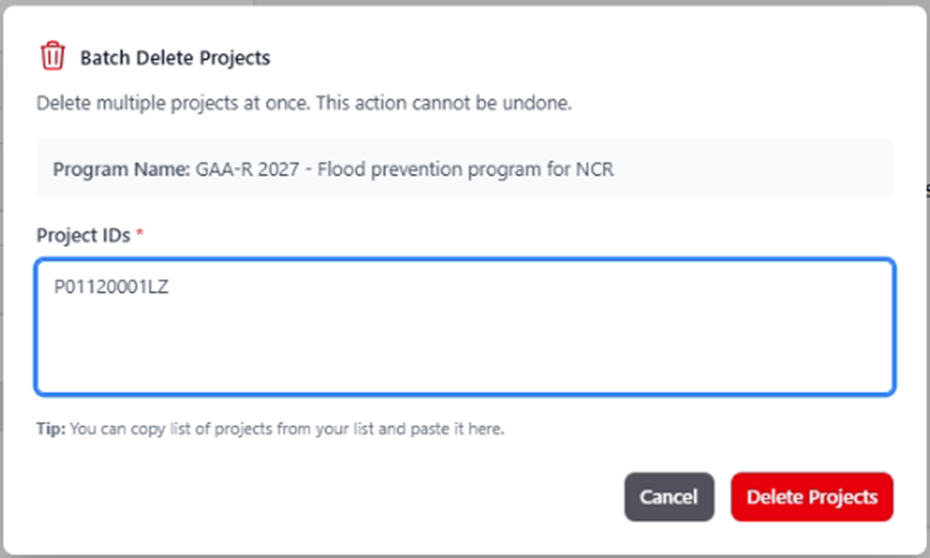
Purpose
The Batch Delete Projects screen allows users to delete multiple projects from a selected program in one action. This screen is used when several project records need to be removed at the same time instead of deleting them one by one.
Because this action affects multiple projects, users should review the selected program and project entries carefully before confirming the deletion.
Who uses this
This screen is available to authorized MYPS users with access to the module.
Prerequisites
Before using this screen, ensure that:
- You are logged in to the MYPS Web application.
- You have opened the relevant program where the projects belong.
- You have permission to delete project records.
- You know which project IDs should be deleted.
- You have reviewed the project list before performing the deletion.

Field reference
No. | Fields/Blocks/Objects | Description | Values / Actions
UI-UX-0025-01 | PROGRAM NAME | Displays the name of the program that the project belongs to. | Text message; Displays the program name (e.g., "GAA-R 2027 - Flood prevention program for NCR").
UI-UX-0025-02 | PROJECTS TO BE DELETED | Displays the project(s) that will be affected by the deletion. | Text message; Displays the project IDs and descriptions to be deleted.
UI-UX-0025-03 | CONFIRMATION INSTRUCTION TEXT | Instructs the user to type a specific word ("DELETE") to confirm the deletion. | Instruction text; Displays "Type DELETE to confirm."
UI-UX-0025-04 | CONFIRMATION INPUT FIELD | A text field for the user to type the confirmation keyword ("DELETE"). | Text input; User must type "DELETE" to proceed.
UI-UX-0025-05 | CANCEL BUTTON | Cancels the delete operation and closes the modal. | Button labeled "Cancel"; Action: Closes the modal without deleting.
UI-UX-0025-06 | DELETE BUTTON | Confirms the deletion of the selected project(s). | Button labeled "Yes, Delete Projects"; Action: Confirms and deletes the project(s).

Step-by-step: Delete multiple projects
- Open the Batch Delete Projects modal
From the selected program, open the batch delete function for projects.
- Review the program name
Check the PROGRAM NAME displayed in the modal.
Confirm that the deletion is being performed under the correct program.
- Review the projects to be deleted
Look at the PROJECTS TO BE DELETED section.
Confirm that the displayed project IDs and descriptions match the projects you intend to remove.
- Read the confirmation instruction
Review the CONFIRMATION INSTRUCTION TEXT shown in the modal.
- Type the confirmation keyword
In the CONFIRMATION INPUT FIELD, type DELETE exactly as instructed.
- Confirm the deletion
Click DELETE BUTTON to proceed with removing the selected projects.
- Cancel the action, if needed
If you do not want to continue, click CANCEL BUTTON to close the modal without deleting any records.

On success
- The selected projects are deleted from the program.
- The project list is updated to reflect the removal.
- The deleted records no longer appear in the current program view.

Common Outcomes & What to Do
Message / Situation | What It Means | What To Do
Confirmation keyword not entered | The required confirmation text was not provided. | Type DELETE in the confirmation field, then try again.
Confirmation keyword does not match | The entered word does not match the required confirmation text. | Re-enter DELETE exactly as instructed.

Confirm Batch Delete (UI-UX-0026)
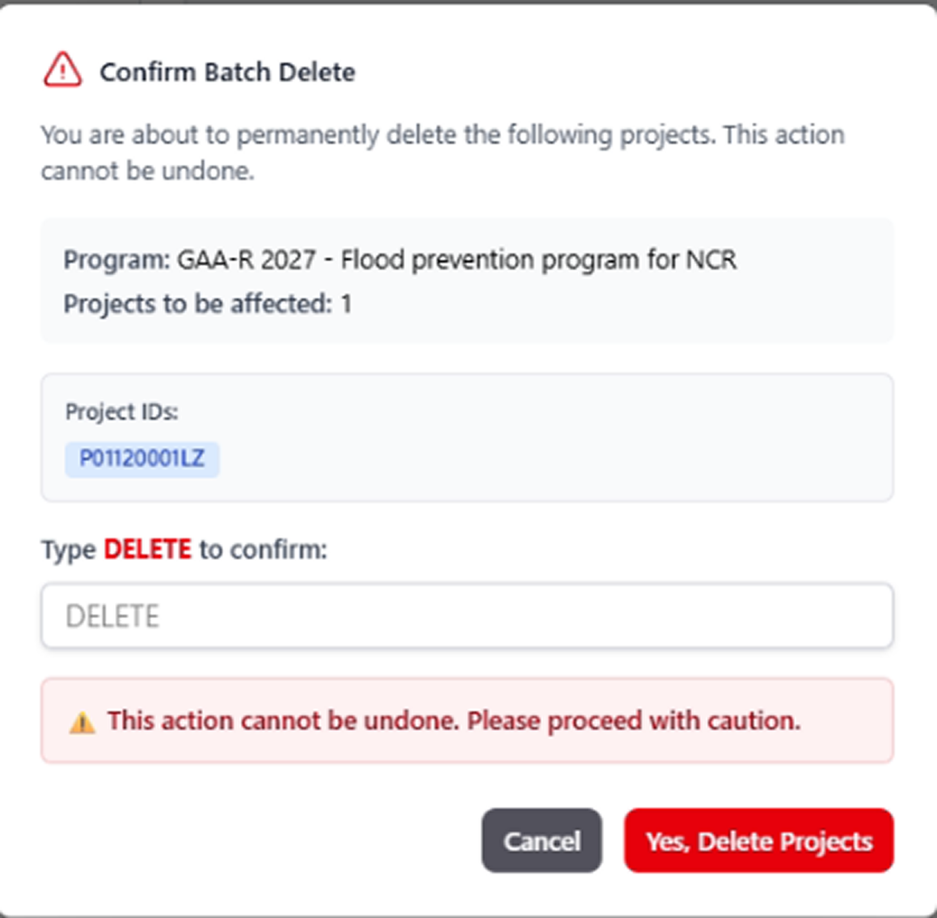
Purpose
The Confirm Batch Delete feature allows users to permanently delete multiple projects from the system. This action cannot be undone, and it requires confirmation by typing the word "DELETE" to proceed with the deletion.
Who Uses This
This screen is available to authorized MYPS users with access to the module.
Prerequisites
- You must be logged into your MYPS account.
- You must have the necessary permissions to delete projects.
- You must select the projects you intend to delete.
Field Reference
No. | Fields/Blocks/Objects | Description | Values / Actions
UI-UX-0026-01 | PROGRAM NAME | Displays the name of the program that the project belongs to. | Text message; Displays the program name (e.g., "GAA-R 2027 - Flood prevention program for NCR").
UI-UX-0026-02 | PROJECTS TO BE DELETED | Displays the project(s) that will be affected by the deletion. | Text message; Displays the project IDs and descriptions to be deleted.
UI-UX-0026-03 | CONFIRMATION INSTRUCTION TEXT | Instructs the user to type a specific word ("DELETE") to confirm the deletion. | Instruction text; Displays "Type DELETE to confirm."
UI-UX-0026-04 | CONFIRMATION INPUT FIELD | A text field for the user to type the confirmation keyword ("DELETE"). | Text input; User must type "DELETE" to proceed.
UI-UX-0026-05 | CANCEL BUTTON | Cancels the delete operation and closes the modal. | Button labeled "Cancel"; Action: Closes the modal without deleting.
UI-UX-0026-06 | DELETE BUTTON | Confirms the deletion of the selected project(s). | Button labeled "Yes, Delete Projects"; Action: Confirms and deletes the project(s).
Step-by-Step: Confirm Batch Delete
- Select the Projects to Delete
In the Programs section, check the projects that you wish to delete from the program.
Click on the Batch Actions button and select the Delete option to begin the batch delete process.
- Open the Confirm Batch Delete Modal
The Confirm Batch Delete modal will open, displaying the Program Name and the list of Projects to Be Deleted.
- Review the Projects to Be Deleted
Verify the Program Name and the Projects to Be Deleted. Ensure that all selected projects are correct.
- Read the Confirmation Instruction Text
The Confirmation Instruction Text will instruct you to type "DELETE" to confirm the deletion.
- Type “DELETE” in the Input Field
In the Confirmation Input Field, type the word "DELETE" to confirm your decision to delete the selected projects.
- Proceed with Deletion
Once you have typed "DELETE", click the Delete Button labeled "Yes, Delete Projects" to confirm the deletion and remove the selected projects.
- Cancel the Deletion (if needed)
If you decide not to delete the projects, click the Cancel Button to close the modal without performing any actions.
Common Outcomes & What to Do
Message/Situation | What it Means | What You Should Do
“Projects deleted successfully” | The selected projects have been successfully deleted. | Verify that the projects are no longer listed under the program and confirm the changes.
“Required confirmation missing” | The confirmation word "DELETE" was not typed correctly. | Ensure that you have typed "DELETE" in the Confirmation Input Field and try again.
“Error processing deletion” | There was an issue processing the deletion. | Review the selected projects and retry. If the issue persists, contact support.

Restrict Publish (UI-UX-0027)
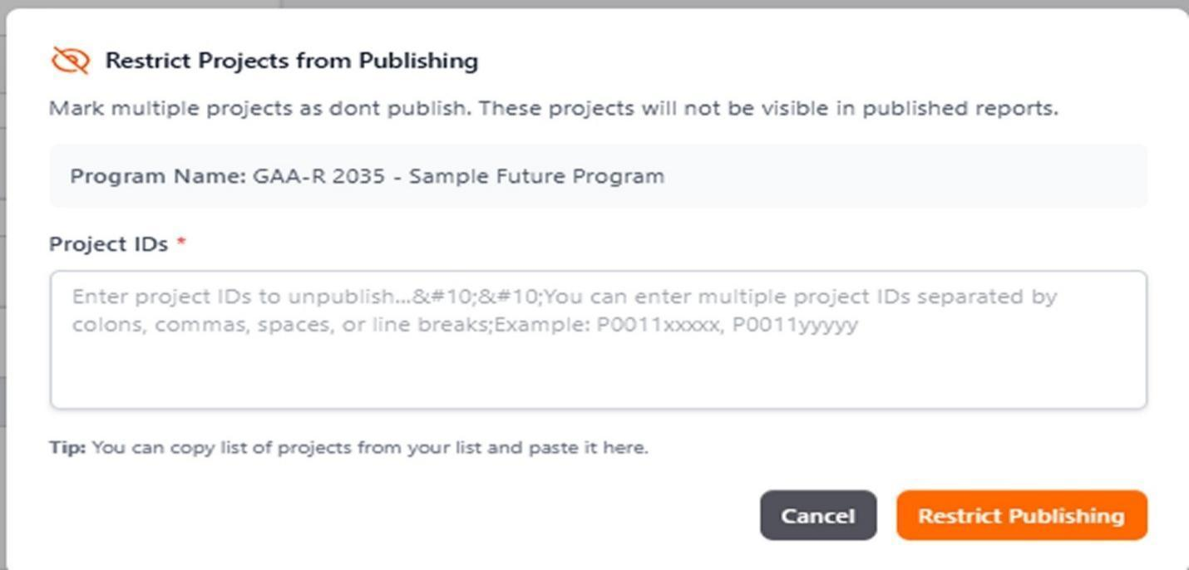
Purpose
The Restrict Projects from Publishing modal allows users to mark one or multiple projects as “Do Not Publish.” Projects restricted in this way will not appear in any published reports. This feature ensures sensitive or incomplete project data is not inadvertently published.
Who uses this
This screen is available to authorized MYPS users with access to the module.
Prerequisites
Before using this modal:
You must be logged in to MYPS Web.
A program must be selected from which projects will be restricted.
You must have permission to restrict project publishing.

Field reference
No. | Fields/Blocks/Objects | Description | Values / Actions
UI-UX-0027-01 | MODAL TITLE | Title of the modal used to restrict selected projects from being included in publishing. | Static text: “Restrict Projects from Publishing”
UI-UX-0027-02 | INSTRUCTION / WARNING MESSAGE | Instruction text explaining the purpose and effect of the restriction action. | Static text: “Mark one or more projects as Do Not Publish. These projects will be excluded from published reports.”
UI-UX-0027-03 | PROGRAM NAME | Displays the name of the currently selected program where the projects belong. | Read-only text; auto-populated from selected program. Example: “GAA-R 2035 - Sample Future Program”
UI-UX-0027-04 | PROJECT IDS | Multi-line input field where the user enters one or more project IDs to be restricted from publishing. | Required text area; accepts multiple Project IDs.
UI-UX-0027-05 | PLACEHOLDER / INPUT GUIDANCE | Helper text inside the Project IDs field explaining accepted separators and sample format. | Placeholder text: “Enter project IDs to unpublish… You can enter multiple project IDs separated by colons, commas, spaces, or line breaks; Example: P0011xxxxx, P0011yyyyy”
UI-UX-0027-06 | TIP MESSAGE | Supplemental helper text guiding the user on how to populate the Project IDs field. | Static helper text: “Tip: You can copy list of projects from your list and paste it here.”
UI-UX-0027-07 | CANCEL BUTTON | Button used to close the modal without applying any changes. | Button: “Cancel”; closes modal and discards unsaved input.
UI-UX-0027-08 | RESTRICT PUBLISHING BUTTON | Button used to apply the restriction to the entered project IDs. | Button: “Restrict Publishing”; validates input and marks listed projects as Do Not Publish / excluded from published reports.

Step-by-step: Restrict Projects from Publishing
- Open the Restrict Projects modal
Access the program for which you want to restrict projects, then open the Restrict Projects from Publishing modal.
- Review program name
Confirm the Program Name displayed is correct.
- Enter project IDs
Click the Project IDs field and type the IDs of the projects you wish to restrict.
Multiple IDs may be separated by colons, commas, spaces, or line breaks.
Example: P0011xxxxx, P0011yyyyy
- Verify input guidance
Review the Placeholder / Input Guidance and Tip Message to ensure correct entry format.
- Apply restriction
Click Restrict Publishing to validate the input and mark the projects as Do Not Publish.
- Cancel action (if needed)
Click Cancel to close the modal without applying changes.
On success
- Entered project IDs are marked as Do Not Publish.
- These projects will no longer appear in published reports.
Common Outcomes & What to Do
Message / Situation | What It Means | What To Do
No project IDs entered | Required field is blank. | Enter one or more project IDs and try again.
Invalid project ID format | Input does not match accepted format. | Correct the IDs using commas, spaces, colons, or line breaks.
Restriction applied successfully | Projects marked as Do Not Publish. | Confirm projects are excluded from published reports.

Allow Publishing (UI-UX-0028)
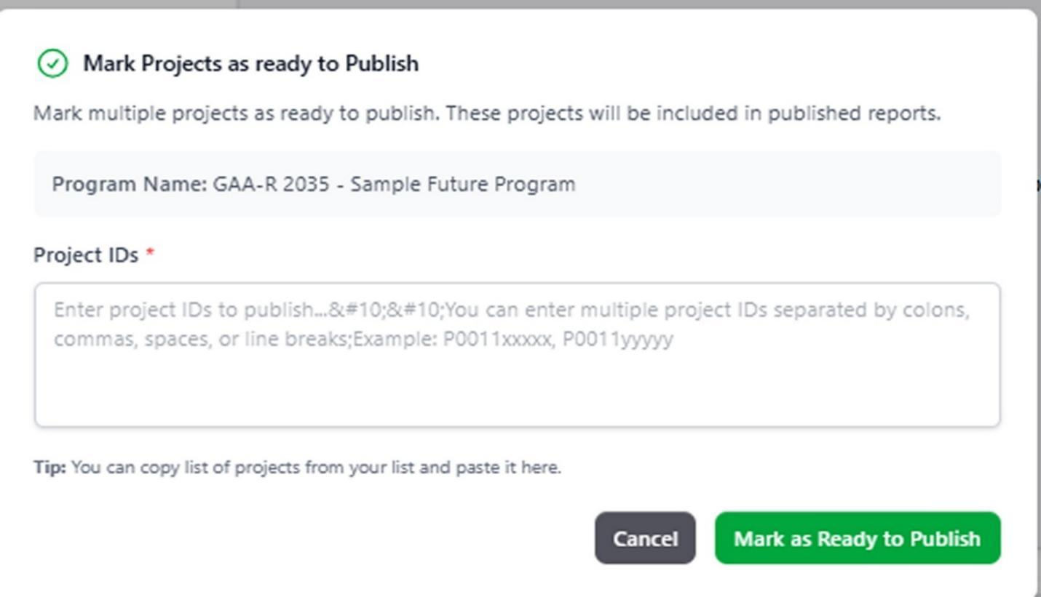Purpose
The Mark Projects as Ready to Publish modal allows users to designate one or multiple projects as ready for publishing. Projects marked in this way will appear in published reports, ensuring that only approved projects are included in the official outputs.
Who uses this
This screen is available to authorized MYPS users with access to the module.
Prerequisites
Before using this modal:
- You must be logged in to MYPS Web.
- A program must be selected, and you must have the required permissions.
- You must have the project IDs that you want to mark as ready for publishing.
Field reference
No. | Fields/Blocks/Objects | Description | Values / Actions
UI-UX-0028-01 | MODAL TITLE / MARK PROJECTS AS READY TO PUBLISH | Title of the modal used to mark selected projects as allowed or ready for publishing. | Read-only heading; displays “Mark Projects as ready to Publish.”
UI-UX-0028-02 | INSTRUCTION / INFORMATION MESSAGE | Explains the purpose and effect of the action. | Read-only text; informs the user that marked projects as ready to publish and that these projects will be included in published reports.
UI-UX-0028-03 | PROGRAM NAME | Displays the name of the program where the selected projects belong. | Read-only text/display field; example shown: “GAA-R 2035 - Sample Future Program.”
UI-UX-0028-04 | PROJECT IDS | Input area where the user enters one or more project IDs to be marked as ready for publishing. | Required text area; accepts multiple project IDs separated by colons, commas, spaces, or line breaks. Example shown: P0011xxxxx, P0011yyyyy.
UI-UX-0028-05 | PLACEHOLDER / INPUT GUIDANCE | Helper text inside the Project IDs field explaining the accepted input format. | Instructional placeholder text; tells the user they can enter multiple project IDs and shows a sample format for publishing.
UI-UX-0028-06 | TIP MESSAGE | Additional guidance to help the user populate the Project IDs field efficiently. | Read-only tip text; example shown: “You can copy list of projects from your list and paste it here.”
UI-UX-0028-07 | CANCEL BUTTON | Cancels the action and closes the modal without applying the publish-ready status. | Button labeled “Cancel”; closes the modal and discards the action.
UI-UX-0028-08 | MARK AS READY TO PUBLISH BUTTON | Confirms the action and marks the entered project IDs as ready to publish. | Button labeled “Mark as Ready to Publish”; applies the publish-ready status to the listed projects so they can be included in published reports.

Step-by-step: Mark Projects as Ready to Publish
- Open the modal
From the program or project list, select Mark Projects as Ready to Publish.
- Confirm program name
Check the Program Name field to ensure you are marking projects under the correct program.
- Enter project IDs
Click the Project IDs field and enter one or multiple project IDs.
Use colons, commas, spaces, or line breaks to separate multiple IDs.
Example: P0011xxxxx, P0011yyyyy
- Check placeholder and tip guidance
Review the Placeholder / Input Guidance and Tip Message for proper formatting.
- Apply publish-ready status
Click Mark as Ready to Publish to validate the input and mark the projects for publishing.
- Cancel if needed
Click Cancel to close the modal without applying any changes.
On success
- Entered project IDs are marked as ready to publish.
- These projects will be included in all future published reports.

Common Outcomes & What to Do
Message / Situation | What It Means | What To Do
No project IDs entered | Required field is blank. | Enter one or more project IDs and try again.
Invalid project ID format | Input does not meet the required format. | Correct IDs using commas, spaces, colons, or line breaks.

Import Projects (UI-UX-0029)
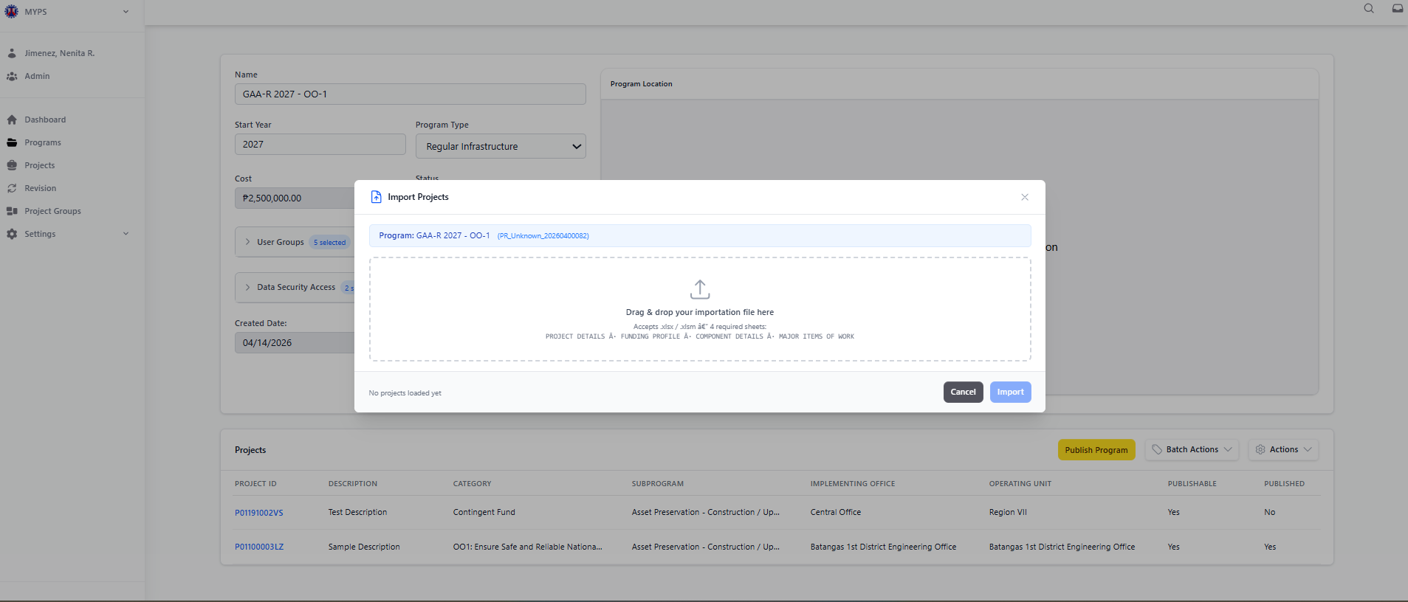
Purpose
The Import Projects screen allows authorized users to upload a project import file and add multiple projects into the selected MYPS program in one process.
This screen helps users load project data using the approved MYPS import template instead of encoding each project manually. It also helps users validate the file before the data is added to the system.
Who uses this
This screen is available to authorized MYPS users with access to the module.

Prerequisites
Before using this screen, ensure that:
- You have successfully signed in to the MYPS Web application.
- Your account is active and assigned to the correct role and office/unit.
- You have permission to access the Programs module and import projects.
- The target program already exists and is open in the Program Details screen.
- You have the approved MYPS project import file/template.
- The import file follows the required format, sheets, and field structure.
- Network or VPN access is available, if required by your office.
Field reference
No. | Fields/Blocks/Objects | Description | Values / Actions
UI-UX-0029-01 | IMPORT PROJECTS TITLE | Displays the title of the modal dialog for importing projects into the selected program. | Text label: “Import Projects”; read-only.
UI-UX-0029-02 | PROGRAM NAME | Displays the program where the imported projects will be added. | Read-only text showing the selected program name/code.
UI-UX-0029-03 | DRAG DROP IMPORT FILE | Upload area for the project import file. | Drag and drop a valid import file or click the upload area to browse. File must follow the approved MYPS template and required sheets/format.
UI-UX-0029-04 | IMPORT INSTRUCTION TEXT | Provides guidance to the user on how to upload the file and what template structure is expected. | Displays upload instructions and required import content before processing.
UI-UX-0029-05 | SELECT / CHANGE IMPORT FILE | Allows the user to replace the currently selected file before import. | Click to choose another file; replaces the previously attached file.
UI-UX-0029-06 | IMPORT SUMMARY / PREVIEW | Displays a summary of the loaded import data before saving to the system. | Read-only preview may show totals for projects, funding, components, major items, and related data once a valid file is loaded.
UI-UX-0029-07 | VALIDATION / ERROR MESSAGE AREA | Shows file validation results, missing fields, invalid formats, duplicate entries, or import readiness status. | Displays system messages such as validation errors or status text like “No projects loaded yet.” Errors must be resolved before import.
UI-UX-0029-08 | CANCEL BUTTON | Cancels the import process and closes the modal without saving imported data. | Button labeled “Cancel”; closes the modal and discards the current import session.
UI-UX-0029-09 | IMPORT BUTTON | Executes the import of projects into the selected MYPS program. | Button labeled “Import”; validates the file and saves projects only when all required checks pass.
UI-UX-0029-10 | CLOSE BUTTON | Closes the modal dialog from the upper-right corner. | Click Close to close the modal without importing.

Step-by-step: Import Projects into a Program
- Open the Programs module
From the left-side navigation menu, select Programs.
- Open the target program
Locate and open the program where the imported projects will be added.
- Open the Import Projects modal
From the Program Details screen, select the action for importing projects. Wait for the Import Projects modal to appear.
- Confirm the program name
Review the PROGRAM NAME field and confirm that the import will be applied to the correct program.
- Review the import instructions
Read the IMPORT INSTRUCTION TEXT to confirm the required template and upload format.
- Attach the import file
Use the DRAG DROP IMPORT FILE area to:
  - drag and drop the import file into the upload area, or
  - click the upload area to browse and select the file from your computer.
- Replace the file, if needed
If you selected the wrong file, use SELECT / CHANGE IMPORT FILE to choose a different file before importing.
- Wait for file validation
Allow the system to read the file and perform initial validation checks.
- Review the summary or preview
Check the IMPORT SUMMARY / PREVIEW area, if shown, to review the loaded data such as projects, funding, components, and major items.
- Review validation messages
Check the VALIDATION / ERROR MESSAGE AREA for warnings, errors, or status messages. Resolve any issues in the source file before continuing.
- Import the file
If the file passes validation, click IMPORT.
- Wait for processing
Allow the system to process the file and add the project data to the selected MYPS program.
- Return to the program project list
After the import is completed, review the Projects section of the program to confirm that the imported records are now available.
- Cancel or close if not proceeding
If you do not want to continue with the import, click CANCEL or the CLOSE BUTTON (X) to exit without saving.
On success
- The Import Projects modal opens correctly.
- The selected program name is displayed properly.
- A valid import file is accepted by the system.
- The import summary or preview is displayed, if applicable.
- No blocking validation errors remain.
- The projects are successfully imported into the selected MYPS program.
- The imported records become visible in the program’s project list.
Common Outcomes & What to Do
Message / Situation | What It Means | What To Do
No projects loaded yet | No valid file has been uploaded yet, or the system has not loaded any import data. | Upload a valid import file using the approved MYPS template.
Import button is disabled | The file may not yet be uploaded, validation may still be in progress, or there are blocking errors. | Wait for validation to finish and review any messages shown in the validation area.

Export Projects (UI-UX-0030)
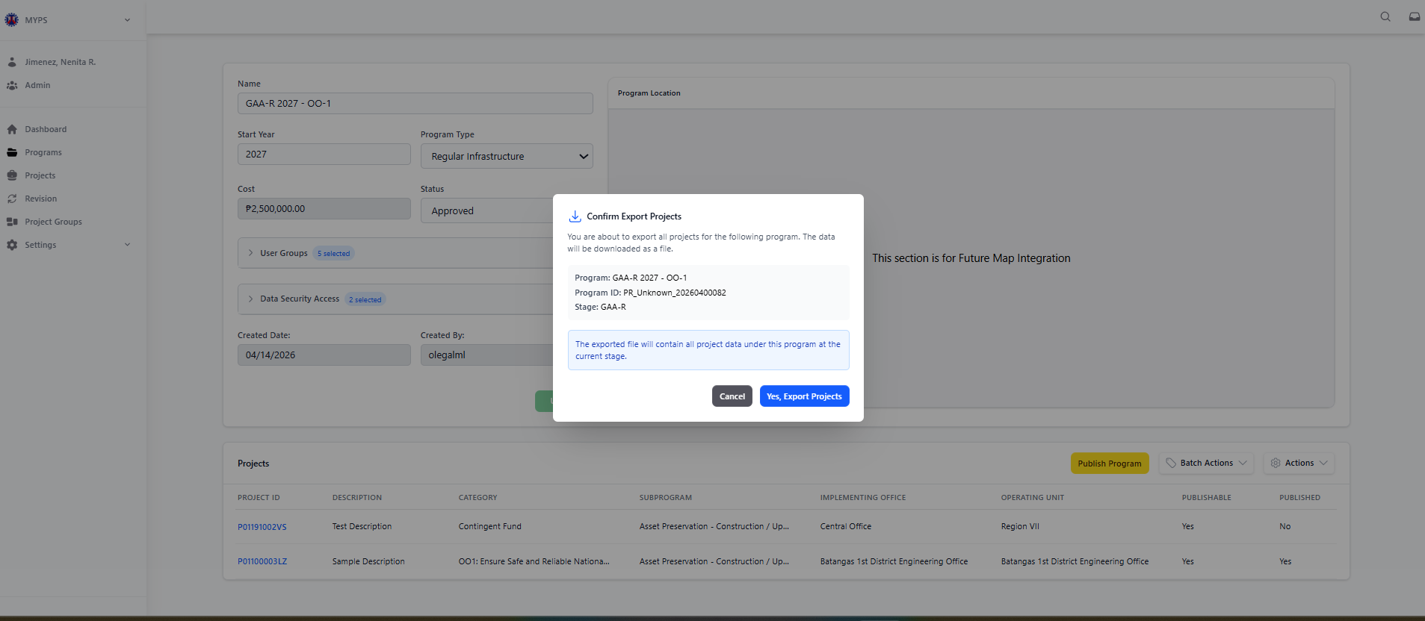
Purpose
This screen allows authorized users to export all projects under a selected MYPS Program and Program Stage. The export function downloads the project data into a file for reporting, review, validation, consolidation, or offline reference. The confirmation modal ensures that the user verifies the correct Program, Program ID, and Stage before downloading the project data.
Who uses this
This screen is available to authorized MYPS users with access to the module.
Prerequisites
Before using this screen, ensure that:
- You are signed in to MYPS Web.
- You have permission to view the selected program.
- You have permission to export project data.
- The selected program already exists in MYPS.
- The program has projects listed under the selected stage.
- The browser allows file downloads.

Field reference
No. | Fields / Blocks / Objects | Description | Values / Actions
UI-UX-0030-01 | CONFIRM EXPORT PROJECTS TITLE | Displays the title of the export confirmation modal. | Read-only title; indicates that the user is confirming an export action.
UI-UX-0030-02 | CONFIRMATION MESSAGE | Informs the user that all projects under the selected program will be exported. | Message such as: You are about to export all projects for the following program. This data will be downloaded as a file.
UI-UX-0030-03 | PROGRAM | Displays the selected program name. | Read-only display value. Example: GAA-R 2025 - Sample Future Program.
UI-UX-0030-04 | PROGRAM ID | Displays the system identifier of the selected program. | Read-only display value. Example: PR_Unknown_20260300011.
UI-UX-0030-05 | STAGE | Displays the current program stage being exported. | Read-only display value. Example: GAA-R.
UI-UX-0030-06 | EXPORT INFORMATION MESSAGE | Provides an additional reminder about the content of the export file. | Indicates that the exported file will contain all project data under the selected program at the current stage.
UI-UX-0030-07 | CANCEL BUTTON | Closes the confirmation modal without exporting project data. | Button labeled Cancel; returns the user to the Program Details page.
UI-UX-0030-08 | YES, EXPORT PROJECTS BUTTON | Confirms the export action and starts the file download. | Button labeled Yes, Export Projects; downloads the project export file if the action is successful.

Step-by-step: Export projects from a program
1. Open the Programs module
Sign in to MYPS Web. From the left navigation menu, click Programs.
2. Open the program details page
Locate the program that contains the projects to be exported. Open the program record to display the Program Details page.
3. Review the program information
Before exporting, review the displayed program information, including:
- Program name
- Start year
- Program type
- Cost
- Status
- User groups
- Data security access
- Created date and created by
Confirm that the correct program record is open.
4. Review the project list
Check the project table under the program. Review the visible project records, including the project ID, description, category, operating office, and other displayed project details.
5. Select the export action
Open the available action menu or export button from the Program Details page. Select the option to export projects.
The Confirm Export Projects modal will appear.
6. Confirm the export details
In the modal, review the following fields:
- Program
- Program ID
- Stage
Make sure the displayed values match the program and stage you intend to export.
7. Read the export information message
Review the information message stating that the exported file will contain all project data under the selected program at the current stage.
Proceed only if the selected program and stage are correct.
8. Cancel if needed
If the displayed program or stage is incorrect, click Cancel. The modal will close and no file will be downloaded.
9. Confirm export
If all details are correct, click Yes, Export Projects.
Wait for the system to generate and download the export file.
10. Verify the downloaded file
After download, open the file and confirm that it contains the expected project records for the selected program and stage.
On success
- The system generates the project export file.
- The file is downloaded through the browser.
- The exported file contains project data under the selected program and current stage.
- The user may use the exported file for reporting, validation, or offline review.
Common Outcomes & What to Do
Message / Situation | What It Means | What To Do
File downloaded successfully | The project export was generated and downloaded. | Open the file and verify that the expected project records are included.
No projects available for export | The selected program or stage has no project records. | Review the program project list before exporting again.

Generate Report / View AIP Report (UI-UX-0031)
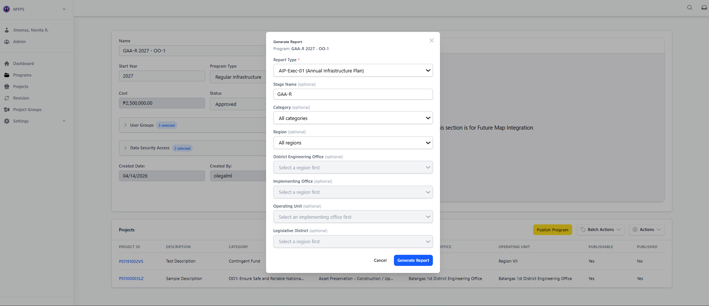
Purpose
The Generate Report modal allows users to create project or program reports based on selected parameters and filters. Users can specify report type, stage, category, region, and office to generate a tailored output for monitoring, planning, or publication.
Who uses this
This screen is available to authorized MYPS users with access to the module.

Prerequisites
Before using this modal:
- You must be logged in to MYPS Web.
- A program must be selected for which the report will be generated.
- You should know which report type and optional filters you want to apply.
Field reference
No. | Fields/Blocks/Objects | Description | Values / Actions
UI-UX-0031-01 | PROGRAM | Displays the selected program for which the report will be generated. | Read-only text/display field; shows the program context at the top of the modal. Example: GAA - R 2020 - DO_OO1 TARLAC-PANGASINAN - LA UNION EXPRESSWAY PROJECT (TPLEX).
UI-UX-0031-02 | REPORT TYPE | Dropdown field for selecting the type of report to generate. | Dropdown; example shown: AIP (Annual Investment Plan). User selects the report format/type.
UI-UX-0031-03 | STAGE NAME | Field for selecting or displaying the program stage to be used for the report. | Dropdown / selectable field; optional. Example shown: GAA-R.
UI-UX-0031-04 | CATEGORY | Dropdown field for filtering the report by project category. | Dropdown; optional. Example shown: All categories.
UI-UX-0031-05 | REGION | Dropdown field for filtering the report by region. | Dropdown; optional. Example shown: All regions.
UI-UX-0031-06 | DISTRICT ENGINEERING OFFICE | Dropdown field for filtering the report by District Engineering Office. | Dropdown; optional. Dependent on selected region. Example shown: Select a region first.
UI-UX-0031-07 | IMPLEMENTING OFFICE | Dropdown field for filtering the report by implementing office. | Dropdown; optional. Dependent on selected region. Example shown: Select a region first.
UI-UX-0031-08 | OPERATING UNIT | Dropdown field for filtering the report by operating unit. | Dropdown; optional. Dependent on selected implementing office. Example shown: Select an implementing office first.
UI-UX-0031-09 | LEGISLATIVE DISTRICT | Dropdown field for filtering the report by legislative district. | Dropdown; optional. Dependent on selected region. Example shown: Select a region first.
UI-UX-0031-10 | CANCEL | Action button to close the modal without generating the report. | Button labeled “Cancel”; closes the modal and discards the report generation action.
UI-UX-0031-11 | GENERATE REPORT | Action button to generate the report based on the selected parameters and filters. | Button labeled “Generate Report”; generates the selected report using the chosen filters and criteria.

Step-by-step: Generate a Report
- Open the Generate Report modal
From the selected program screen, open the report-generation function to display the Generate Report modal.
- Review the Program field
Check the Program field at the top of the modal. Confirm that the report will be generated for the correct selected program.
- Select the Report Type
In Report Type, choose the report you want to generate. Use the appropriate report type based on your reporting requirement.
- Select the Stage Name if needed
In Stage Name, choose the applicable program stage if the report requires a stage filter. Leave it as default if no specific stage is needed.
- Select Category if needed
In Category, choose a project category if you want to limit the report to a specific category. Otherwise, keep the default option such as All categories.
- Select Region if needed
In Region, choose a region if you want to filter the report geographically. Some dependent fields will become available based on the selected region.
- Select District Engineering Office if needed
If a region has been selected, choose the applicable District Engineering Office. If no region is selected, this field may remain unavailable.
- Select Implementing Office if needed
If a region has been selected, choose the appropriate Implementing Office for the report filter.
- Select Operating Unit if needed
If an implementing office has been selected, choose the Operating Unit. This field depends on the implementing office selection.
- Select Legislative District if needed
If a region has been selected, choose the Legislative District if required for the report scope.
- Review all selected filters
Before generating the report, review the selected values for:
  - Report Type
  - Stage Name
  - Category
  - Region
  - District Engineering Office
  - Implementing Office
  - Operating Unit
  - Legislative District
Make sure the filter combination matches the intended report output.
- Generate the report
Click Generate Report to create the report based on the selected parameters and filters.
- Cancel if needed
If you do not want to continue, click Cancel to close the modal without generating a report.
Example inputs
Valid report setup examples:
- Report Type: AIP
- Stage Name: HGAB
- Category: All categories
- Region: All regions
Filtered report example:
- Report Type: selected report type
- Stage Name: specific stage
- Region: selected region
- Implementing Office: selected office
On Success
After successful report generation:
- the selected report is generated using the chosen parameters
- the output reflects the selected program and applied filters
- the user can proceed with review, printing, download, or other follow-up actions depending on system configuration
Common Outcomes & What to Do
Message / Situation | What It Means | What To Do
No reports are available | No report type is currently available for the selected program stage or context. | Check the selected program stage and verify whether reporting is available for that context.
Required filter dependency not met | A dependent field cannot be selected because the required parent field is still empty. | Select the required parent field first, such as Region or Implementing Office.

Project (UI-UX-0032)
Project List Search and Column Alignment
Search the Projects list by Project ID unless the current production UI explicitly supports additional fields. The search field placeholder should read “Search by Project ID…”.
Verify the production grid columns against the current test script and UI screenshots before publication. The documented list should not include columns that are not displayed in the application.
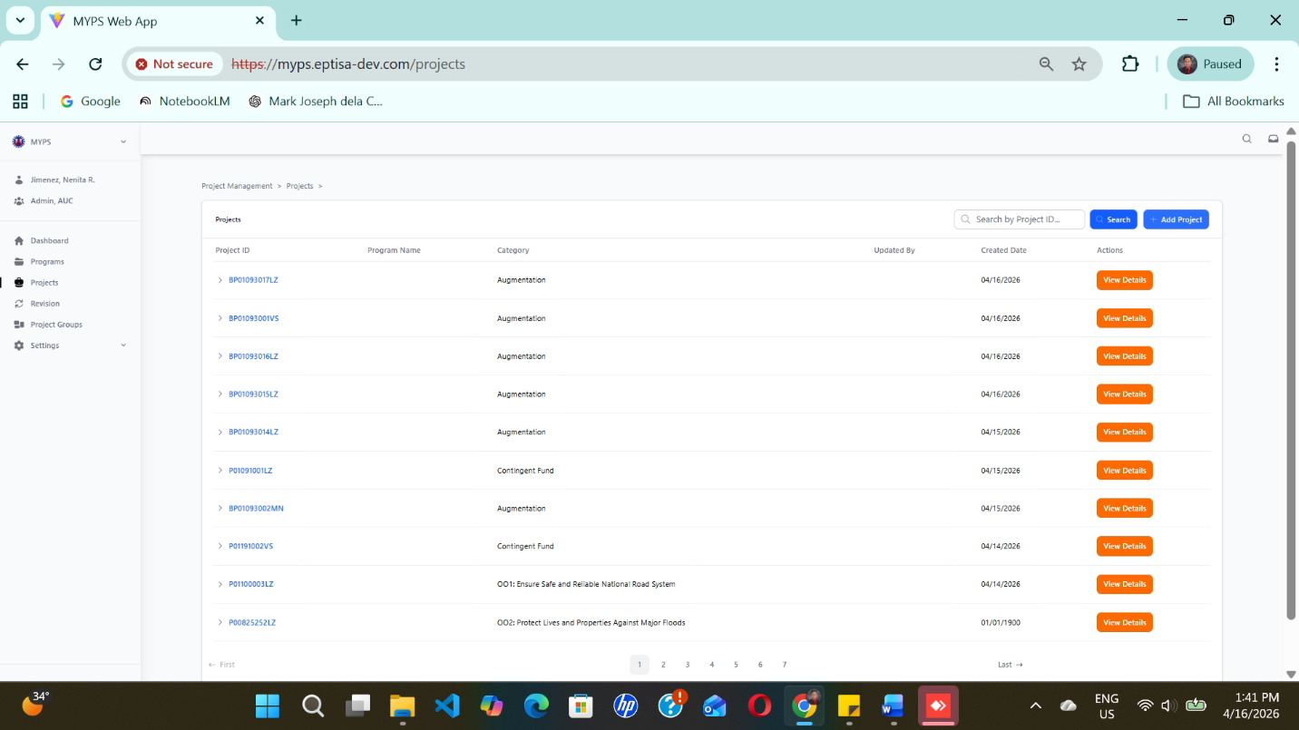
Purpose
The Project screen allows authorized users to search by Project ID, view, and manage individual project records in MYPS. It shows key project information such as Project ID, Program Name, Category, Updated By, and Created Date. It also allows users to open project details or begin adding a new project.
Who uses this
This screen is available to authorized MYPS users with access to the module.
Prerequisites
Before using this screen, ensure that:
- You are logged in to the MYPS Web application.
- Your account is active and assigned to the correct role and office/unit.
- You have permission to access the Projects module.
- Network or VPN access is available, if required by your office.
Field Reference
No. | Fields/Blocks/Objects | Description | Values / Actions
UI-UX-0032-01 | SEARCH PROJECT FIELD | Input field allowing users to search for specific projects by Project ID. | Text input; placeholder “Search by Project ID…”; allowed: letters, numbers, spaces, “-”, “_”, “/”; max 100 chars.
UI-UX-0032-02 | SEARCH BUTTON | Executes the project search based on the entered keyword/s. | Primary button; click or enter; clears pagination to first page; persists last query per session.
UI-UX-0032-03 | ADD PROJECT BUTTON | Opens a form/modal for creating a new project record. | Buttons “Add Project”; Opens a form/modal for creating a new project record.
UI-UX-0032-04 | PROJECT ID | Lists unique identifiers for each project entry (clickable links). | Alphanumeric text; Listed as clickable links. (A Project ID is a unique identifier assigned by the user upon entry into MYPS, for example, P01155611LZ.)
UI-UX-0032-05 | PROGRAM NAME | Displays the program under which each project belongs. | Alphanumeric + punctuation; 5–200 chars; Name of the parent program. (A Program is defined as a collection of Projects.)
UI-UX-0032-06 | CATEGORY | Displays the project’s classification or funding purpose. | Alphanumeric text + punctuations; Tells project category.
UI-UX-0032-07 | UPDATED BY | Displays the user who recently updated the project entry. | Alphanumeric + punctuation; 5–200 chars; Value is a username or name of program updater.
UI-UX-0032-08 | CREATED BY | Displays the user who created the project entry. | Alphanumeric + punctuation; 5–200 chars; Value is a username or name of program creator.
UI-UX-0032-09 | CREATED DATE | Shows the date when each project record was created. | Numeric in MM/DD/YYYY format; Range: Month: 01-12, Day: 01-31, Year: 1990–2100.
UI-UX-0032-10 | ACTIONS/VIEW DETAILS | Displays available user actions for each project. | Button “View Details”; Allows the user to view more details about a project.
UI-UX-0032-11 | PAGINATION / RECORD SUMMARY | Indicates the number of displayed records relative to total records. | Alphanumeric text; Summarizes page count and introduces navigation control.

Step-by-step: Search and open a project
- Open the Projects module
From the left-side navigation menu, select Projects.
- Wait for the Projects screen to load
Review the project table and available controls at the top of the screen.
- Search for a project, if needed
In the SEARCH PROJECT FIELD, type the project ID or project name keyword you want to find.
- Run the search
Click SEARCH BUTTON or press Enter.
- Review the search results
Check the returned records in the projects table.
- Review the listed project information
Confirm the values shown in the columns, including:
  - Project ID
  - Program Name
  - Category
  - Updated By
  - Created Date
- Open the project record
Select the PROJECT ID link or use ACTIONS / VIEW DETAILS to open the selected project.
- Add a new project, if required
If you need to create a new project, click ADD PROJECT BUTTON.
- Check for empty results
If no record is shown, review the search keyword and try again.
- Continue to the next task
Once the correct project is opened, proceed with the next required MYPS activity.
On success
- The Projects screen loads correctly.
- Matching project records are displayed when a valid search is entered.
- The project table shows the available project details properly.
- The selected project opens successfully when the user clicks the Project ID or View Details action.
- The Add Project action opens the new project entry screen when permitted.

Common Outcomes & What to Do
Message / Situation | What It Means | What To Do
No projects found | No project record matches the entered search keyword. | Check the spelling, try a different keyword, or search using the full Project ID if available.
Search returns too many results | The search keyword is too broad. | Refine the keyword using a more specific Project ID or project name.
Project ID link cannot be opened | The record may not have loaded correctly, or your access may be limited. | Refresh the page and try again. If the issue continues, report it to support.

Project Stages (UI-UX-0033)
Purpose
The Project Stages screen allows authorized users to view the stage history of a selected project. When a project row is expanded from the Projects list, the system displays the project’s available stages, including the stage name, description, category, subprogram, creator, creation date, and available action.
This screen helps users review how a project appears across different program stages, such as BP, NEP, HGAB, GAA, and GAA-R, and open the detailed record for a selected stage.

Who Uses This
This screen is available to authorized MYPS users with access to the module.

Prerequisites
- You are logged in to the MYPS Web application.
- You have permission to access the Projects module.
- The project record already exists in MYPS.

Field Reference
No. | Fields/Blocks/Objects | Description | Values / Actions
UI-UX-0033-01 | PROJECT ID | Displays the unique identifier of the project. | Read-only text field displaying the project ID (e.g., "P0123456").
UI-UX-0033-02 | STAGE NAME | Displays the stage of the project (e.g., BP, NEP, GAA). | Dropdown field for selecting the project stage (e.g., "BP").
UI-UX-0033-03 | DESCRIPTION | Displays the description of the project. | Text field showing the project description (e.g., "Flood prevention program for NCR").
UI-UX-0033-04 | CATEGORY | Displays the project category again (same as above, appears multiple times). | Dropdown field to select the project category.
UI-UX-0033-05 | SUBPROGRAM | Displays the Subprogram associated with the project. | Dropdown field for selecting the project subprogram (e.g., "Network Development").
UI-UX-0033-06 | CREATED BY | Displays the name of the person who created the project. | Text field showing the creator's name.
UI-UX-0033-07 | CREATED DATE | Displays the date when the project was created. | Read-only text field displaying the project creation date.
UI-UX-0033-08 | ACTIONS/ VIEW DETAILS | Button to view detailed information about the project. | Button labeled “View Details”; actions leads to viewing further project details

Step-by-Step: View Project Stages
- Open the Projects module
From the left-side navigation menu, click Projects.
- Locate the project record
Use the Projects list or the search field to find the project you want to review.
- Expand the project row
Click the arrow or expandable control beside the project ID.
The system displays the project stage records below the selected project.
- Review the available stages
Check the stage records displayed in the expanded table. Review the following information:
  - Project ID
  - Stage Name
  - Description
  - Category
  - Subprogram
  - Created By
  - Created Date
- Open a stage record
Click View Details beside the stage you want to review.
The system opens the detailed project information for the selected project stage.
- Return to the Projects list, if needed
After reviewing the details, return to the Projects list to open another stage or another project.
On Success
The selected project expands successfully, and the system displays all available project stage records. The user can review the stage information and open the detailed project record by clicking View Details.
Common Outcomes & What to Do
Message / Situation | What it means | What you should do
No stage records are displayed | The selected project may not have available stage records, or the data did not load properly. | Refresh the page and try again. If the issue continues, report it to support.
View Details button is not visible | Your role may not have permission to open project details, or the action may be restricted for the selected record. | Confirm your access with the MYPS administrator.

Add Project Details (UI-UX-0034)
Test-Aligned Add Project Field Sequence
When adding a project, verify the field sequence and required/optional status against the latest test script. Include Multi-Year ID, Sub Category, Originating Agency, Region Wide, Feasibility, Feasibility Date, Detailed Design, and Detailed Design Date where those fields are present in the UI.
Expected result: After saving a valid project, the project appears in the Projects module and can be selected or linked within the applicable program workflow. If a duplicate or potential issue is detected, the Proceed with Caution dialog appears; select Cancel to review or Yes, Proceed Anyway to continue.
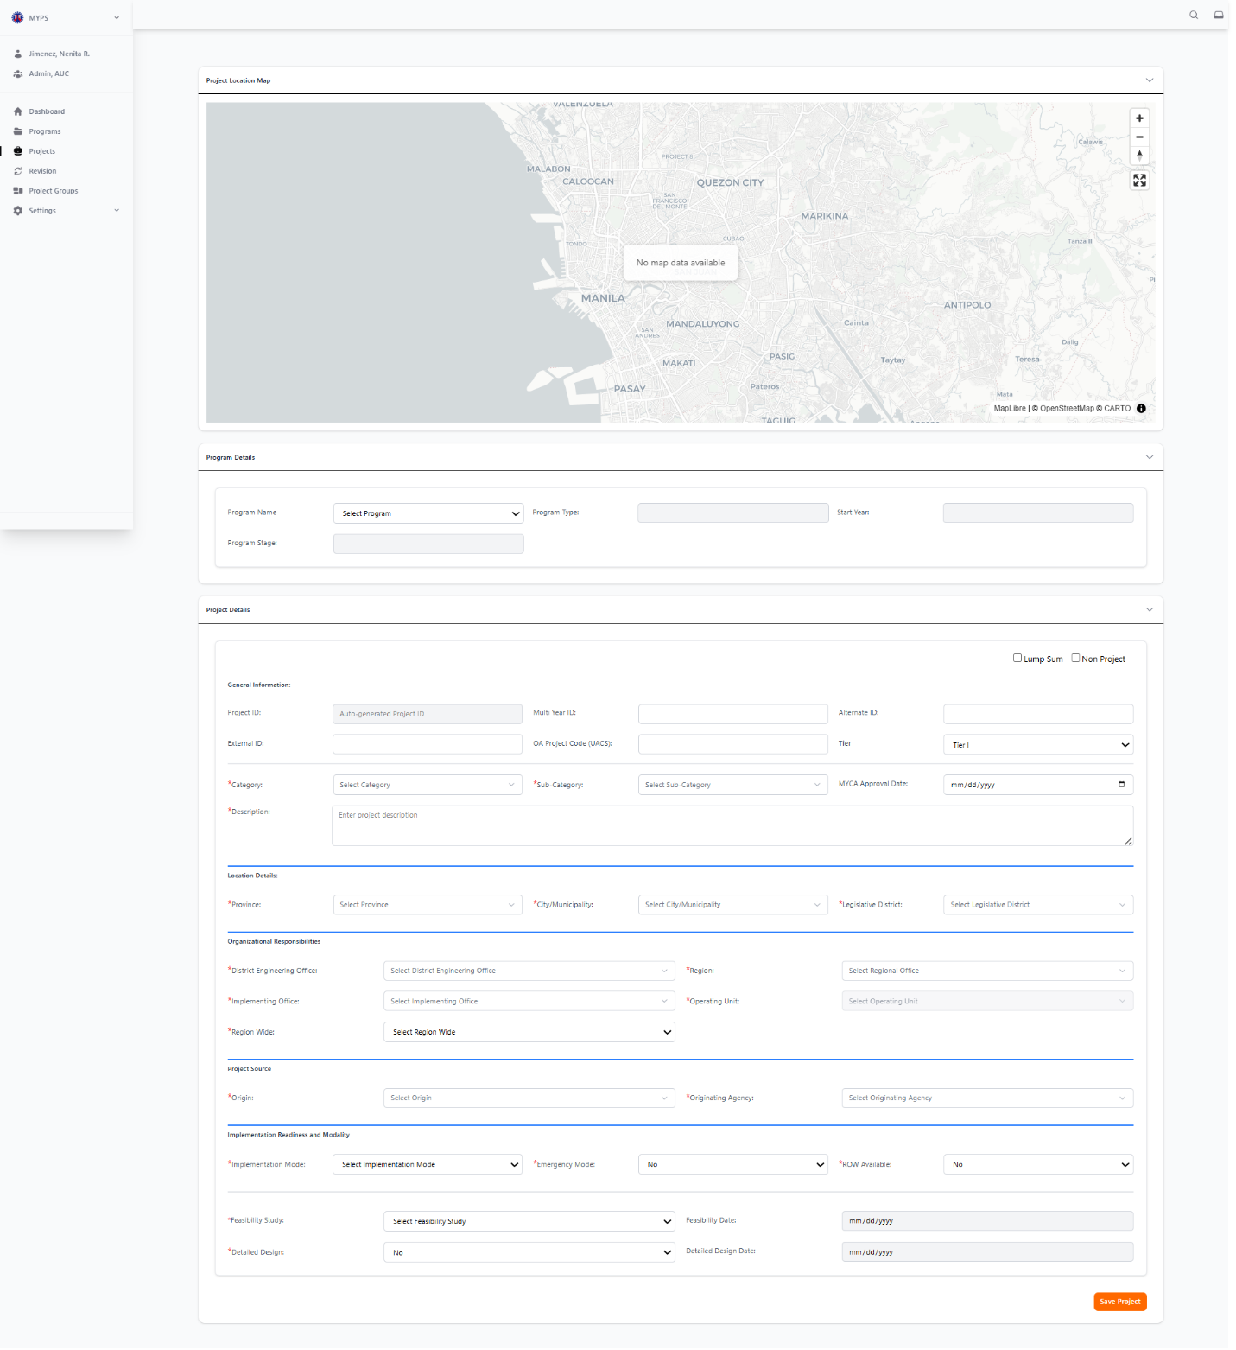
Purpose
The Add Project Details feature allows users to input and update detailed information about a new or existing project under a selected program. This feature is essential for organizing and managing project data efficiently within the MYPS platform.
Who Uses This
This screen is available to authorized MYPS users with access to the module.
Prerequisites
- You must be logged into your MYPS account.
- You must have access to the specific program and project to add or update project details.
Field Reference
No. | Fields/Blocks/Objects | Description | Values / Actions
UI-UX-0034-01 | PROGRAM NAME | Dropdown to select the program under which the project falls. | Dropdown field for selecting a program (e.g., "NEP 2025").
UI-UX-0034-02 | PROGRAM TYPE | Defines the type of program the project is part of (e.g., Infrastructure, Social). | Dropdown field for selecting the program type (e.g., "Regular Infrastructure").
UI-UX-0034-03 | START YEAR | The starting year for the project. | Numeric input (e.g., 2025).
UI-UX-0034-04 | PROJECT ID | The unique identifier assigned to the project. | Auto-generated alphanumeric code (e.g., "P01234567").
UI-UX-0034-05 | MULTI YEAR ID | Identifies multi-year projects. | Alphanumeric; for tracking multi-year projects.
UI-UX-0034-06 | ALTERNATE ID | Alternative project identifier, if any. | Text input; alphanumeric.
UI-UX-0034-07 | EXTERNAL ID | External identification for the project from other systems. | Text input; alphanumeric identifier from external systems.
UI-UX-0034-08 | OA PROJECT CODE (UACS) | The UACS (Unified Accounting Code Structure) code for the project. | Dropdown or text input for the project code.
UI-UX-0034-09 | TIER | Specifies the tier level for the project (e.g., Tier I). | Dropdown field for selecting the project tier (e.g., "Tier I").
UI-UX-0034-10 | CATEGORY | The main category for the project (e.g., "Road," "Bridge"). | Dropdown field for selecting the category (e.g., "Road").
UI-UX-0034-11 | SUB CATEGORY | The sub-category under the main project category. | Dropdown field for selecting a sub-category (e.g., "Road Expansion").
UI-UX-0034-12 | MYCA APPROVAL DATE | The approval date for the project by the MYCA (Multi-Year Capital Assistance). | Date input field (MM/DD/YYYY).
UI-UX-0034-13 | DESCRIPTION | A brief description of the project. | Text input for entering a short description of the project (e.g., "Road expansion project in Cebu").
UI-UX-0034-14 | PROVINCE | The province where the project is located. | Dropdown field for selecting the province.
UI-UX-0034-15 | CITY/MUNICIPALITY | The city or municipality where the project is located. | Dropdown field for selecting the city or municipality.
UI-UX-0034-16 | LEGISLATIVE DISTRICT | The legislative district for the project. | Dropdown field for selecting the legislative district.
UI-UX-0034-17 | DISTRICT ENGINEERING OFFICE | The responsible district engineering office overseeing the project. | Dropdown field for selecting the District Engineering Office.
UI-UX-0034-18 | IMPLEMENTING OFFICE | The office implementing the project. | Dropdown field for selecting the Implementing Office.
UI-UX-0034-19 | REGION | The region where the project is located. | Dropdown field for selecting the region (e.g., "Region I").
UI-UX-0034-20 | OPERATING UNIT | The operating unit responsible for the project. | Dropdown field for selecting the Operating Unit.
UI-UX-0034-21 | ORIGIN | The source of the project funding (e.g., National, Local). | Dropdown field for selecting the project origin (e.g., "National," "Local").
UI-UX-0034-22 | ORIGINATING AGENCY | The agency originating the project. | Dropdown field for selecting the originating agency.
UI-UX-0034-23 | IMPLEMENTATION MODE | Specifies the mode of implementation (e.g., Design-Bid-Build). | Dropdown field for selecting the implementation mode (e.g., "Design-Bid-Build").
UI-UX-0034-24 | EMERGENCY MODE | Indicates whether the project is under emergency mode. | Dropdown field for selecting Yes/No for emergency mode status.
UI-UX-0034-25 | ROW AVAILABLE | Indicates if Right of Way (ROW) is available for the project. | Dropdown field for selecting Yes/No for ROW availability.
UI-UX-0034-26 | FEASIBILITY STUDY | Indicates whether a feasibility study was conducted for the project. | Yes/No dropdown field for feasibility study status.
UI-UX-0034-27 | FEASIBILITY DATE | The date when the feasibility study for the project was completed. | Date input field (MM/DD/YYYY) for the feasibility study completion date.
UI-UX-0034-28 | DETAILED DESIGN | Indicates if the detailed design for the project has been completed. | Yes/No dropdown for detailed design status.
UI-UX-0034-29 | DETAILED DESIGN DATE | The date when the detailed design was completed. | Date input field for the completion date of detailed design (MM/DD/YYYY).
UI-UX-0034-30 | LUMP SUM | Indicates whether the project is a lump sum project (no detailed breakdown). | Yes/No dropdown for lump sum status.
UI-UX-0034-31 | NON-PROJECT | Indicates if the entry is not a standard project, but a non-project entry. | Yes/No dropdown for non-project status.
UI-UX-0034-32 | SAVE PROJECT | Button to save all entered project information. | Button labeled "Save Project"; action saves the project details.

Step-by-Step: Add Project Details
- Select Program for the Project
  - In the Program Name dropdown, select the program under which the project will be categorized (e.g., "NEP 2025").
- Define the Program Type
  - In the Program Type dropdown, choose the type of program (e.g., "Regular Infrastructure").
- Enter Start Year
  - In the Start Year field, input the year the project will start (e.g., "2025").
- Enter Project ID
  - The Project ID will be auto-generated upon selecting the program. Review the generated ID (e.g., "P01234567").
- Input Multi-Year ID (if applicable)
  - If the project spans multiple years, enter the Multi-Year ID (e.g., "MY12345").
- Enter Alternate Project ID (Optional)
  - If needed, enter an Alternate ID for the project (e.g., "AltID123").
- Input External ID (if applicable)
  - If the project has an identifier from an external system, enter it in the External ID field.
- Select Subproject (if applicable)
  - If applicable, select a subproject from the Subproject dropdown (e.g., "Asset Preservation").
- Choose Implementing Office
  - Select the office responsible for implementing the project from the Implementing Office dropdown.
- Choose Operating Unit
  - Select the unit responsible for operating the project from the Operating Unit dropdown.
- Review Information
  - Double-check all entered information to ensure it is correct and complete.
- Save the Project
  - Click the Save Project button to save the entered project detail

Common Outcomes & What to Do
Message/Situation | What it Means | What You Should Do
"Project saved successfully" | The project has been successfully added. | Verify the project details to ensure all information is accurate.
"Invalid Program Name" | The program name selected is invalid. | Recheck the program name and ensure it is selected from the dropdown.
"Permission error" | You do not have the necessary permissions to add projects. | Contact your administrator to request the necessary permissions.

Save New Project (UI-UX-0035)
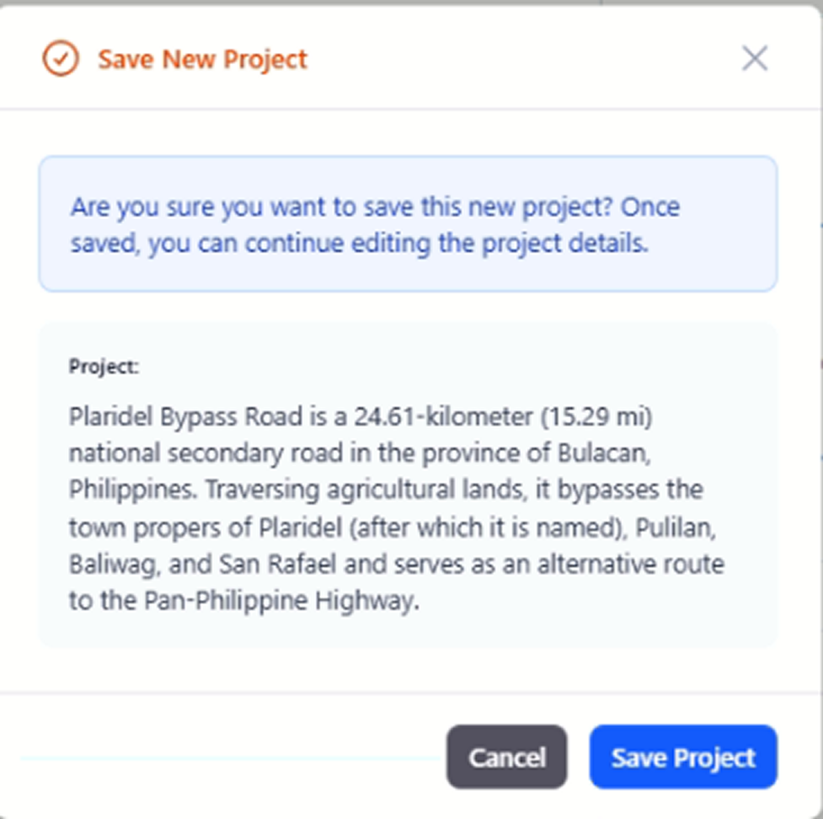
Purpose
The "Save New Project" feature allows users to finalize the creation of a new project by saving its details into the system. This action ensures that all provided information is stored and can be further edited later.

Who Uses This
This screen is available to authorized MYPS users with access to the module.

Prerequisites
- You must be logged into your MYPS account.
- You need to have the appropriate permissions to create new projects in the system.

Field Reference
No. | Fields/Blocks/Objects | Description | Values / Actions
UI-UX-0035-01 | PROJECT DESCRIPTION | Displays a summary of the project being saved. | Text box that includes the description of the project.
UI-UX-0035-02 | SAVE BUTTON | Allows saving the new project once the data is reviewed. | Button labeled "Save Project" which saves the current project details.
UI-UX-0035-03 | CANCEL BUTTON | Cancels the project saving process. | Button labeled "Cancel" which closes the save form without saving any details.

Step-by-Step: Save New Project
- Access the Save New Project Modal
  - Log in to your MYPS account.
  - Navigate to the Programs section under the Side Navigation menu.
  - Click on the "Add Project" button to open the "Save New Project" modal.
- Review Project Description
  - Ensure that the Project Description field accurately summarizes the details of the new project.
  - The description will be pre-filled based on your input in the "Project Details" section.
- Save the Project
  - Once you’ve reviewed the project description and verified that all information is correct, click the Save Project button.
  - This action will save the new project into the system.
- Cancel the Save Process
  - If you wish to cancel the process and not save the project, click the Cancel button.
  - This will close the modal without saving any of the project details.
Common Outcomes & What to Do
Message/Situation | What it Means | What You Should Do
"Project saved successfully" | The project has been saved successfully. | Verify the new project details are visible in the list.
"Error: Missing description" | The project description was not entered. | Ensure that the Project Description field is filled in before saving.

View Edit Project Details (UI-UX-0036)
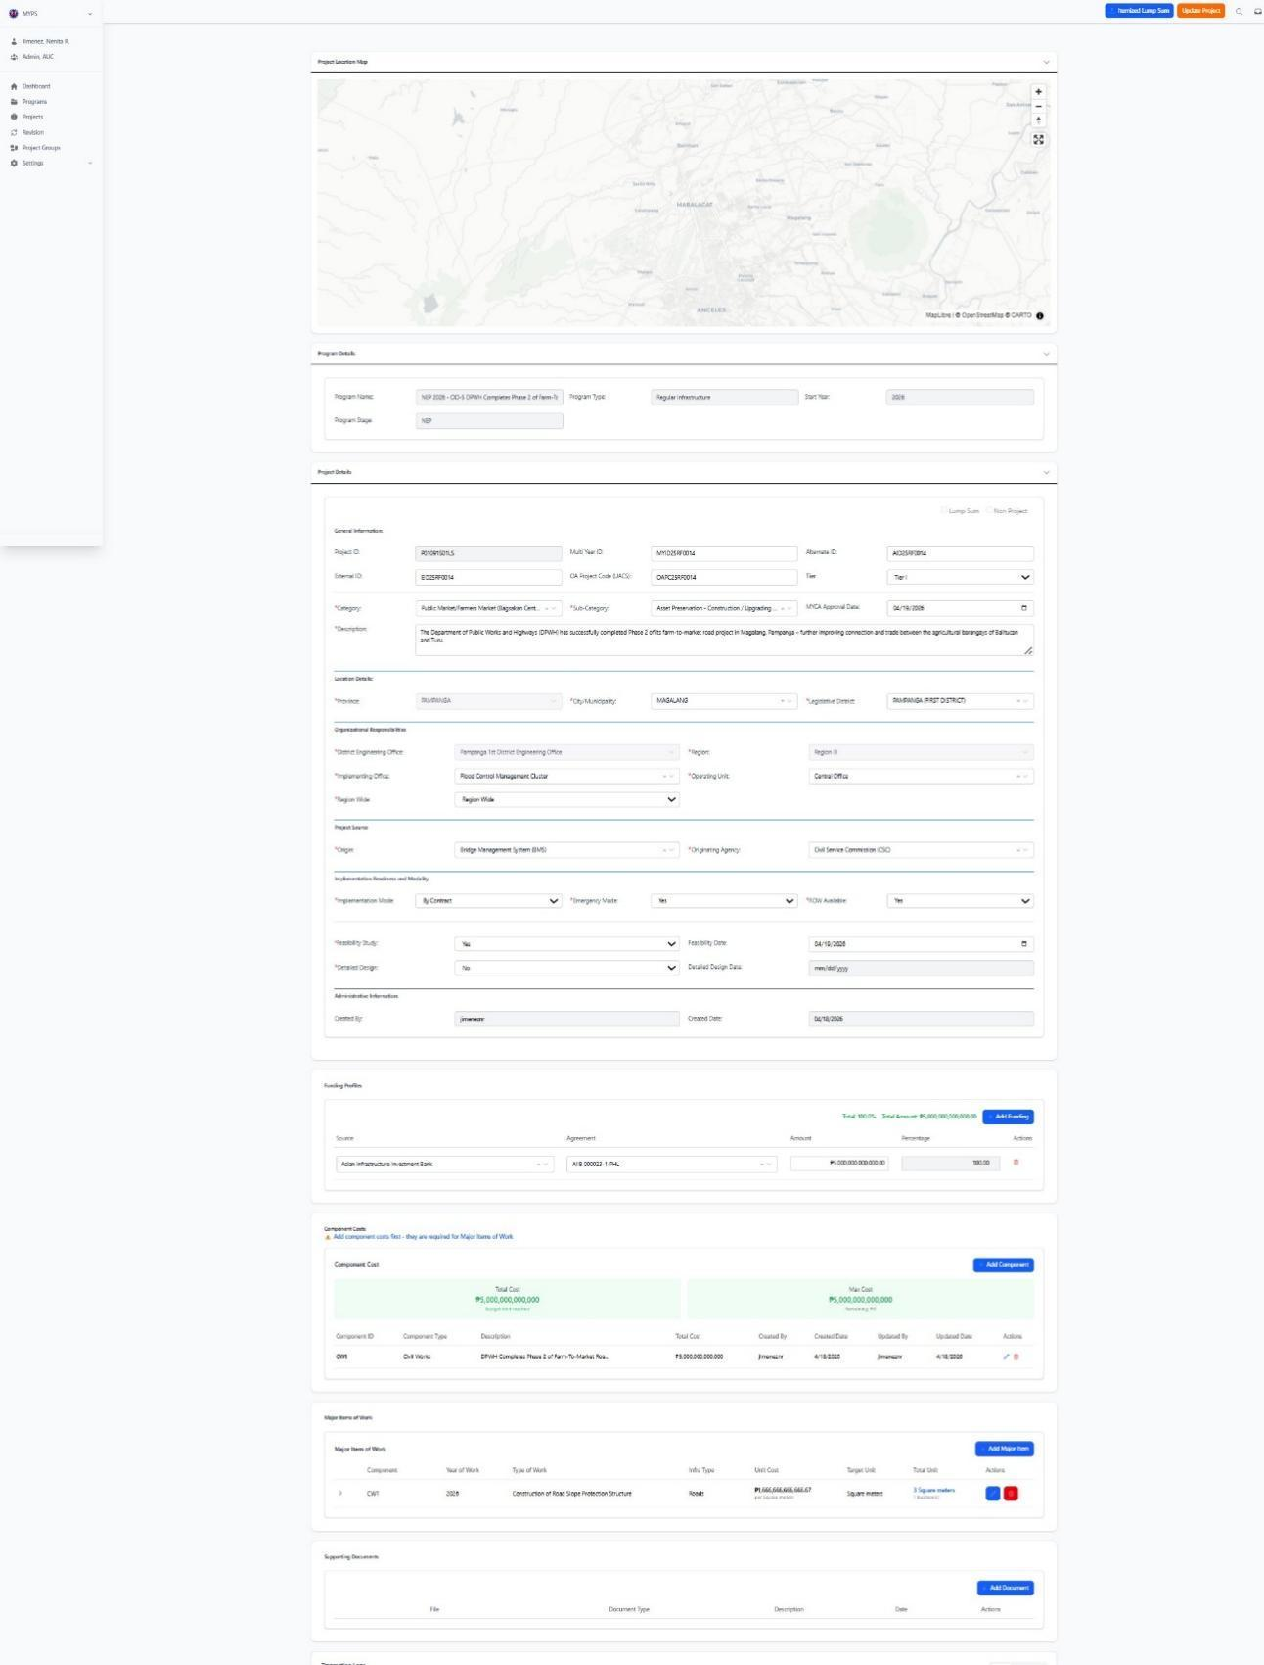

Purpose
The View Edit Project Details screen allows authorized users to review and update the detailed information of an existing Project in MYPS Web.
This screen is used after a Project has already been created. It gives users access to project-level data such as identification codes, classification, location, office assignments, implementation details, feasibility and design status, and related sections such as Funding Profile, Component Costs, Major Items of Work, and Supporting Documents. It serves as the main editing page for maintaining the correctness and completeness of Project information.

Who uses this
This screen is available to authorized MYPS users with access to the module.

Prerequisites
Before using this screen, ensure that:
You are signed in to the MYPS Web application.
You have permission to view or edit Project records.
The Project already exists in MYPS.
The Project is linked to a valid Program.
Required reference data such as Category, Sub-Category, Office, Region, and Origin values are available in the system.
Field Reference
No. | Fields/Blocks/Objects | Description | Values / Actions
UI-UX-0036-01 | PROGRAM NAME | Dropdown to select the program under which the project falls. | Dropdown field for selecting a program from existing options.
UI-UX-0036-02 | PROGRAM TYPE | Defines the type of program. | Dropdown field for selecting the program type, such as Regular Infrastructure.
UI-UX-0036-03 | START YEAR | The starting year for the project. | Numeric input, such as 2025 or 2026.
UI-UX-0036-04 | PROJECT ID | The unique identifier assigned to the project. | Auto-generated alphanumeric code.
UI-UX-0036-05 | MULTI YEAR ID | Identifies multi-year projects. | Alphanumeric value for tracking multi-year projects.
UI-UX-0036-06 | ALTERNATE ID | Alternative project identifier, if any. | Text input; alphanumeric.
UI-UX-0036-07 | EXTERNAL ID | External identification for the project from other systems. | Text input; alphanumeric identifier from external systems.
UI-UX-0036-08 | OA PROJECT CODE (UACS) | The UACS code for the project. | Dropdown or text input for the project code.
UI-UX-0036-09 | TIER | Specifies the tier level for the project. | Dropdown field for selecting the project tier.
UI-UX-0036-10 | CATEGORY | The main category for the project. | Dropdown field for selecting the category.
UI-UX-0036-11 | SUB CATEGORY | The sub-category under the main project category. | Dropdown field for selecting a sub-category.
UI-UX-0036-12 | MYCA APPROVAL DATE | The approval date for the project by the MYCA. | Date input field in MM/DD/YYYY format.
UI-UX-0036-13 | DESCRIPTION | A brief description of the project. | Text input for entering a short description of the project.
UI-UX-0036-14 | PROVINCE | The province where the project is located. | Dropdown field for selecting the province.
UI-UX-0036-15 | CITY/MUNICIPALITY | The city or municipality where the project is located. | Dropdown field for selecting the city or municipality.
UI-UX-0036-16 | LEGISLATIVE DISTRICT | The legislative district for the project. | Dropdown field for selecting the legislative district.
UI-UX-0036-17 | DISTRICT ENGINEERING OFFICE | The responsible district engineering office overseeing the project. | Dropdown field for selecting the District Engineering Office.
UI-UX-0036-18 | IMPLEMENTING OFFICE | The office implementing the project. | Dropdown field for selecting the Implementing Office.
UI-UX-0036-19 | REGION | The region where the project is located. | Dropdown field for selecting the region.
UI-UX-0036-20 | OPERATING UNIT | The operating unit responsible for the project. | Dropdown field for selecting the Operating Unit.
UI-UX-0036-21 | ORIGIN | The source or origin classification of the project. | Dropdown field for selecting the project origin.
UI-UX-0036-22 | ORIGINATING AGENCY | The agency originating the project. | Dropdown field for selecting the originating agency.
UI-UX-0036-23 | IMPLEMENTATION MODE | Specifies the mode of implementation. | Dropdown field for selecting the implementation mode.
UI-UX-0036-24 | EMERGENCY MODE | Indicates whether the project is under emergency mode. | Yes/No dropdown field.
UI-UX-0036-25 | ROW AVAILABLE | Indicates if Right of Way is available for the project. | Yes/No dropdown field.
UI-UX-0036-26 | FEASIBILITY STUDY | Indicates whether a feasibility study was conducted for the project. | Yes/No dropdown field.
UI-UX-0036-27 | FEASIBILITY DATE | The date when the feasibility study was completed. | Date input field in MM/DD/YYYY format.
UI-UX-0036-28 | DETAILED DESIGN | Indicates if the detailed design has been completed. | Yes/No dropdown field.
UI-UX-0036-29 | DETAILED DESIGN DATE | The date when the detailed design was completed. | Date input field in MM/DD/YYYY format.
UI-UX-0036-30 | LUMP SUM | Indicates whether the project is a lump sum project. | Yes/No dropdown or toggle field.
UI-UX-0036-31 | NON-PROJECT | Indicates whether the entry is a non-project. | Yes/No dropdown or toggle field.
UI-UX-0036-32 | ITEMIZED LUMP SUM | Indicates whether the lump sum project has itemized details. | Display or editable field depending on project type and permissions.
UI-UX-0036-33 | UPDATE PROJECT | Action button used to save and apply changes made to the current project record. | Button labeled Update Project; validates the encoded or edited details and updates the record in the system.

Step-by-step: View and edit Project details
1. Open the Project record
- Sign in to MYPS Web.
- Go to Projects.
- Open the selected Project from the Project List screen.
- Wait for the View Edit Project Details page to load.
2. Review the Project Location Map
- Check the Project Location Map at the top of the page.
- Confirm that the mapped location corresponds to the selected Project.
- If map data is missing, continue with the Project review and coordinate with the GIS or system administrator if location validation is required.
3. Review Program Details
- Check the Program Details section.
- Confirm the Program Name, Program Type, and Start Year.
- Make sure the Project is linked to the correct Program.
4. Review and update the Project Details section
Review and update the fields as needed:
- Project ID
- Multi Year ID
- Alternate ID
- External ID
- OA Project Code (UACS)
- Tier
- Category
- Sub Category
- MYCA Approval Date
- Description
- Province
- City/Municipality
- Legislative District
- District Engineering Office
- Implementing Office
- Region
- Operating Unit
- Origin
- Originating Agency
- Implementation Mode
- Emergency Mode
- ROW Available
- Feasibility Study
- Feasibility Date
- Detailed Design
- Detailed Design Date
- Lump Sum
- Non-Project
- Itemized Lump Sum, if applicable
5. Review related lower sections
After checking the Project Details, review the related sections shown below the form:
- Funding Profile
- Component Costs
- Major Items of Work
- Supporting Documents
Use these sections to confirm that the Project details remain consistent with the Project’s financial, component, and document records.
6. Save the changes
- After completing all necessary updates, click Update Project.
- Wait for the system to validate the data and save the changes.
- Example inputs
Valid examples:
- Start Year: 2026
- Tier: Tier I
- Implementation Mode: Design-Bid-Build
- Emergency Mode: No
- ROW Available: Yes
- Feasibility Study: Yes
- Feasibility Date: 04/18/2026
- Detailed Design: No
Project description example:
- Rehabilitation and upgrading of road section including drainage improvement and slope protection works.
On success
- The Project details are updated successfully.
- The edited values are saved in the Project record.
- The Project page refreshes or remains open with the updated data displayed.
- Related sections such as Funding Profile, Component Costs, and Major Items of Work remain available for further review.

Import Lump Sum Project (UI-UX-0037)

Eligibility and File Type
The Itemized Lump Sum option appears only when editing an existing project whose Project ID ends with LS and the project has not reached the final published stage. Use an .xlsx file unless the current production UI explicitly supports another format.
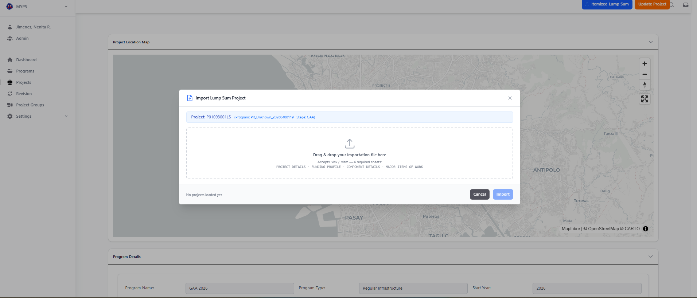
Purpose
The Import Lump Sum Project screen allows authorized users to upload Lump Sum Project data from external files into MYPS Web. It supports the import of data related to a Lump Sum project, including the necessary project details and relevant attributes, allowing users to quickly import and update project records without manually entering data.
This modal is designed to handle the Lump Sum project type and allows for bulk import functionality by dragging and dropping the project file (typically in CSV or XLSX format).

Who uses this
This screen is available to authorized MYPS users with access to the module.
Prerequisites
Before using this screen, ensure that:
- You are signed in to your MYPS account.
- You have permission to access Lump Sum Project Import functionality.
- The Lump Sum project data is available in an importable file format (CSV, XLSX, or as specified by the organization).
- The selected project (identified by Project ID) is ready for importing Lump Sum data.
- Your browser session and network connection are active.

Field Reference
No. | Fields/Blocks/Objects | Description | Values/Actions
UI-UX-0037-01 | PROJECT ID | Unique identifier for the project. | Auto-populated for the selected project; read-only.
UI-UX-0037-02 | PROJECT NAME | Displays the name of the current project. | Read-only; dynamically shows the selected project name.
UI-UX-0037-03 | FILE IMPORT AREA | Drag-and-drop area for importing the Lump Sum project data file. | Drag and drop the file here or click to browse for the file. Supported file types: CSV, XLSX, or as per organization’s specification.
UI-UX-0037-04 | IMPORT BUTTON | Submits the file for import. | Click Import to upload the file into MYPS Web.
UI-UX-0037-05 | CANCEL BUTTON | Closes the modal without importing. | Click Cancel to exit the modal without performing the import action.
UI-UX-0037-06 | FILE STATUS | Displays the status of the uploaded file. | File Ready, Processing, or Failed depending on the file’s state.
UI-UX-0037-07 | ERROR MESSAGE | Displays error details if the file upload failed. | Textual description of the issue encountered during file upload.

Step-by-step: Import a Lump Sum Project
1. Open the Lump Sum Project Import modal
- Sign in to MYPS Web.
- Go to the Projects section.
- Open the View/Edit Project Details page for the selected project.
- Click on the Import Lump Sum button to open the import modal.
2. Review project details
- Check the Project ID and Project Name to ensure the correct project is selected.
- Confirm that the project is a Lump Sum project and the data you are uploading is appropriate for this project type.
3. Upload the project data file
- In the File Import Area, either drag and drop the file or click to browse for the file to upload.
- Make sure the file is in a supported format (e.g., CSV, XLSX).
- If the file is correctly formatted, it will display File Ready status.
- If an error occurs during upload, the system will display an error message.
4. Submit the file
- After confirming the file is correct, click the Import button to upload the file and process the data.
- Wait for the File Status to update to Processing or Completed.
5. Handle file errors (if any)
- If the file upload fails, an Error Message will be displayed.
- Address the error by reviewing the file format, data validity, and re-uploading it if necessary.
6. Confirm the import status
- Once the import is complete, the status will update to Completed.
- Review the project details to ensure that the data has been successfully imported and updated.

Common Outcomes & What to Do
Message / Situation | What It Means | What To Do
File Ready | The file is ready for upload. | Proceed with clicking Import to submit the file.
Processing | The system is processing the file. | Wait for the import to complete.
File Failed | The uploaded file failed to process. | Review the Error Message and fix the issue (e.g., check file format, ensure correct data structure).

Funding Profiles (UI-UX-0038)

Funding Profile Validation Rules
Condition | Expected system behavior / user action
No amount entered | System displays: “Total funding percentage must equal 100%. Current total: 0.0%.” Enter valid funding amounts.
Total below 100% | Adjust funding entries until the total equals 100%, allowing the configured tolerance if enabled.
Total above 100% | Reduce one or more amounts until the total equals 100%, allowing the configured tolerance if enabled.
Tolerance rule | Use exactly 100% ±0.03% only if confirmed in the current production configuration.
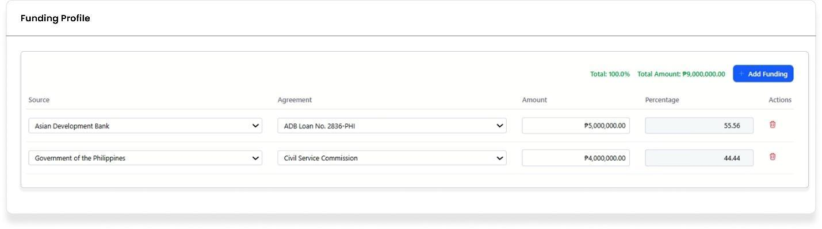
Purpose
To enter and manage the funding profile for a project, including the source of funding, agreement type, amount, and percentage allocation.
Who uses this
This screen is available to authorized MYPS users with access to the module.

Prerequisites
- You have an active MYPS account with sufficient permissions to manage funding profiles.
- You are logged into the MYPS Web application.
Field reference
No. | Fields/Blocks/Objects | Description | Values / Actions
UI-UX-0038-01 | SOURCE | Identifies the main funding origin or entity providing financial support for the project. | Identifies each stage of the  Source type of DPWH, ADB, Government of the Philippines.
UI-UX-0038-02 | AGREEMENT | Specifies the particular funding arrangement, grant, or budget line item associated with the source. | Identifies each stage of the  Agreement type of DPWH GENERAL APPROPRIATIONS ACT 2026, Civil Service Commission, PAMANA 2018, etc. .
UI-UX-0038-03 | AMOUNT | Represents the allocated or proposed monetary value provided by the funding source. | Numeric; 5–200 chars; Monetary value of Road Construction (Year 1) ₱ 460,277,010.
UI-UX-0038-04 | PERCENTAGE | Indicates the share or proportion of the total funding that the source contributes. | Numeric + punctuation; 5–200 chars; Percentage value. Crucially, the funding percentage must equal 100% for the project to be considered Fully Compliant for publishing to the Project and Contract Management Application (PCMA).
UI-UX-0038-05 | TOTAL AMOUNT | Displays the sum of all funding contributions across sources. | Numeric + punctuation; 5–200 chars; Calculated Monetary value of Road Construction (Year 1) ₱ 460,277,010.
UI-UX-0038-06 | TOTAL PERCENTAGE | Shows the cumulative percentage of all funding entries. | Numeric + punctuation; 5–200 chars; Calculated percentage value. The total must not exceed 100%.
UI-UX-0038-07 | ACTION/DELETE | Removes the Funding Profile from the list (soft delete/archive). Shown only when deletable and user is authorized. | Buttons “Delete”; This action is restricted during certain revisions; for instance, original funding agreements cannot be deleted during a Change in Funding revision (e.g., Expiry of Loan Funding).
UI-UX-0038-08 | ADD FUNDING BUTTON | Adds a new funding entry row to the list. | Buttons “Add Funding”; This action is used during the "Additional Funding" revision type (to add buffer funds or funds for Right-of-Way) and the "Change in Funding" revision type (to add a new funding agreement, such as switching from Loan Fund to Local Funding).

Step-by-step: Add Funding Profile
- Open the Funding Profiles page
  - Launch your browser and go to the MYPS Web application URL provided by your office.
- Add a new funding source
  - Click the + Add Funding button to add a new funding profile.
- Select the Funding Source
  - From the SOURCE dropdown, select the main funding entity for the project.
    - Example valid entries: "Government of the Philippines", "ADB".
- Select the Agreement Type
  - From the AGREEMENT dropdown, select the funding agreement related to the selected source.
    - Example valid entries: "DPWH GENERAL APPROPRIATIONS ACT 2026", "Civil Service Commission".
- Enter the Amount
  - In the AMOUNT field, enter the monetary value of the funding allocation.
    - Example valid entries: 500, 1000, etc.
  - The TOTAL AMOUNT field will automatically update to reflect the sum of all funding amounts.
- Enter the Percentage
  - In the PERCENTAGE field, enter the percentage of the total funding that this source contributes.
    - Example valid entries: 50, 30, etc.
  - The TOTAL PERCENTAGE will automatically update based on the entered percentage values.
  - Important: The total percentage must add up to 100% for the funding profile to be valid. If the total percentage is incorrect, a validation error message will appear.
- Save the Funding Profile
  - After entering the amount and percentage, click the Save button to save the funding profile.
- Review and Correct Validation Issues
  - If there are any validation issues (e.g., the total percentage does not equal 100%), a warning message will appear at the bottom of the page.
  - Ensure that the TOTAL PERCENTAGE is exactly 100%. Adjust the percentages if necessary.
  - Once the validation issues are resolved, click Save again.
On success
- The funding profile will be saved, and the page will refresh to show the updated funding information.
- The TOTAL AMOUNT and TOTAL PERCENTAGE will reflect the new values.

Common Outcomes & What to Do
Message / Situation | What it Means | What You Should Do
"Total percentage must equal 100%." | The sum of percentages across all funding sources is not 100%. | Adjust the percentage values so that they add up to exactly 100%.
"Funding added successfully." | The funding profile was successfully added. | Review the funding profile to ensure all values are correct.

Component Cost (UI-UX-0039)

Common Component Cost Validation Messages
Validation condition | Recommended user action
Missing Year | Select the applicable year for each component cost row before saving.
Missing Amount | Enter the component amount before saving.
Amount exceeds Funding Profile / maximum budget | Reduce the amount or update the funding profile so the component cost does not exceed the allowed budget.

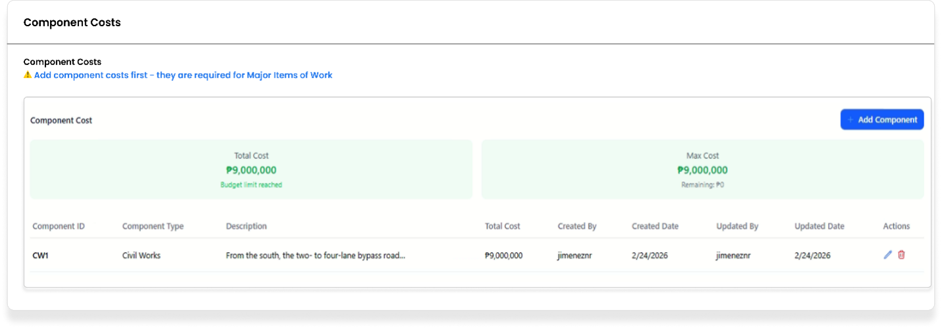
Purpose
To manage and track the individual costs associated with various components of a project, ensuring accurate budgeting and tracking of expenses.
Who uses this
This screen is available to authorized MYPS users with access to the module.
Prerequisites
- You have an active MYPS account with sufficient permissions to manage component costs.
- You are logged into the MYPS Web application.

Field reference
No. | Fields/Blocks/Objects | Description | Values / Actions
UI-UX-0039-01 | TOTAL COST | Displays the sum of all component costs currently added. It updates automatically as new items are added. | Numeric + punctuation; 5–200 chars; This is a calculated monetary value. The total of all Project Component Costs must equal the Total Project Cost.
UI-UX-0039-02 | MAX COST | Shows the maximum allowable budget for component costs. | Numeric; 5–200 chars; Monetary ceiling value.
UI-UX-0039-03 | COMPONENT ID | Unique identifier or code for the project component. | Alphanumeric + punctuation; 5–200 chars; Component IDs include abbreviations such as CW1A (running subscript for terminated balance of work components).
UI-UX-0039-04 | COMPONENT TYPE | Describes the type of project component being funded or tracked. | Alphanumeric + punctuation; 5–200 chars; Component Type; Consultancy, Construction Supervision, Civil Works, Design Component of a design and build project, etc.
UI-UX-0039-05 | DESCRIPTION | Additional details or notes about the component. | Alphanumeric + punctuation; 5–200 chars; Text/notes. For new components created after a termination (to cover the balance of works), the description will have " - balance of works" appended to it.
UI-UX-0039-06 | TOTAL COST (per component) | Amount assigned to a particular component. | Alphanumeric + punctuation; 5–200 chars; Monetary value. This amount must be greater than zero for the EAO Component Cost. If a component is deemed non-implementable, its cost is set to zero (0).
UI-UX-0039-07 | CREATED BY | User or account that added the component. | Alphanumeric + punctuation; 5–200 chars; Username or account ID.
UI-UX-0039-08 | CREATED DATE | The date when the component cost entry was created. | 4-digit numeric (YYYY); range 1990–2100; required.
UI-UX-0039-09 | UPDATED BY | The username of the person who last updated the record (if applicable). | Alphanumeric + punctuation; 5–200 chars; Username or account ID
UI-UX-0039-10 | UPDATED DATE | The most recent update date. | 4-digit numeric (YYYY); range 1990–2100; required.
UI-UX-0039-11 | ACTIONS/VIEW | Opens the Component Costs in view/edit mode depending on user permissions. | Button “View”; keyboard shortcut Enter when row focused; logs access; edit controls enabled only for authorized roles.
UI-UX-0039-12 | ACTIONS/DELETE | Removes the Component Costs from the list (soft delete/archive). Shown only when deletable and user is authorized. | Button “Delete”;This action is restricted during certain revisions; for instance, Component Cost.
UI-UX-0039-13 | ADD COST BUTTON | Used to add a new component cost record. | Button “Add Cost”; This is located in the Component Cost tab within the details pane of a selected Project.

Step-by-step: Manage Component Costs
- Open the Component Cost page
  - Launch your browser and navigate to the MYPS Web application.
- Add a New Component Cost
  - Click the Add Cost button located in the Component Cost section of the project’s details panel.
  - Fill in the following fields:
    - Component ID: Enter a unique identifier for the component.
    - Component Type: Select the type of the component from the dropdown (e.g., Design, Supervision).
    - Description: Provide a brief description or notes about the component (e.g., "Civil Works for Phase 2").
    - Total Cost (per component): Enter the allocated budget for the component.
    - Created By: This will automatically fill with your user ID, but you can modify if needed.
- Save the Component Cost
  - Once all fields are filled in, click the Save button.
  - The component will be added, and the Total Cost will automatically update to reflect the sum of all component costs.
- Edit an Existing Component Cost
  - Locate the component in the list of project components.
  - Click the View button under the Actions/VIEW column to edit the details of the component.
  - Modify the required fields (e.g., Description, Total Cost (per component)).
  - After making changes, click the Save button to update the record.
- Delete a Component Cost
  - If you need to remove a component, click the Delete button in the Actions/DELETE column.
  - A confirmation message will prompt you to confirm the deletion. Click Yes to proceed.
  - The component will be removed from the list, and the Total Cost will be updated automatically.
- Monitor the Total Costs
  - The TOTAL COST field will automatically update to reflect the sum of all added component costs.
  - The MAX COST field shows the maximum allowable budget, which helps in managing project funding.
On success
- The component cost will be successfully added, edited, or deleted, and the system will update the TOTAL COST accordingly.
- Validation will occur to ensure that each component’s total cost does not exceed the project’s funding limits.

Common Outcomes & What to Do
Message / Situation | What it Means | What You Should Do
"Total cost exceeds project budget." | The total component costs exceed the allocated budget. | Review and adjust individual component costs to align with the project budget.
"Component deleted successfully." | The component cost has been removed from the list. | Review the updated component list to ensure the correct component was deleted.

Add Project Component Costs (UI-UX-0040)
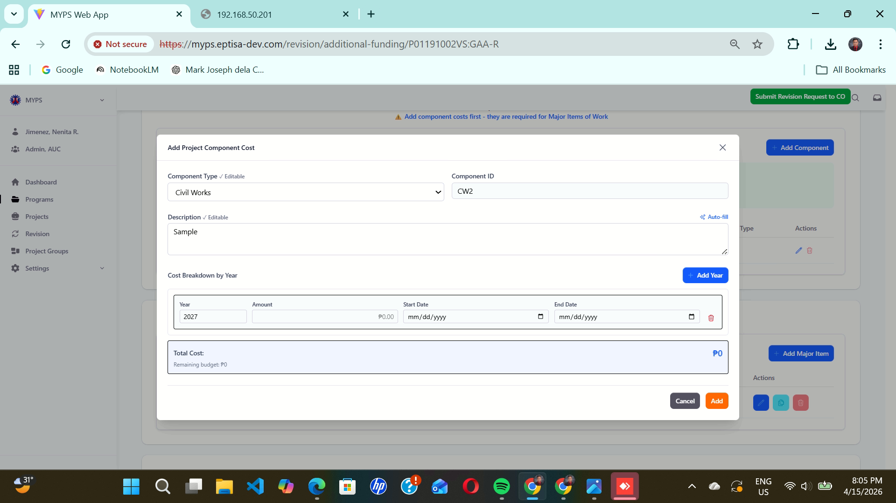
Purpose
The Add Project Component Costs screen allows users to enter or update the yearly cost breakdown for a project component. It is used to define the component type, component ID, description, year, amount, and implementation schedule for each cost entry.
This screen helps users organize project component costs clearly by year and by component so the project cost profile can be reviewed accurately.

Who uses this
This screen is available to authorized MYPS users with access to the module.
Prerequisites
Before using this screen, ensure that:
- You are logged in to the MYPS Web application.
- You have opened the relevant project record.
- You have access to the Component Costs section of the selected project.
- You have the required component, year, amount, and schedule details.
- You have permission to add or update project component costs.
Field reference
No. | Fields/Blocks/Objects | Description | Values / Actions
UI-UX-0040-01 | COMPONENT TYPE | Dropdown menu for selecting the specific project component or work category. | Identifies each stage of the component type of Consultancy, Construction Supervision, Civil Works, Design Component of a design and build project, etc.
UI-UX-0040-02 | COMPONENT ID | Auto-generated or prefilled short code identifier for the selected component type. | Text Input; FS, CW, DR. If a new component is created after a termination to cover the balance of works, the Component ID will typically use a running subscript starting from “A” (e.g., CW1A).
UI-UX-0040-03 | DESCRIPTION | Text input area to provide additional details or remarks about the component. | Text Input; For balance of works components created after termination, the description will have “ - balance of works” appended to it.
UI-UX-0040-04 | YEAR | Input field for specifying the applicable budget or implementation year of the component cost breakdown. | Text Input; 4-digit numeric year (e.g., 2020). Used to identify the year to which the entered amount and schedule apply.
UI-UX-0040-05 | AMOUNT | Input field for entering the allocated monetary value for the selected year. | Text Input; monetary value in peso format (e.g., ₱0.00). Must be a valid positive numeric amount.
UI-UX-0040-06 | START DATE | Date field for entering the intended start date of the component cost item for the specified year. | Date Picker / Text Input; MM/DD/YYYY format. User selects or enters the planned start date.
UI-UX-0040-07 | END DATE | Date field for entering the intended completion date of the component cost item for the specified year. | Date Picker / Text Input; MM/DD/YYYY format. User selects or enters the planned end date.
UI-UX-0040-08 | DELETE | Action control for removing a specific cost breakdown row from the list. | Icon Button (Trash/Delete); removes the selected row item and updates the total cost accordingly.

Step-by-step: Add Project Component Costs
- Open the project record
Navigate to the relevant project, then open the Component Costs section.
- Open the Add Project Component Costs screen
Select the option to add or update a component cost entry.
- Select the Component Type
In COMPONENT TYPE, choose the correct project component or work category from the dropdown list.
- Review the Component ID
Check the COMPONENT ID field.
If the value is prefilled, confirm that it matches the selected component type.
If applicable, use the correct running subscript format for balance of works components.
- Enter the Description
In DESCRIPTION, type the remarks or additional details for the component cost entry.
- Enter the Year
In YEAR, type the 4-digit year that applies to the cost item.
- Enter the Amount
In AMOUNT, type the peso value for the selected component and year.
- Enter the Start Date
In START DATE, select or type the intended start date in MM/DD/YYYY format.
- Enter the End Date
In END DATE, select or type the intended completion date in MM/DD/YYYY format.
- Review the entry
Check the component type, ID, description, year, amount, and dates before proceeding.
- Add more rows, if needed
Repeat the same process for other component cost entries required for the project.
- Delete an incorrect row, if needed
Click the DELETE action for the row that should be removed.
Confirm that the remaining list and total cost are still correct.
On success
- The project component cost entry is recorded correctly.
- The component, year, amount, and schedule details are displayed in the list.
- If a row is deleted, it is removed from the screen and the total cost is updated accordingly.
Common Outcomes & What to Do
Message / Situation | What It Means | What To Do
Component Type not selected | No component category was chosen. | Select the correct component type before continuing.
Component ID is missing or incorrect | The component code does not match the selected component or expected format. | Review the selected component type and confirm the correct component ID.

Major Items of Work (UI-UX-0041)

Major Item and Work Location Dependency
Work Locations become available only after a Major Item of Work is populated and saved or added. If the current UI includes “No work target” and “Generate ID,” complete those actions before entering coordinates, length, and chainage details.
Use the exact modal button label shown in the current UI. If the test script says “Add Item” but the application button says “Save,” update the test script or add a note to reconcile the difference.
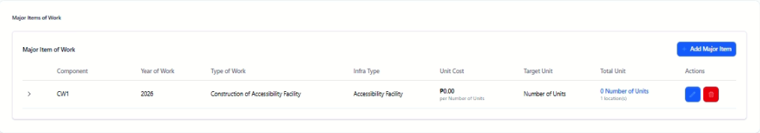
Purpose
The Major Items of Work feature allows users to define and configure work locations for a specific project. This includes specifying the component, year of work, type of work, infrastructure details, and other administrative details necessary for tracking project progress and output.
Who Uses This
This screen is available to authorized MYPS users with access to the module.
Prerequisites
- You must be logged into your MYPS account.
- You must have permission to view/edit major items of work.
- The project must already be created in the system.
Field Reference
No. | Fields/Blocks/Objects | Description | Values / Actions
UI-UX-0041-01 | COMPONENT | Identifies the component to which a Major Item of Work is done. | Alphanumeric + punctuation; 5–200 chars; Component IDs include abbreviations such as CW1A (running subscript for terminated balance of work components).
UI-UX-0041-02 | YEAR OF WORK | Indicates the year in which the major work is planned or will occur. | 4-digit numeric (YYYY); range 1990–2100; required.
UI-UX-0041- 03 | TYPE OF WORK | Describes the nature of the work being carried out. | Configurable via Type of Work; examples: Accessibility Facility, Bridges, Roads, Buildings etc.
UI-UX-0041- 04 | INFRA TYPE | Specifies the type of infrastructure under the project. | Configurable via Infra Type; examples: Bridges, Roads, Buildings etc.
UI-UX-0041- 05 | UNIT COST | Defines the unit of measurement for the work target. | Numeric + punctuation; 5–200 chars; Monetary value per unit.
UI-UX-0041- 06 | TARGET UNIT | Measurement unit used for physical accomplishment tracking. | Numeric + punctuation; 5–200 chars This field is disabled for editing and is automatically populated based on the selected Type of Work.
UI-UX-0041- 07 | TOTAL UNIT | Sum of all target units across all locations. | Text Input;Calculated value.
UI-UX-0041- 08 | ACTIONS/EDIT | This function allows users to edit or update existing Major Items of Work within a project component. | Button “Edit”; edit or update existing Major Items of Work within a project component.
UI-UX-0041- 09 | ACTIONS/DELETE | This function allows the user to remove or delete an existing Major Item of Work from the project component list. | Button “Delete”; remove or delete an existing Major Item of Work from the project component list.

Step-by-Step: Add Major Item of Work
- Open the Major Items of Work Page
  - Launch your browser and go to the MYPS Web URL provided by your office.
- Select the Component
  - From the Component dropdown, select the relevant component (e.g., "CWI" for a particular project or road work).
  - Enter the corresponding Year of Work (e.g., 2025).
- Choose the Type of Work
  - From the Type of Work dropdown, select the appropriate type of work (e.g., “Construction of Underpass”).
- Choose the Infrastructure Type
  - From the Infra Type dropdown, select the infrastructure type (e.g., “Roads” or “Bridges”).
- Set the Unit Cost
  - In the Unit Cost field, enter the cost per unit for the work target (e.g., 90.00 per square meter).
- Set the Target Unit
  - In the Target Unit field, select the unit of measurement for the work target (e.g., “Square meters”).
- Specify the Total Unit
  - The Total Unit field will be automatically populated based on the total units selected across all locations.
- Add Work Locations
  - Under Work Locations, click Add Location to add a new location for the project.
  - Enter the Start X Coordinate and End X Coordinate for defining the work location.
- Enter Detailed Scope
  - In the Detailed Scope field, provide a brief description of the scope of work to be performed (e.g., “Construction of underpass along Tarlac City”).
- Set the Physical Target
  - In the Physical Target (Square meters) field, enter the total physical target for the project (e.g., 1000 m²).
- Enter the Start and End Stations
  - In the Start Station (Km) and End Station (Km) fields, specify the starting and ending stations of the work segment.
- Save the Work Item
  - After entering all necessary information, click Save to add the Major Item of Work to the project.
  - A confirmation message will appear once the work item has been successfully saved.
On Success
- The major item of work will be added to the project.
- You will see a confirmation message indicating that the changes have been saved successfully.
Common Outcomes & What to Do
Message / Situation | What it Means | What You Should Do
“Major item added successfully.” | The major item was successfully added. | Review the added item to ensure all details are correct.
“Required field missing.” | A required field was not filled out. | Complete the missing required field and save again.

Add Major Items of Work (UI-UX-0042)
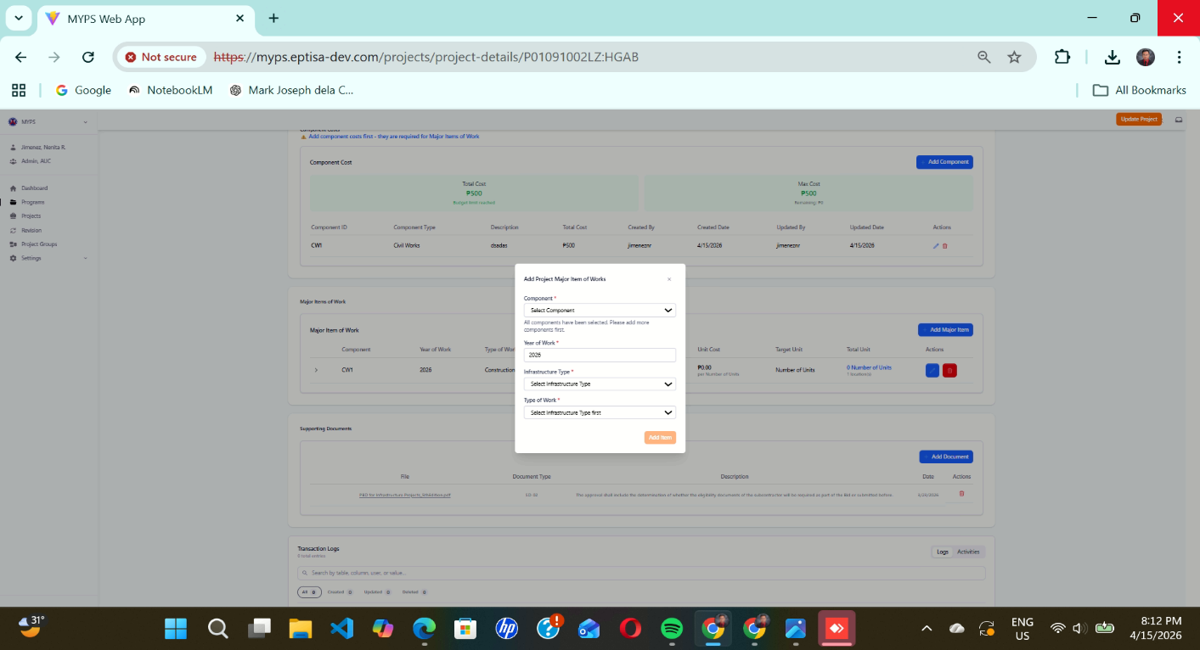
Purpose
Allow users to add a new Major Item of Work to a project by specifying its component, year of work, infrastructure type, and type of work.
Who uses this
This screen is available to authorized MYPS users with access to the module.
Prerequisites
- You are logged into the application.
- You have a project open and available for adding major items of work.
Field reference
No. | Fields/Blocks/Objects | Description | Values / Actions
UI-UX-0042-01 | COMPONENT | Dropdown list used to select the project’s component or work classification (e.g., Civil Works, Electrical Works). | Identifies each stage of the  Add Major Items of Work type of FS, DED, CWD, CW, DR, ROW1, ROW2, CS, LS, EAO, OTH.
UI-UX-0042-02 | YEAR OF WORK | Indicates the specific year the work is scheduled to be implemented or started. | 4-digit numeric (YYYY); range 1990–2100; required.
UI-UX-0042-03 | INFRASTRUCTURE TYPE | Dropdown field to select the type of infrastructure involved (e.g., Roads, Bridges, Buildings). | Identifies each stage of the  infrastructure type Roads, Bridges, Buildings, Hospitals, School Buildings etc.
UI-UX-0042-04 | TYPE OF WORK | Dropdown field to select the type of work involved. | Identifies each stage of the  type of work, Infrastructure Type, Major Work Category.
UI-UX-0042-05 | ADD ITEM BUTTON | Allows users to add a new Major Item of Work component. | Button” Add Item”; add a new Major Item of Work component.

Step-by-step: Add Major Item of Work
- Open the Add Major Items of Work screen
Navigate to the relevant section in the application where you can add a new Major Item of Work.
- Select the Component
  - Click on the Component dropdown field.
  - Select the relevant project component from the dropdown list (e.g., CW2).
  - Example valid entries: CW2, CW1, CS, LS
  - Invalid entries: Empty selection, unlisted components.
- Enter the Year of Work
  - Click on the Year of Work input field.
  - Type the year (e.g., 2025).
  - Example valid entry: 2025
  - Invalid entries: 2025abc (letters are not allowed).
- Select the Infrastructure Type
  - Click on the Infrastructure Type dropdown field.
  - Choose the type of infrastructure (e.g., Bridges).
  - Example valid entries: Bridges, Roads, Buildings
  - Invalid entries: No selection, non-existent infrastructure types.
- Select the Type of Work
  - Click on the Type of Work dropdown field.
  - Choose the relevant type of work (e.g., Construction, Renovation).
  - Example valid entries: Construction, Renovation
  - Invalid entries: Empty selection, unlisted types of work.
- Add the Item
  - After completing all fields, click the Add Item button to submit the new Major Item of Work.
  - The item will be added to your project’s list of major items.
On Success
- A confirmation message will appear stating that the new Major Item of Work has been successfully added.
- You will see the newly added item in the project’s Major Items list.

Common Outcomes & What to Do
Message / Situation | What it Means | What You Should Do
“Component selection is required.” | The component field was left empty. | Select a valid component from the dropdown.
“Invalid year format.” | The year entered is outside the valid range. | Ensure the year is a 4-digit number within the range 1990–2100.

Major Items of Work, Infra Type, Accessibility Facility (UI-UX-0043)
Purpose
Configure the major items of work for infrastructure projects and define their physical targets, coordinates, and related details, including the accessibility facility requirements.
Who uses this
This screen is available to authorized MYPS users with access to the module.

Prerequisites
Before using this screen, ensure that:
• You are signed in to MYPS Web.
• You have access to the relevant infrastructure project.
• You have the required permissions to add or edit major items of work.
Field Reference
No. | Fields/Blocks/Objects | Description | Values / Actions
UI-UX-0043-01 | INFRASTRUCTURE ID | Unique ID for the infrastructure. | Alphanumeric (e.g., "AF23965"). Auto-generated or inputted manually.
UI-UX-0043-02 | GENERATE ID | Button to generate a unique infrastructure ID. | Action button to auto-generate an ID.
UI-UX-0043-03 | DETAILED SCOPE | Detailed description of the work to be done. | Text field to enter the detailed work description.
UI-UX-0043-04 | TARGET UNIT | Unit of measurement for the work. | Numeric value (e.g., 100 units).
UI-UX-0043-05 | PHYSICAL TARGET (Number of Units) | The physical target for the work. | Numeric value (e.g., 100 units).
UI-UX-0043-06 | START COORDINATES X | X-coordinate for the starting point of the work. | Numeric value (e.g., 12.34567).
UI-UX-0043-07 | START COORDINATES Y |  | Numeric value (e.g., 98.76543).
  Y-coordinate for the starting point of the work.
UI-UX-0043-08 | END X COORDINATES | X-coordinate for the ending point of the work. | Numeric value (e.g., 12.67890).
UI-UX-0043-09 | END Y COORDINATES |  | Numeric value (e.g., 98.87654).
  Y-coordinate for the ending point of the work.
UI-UX-0043-10 | LENGTH (Linear meters) | The length of the work in linear meters. | Numeric value (e.g., 500 meters).
UI-UX-0043-11 | ADD LOCATION |  | Action button to open location input form.
  Button to add the geographical location for the work.

Step-by-Step: Major Items of Work Configuration
1.) Open the Major Items of Work screen
- Navigate to the program or project where the infrastructure work needs to be configured.
2.) Generate or enter Infrastructure ID
- If the infrastructure ID is not already provided, click the Generate ID button to auto-generate a unique ID. Alternatively, you can manually enter the infrastructure ID in the INFRASTRUCTURE ID field.
3.) Enter Target Unit
- In the Target Unit field, select or enter the unit of measurement for the work (e.g., “Number of Units”).
4.) Define the Physical Target (Number of Units)
- In the PHYSICAL TARGET (Number of Units) field, enter the target amount for the work, such as “100 units”.
5.) Enter the Coordinates
- Enter the START COORDINATES X and START COORDINATES Y for the starting point of the work.
- Enter the END X COORDINATES and END Y COORDINATES for the ending point of the work.
Example valid entries:
- Start Coordinates X: 12.34567
- Start Coordinates Y: 98.76543
- End Coordinates X: 12.67890
- End Coordinates Y: 98.87654
Invalid entries: Coordinates with incorrect format or missing values.
6.) Enter the Length of the Work
- In the LENGTH (Linear meters) field, input the length of the work in meters (e.g., “500 meters”).
7.) Add Detailed Scope of Work
- In the DETAILED SCOPE field, provide a detailed description of the work to be done.
8.) Add Location
- Click the ADD LOCATION button to open the location input form. Fill in the relevant geographical information (e.g., region, city, district) for the work.
9.) Save and Review
- After entering all necessary details, click Save (if available) or review the work location and details to ensure they are correctly configured.
On Success
• The Major Items of Work configuration will be successfully saved and linked to the infrastructure project.
• Verify the Infrastructure ID, coordinates, target units, and scope details on the form.
• If any information is incorrect or missing, return to the respective field to make corrections.

Common Outcomes & What to Do
Message / Situation | What it Means | What You Should Do
"Invalid input in Coordinates" | The coordinates entered are not in the correct format or out of range. | Ensure the coordinates are numeric and within the valid range.
"Target Unit is required" | No target unit selected. | Select or enter a unit of measurement for the work.
"Length field is required" | The length of the work in linear meters is missing. | Enter a valid numeric value for the length.

Major Items of Work Infra Type, Bridges (UI-UX-0044)
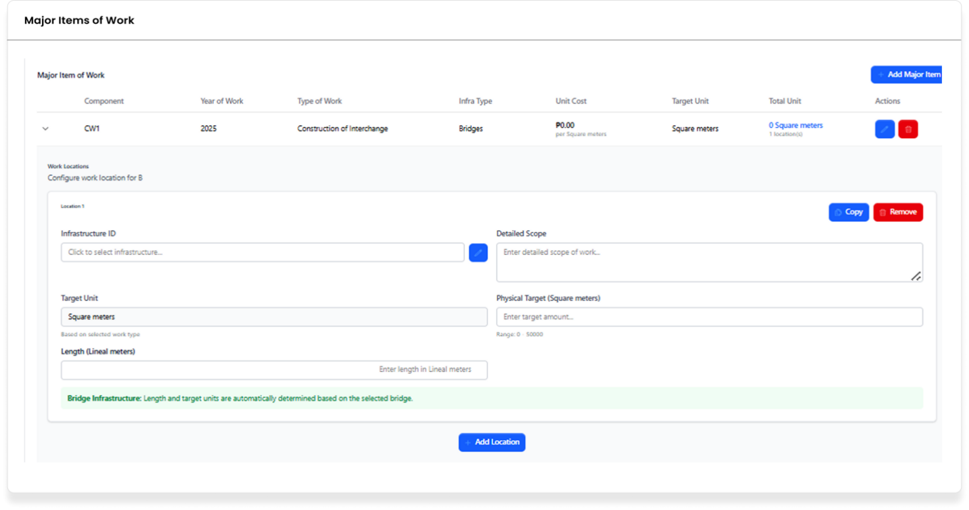
Purpose
Configure the major items of work for infrastructure projects related to bridges, including defining physical targets, coordinates, and detailed scope.

Who uses this
This screen is available to authorized MYPS users with access to the module.

Prerequisites
Before using this screen, ensure that:
• You are signed in to MYPS Web.
• You have access to the relevant infrastructure project.
• You have the required permissions to add or edit major items of work for bridge-related projects.

Field Reference
No. | Fields/Blocks/Objects | Description | Values / Actions
UI-UX-0044-01 | INFRASTRUCTURE ID | Unique ID for the infrastructure. | Alphanumeric (e.g., "AF23965"). Auto-generated or inputted manually.
UI-UX-0044-02 | DETAILED SCOPE | Detailed description of the work to be done. | Text field to enter the detailed work description.
UI-UX-0044-03 | TARGET UNIT | Unit of measurement for the work. | Numeric value (e.g., 100 units).
UI-UX-0044-04 | PHYSICAL TARGET (Square meters) | The physical target for the work in square meters. | Numeric value (e.g., 1000 square meters).
UI-UX-0044-05 | LENGTH (Linear meters) |  | Numeric value (e.g., 500 meters).
  The length of the work in linear meters.
UI-UX-0044-06 | ADD LOCATION | Button to add the geographical location for the work. | Action button to open location input form.

Step-by-Step: Major Items of Work Configuration for Bridges
1.) Open the Major Items of Work screen
- Navigate to the program or project where the infrastructure work for bridges needs to be configured.
2.) Generate or enter Infrastructure ID
- If the infrastructure ID is not already provided, click the Generate ID button to auto-generate a unique ID. Alternatively, you can manually enter the infrastructure ID in the INFRASTRUCTURE ID field.
3.) Enter Target Unit
- In the TARGET UNIT field, select or enter the unit of measurement for the work (e.g., “Square meters”).
4.) Define the Physical Target (Square meters)
- In the PHYSICAL TARGET (Square meters) field, enter the target area for the work, such as “1000 square meters.”
5.) Enter the Coordinates
- Enter the START COORDINATES X and START COORDINATES Y for the starting point of the work.
- Enter the END X COORDINATES and END Y COORDINATES for the ending point of the work.
Example valid entries:
- Start Coordinates X: 12.34567
- Start Coordinates Y: 98.76543
- End Coordinates X: 12.67890
- End Coordinates Y: 98.87654
Invalid entries: Coordinates with incorrect format or missing values.
6.) Enter the Length of the Work
- In the LENGTH (Linear meters) field, input the length of the work in meters (e.g., “500 meters”).
7.) Add Detailed Scope of Work
- In the DETAILED SCOPE field, provide a detailed description of the work to be done.
8.) Add Location
- Click the ADD LOCATION button to open the location input form. Fill in the relevant geographical information (e.g., region, city, district) for the work.
9.) Bridge Infrastructure Automatic Values
- The Bridge Infrastructure section will automatically populate the Length (Linear meters) and Target Unit (Square meters) fields based on the selected bridge infrastructure type.
10.) Save and Review
- After entering all necessary details, click Save (if available) or review the work location and details to ensure they are correctly configured.
On Success
• The Major Items of Work configuration for the bridge will be successfully saved and linked to the infrastructure project.
• Verify the Infrastructure ID, coordinates, target units, and scope details on the form.
• If any information is incorrect or missing, return to the respective field to make corrections.
Common Outcomes & What to Do
Message / Situation | What it Means | What You Should Do
"Invalid input in Coordinates" | The coordinates entered are not in the correct format or out of range. | Ensure the coordinates are numeric and within the valid range.
"Target Unit is required" | No target unit selected. | Select or enter a unit of measurement for the work.

Major Items of Work, Infra Type, Consultancy (UI-UX-0045)
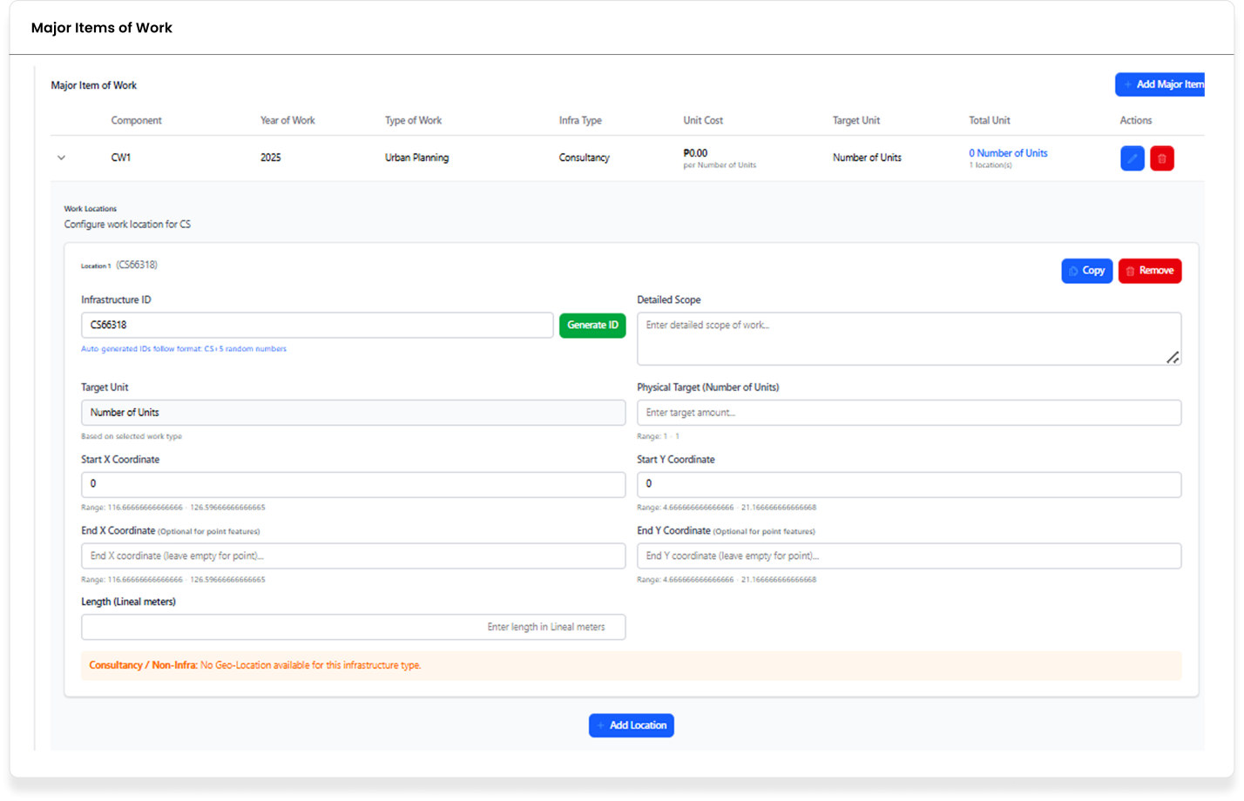
Purpose
Configure the major items of work for infrastructure projects related to consultancy, including defining physical targets, coordinates, and detailed scope.
Who uses this
This screen is available to authorized MYPS users with access to the module.
Prerequisites
Before using this screen, ensure that:
• You are signed in to MYPS Web.
• You have access to the relevant infrastructure project.
• You have the required permissions to add or edit major items of work for consultancy-related projects.

Field Reference
No. | Fields/Blocks/Objects | Description | Values / Actions
UI-UX-0045-01 | INFRASTRUCTURE ID | A unique identifier for the infrastructure entry. | A text field to input or auto-generate the ID.
UI-UX-0045-02 | GENERATE ID | Button to auto-generate the Infrastructure ID. | Action: Click to generate a unique ID in the format "CS" followed by random numbers.
UI-UX-0045-03 | DETAILED SCOPE | A field to input a description of the work involved. | Text input field to provide a detailed scope of the project.
UI-UX-0045-04 | TARGET UNIT | Defines the unit type for the work. | Drop-down or text field to select the unit, e.g., "Number of Units."
UI-UX-0045-05 | PHYSICAL TARGET (Number of Units) | Specifies the number of units for the physical target. | A numerical input field to define the target amount (range 1-1).
UI-UX-0045-06 | START COORDINATES X | X-coordinate of the starting point. | Text input for the start X coordinate (numeric values).
UI-UX-0045-07 | START COORDINATES Y | Y-coordinate of the starting point. | Text input for the start Y coordinate (numeric values).
UI-UX-0045-07 | END X COORDINATES | X-coordinate of the endpoint. | Optional text input for the end X coordinate (numeric values).
UI-UX-0045-08 | END Y COORDINATES | Y-coordinate of the endpoint. | Optional text input for the end Y coordinate (numeric values).
UI-UX-0045-08 | LENGTH (LINEAR METERS) | The length of the work in linear meters. | Text input to enter the length in meters.
UI-UX-0045-09 | ADD LOCATION | Button to add a new location. | Action: Click to add a location for the infrastructure.

Step-by-Step: Major Items of Work Configuration for Consultancy
1.) Open the Major Items of Work screen
- Navigate to the program or project where the consultancy work needs to be configured.
2.) Generate or enter Infrastructure ID
- If the infrastructure ID is not already provided, click the Generate ID button to auto-generate a unique ID. Alternatively, you can manually enter the infrastructure ID in the INFRASTRUCTURE ID field.
3.) Enter Target Unit
- In the TARGET UNIT field, select or enter the unit of measurement for the work (e.g., “Number of Units”).
4.) Define the Physical Target (Number of Units)
- In the PHYSICAL TARGET (Number of Units) field, enter the target number of units for the work, such as “100 units”.
5.) Enter the Coordinates
- Enter the START COORDINATES X and START COORDINATES Y for the starting point of the work.
- Enter the END X COORDINATES and END Y COORDINATES for the ending point of the work (if available).
Example valid entries:
- Start Coordinates X: 12.34567
- Start Coordinates Y: 98.76543
- End Coordinates X: 12.67890
- End Coordinates Y: 98.87654
Invalid entries: Coordinates with incorrect format or missing values.
6.) Enter the Length of the Work
- In the LENGTH (Linear meters) field, input the length of the work in meters (e.g., “500 meters”).
7.) Add Detailed Scope of Work
- In the DETAILED SCOPE field, provide a detailed description of the work to be done.
8.) Add Location
- Click the ADD LOCATION button to open the location input form. Fill in the relevant geographical information (e.g., region, city, district) for the work.
9.) Consultancy/Non-Infrastructure Configuration
- The Consultancy / Non-Infrastructure field will be selected automatically based on the work type. If it's a consultancy project, this option will disable geo-location entry.
10.) Save and Review
- After entering all necessary details, click Save (if available) or review the work location and details to ensure they are correctly configured.
On Success
• The Major Items of Work configuration for the consultancy project will be successfully saved and linked to the infrastructure project.
• Verify the Infrastructure ID, coordinates, target units, and scope details on the form.
• If any information is incorrect or missing, return to the respective field to make corrections.
Common Outcomes & What to Do
Message / Situation | What it Means | What You Should Do
"Invalid input in Coordinates" | The coordinates entered are not in the correct format or out of range. | Ensure the coordinates are numeric and within the valid range.
"Target Unit is required" | No target unit selected. | Select or enter a unit of measurement for the work.
"Length field is required" | The length of the work in linear meters is missing. | Enter a valid numeric value for the length.

Major Items of Work, Infra Type, Flood Control Structures (UI-UX-0046)
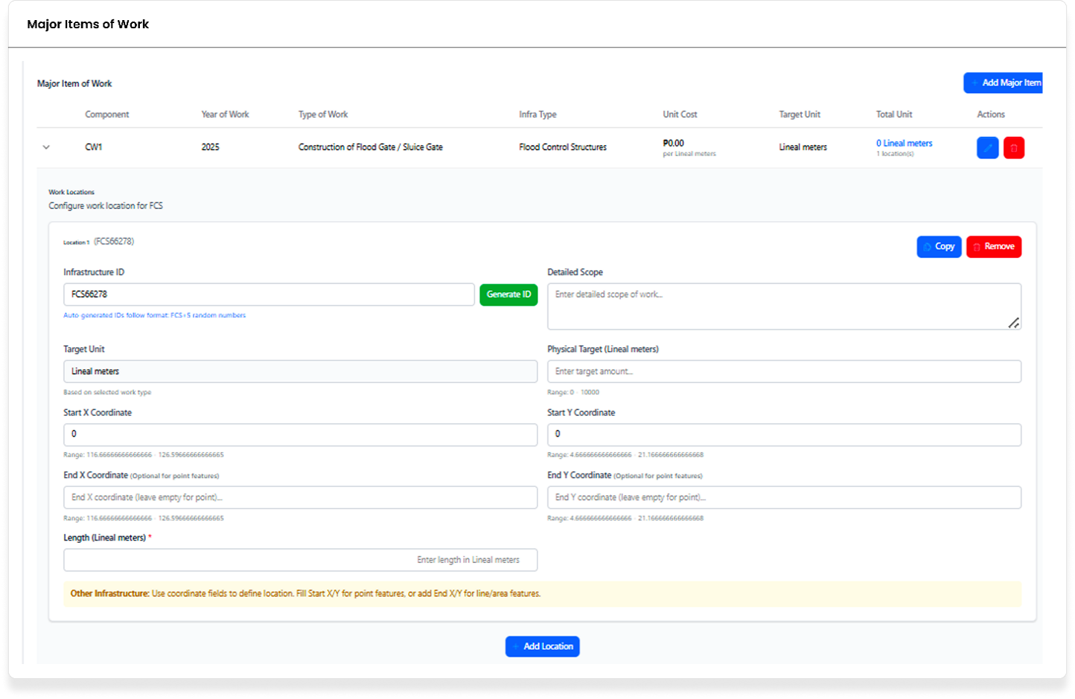
Purpose
Configure the major items of work for infrastructure projects related to flood control structures, including defining physical targets, coordinates, and detailed scope.
Who uses this
This screen is available to authorized MYPS users with access to the module.
Prerequisites
Before using this screen, ensure that:
• You are signed in to MYPS Web.
• You have access to the relevant infrastructure project.
• You have the required permissions to add or edit major items of work for flood control structures.

Field Reference
No. | Fields/Blocks/Objects | Description | Values / Actions
UI-UX-0046-01 | INFRASTRUCTURE ID | Unique identifier for the infrastructure entry. | A text field for entering or generating the Infrastructure ID (e.g., "FCS66278").
UI-UX-0046-02 | GENERATE ID | Button to generate a unique Infrastructure ID. | Action: Click to auto-generate the ID following the "FCS-####" format.
UI-UX-0046-03 | DETAILED SCOPE | A field to describe the work involved. | Text input for entering the detailed scope of the work.
UI-UX-0046-04 | TARGET UNIT | Defines the unit type for the work. | Drop-down or text input to specify unit type (e.g., "Lineal meters").
UI-UX-0046-05 | PHYSICAL TARGET (Lineal meters) | Specifies the target number of units (lineal meters). | Numeric input for defining the target value (range: 0 - 10,000).
UI-UX-0046-06 | START COORDINATES X | X-coordinate of the start location. | Text input for the start X coordinate (numeric values).
UI-UX-0046-07 | START COORDINATES Y | Y-coordinate of the start location. | Text input for the start Y coordinate (numeric values).
UI-UX-0046-08 | END X COORDINATES | X-coordinate of the end location. | Optional input for the end X coordinate (numeric values).
UI-UX-0046-09 | END Y COORDINATES | Y-coordinate of the end location. | Optional input for the end Y coordinate (numeric values).
UI-UX-0046-10 | LENGTH (LINEAL METERS) | Specifies the length of the work in linear meters. | Text input for entering the length of the work (linear meters).
UI-UX-0046-11 | ADD LOCATION | Button to add a new location to the infrastructure. | Action: Click to add the location data for the infrastructure.

Step-by-Step: Major Items of Work Configuration for Flood Control Structures
1.) Open the Major Items of Work screen
- Navigate to the program or project where the flood control infrastructure work needs to be configured.
2.) Generate or enter Infrastructure ID
- If the infrastructure ID is not already provided, click the Generate ID button to auto-generate a unique ID. Alternatively, you can manually enter the infrastructure ID in the INFRASTRUCTURE ID field.
3.) Enter Target Unit
- In the TARGET UNIT field, select or enter the unit of measurement for the work (e.g., “Linear meters”).
4.) Define the Physical Target (Linear meters)
- In the PHYSICAL TARGET (Linear meters) field, enter the target length for the work, such as “500 meters”.
5.) Enter the Coordinates
- Enter the START COORDINATES X and START COORDINATES Y for the starting point of the work.
- Enter the END X COORDINATES and END Y COORDINATES for the ending point of the work (if applicable).
Example valid entries:
- Start Coordinates X: 12.34567
- Start Coordinates Y: 98.76543
- End Coordinates X: 12.67890
- End Coordinates Y: 98.87654
Invalid entries: Coordinates with incorrect format or missing values.
6.) Enter the Length of the Work
- In the LENGTH (Linear meters) field, input the length of the work in meters (e.g., “500 meters”).
7.) Add Detailed Scope of Work
- In the DETAILED SCOPE field, provide a detailed description of the work to be done.
8.) Add Location
- Click the ADD LOCATION button to open the location input form. Fill in the relevant geographical information (e.g., region, city, district) for the work.
9.) Flood Control Structure Automatic Values
- The Flood Control Structure section will automatically populate the Length (Linear meters) and Target Unit (Linear meters) fields based on the selected flood control structure type.
10.) Save and Review
- After entering all necessary details, click Save (if available) or review the work location and details to ensure they are correctly configured.
On Success
• The Major Items of Work configuration for the flood control structure will be successfully saved and linked to the infrastructure project.
• Verify the Infrastructure ID, coordinates, target units, and scope details on the form.
• If any information is incorrect or missing, return to the respective field to make corrections.
Common Outcomes & What to Do
Message / Situation | What it Means | What You Should Do
"Invalid input in Coordinates" | The coordinates entered are not in the correct format or out of range. | Ensure the coordinates are numeric and within the valid range.
"Target Unit is required" | No target unit selected. | Select or enter a unit of measurement for the work.
"Length field is required" | The length of the work in linear meters is missing. | Enter a valid numeric value for the length.

Major Items of Work, Infra Type, Hospitals (UI-UX-0047)
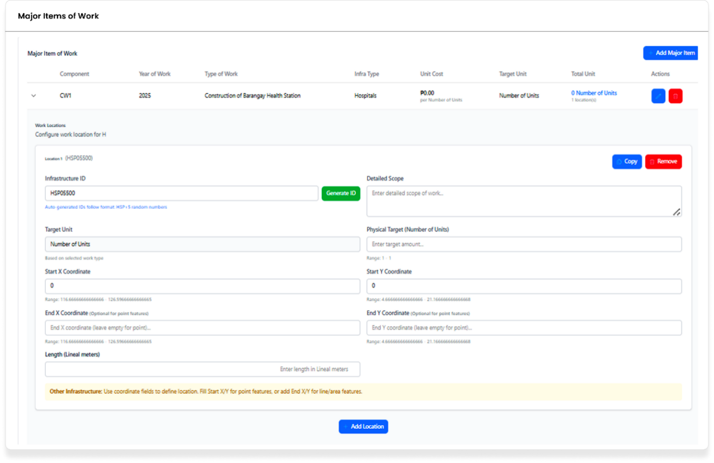
Purpose
Configure the major items of work for infrastructure projects related to hospitals, including defining physical targets, coordinates, and detailed scope.
Who uses this
This screen is available to authorized MYPS users with access to the module.
Prerequisites
Before using this screen, ensure that:
• You are signed in to MYPS Web.
• You have access to the relevant infrastructure project.
• You have the required permissions to add or edit major items of work for hospital-related projects.

Field Reference
No. | Fields/Blocks/Objects | Description | Values / Actions
UI-UX-0047-01 | INFRASTRUCTURE ID | Unique identifier for the infrastructure entry. | A text field to input or auto-generate the Infrastructure ID (e.g., "HSP05050").
UI-UX-0047-02 | GENERATE ID | Button to auto-generate the Infrastructure ID. | Action: Click to generate a unique ID following the "HSP-####" format.
UI-UX-0047-03 | DETAILED SCOPE | A field to describe the work involved. | Text input for entering the detailed scope of the project (e.g., construction details).
UI-UX-0047-04 | TARGET UNIT | Defines the unit type for the work. | Drop-down or text input to specify unit type (e.g., "Number of Units").
UI-UX-0047-05 | PHYSICAL TARGET (Number of Units) | Specifies the target number of units (for hospitals). | Numeric input for defining the target number of units (range: 1-1).
UI-UX-0047-06 | START COORDINATES X | X-coordinate of the start location. | Text input for the start X coordinate (numeric values).
UI-UX-0047-07 | START COORDINATES Y | Y-coordinate of the start location. | Text input for the start Y coordinate (numeric values).
UI-UX-0047-08 | END X COORDINATES | X-coordinate of the end location. | Optional input for the end X coordinate (numeric values).
UI-UX-0047-09 | END Y COORDINATES | Y-coordinate of the end location. | Optional input for the end Y coordinate (numeric values).
UI-UX-0047-10 | LENGTH (LINEAL METERS) | Specifies the length of the work in linear meters. | Text input for entering the length of the work (in linear meters).
UI-UX-0047-11 | ADD LOCATION | Button to add a new location to the infrastructure. | Action: Click to add location data for the hospital infrastructure.

Step-by-Step: Major Items of Work Configuration for Hospitals
1.) Open the Major Items of Work screen
- Navigate to the program or project where the hospital infrastructure work needs to be configured.
2.) Generate or enter Infrastructure ID
- If the infrastructure ID is not already provided, click the Generate ID button to auto-generate a unique ID. Alternatively, you can manually enter the infrastructure ID in the INFRASTRUCTURE ID field.
3.) Enter Target Unit
- In the TARGET UNIT field, select or enter the unit of measurement for the work (e.g., “Number of Units”).
4.) Define the Physical Target (Number of Units)
- In the PHYSICAL TARGET (Number of Units) field, enter the target number of units for the work, such as “100 units”.
5.) Enter the Coordinates
- Enter the START COORDINATES X and START COORDINATES Y for the starting point of the work.
- Enter the END X COORDINATES and END Y COORDINATES for the ending point of the work (if applicable).
Example valid entries:
- Start Coordinates X: 12.34567
- Start Coordinates Y: 98.76543
- End Coordinates X: 12.67890
- End Coordinates Y: 98.87654
Invalid entries: Coordinates with incorrect format or missing values.
6.) Enter the Length of the Work
- In the LENGTH (Linear meters) field, input the length of the work in meters (e.g., “500 meters”).
7.) Add Detailed Scope of Work
- In the DETAILED SCOPE field, provide a detailed description of the work to be done.
8.) Add Location
- Click the ADD LOCATION button to open the location input form. Fill in the relevant geographical information (e.g., region, city, district) for the work.
9.) Hospital Infrastructure Automatic Values
- The Hospital Infrastructure section will automatically populate the Length (Linear meters) and Target Unit (Number of Units) fields based on the selected hospital infrastructure type.
10.) Save and Review
- After entering all necessary details, click Save (if available) or review the work location and details to ensure they are correctly configured.
On Success
• The Major Items of Work configuration for the hospital will be successfully saved and linked to the infrastructure project.
• Verify the Infrastructure ID, coordinates, target units, and scope details on the form.
• If any information is incorrect or missing, return to the respective field to make corrections.

Common Outcomes & What to Do
Message / Situation | What it Means | What You Should Do
"Invalid input in Coordinates" | The coordinates entered are not in the correct format or out of range. | Ensure the coordinates are numeric and within the valid range.
"Target Unit is required" | No target unit selected. | Select or enter a unit of measurement for the work.
"Length field is required" | The length of the work in linear meters is missing. | Enter a valid numeric value for the length.

Major Items of Work Infra Type, Local Bridges (UI-UX-0048)
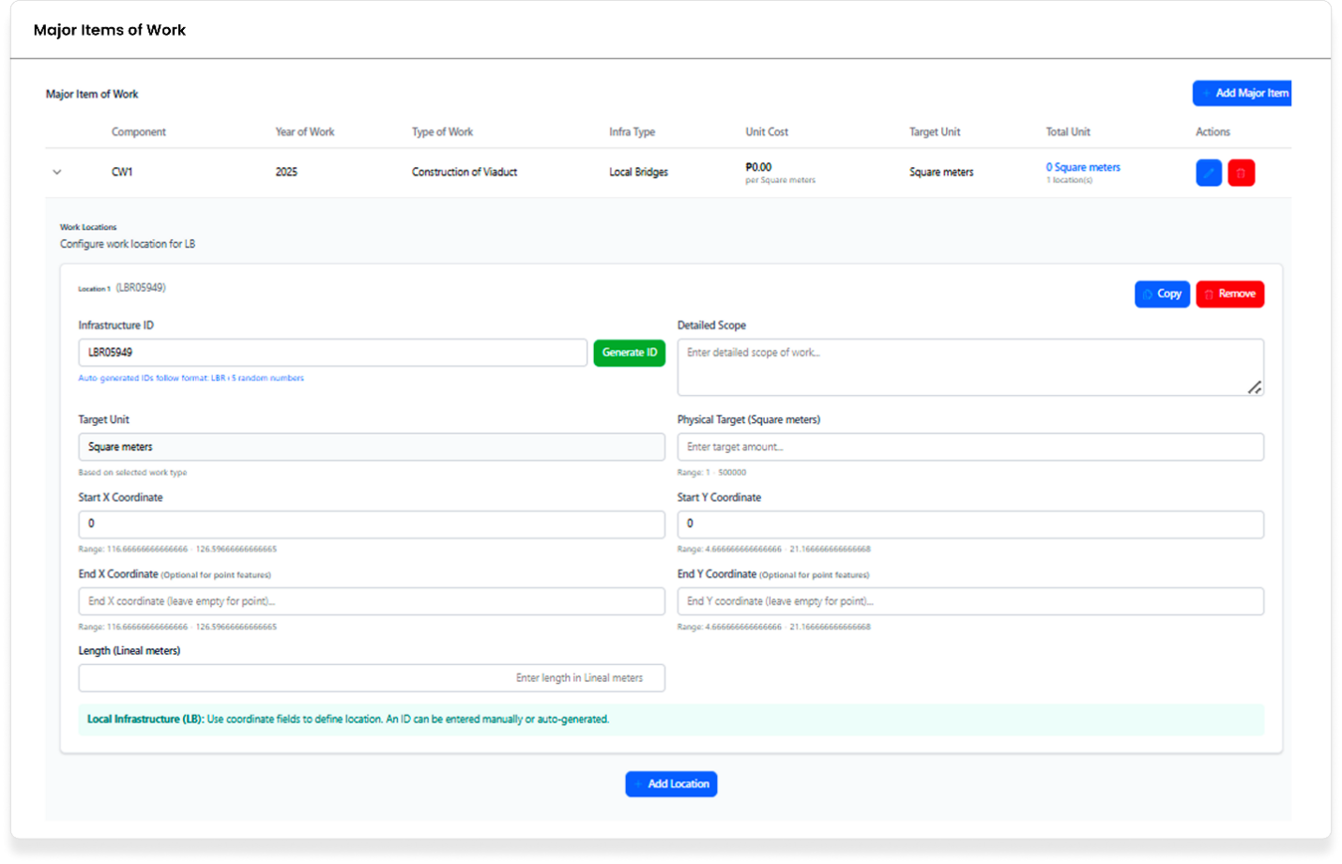
Purpose
Configure the major items of work for local bridge infrastructure projects, including defining physical targets, coordinates, and detailed scope of work.
Who uses this
This screen is available to authorized MYPS users with access to the module.
Prerequisites
Before using this screen, ensure that:
• You are signed in to MYPS Web.
• You have access to the relevant local bridge project.
• You have the required permissions to add or edit major items of work for local bridge projects.

Field Reference
No. | Fields/Blocks/Objects | Description | Values / Actions
UI-UX-0048-01 | INFRASTRUCTURE ID | Unique identifier for the infrastructure entry. | A text field to input or auto-generate the Infrastructure ID (e.g., "LBR09549").
UI-UX-0048-02 | GENERATE ID | Button to auto-generate the Infrastructure ID. | Action: Click to generate a unique ID following the "LBR-####" format.
UI-UX-0048-03 | DETAILED SCOPE | A field to describe the work involved. | Text input for entering the detailed scope of the project (e.g., construction details for a bridge).
UI-UX-0048-04 | TARGET UNIT | Defines the unit type for the work. | Drop-down or text input to specify unit type (e.g., "Square meters").
UI-UX-0048-05 | PHYSICAL TARGET (Square meters) | Specifies the target number of units in square meters. | Numeric input for defining the target number of units (range: 1 - 500,000).
UI-UX-0048-06 | START COORDINATES X | X-coordinate of the start location. | Text input for the start X coordinate (numeric values).
UI-UX-0048-07 | START COORDINATES Y | Y-coordinate of the start location. | Text input for the start Y coordinate (numeric values).
UI-UX-0048-08 | END X COORDINATES | X-coordinate of the end location. | Optional input for the end X coordinate (numeric values).
UI-UX-0048-09 | END Y COORDINATES | Y-coordinate of the end location. | Optional input for the end Y coordinate (numeric values).
UI-UX-0048-10 | LENGTH (LINEAL METERS) | Specifies the length of the work in linear meters. | Text input for entering the length of the work (in linear meters).
UI-UX-0048-11 | ADD LOCATION | Button to add a new location to the infrastructure. | Action: Click to add the location data for the local bridge infrastructure.

Step-by-Step: Major Items of Work Configuration for Local Bridges
1.) Open the Major Items of Work screen
- Navigate to the program or project where the local bridge infrastructure work needs to be configured.
2.) Generate or enter Infrastructure ID
- If the infrastructure ID is not already provided, click the Generate ID button to auto-generate a unique ID. Alternatively, you can manually enter the infrastructure ID in the INFRASTRUCTURE ID field.
3.) Enter Target Unit
- In the TARGET UNIT field, select or enter the unit of measurement for the work (e.g., “Square meters”).
4.) Define the Physical Target (Square meters)
- In the PHYSICAL TARGET (Square meters) field, enter the target number of square meters for the work, such as “1000 square meters”.
5.) Enter the Coordinates
- Enter the START COORDINATES X and START COORDINATES Y for the starting point of the work.
- Enter the END X COORDINATES and END Y COORDINATES for the ending point of the work (if applicable).
Example valid entries:
- Start Coordinates X: 12.34567
- Start Coordinates Y: 98.76543
- End Coordinates X: 12.67890
- End Coordinates Y: 98.87654
Invalid entries: Coordinates with incorrect format or missing values.
6.) Enter the Length of the Work
- In the LENGTH (Linear meters) field, input the length of the work in meters (e.g., “500 meters”).
7.) Add Detailed Scope of Work
- In the DETAILED SCOPE field, provide a detailed description of the work to be done.
8.) Add Location
- Click the ADD LOCATION button to open the location input form. Fill in the relevant geographical information (e.g., region, city, district) for the work.
9.) Local Infrastructure Automatic Values
- The Local Infrastructure section will automatically populate the Length (Linear meters) and Target Unit (Square meters) fields based on the selected local bridge infrastructure type.
10.) Save and Review
- After entering all necessary details, click Save (if available) or review the work location and details to ensure they are correctly configured.
On Success
• The Major Items of Work configuration for the local bridge will be successfully saved and linked to the infrastructure project.
• Verify the Infrastructure ID, coordinates, target units, and scope details on the form.
• If any information is incorrect or missing, return to the respective field to make corrections.
Common Outcomes & What to Do
Message / Situation | What it Means | What You Should Do
"Invalid input in Coordinates" | The coordinates entered are not in the correct format or out of range. | Ensure the coordinates are numeric and within the valid range.
"Target Unit is required" | No target unit selected. | Select or enter a unit of measurement for the work.
"Length field is required" | The length of the work in linear meters is missing. | Enter a valid numeric value for the length.

Major Items of Work, Infra Type, Local Flood Control Structures (UI-UX-0049)
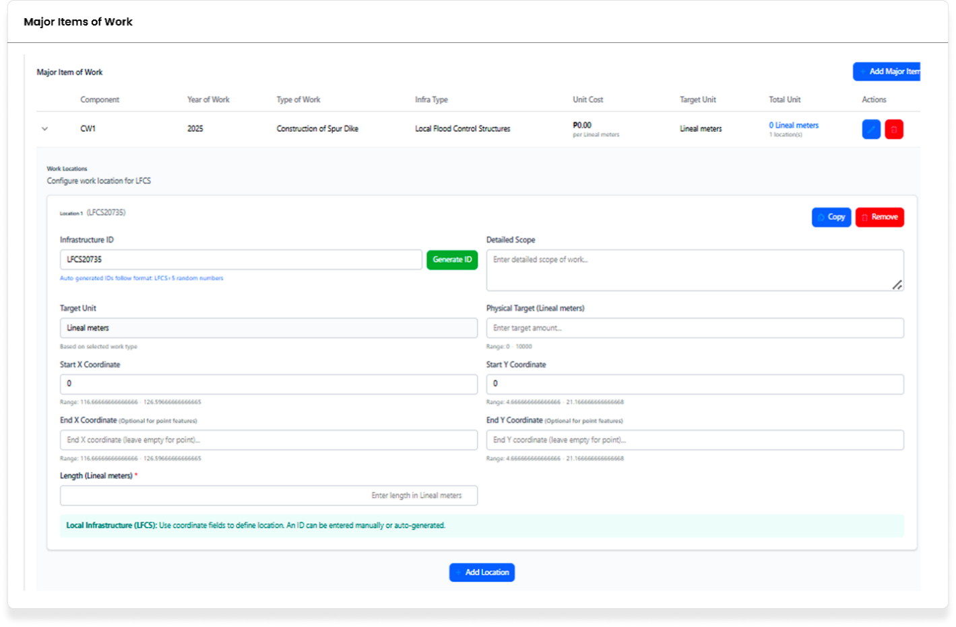
Purpose
Configure the major items of work for infrastructure projects related to local flood control structures, including defining physical targets, coordinates, and detailed scope of work.
Who uses this
This screen is available to authorized MYPS users with access to the module.

Prerequisites
Before using this screen, ensure that:
• You are signed in to MYPS Web.
• You have access to the relevant local flood control infrastructure project.
• You have the required permissions to add or edit major items of work for local flood control structures.
Field Reference
No. | Fields/Blocks/Objects | Description | Values / Actions
UI-UX-0049-01 | INFRASTRUCTURE ID | Unique identifier for the infrastructure entry. | Text field to input or auto-generate the Infrastructure ID (e.g., "LBR09549").
UI-UX-0049-02 | GENERATE ID | Button to auto-generate the Infrastructure ID. | Action: Click to generate a unique ID following the "LBR-####" format.
UI-UX-0049-03 | DETAILED SCOPE | A field to describe the work involved. | Text input for entering the detailed scope of the project (e.g., construction details for a bridge).
UI-UX-0049-04 | TARGET UNIT | Defines the unit type for the work. | Drop-down or text input to specify unit type (e.g., "Square meters").
UI-UX-0049-05 | PHYSICAL TARGET (SQUARE METERS) | Specifies the target number of units in square meters. | Numeric input for defining the target number of units (range: 1 - 500,000).
UI-UX-0049-06 | START COORDINATES X | X-coordinate of the start location. | Text input for the start X coordinate (numeric values).
UI-UX-0049-07 | START COORDINATES Y | Y-coordinate of the start location. | Text input for the start Y coordinate (numeric values).
UI-UX-0049-08 | END X COORDINATES | X-coordinate of the end location. | Optional input for the end X coordinate (numeric values).
UI-UX-0049-09 | END Y COORDINATES | Y-coordinate of the end location. | Optional input for the end Y coordinate (numeric values).
UI-UX-0049-10 | LENGTH (LINEAL METERS) | Specifies the length of the work in linear meters. | Text input for entering the length of the work (in linear meters).
UI-UX-0049-11 | ADD LOCATION | Button to add a new location to the infrastructure. | Action: Click to add the location data for the local bridge infrastructure.

Step-by-Step: Major Items of Work Configuration for Local Flood Control Structures
1.) Open the Major Items of Work screen
- Navigate to the program or project where the local flood control infrastructure work needs to be configured.
2.) Generate or enter Infrastructure ID
- If the infrastructure ID is not already provided, click the Generate ID button to auto-generate a unique ID. Alternatively, you can manually enter the infrastructure ID in the INFRASTRUCTURE ID field.
3.) Enter Target Unit
- In the TARGET UNIT field, select or enter the unit of measurement for the work (e.g., “Linear meters”).
4.) Define the Physical Target (Linear meters)
- In the PHYSICAL TARGET (Linear meters) field, enter the target length for the work, such as “500 meters”.
5.) Enter the Coordinates
- Enter the START COORDINATES X and START COORDINATES Y for the starting point of the work.
- Enter the END X COORDINATES and END Y COORDINATES for the ending point of the work (if applicable).
Example valid entries:
- Start Coordinates X: 12.34567
- Start Coordinates Y: 98.76543
- End Coordinates X: 12.67890
- End Coordinates Y: 98.87654
Invalid entries: Coordinates with incorrect format or missing values.
6.) Enter the Length of the Work
- In the LENGTH (Linear meters) field, input the length of the work in meters (e.g., “500 meters”).
7.) Add Detailed Scope of Work
- In the DETAILED SCOPE field, provide a detailed description of the work to be done.
8.) Add Location
- Click the ADD LOCATION button to open the location input form. Fill in the relevant geographical information (e.g., region, city, district) for the work.
9.) Local Infrastructure Automatic Values
- The Local Infrastructure section will automatically populate the Length (Linear meters) and Target Unit (Linear meters) fields based on the selected local flood control infrastructure type.
10.) Save and Review
- After entering all necessary details, click Save (if available) or review the work location and details to ensure they are correctly configured.
On Success
• The Major Items of Work configuration for the local flood control structure will be successfully saved and linked to the infrastructure project.
• Verify the Infrastructure ID, coordinates, target units, and scope details on the form.
• If any information is incorrect or missing, return to the respective field to make corrections.
Common Outcomes & What to Do
Message / Situation | What it Means | What You Should Do
"Invalid input in Coordinates" | The coordinates entered are not in the correct format or out of range. | Ensure the coordinates are numeric and within the valid range.
"Target Unit is required" | No target unit selected. | Select or enter a unit of measurement for the work.
"Length field is required" | The length of the work in linear meters is missing. | Enter a valid numeric value for the length.

Major Items of Work, Infra Type, Local Roads (UI-UX-0050)
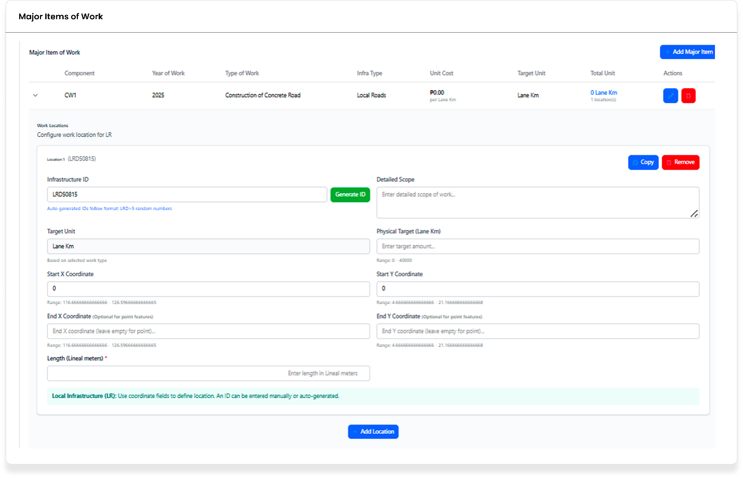
Purpose
Configure the major items of work for infrastructure projects related to local roads, including defining physical targets, coordinates, and detailed scope of work.
Who uses this
This screen is available to authorized MYPS users with access to the module.
Prerequisites
Before using this screen, ensure that:
• You are signed in to MYPS Web.
• You have access to the relevant local road project.
• You have the required permissions to add or edit major items of work for local roads.

Field Reference
No. | Fields/Blocks/Objects | Description | Values / Actions
UI-UX-0050-01 | INFRASTRUCTURE ID | Unique identifier for the infrastructure entry. | Text field to input or auto-generate the Infrastructure ID (e.g., "LCR11234").
UI-UX-0050-02 | GENERATE ID | Button to auto-generate the Infrastructure ID. | Action: Click to generate a unique ID following the "LCR-####" format.
UI-UX-0050-03 | DETAILED SCOPE | A field to describe the work involved. | Text input for entering the detailed scope of the project (e.g., construction details for local roads).
UI-UX-0050-04 | TARGET UNIT | Defines the unit type for the work. | Drop-down or text input to specify unit type (e.g., "Lane Km").
UI-UX-0050-05 | PHYSICAL TARGET (SQUARE METERS) | Specifies the target number of units in lane kilometers. | Numeric input for defining the target number of units (range: 1 - 500,000).
UI-UX-0050-06 | START COORDINATES X | X-coordinate of the start location. | Text input for the start X coordinate (numeric values).
UI-UX-0050-07 | START COORDINATES Y | Y-coordinate of the start location. | Text input for the start Y coordinate (numeric values).
UI-UX-0050-08 | END X COORDINATES | X-coordinate of the end location. | Optional input for the end X coordinate (numeric values).
UI-UX-0050-09 | END Y COORDINATES | Y-coordinate of the end location. | Optional input for the end Y coordinate (numeric values).
UI-UX-0050-10 | LENGTH (LINEAL METERS) | Specifies the length of the work in linear meters. | Text input for entering the length of the work (in linear meters).
UI-UX-0050-11 | ADD LOCATION | Button to add a new location to the infrastructure. | Action: Click to add the location data for the local road’s infrastructure.

Step-by-Step: Major Items of Work Configuration for Local Roads
1.) Open the Major Items of Work screen
- Navigate to the program or project where the local road infrastructure work needs to be configured.
2.) Generate or enter Infrastructure ID
- If the infrastructure ID is not already provided, click the Generate ID button to auto-generate a unique ID. Alternatively, you can manually enter the infrastructure ID in the INFRASTRUCTURE ID field.
3.) Enter Target Unit
- In the TARGET UNIT field, select or enter the unit of measurement for the work (e.g., “Lane Km”).
4.) Define the Physical Target (Lane Km)
- In the PHYSICAL TARGET (Lane Km) field, enter the target length for the work, such as “10 Lane Km”.
5.) Enter the Coordinates
- Enter the START COORDINATES X and START COORDINATES Y for the starting point of the work.
- Enter the END X COORDINATES and END Y COORDINATES for the ending point of the work (if applicable).
Example valid entries:
- Start Coordinates X: 12.34567
- Start Coordinates Y: 98.76543
- End Coordinates X: 12.67890
- End Coordinates Y: 98.87654
Invalid entries: Coordinates with incorrect format or missing values.
6.) Enter the Length of the Work
- In the LENGTH (Linear meters) field, input the length of the work in meters (e.g., “1000 meters”).
7.) Add Detailed Scope of Work
- In the DETAILED SCOPE field, provide a detailed description of the work to be done.
8.) Add Location
- Click the ADD LOCATION button to open the location input form. Fill in the relevant geographical information (e.g., region, city, district) for the work.
9.) Local Infrastructure Automatic Values
- The Local Infrastructure section will automatically populate the Length (Linear meters) and Target Unit (Lane Km) fields based on the selected local road infrastructure type.
10.) Save and Review
- After entering all necessary details, click Save (if available) or review the work location and details to ensure they are correctly configured.
On Success
• The Major Items of Work configuration for the local road infrastructure will be successfully saved and linked to the infrastructure project.
• Verify the Infrastructure ID, coordinates, target units, and scope details on the form.
• If any information is incorrect or missing, return to the respective field to make corrections.
Common Outcomes & What to Do
Message / Situation | What it Means | What You Should Do
"Invalid input in Coordinates" | The coordinates entered are not in the correct format or out of range. | Ensure the coordinates are numeric and within the valid range.

Major Items of Work, Infra Type, Multi-Purpose Buildings (UI-UX-0051)
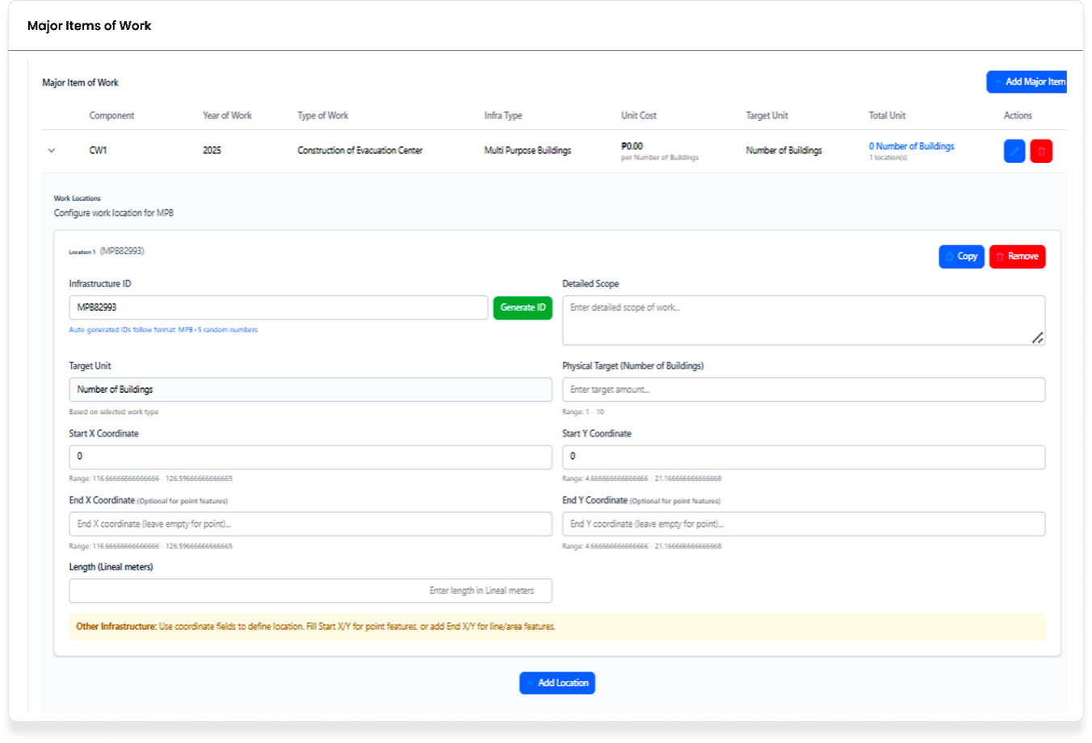
Purpose
Configure the major items of work for infrastructure projects related to multi-purpose buildings, including defining physical targets, coordinates, and detailed scope of work.
Who uses this
This screen is available to authorized MYPS users with access to the module.
Prerequisites
Before using this screen, ensure that:
• You are signed in to MYPS Web.
• You have access to the relevant multi-purpose building project.
• You have the required permissions to add or edit major items of work for multi-purpose building projects.

Field Reference
No. | Fields/Blocks/Objects | Description | Values / Actions
UI-UX-0051-01 | INFRASTRUCTURE ID | Unique identifier for the infrastructure entry. | Text field to input or auto-generate the Infrastructure ID (e.g., "LCR11234").
UI-UX-0051-02 | GENERATE ID | Button to auto-generate the Infrastructure ID. | Action: Click to generate a unique ID following the "LCR-####" format.
UI-UX-0051-03 | DETAILED SCOPE | A field to describe the work involved. | Text input for entering the detailed scope of the project (e.g., construction details for local roads).
UI-UX-0051-04 | TARGET UNIT | Defines the unit type for the work. | Drop-down or text input to specify unit type (e.g., "Lane Km").
UI-UX-0051-05 | PHYSICAL TARGET (SQUARE METERS) | Specifies the target number of units in lane kilometers. | Numeric input for defining the target number of units (range: 1 - 500,000).
UI-UX-0051-06 | START COORDINATES X | X-coordinate of the start location. | Text input for the start X coordinate (numeric values).
UI-UX-0051-07 | START COORDINATES Y | Y-coordinate of the start location. | Text input for the start Y coordinate (numeric values).
UI-UX-0051-08 | END X COORDINATES | X-coordinate of the end location. | Optional input for the end X coordinate (numeric values).
UI-UX-0051-09 | END Y COORDINATES | Y-coordinate of the end location. | Optional input for the end Y coordinate (numeric values).
UI-UX-0051-10 | LENGTH (LINEAL METERS) | Specifies the length of the work in linear meters. | Text input for entering the length of the work (in linear meters).
UI-UX-0051-11 | ADD LOCATION | Button to add a new location to the infrastructure. | Action: Click to add the location data for the local roads infrastructure.

Step-by-Step: Major Items of Work Configuration for Multi-Purpose Buildings
1.) Open the Major Items of Work screen
- Navigate to the program or project where the multi-purpose building infrastructure work needs to be configured.
2.) Generate or enter Infrastructure ID
- If the infrastructure ID is not already provided, click the Generate ID button to auto-generate a unique ID. Alternatively, you can manually enter the infrastructure ID in the INFRASTRUCTURE ID field.
3.) Enter Target Unit
- In the TARGET UNIT field, select or enter the unit of measurement for the work (e.g., “Number of Buildings”).
4.) Define the Physical Target (Number of Buildings)
- In the PHYSICAL TARGET (Number of Buildings) field, enter the target number of buildings for the work, such as “5 buildings”.
5.) Enter the Coordinates
- Enter the START COORDINATES X and START COORDINATES Y for the starting point of the work.
- Enter the END X COORDINATES and END Y COORDINATES for the ending point of the work (if applicable).
Example valid entries:
- Start Coordinates X: 12.34567
- Start Coordinates Y: 98.76543
- End Coordinates X: 12.67890
- End Coordinates Y: 98.87654
Invalid entries: Coordinates with incorrect format or missing values.
6.) Enter the Length of the Work
- In the LENGTH (Linear meters) field, input the length of the work in meters (e.g., “500 meters”).
7.) Add Detailed Scope of Work
- In the DETAILED SCOPE field, provide a detailed description of the work to be done.
8.) Add Location
- Click the ADD LOCATION button to open the location input form. Fill in the relevant geographical information (e.g., region, city, district) for the work.
9.) Multi-Purpose Building Infrastructure Automatic Values
- The Multi-Purpose Building Infrastructure section will automatically populate the Length (Linear meters) and Target Unit (Number of Buildings) fields based on the selected multi-purpose building infrastructure type.
10.) Save and Review
- After entering all necessary details, click Save (if available) or review the work location and details to ensure they are correctly configured.
On Success
• The Major Items of Work configuration for the multi-purpose building will be successfully saved and linked to the infrastructure project.
• Verify the Infrastructure ID, coordinates, target units, and scope details on the form.
• If any information is incorrect or missing, return to the respective field to make corrections.
Common Outcomes & What to Do
Message / Situation | What it Means | What You Should Do
"Invalid input in Coordinates" | The coordinates entered are not in the correct format or out of range. | Ensure the coordinates are numeric and within the valid range.

Major Items of Work, Infra Type, Non-Infra (UI-UX-0052)
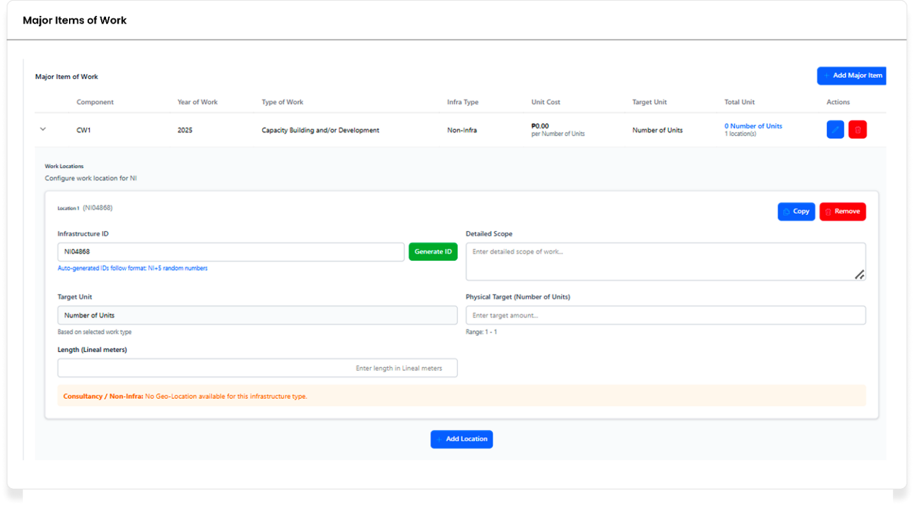
Purpose
Configure the major items of work for non-infrastructure projects, including defining physical targets, coordinates, and detailed scope of work.
Who uses this
This screen is available to authorized MYPS users with access to the module.
Prerequisites
Before using this screen, ensure that:
• You are signed in to MYPS Web.
• You have access to the relevant non-infrastructure project.
• You have the required permissions to add or edit major items of work for non-infrastructure projects.

Field Reference
No. | Fields/Blocks/Objects | Description | Values / Actions
UI-UX-0052-01 | INFRASTRUCTURE ID | Unique identifier for the infrastructure entry. | A text field to input or auto-generate the Infrastructure ID (e.g., “NINF00123”).
UI-UX-0052-02 | GENERATE ID | Button to auto-generate the Infrastructure ID. | Action: Click to generate a unique ID following the “NINF-####” format.
UI-UX-0052-03 | DETAILED SCOPE | A field to describe the work involved. | Text input for entering the detailed scope of the project (e.g., development of a new infrastructure or service).
UI-UX-0052-04 | TARGET UNIT | Defines the unit type for the work. | Drop-down or text input to specify unit type (e.g., “Number of Units”).
UI-UX-0052-05 | PHYSICAL TARGET (NUMBER OF UNITS) | Specifies the target number of units. | Numeric input for defining the target number of units (range: 1 – 100).
UI-UX-0052-06 | START COORDINATES X | X-coordinate of the start location. | Text input for the start X coordinate (numeric values).
UI-UX-0052-07 | START COORDINATES Y | Y-coordinate of the start location. | Text input for the start Y coordinate (numeric values).
UI-UX-0052-08 | END X COORDINATES | X-coordinate of the end location. | Optional input for the end X coordinate (numeric values).
UI-UX-0052-09 | END Y COORDINATES | Y-coordinate of the end location. | Optional input for the end Y coordinate (numeric values).
UI-UX-0052-10 | LENGTH (LINEAL METERS) | Specifies the length of the work in linear meters. | Text input for entering the length of the work (in linear meters).
UI-UX-0052-11 | ADD LOCATION | Button to add a new location to the infrastructure. | Action: Click to add the location data for the non-infrastructure work.

Step-by-Step: Major Items of Work Configuration for Non-Infrastructure Projects
- Open the Major Items of Work screen
- Navigate to the program or project where the non-infrastructure work needs to be configured.
- Generate or enter Infrastructure ID
- If the infrastructure ID is not already provided, click the Generate ID button to auto-generate a unique ID. Alternatively, you can manually enter the infrastructure ID in the INFRASTRUCTURE ID field.
- Enter Target Unit
- In the TARGET UNIT field, select or enter the unit of measurement for the work (e.g., “Number of Units”).
- Define the Physical Target (Number of Units)
- In the PHYSICAL TARGET (NUMBER OF UNITS) field, enter the target number of units for the work, such as “5 units”.
- Enter the Coordinates
- Enter the START COORDINATES X and START COORDINATES Y for the starting point of the work.
- Enter the END X COORDINATES and END Y COORDINATES for the ending point of the work (if applicable).
Example valid entries:
- Start Coordinates X: 12.34567
- Start Coordinates Y: 98.76543
- End Coordinates X: 12.67890
- End Coordinates Y: 98.87654
Invalid entries: Coordinates with incorrect format or missing values.
- Enter the Length of the Work
- In the LENGTH (LINEAR METERS) field, input the length of the work in meters (e.g., “500 meters”).
- Add Detailed Scope of Work
- In the DETAILED SCOPE field, provide a detailed description of the work to be done.
- Add Location
- Click the ADD LOCATION button to open the location input form. Fill in the relevant geographical information (e.g., region, city, district) for the work.
- Non-Infrastructure Automatic Values
- The non-infrastructure section will automatically populate and will indicate that no geo-location is required for this infrastructure type.
- Save and Review
- After entering all necessary details, click Save (if available) or review the work location and details to ensure they are correctly configured.
On Success
• The Major Items of Work configuration for the non-infrastructure project will be successfully saved and linked to the infrastructure project.
• Verify the Infrastructure ID, coordinates, target units, and scope details on the form.
• If any information is incorrect or missing, return to the respective field to make corrections.
Common Outcomes & What to Do
Message / Situation | What it Means | What You Should Do
"Invalid input in Coordinates" | The coordinates entered are not in the correct format or out of range. | Ensure the coordinates are numeric and within the valid range.

Major Items of Work, Infra Type, Other of Buildings (UI-UX-0053)
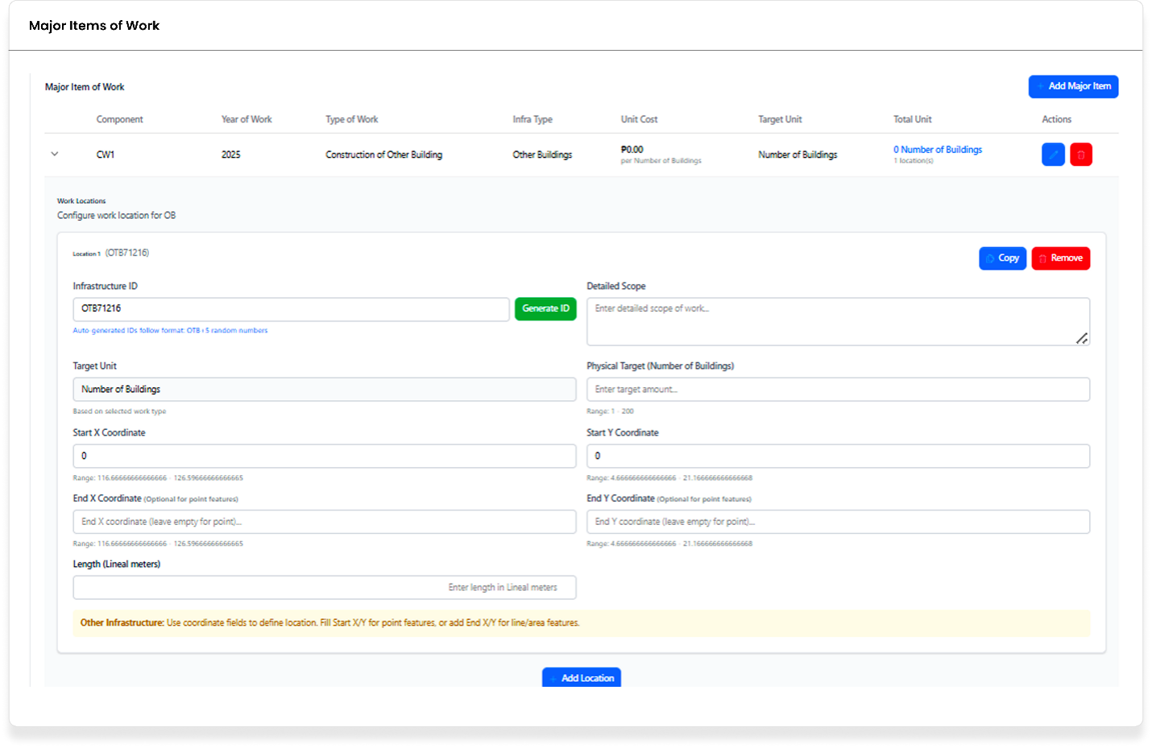
Purpose
Configure the major items of work for infrastructure projects related to other buildings (e.g., multi-purpose structures), including defining physical targets, coordinates, and detailed scope of work.
Who uses this
This screen is available to authorized MYPS users with access to the module.
Prerequisites
Before using this screen, ensure that:
• You are signed in to MYPS Web.
• You have access to the relevant infrastructure project for other buildings.
• You have the required permissions to add or edit major items of work for buildings outside the core building types.
Field Reference
No. | Fields/Blocks/Objects | Description | Values / Actions
UI-UX-0053-01 | INFRASTRUCTURE ID | Unique identifier for the infrastructure entry. | A text field to input or auto-generate the Infrastructure ID (e.g., "OBUILD001").
UI-UX-0053-02 | GENERATE ID | Button to auto-generate the Infrastructure ID. | Action: Click to generate a unique ID following the "OBUILD-####" format.
UI-UX-0053-03 | DETAILED SCOPE | A field to describe the work involved. | Text input for entering the detailed scope of the project (e.g., construction details for other buildings).
UI-UX-0053-04 | TARGET UNIT | Defines the unit type for the work. | Drop-down or text input to specify unit type (e.g., "Number of Buildings").
UI-UX-0053-05 | PHYSICAL TARGET (NUMBER OF UNITS) | Specifies the target number of buildings. | Numeric input for defining the target number of buildings (range: 1 - 100).
UI-UX-0053-06 | START COORDINATES X | X-coordinate of the start location. | Text input for the start X coordinate (numeric values).
UI-UX-0053-07 | START COORDINATES Y | Y-coordinate of the start location. | Text input for the start Y coordinate (numeric values).
UI-UX-0053-08 | END X COORDINATES | X-coordinate of the end location. | Optional input for the end X coordinate (numeric values).
UI-UX-0053-09 | END Y COORDINATES | Y-coordinate of the end location. | Optional input for the end Y coordinate (numeric values).
UI-UX-0053-10 | LENGTH (LINEAL METERS) | Specifies the length of the work in linear meters. | Text input for entering the length of the work (in linear meters).
UI-UX-0053-11 | ADD LOCATION | Button to add a new location to the infrastructure. | Action: Click to add the location data for the non-infrastructure work.

Step-by-Step: Major Items of Work Configuration for Other Buildings
1.) Open the Major Items of Work screen
- Navigate to the program or project where the work for the other buildings needs to be configured.
2.) Generate or enter Infrastructure ID
- If the infrastructure ID is not already provided, click the Generate ID button to auto-generate a unique ID. Alternatively, manually enter the infrastructure ID in the INFRASTRUCTURE ID field.
3.) Enter Target Unit
- In the TARGET UNIT field, select or enter the unit of measurement for the work (e.g., “Number of Buildings”).
4.) Define the Physical Target (Number of Buildings)
- In the PHYSICAL TARGET (Number of Units) field, enter the target number of buildings for the work, such as “10 buildings”.
5.) Enter the Coordinates
- Enter the START COORDINATES X and START COORDINATES Y for the starting point of the work.
- Enter the END X COORDINATES and END Y COORDINATES for the ending point of the work (if applicable).
Example valid entries:
- Start Coordinates X: 12.34567
- Start Coordinates Y: 98.76543
- End Coordinates X: 12.67890
- End Coordinates Y: 98.87654
Invalid entries: Coordinates with incorrect format or missing values.
6.) Enter the Length of the Work
- In the LENGTH (Linear meters) field, input the length of the work in meters (e.g., “500 meters”).
7.) Add Detailed Scope of Work
- In the DETAILED SCOPE field, provide a detailed description of the work to be done.
8.) Add Location
- Click the ADD LOCATION button to open the location input form. Fill in the relevant geographical information (e.g., region, city, district) for the work.
9.) Other Infrastructure Automatic Values
- The Other Infrastructure section will automatically populate and will indicate that no geo-location is required for this infrastructure type.
10.) Save and Review
- After entering all necessary details, click Save (if available) or review the work location and details to ensure they are correctly configured.
On Success
• The Major Items of Work configuration for the non-infrastructure project will be successfully saved and linked to the infrastructure project.
• Verify the Infrastructure ID, coordinates, target units, and scope details on the form.
• If any information is incorrect or missing, return to the respective field to make corrections.

Common Outcomes & What to Do
Message / Situation | What it Means | What You Should Do
“Invalid input in Coordinates” | The coordinates entered are not in the correct format or out of range. | Ensure the coordinates are numeric and within the valid range.
“Target Unit is required” | No target unit selected. | Select or enter a unit of measurement for the work.

Major Items of Work, Infra Type, Rain Water Collector (UI-UX-0054)
Purpose
Configure the major items of work for infrastructure projects related to rainwater collectors, including defining physical targets, coordinates, and detailed scope of work.

Who uses this
This screen is available to authorized MYPS users with access to the module.
Prerequisites
Before using this screen, ensure that:
• You are signed in to MYPS Web.
• You have access to the relevant rainwater collector project.
• You have the required permissions to add or edit major items of work for rainwater collector projects.
Field Reference
No. | Fields/Blocks/Objects | Description | Values / Actions
UI-UX-0054-01 | INFRASTRUCTURE ID | Unique identifier for the infrastructure entry. | A text field to input or auto-generate the Infrastructure ID (e.g., "RWC00123").
UI-UX-0054-02 | GENERATE ID | Button to auto-generate the Infrastructure ID. | Action: Click to generate a unique ID following the "RWC-####" format.
UI-UX-0054-03 | DETAILED SCOPE | A field to describe the work involved. | Text input for entering the detailed scope of the project (e.g., installation of rainwater collectors for a specific area).
UI-UX-0054-04 | TARGET UNIT | Defines the unit type for the work. | Drop-down or text input to specify unit type (e.g., "Number of Units").
UI-UX-0054-05 | PHYSICAL TARGET (NUMBER OF UNITS) | Specifies the target number of units. | Numeric input for defining the target number of units (range: 1 - 100).
UI-UX-0054-06 | START COORDINATES X | X-coordinate of the start location. | Text input for the start X coordinate (numeric values).
UI-UX-0054-07 | START COORDINATES Y | Y-coordinate of the start location. | Text input for the start Y coordinate (numeric values).
UI-UX-0054-08 | END X COORDINATES | X-coordinate of the end location. | Optional input for the end X coordinate (numeric values).
UI-UX-0054-09 | END Y COORDINATES | Y-coordinate of the end location. | Optional input for the end Y coordinate (numeric values).
UI-UX-0054-10 | LENGTH (LINEAL METERS) | Specifies the length of the work in linear meters. | Text input for entering the length of the work (in linear meters).
UI-UX-0054-11 | ADD LOCATION | Button to add a new location to the infrastructure. | Action: Click to add the location data for the rainwater collector infrastructure.

Step-by-Step: Major Items of Work Configuration for Rain Water Collectors
1.) Open the Major Items of Work screen
- Navigate to the program or project where the rainwater collector infrastructure work needs to be configured.
2.) Generate or enter Infrastructure ID
- If the infrastructure ID is not already provided, click the Generate ID button to auto-generate a unique ID. Alternatively, you can manually enter the infrastructure ID in the INFRASTRUCTURE ID field.
3.) Enter Target Unit
- In the TARGET UNIT field, select or enter the unit of measurement for the work (e.g., “Number of Units”).
4.) Define the Physical Target (Number of Units)
- In the PHYSICAL TARGET (NUMBER OF UNITS) field, enter the target number of units for the work, such as “10 units”.
5.) Enter the Coordinates
- Enter the START COORDINATES X and START COORDINATES Y for the starting point of the work.
- Enter the END X COORDINATES and END Y COORDINATES for the ending point of the work (if applicable).
Example valid entries:
- Start Coordinates X: 12.34567
- Start Coordinates Y: 98.76543
- End Coordinates X: 12.67890
- End Coordinates Y: 98.87654
Invalid entries: Coordinates with incorrect format or missing values.
6.) Enter the Length of the Work
- In the LENGTH (LINEAR METERS) field, input the length of the work in meters (e.g., “500 meters”).
7.) Add Detailed Scope of Work
- In the DETAILED SCOPE field, provide a detailed description of the work to be done.
8.) Add Location
- Click the ADD LOCATION button to open the location input form. Fill in the relevant geographical information (e.g., region, city, district) for the work.
9.) Rainwater Collector Infrastructure Automatic Values
- The Rain Water Collector Infrastructure section will automatically populate and will indicate that no geo-location is required for this infrastructure type.
10.) Save and Review
- After entering all necessary details, click Save (if available) or review the work location and details to ensure they are correctly configured.
On Success
• The Major Items of Work configuration for the rainwater collector will be successfully saved and linked to the infrastructure project.
• Verify the Infrastructure ID, coordinates, target units, and scope details on the form.
• If any information is incorrect or missing, return to the respective field to make correction

Common Outcomes & What to Do
Message / Situation | What it Means | What You Should Do
"Invalid input in Coordinates" | The coordinates entered are not in the correct format or out of range. | Ensure the coordinates are numeric and within the valid range.
"Target Unit is required" | No target unit selected. | Select or enter a unit of measurement for the work.

Major Items of Work, Infra Type, Roads (UI-UX-0055)
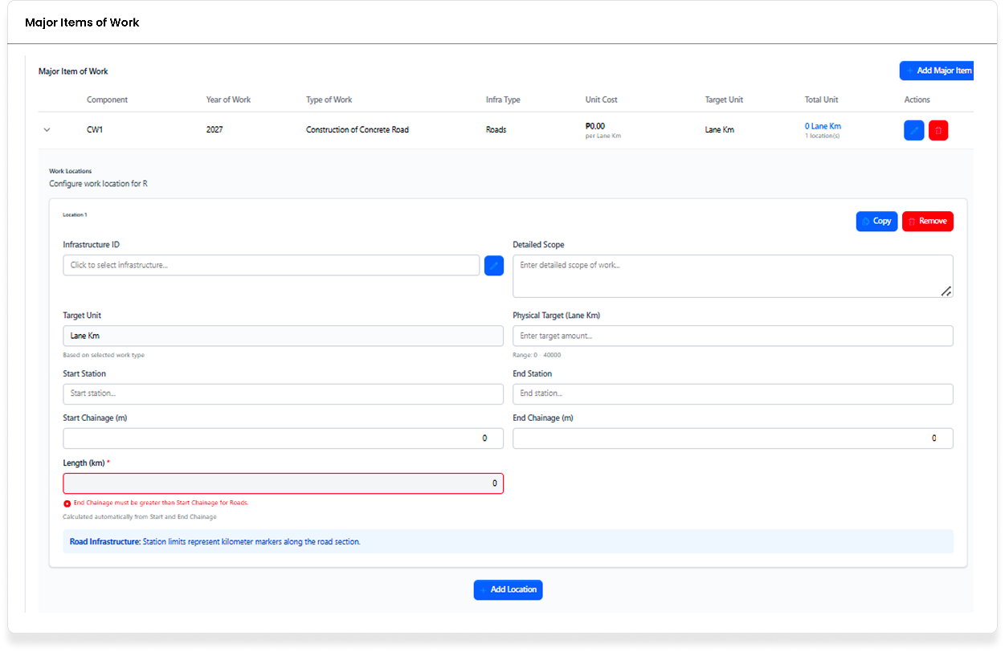
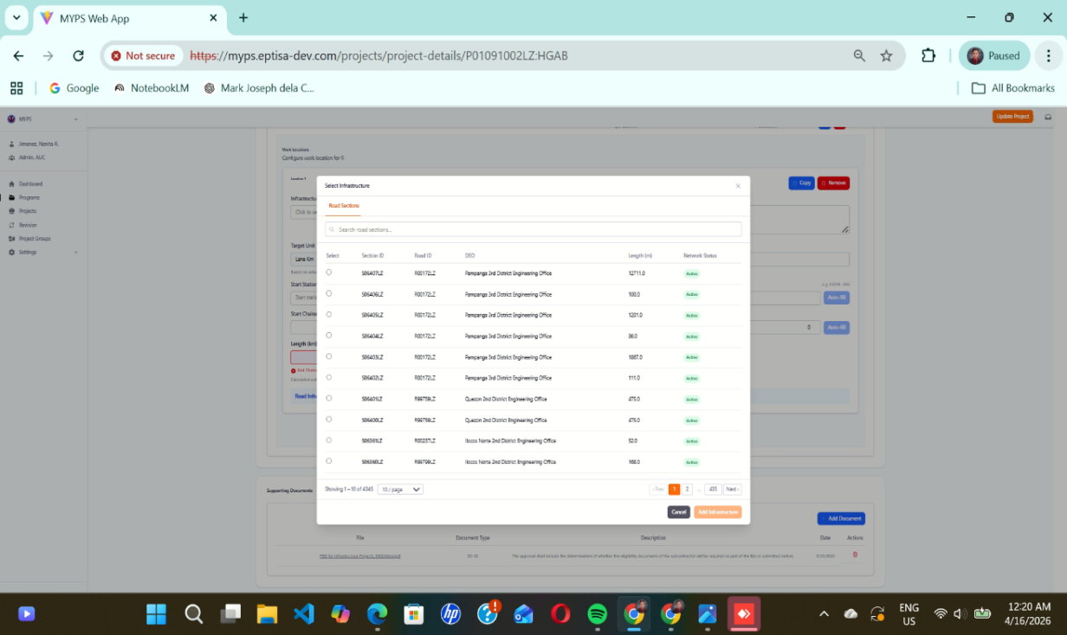
Purpose
The Major Items of Work – Infra Type: Road’s screen allows authorized users to define, review, and manage road infrastructure components of a project. Users can specify work locations, assign road sections, set physical targets, and track measurements for each segment of the road.
Who uses this
This screen is available to authorized MYPS users with access to the module.
Prerequisites
Before using this screen:
- You must be logged in to MYPS Web.
- The project must exist in MYPS.
- You must have permission to add or update infrastructure components.
- Network or VPN access must be available if required by your office.
Field reference
No. | Fields/Blocks/Objects | Description | Values / Actions
UI-UX-0055-01 | INFRASTRUCTURE ID | Unique identifier for the infrastructure type (e.g., Road, Bridge). | Auto-generated or manually assigned.
UI-UX-0055-02 | DETAILED SCOPE | Describes the specific work scope for the selected infrastructure. | Text input to describe detailed work scope.
UI-UX-0055-03 | TARGET UNIT | Unit of measurement for the target (e.g., lane kilometers, bridge segments). | Dropdown selection; units like "Lane Km," "Meter," etc.
UI-UX-0055-04 | PHYSICAL TARGET (Lane Km) | Defines the target physical measurement for the infrastructure work. | Numeric input for lane kilometers, e.g., "10 Km" for road construction.
UI-UX-0055-05 | START STATION | Starting point for the infrastructure project work section. | Numeric entry; station ID or description.
UI-UX-0055-06 | END STATION | End point for the infrastructure project work section. | Numeric entry; station ID or description.
UI-UX-0055-07 | START CHAINAGE (m) | Starting chainage (distance along the road) for the project section. | Numeric input in meters, e.g., "1500 m".
UI-UX-0055-08 | END CHAINAGE (m) | End chainage for the project section. | Numeric input in meters, e.g., "2000 m."
UI-UX-0055-09 | LENGTH (Km) | Total length of the infrastructure work in kilometers. | Numeric input for length in kilometers.
UI-UX-0055-11 | ADD LOCATION | Button to add a new location to the project section. | Action: Opens a location selection form.
UI-UX-0055-12 | SELECT INFRASTRUCTURE ROAD SECTIONS | Select specific road sections for the infrastructure project. | Dropdown selection or multi-select option for road sections.
UI-UX-0055-13 | SECTION ID | Unique identifier for a road section. | Alphanumeric ID for the section.
UI-UX-0055-14 | ROAD ID | Unique identifier for the road. | Alphanumeric ID for the road.
UI-UX-0055-15 | DEO | District Engineering Office assigned to the project. | Dropdown selection of DEO offices.
UI-UX-0055-16 | LENGTH (m) | Length of the road section in meters. | Numeric input in meters.
UI-UX-0055-17 | NETWORK STATUS | Current status of the road network (e.g., active, under construction). | Dropdown selection: Active, Under Construction, Completed, etc.
UI-UX-0055-18 | SELECT INFRASTRUCTURE BRIDGES | Select bridges as part of the infrastructure project. | Dropdown or multi-select for selecting bridges associated with the road project.
UI-UX-0055-19 | BRIDGES ID | Unique identifier for the bridge(s) included in the project. | Alphanumeric ID for each bridge.
UI-UX-0055-20 | BRIDGES NAME | Name or description of the bridge(s) associated with the project. | Text input for the bridge's name or description.
UI-UX-0055-21 | ROAD SECTION ID | Identifier for the road section involved in the infrastructure project. | Alphanumeric ID for the road section.
UI-UX-0055-22 | LENGTH (m) | Length of the bridge in meters. | Numeric input for length in meters.
UI-UX-0055-23 | OVERALL WIDTH (m) | Total width of the bridge or road section in meters. | Numeric input for width in meters.
UI-UX-0055-24 | PAGINATION | Displays the current page and total pages for navigation in the list. | Pagination controls: next, previous, page numbers, etc.
UI-UX-0055-25 | CANCEL | Button to cancel and close the current form or action. | Action: Cancels any changes made and closes the form.
UI-UX-0055-26 | ADD INFRASTRUCTURE | Button to add new infrastructure data to the project. | Action: Opens the add infrastructure modal/form to input data.

Step-by-Step Procedure: Major Items of Work – Infra Type: Road’s
- Open Major Items of Work
Navigate to the selected project and locate the Major Items of Work table.
- Add or select a major item
Click Add Major Item or select an existing item with Infra Type set to Roads.
- Define work location
In the Work Locations panel, select an Infrastructure ID and enter the Detailed Scope, Target Unit, and Physical Target.
- Enter station and chainage
Fill in Start Station, End Station, Start Chainage, and End Chainage.
- Verify length
Ensure Length (Km) matches the distance between start and end chainage.
- Select road sections
Click Select Infrastructure Road Sections and choose the relevant sections in the modal dialog.
- Add location
Click ADD LOCATION to include this road segment.
- Copy or remove entries
Use Copy to duplicate a location or remove to delete it.
- Add additional infrastructure
Click ADD INFRASTRUCTURE to add more road components if needed.
- Cancel or save changes
Click CANCEL to discard or save using workflow-specific save/update controls.

On success
- Road locations are added successfully.
- Road sections are assigned correctly.
- Physical targets and chainages are validated.
- Major Items table reflects all added locations.
Common Outcomes & What to Do
Message / Situation | Meaning | Action
Length validation error | End chainage less than start chainage | Correct start and end chainage values
Road sections unavailable | Region/DEO dependency not satisfied | Select appropriate region/DEO first
Save/Update fails | Required fields missing or invalid | Fill missing fields and retry

Major Items of Work, Infra Type, School Buildings (UI-UX-0056)
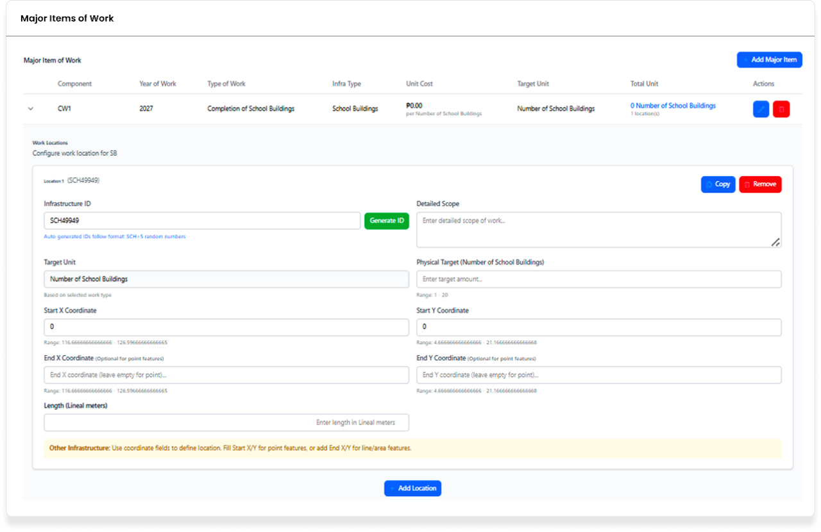

Purpose
The Add Infrastructure – School Buildings screen allows users to enter and manage infrastructure details for school building projects. It is used to record the infrastructure ID, detailed scope of work, physical target, location coordinates, and length-related information for the selected project.
This screen helps ensure that school building infrastructure data is recorded consistently before it is saved to the MYPS project record.
Who uses this
This screen is available to authorized MYPS users with access to the module.
Prerequisites
Before using this screen, ensure that:
- You are logged in to the MYPS Web application.
- You have access to the relevant project or component where the infrastructure entry will be added.
- You have the required infrastructure details, such as scope, target unit, target quantity, and location information.
- You have permission to add or edit infrastructure records.

Field reference
No. | Fields/Blocks/Objects | Description | Values / Actions
UI-UX-0056-01 | INFRASTRUCTURE ID | A unique identifier for each infrastructure entry. | A text field to input or auto-generate the Infrastructure ID (e.g., "RWC00123").
UI-UX-0056-02 | GENERATE ID | Button to auto-generate the Infrastructure ID. | Click to generate a unique ID following the "RWC-####" format.
UI-UX-0056-03 | DETAILED SCOPE | A field to describe the specific work involved. | Text input for entering a detailed description of the project scope (e.g., installation of school buildings).
UI-UX-0056-04 | TARGET UNIT | Defines the unit type for the work. | Drop-down or text input to specify unit type (e.g., "Number of School Buildings").
UI-UX-0056-05 | PHYSICAL TARGET (NUMBER OF SCHOOL BUILDINGS) | Specifies the target number of school buildings to be completed. | Numeric input for defining the target number of units (e.g., "5 School Buildings").
UI-UX-0056-06 | START COORDINATES X | X-coordinate of the starting location. | Text input for the X-coordinate (numeric values).
UI-UX-0056-07 | START COORDINATES Y | Y-coordinate of the starting location. | Text input for the Y-coordinate (numeric values).
UI-UX-0056-08 | END X COORDINATES | X-coordinate of the end location. | Optional input for the end X-coordinate (numeric values).
UI-UX-0056-09 | END Y COORDINATES | Y-coordinate of the end location. | Optional input for the end Y-coordinate (numeric values).
UI-UX-0056-10 | LENGTH (LINEAL METERS) | Specifies the length of the work in linear meters. | Text input for entering the length of the work (in linear meters).
UI-UX-0056-11 | ADD LOCATION | Button to add a new location to the infrastructure project. | Click to add the location data for the infrastructure (e.g., rainwater collectors or school buildings).

Step-by-step: Add School Building Infrastructure Details
- Open the infrastructure entry screen
Navigate to the relevant project or infrastructure section, then open the Add Infrastructure – School Buildings screen.
- Enter or generate the Infrastructure ID
In the INFRASTRUCTURE ID field, either type the ID manually or click GENERATE ID to create a system-formatted identifier.
- Enter the detailed scope
In the DETAILED SCOPE field, type a clear description of the work to be carried out.
Example: installation or construction scope for the school building project.
- Specify the target unit
In the TARGET UNIT field, select or enter the correct unit of work.
Example: Number of School Buildings.
- Enter the physical target
In PHYSICAL TARGET (NUMBER OF SCHOOL BUILDINGS), enter the total target quantity.
Example: 5.
- Enter the start coordinates
In START COORDINATES X and START COORDINATES Y, enter the numeric coordinate values for the starting location.
- Enter end coordinates, if applicable
If the infrastructure entry requires an ending location, enter values in END X COORDINATES and END Y COORDINATES.
- Enter the length
In LENGTH (LINEAL METERS), type the required length value, if applicable.
- Add the location
Click ADD LOCATION to apply the location details to the infrastructure entry.
- Review the entered details
Check that the ID, scope, unit, target, coordinates, and length values are correct before proceeding to the next MYPS action.
On success
- The infrastructure details are accepted by the screen.
- The location data is added to the infrastructure entry.
- The school building infrastructure record is ready for the next step in the project workflow.
Common Outcomes & What to Do
Message / Situation | What It Means | What To Do
Infrastructure ID is blank | No identifier was entered or generated. | Enter an Infrastructure ID manually or click Generate ID.
Invalid coordinate value | One or more coordinate fields contain an invalid value. | Re-enter the coordinates using valid numeric values.
Physical target not entered | The target quantity has not been provided. | Enter the required number of school buildings before continuing.

Major Items of Work, Infra Type, Septage and Sewage Plant (UI-UX-0057)
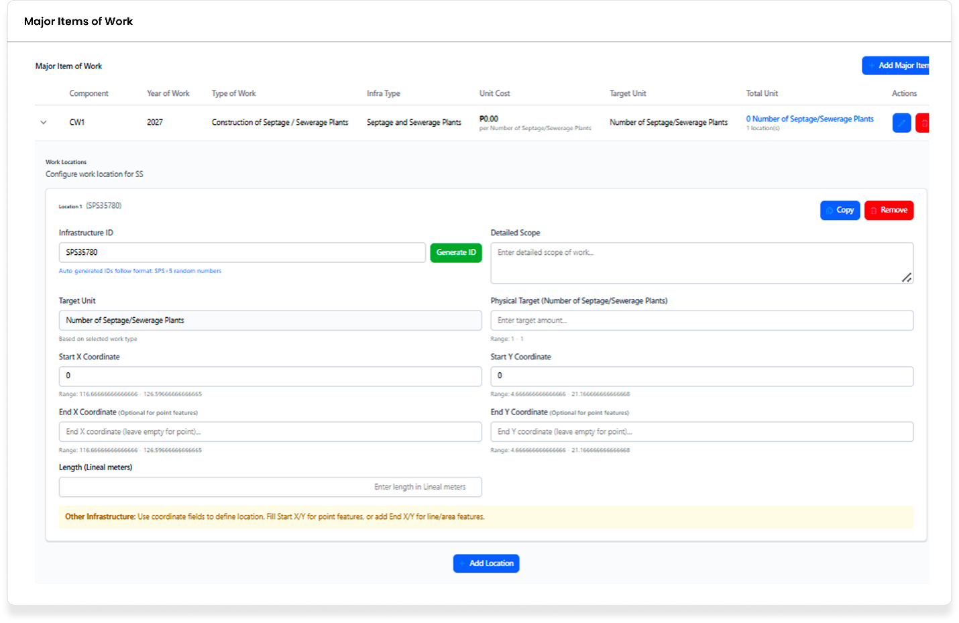
Purpose
The Add Infrastructure – Septage / Sewage Plants screen allows users to enter and manage infrastructure details for septage or sewage plant projects. It is used to record the infrastructure ID, detailed scope, target unit, physical target, coordinates, and length information for the selected project.
This screen helps ensure that septage or sewage plant infrastructure data is entered in a consistent format before it is saved to the MYPS project record.
Who uses this
This screen is available to authorized MYPS users with access to the module.
Prerequisites
Before using this screen, ensure that:
- You are logged in to the MYPS Web application.
- You have access to the relevant project or infrastructure section where the entry will be added.
- You have the required project details, including work scope, target quantity, and location information.
- You have permission to add or update infrastructure records.
Field reference
No. | Fields/Blocks/Objects | Description | Values / Actions
UI-UX-0057-01 | INFRASTRUCTURE ID | Unique identifier for the infrastructure project. | A text field to input or auto-generate the Infrastructure ID (e.g., "RWC00123").
UI-UX-0057-02 | GENERATE ID | Button to auto-generate the Infrastructure ID. | Action: Click to generate a unique ID in the format "RWC-####".
UI-UX-0057-03 | DETAILED SCOPE | A field to describe the work involved in the project. | Text input for entering the detailed scope of the project (e.g., construction of septage/sewage plants).
UI-UX-0057-04 | TARGET UNIT | Defines the unit type for the project work. | Dropdown or text input to specify unit type (e.g., "Number of Septage/Sewage Plants").
UI-UX-0057-05 | PHYSICAL TARGET | Specifies the target number of units (plants) to be completed. | Numeric input for defining the target number of plants (e.g., "5 Septage/Sewage Plants").
UI-UX-0057-06 | START COORDINATES X | X-coordinate of the starting location for the project. | Text input for the start X coordinate (numeric values).
UI-UX-0057-07 | START COORDINATES Y | Y-coordinate of the starting location for the project. | Text input for the start Y coordinate (numeric values).
UI-UX-0057-08 | END X COORDINATES | X-coordinate of the end location for the project (optional). | Optional input for the end X coordinate (numeric values).
UI-UX-0057-09 | END Y COORDINATES | Y-coordinate of the end location for the project (optional). | Optional input for the end Y coordinate (numeric values).
UI-UX-0057-10 | LENGTH (LINEAL METERS) | Specifies the length of the work in linear meters. | Text input for entering the length of the project (in linear meters).
UI-UX-0057-11 | ADD LOCATION | Button to add a new location to the infrastructure project. | Action: Click to add location data for the Septage/Sewage Plant infrastructure.

Step-by-step: Add Septage / Sewage Plant Infrastructure Details
- Open the infrastructure entry screen
Navigate to the relevant project or infrastructure section, then open the Add Infrastructure – Septage / Sewage Plants screen.
- Enter or generate the Infrastructure ID
In the INFRASTRUCTURE ID field, either type the ID manually or click GENERATE ID to create a system-formatted identifier.
- Enter the detailed scope
In the DETAILED SCOPE field, type a clear description of the work involved.
Example: construction of septage or sewage plant facilities.
- Specify the target unit
In the TARGET UNIT field, select or enter the correct unit of work.
Example: Number of Septage/Sewage Plants.
- Enter the physical target
In the PHYSICAL TARGET field, enter the target number of plants to be completed.
Example: 5.
- Enter the start coordinates
In START COORDINATES X and START COORDINATES Y, enter the numeric coordinate values for the starting location.
- Enter end coordinates, if applicable
If the entry requires an ending location, fill in END X COORDINATES and END Y COORDINATES.
- Enter the project length
In LENGTH (LINEAL METERS), type the length value if applicable to the recorded work.
- Add the location
Click ADD LOCATION to apply the entered location details to the infrastructure record.
- Review the entered details
Check that the ID, scope, unit, target, coordinates, and length values are complete and accurate before proceeding to the next step.
On success
- The infrastructure details are accepted by the screen.
- The location information is added to the infrastructure entry.
- The septage or sewage plant record is ready for the next MYPS action or saving process.
Common Outcomes & What to Do
Message / Situation | What It Means | What To Do
Infrastructure ID is blank | No identifier was entered or generated. | Enter the Infrastructure ID manually or click Generate ID.
Invalid coordinate value | One or more coordinate fields contain an invalid value. | Re-enter the coordinates using valid numeric values.
Physical target not entered | The target number of units was not provided. | Enter the required physical target before continuing.

Major Items of Work, Infra Type, Water Supply Systems (UI-UX-0058)
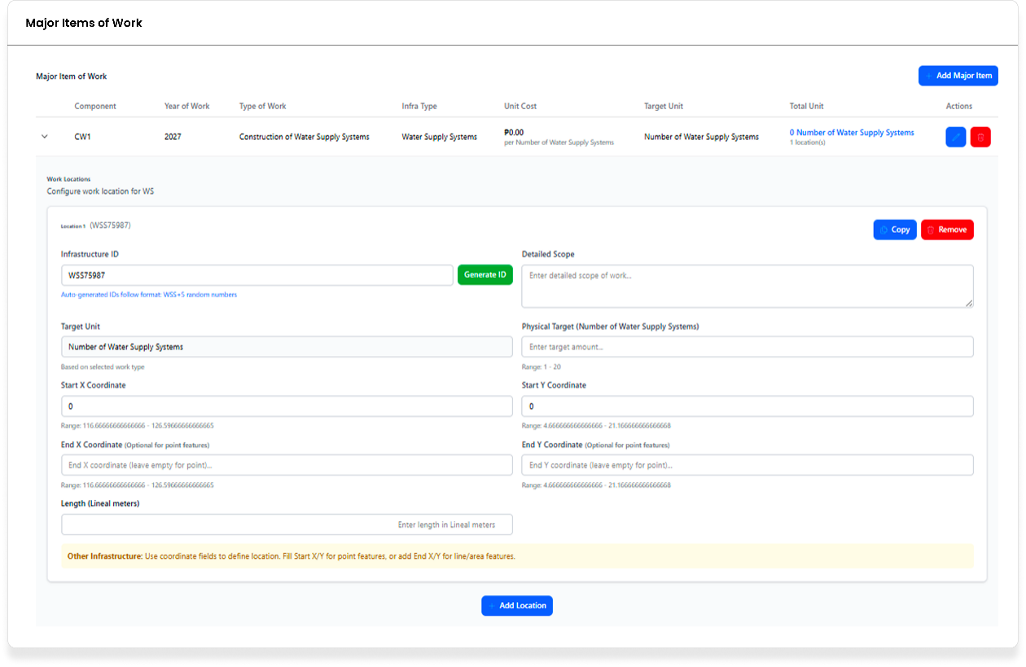
Purpose
The Water Supply Systems screen allows users to enter location-level infrastructure details for a water supply system major item of work. It is used to record the infrastructure ID, scope of work, target quantity, coordinates, length, and additional location entries under the same work item.

Who uses this
This screen is available to authorized MYPS users with access to the module.
Prerequisites
Before using this screen, ensure that:
- You are logged in to the MYPS Web application.
- You have opened the relevant project component or major item of work for a water supply system entry.
- You have the required scope, target, and location details for the infrastructure item.
- You have permission to add or edit infrastructure location records.
Field reference
No. | Field | Description | Allowed values / Actions
UI-UX-0058-13 | INFRASTRUCTURE ID | Unique identifier for the water supply system infrastructure entry. | Text input; auto-generated or manually confirmed. Example format: WS123456.
UI-UX-0058-14 | GENERATE ID | Generates the infrastructure ID for the selected location entry. | Button: Generate ID.
UI-UX-0058-15 | DETAILED SCOPE | Describes the specific scope of work for the water supply system item. | Free-text input. Example: construction of water pipes, rehabilitation of existing supply systems.
UI-UX-0058-16 | TARGET UNIT (LOCATION LEVEL) | Displays the applicable unit of measure for the selected work type. | Read-only/display text. Example: Number of Water Supply Systems.
UI-UX-0058-17 | PHYSICAL TARGET | Encodes the actual target quantity for the location. | Numeric input. Example: 50 systems.
UI-UX-0058-18 | START X COORDINATE | Records the starting X coordinate of the location. | Numeric text input; required for point or line definition as applicable.
UI-UX-0058-19 | START Y COORDINATE | Records the starting Y coordinate of the location. | Numeric text input; required for point or line definition as applicable.
UI-UX-0058-20 | END X COORDINATE | Records the ending X coordinate of the location, if applicable. | Optional numeric text input.
UI-UX-0058-21 | END Y COORDINATE | Records the ending Y coordinate of the location, if applicable. | Optional numeric text input.
UI-UX-0058-22 | LENGTH (LINEAL METERS) | Records the length of the work item in meters, when applicable. | Numeric text input. Example: 100 meters.
UI-UX-0058-23 | COPY | Duplicates the selected location block for faster entry of similar records. | Button: Copy.
UI-UX-0058-24 | REMOVE | Deletes the selected location block from the work item. | Button: Remove.
UI-UX-0058-25 | ADD LOCATION | Adds another location entry under the same major item of work. | Button: Add Location.
UI-UX-0058-26 | LOCATION GUIDANCE MESSAGE | Provides instruction on how coordinates should be used for point or line/area features. | Informational text. Example: Use Start X/Y for point features, End X/Y for line/area features.

Step-by-step: Add Water Supply System Location Details
- Open the Water Supply Systems screen
Navigate to the relevant project component or major item of work, then open the Water Supply Systems location entry screen.
- Enter or generate the Infrastructure ID
In INFRASTRUCTURE ID, either type the identifier manually or click GENERATE ID to create one.
- Enter the detailed scope
In DETAILED SCOPE, type a clear description of the work to be performed for this location entry.
- Review the target unit
Check TARGET UNIT (LOCATION LEVEL) and confirm that it matches the selected work type.
- Enter the physical target
In PHYSICAL TARGET, enter the target quantity for this location.
- Enter the start coordinates
In START X COORDINATE and START Y COORDINATE, enter the numeric values for the starting location.
- Enter the end coordinates, if applicable
If the work item requires line or area definition, fill in END X COORDINATE and END Y COORDINATE.
- Enter the length
In LENGTH (LINEAL METERS), enter the work length if applicable.
- Review the coordinate guidance
Read the LOCATION GUIDANCE MESSAGE to confirm whether only start coordinates or both start and end coordinates are needed.
- Add another location, if needed
Click ADD LOCATION to create another location entry under the same major item of work.
- Copy a similar location entry, if needed
Click COPY to duplicate the selected location block and update only the fields that differ.
- Remove an incorrect location entry, if needed
Click REMOVE to delete the selected location block.
- Review all entries
Check the infrastructure ID, scope, target, coordinates, and length before proceeding to the next MYPS action.
On success
- The water supply system location entry is accepted by the screen.
- The location details are recorded under the selected major item of work.
- Additional locations may be added, copied, or removed as needed.
Common Outcomes & What to Do
Message / Situation | What It Means | What To Do
Infrastructure ID is blank | No identifier was entered or generated. | Enter the ID manually or click Generate ID.
Physical target is missing | The target quantity was not provided. | Enter the required physical target before continuing.
Invalid coordinate value | One or more coordinate fields contain invalid data. | Re-enter the coordinates using valid numeric values.

- project or component reference, if applicable

Major Items of Work, Infra Type, Waterway (UI-UX-0059)
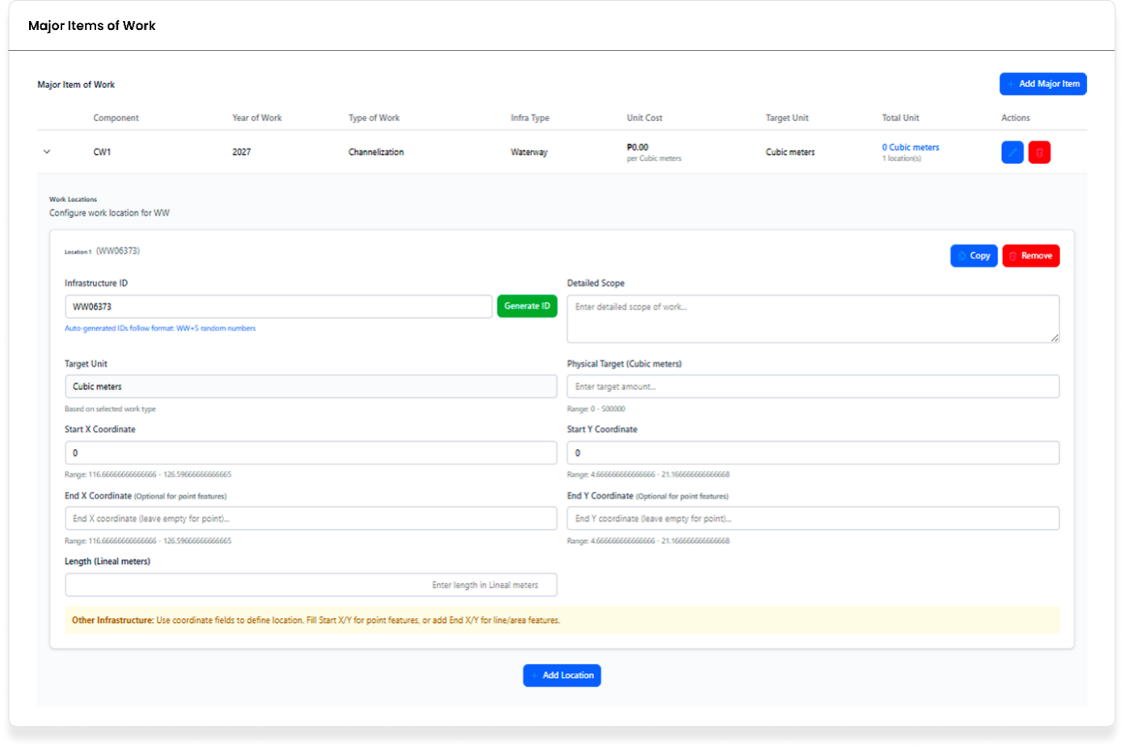
Purpose
The Add Infrastructure – Waterway screen allows users to enter and manage infrastructure details for a waterway-related work item. It is used to record the infrastructure ID, work type, year of work, scope, target unit, unit cost, physical target, coordinates, length, and other related infrastructure information.
Who uses this
This screen is available to authorized MYPS users with access to the module.
Prerequisites
Before using this screen, ensure that:
- You are logged in to the MYPS Web application.
- You have access to the relevant project, component, or major item of work where the infrastructure entry will be added.
- You have the required scope, target, and location information for the work item.
- You have permission to add or update infrastructure records.
Field reference
No. | Fields/Blocks/Objects | Description | Values / Actions
UI-UX-0059-01 | INFRASTRUCTURE ID | Unique identifier for the infrastructure item | Auto-generated alphanumeric ID (e.g., "WW100781")
UI-UX-0059-02 | WORK TYPE | Type of work to be performed | Dropdown selection: e.g., "Waterway", "Road Construction", etc.
UI-UX-0059-03 | YEAR OF WORK | Year the work is scheduled to begin | Numeric value (e.g., "2027")
UI-UX-0059-04 | DETAILED SCOPE | Detailed description of the work involved | Text field to input detailed work scope
UI-UX-0059-05 | TARGET UNIT | Unit of measurement for the work | Dropdown: e.g., "Cubic meters", "Square meters", etc.
UI-UX-0059-06 | UNIT COST | Cost per unit for the work | Numeric value (e.g., "₱10,000 per cubic meter")
UI-UX-0059-07 | TOTAL UNIT | Total units planned for the work | Numeric value (e.g., "500 cubic meters")
UI-UX-0059-08 | PHYSICAL TARGET (Cubic meters) | Physical target for the work | Numeric value (e.g., "300 cubic meters")
UI-UX-0059-09 | START & END COORDINATES | Geographical coordinates marking the start and end points of the work | Text input for latitude and longitude (e.g., "Start: 14.456, 120.678" and "End: 14.467, 120.679")
UI-UX-0059-10 | LENGTH (Linear meters) | The length of the work item in linear meters | Numeric value (e.g., "100 meters")
UI-UX-0059-11 | ADD LOCATION | Button to add the geographical location of the work | Action button that opens a location input form
UI-UX-0059-12 | OTHER INFRASTRUCTURES | Additional infrastructure that may need to be added for the work | Text input field for adding other infrastructure data (e.g., "Use coordinates to define points")

Step-by-Step Procedure Step-by-step: Add Waterway Infrastructure Details
- Open the infrastructure entry screen
Navigate to the relevant project, component, or major item of work, then open the Add Infrastructure – Waterway screen.
- Review the Infrastructure ID
Check the INFRASTRUCTURE ID field.
Confirm that the displayed ID is correct if it is auto-generated.
- Select the work type
In WORK TYPE, choose the correct type of work from the dropdown list.
- Enter the year of work
In YEAR OF WORK, type the year the work is scheduled to begin.
- Enter the detailed scope
In DETAILED SCOPE, type a clear description of the work to be performed.
- Select the target unit
In TARGET UNIT, choose the applicable unit of measurement for the work item.
- Enter the unit cost
In UNIT COST, type the cost per unit using the expected numeric value.
- Enter the total unit
In TOTAL UNIT, enter the total planned quantity for the work.
- Enter the physical target
In PHYSICAL TARGET (Cubic meters), type the actual physical target for the work item.
- Enter the start and end coordinates
In START & END COORDINATES, enter the location details for the work item.
Include both start and end values if the work covers a line or section.
- Enter the length
In LENGTH (Linear meters), type the length of the work item if applicable.
- Add the location
Click ADD LOCATION to open the location input form and apply the location details to the infrastructure entry.
- Enter other infrastructure details, if needed
In OTHER INFRASTRUCTURES, type any additional infrastructure information relevant to the work item.
- Review all entered details
Check the work type, year, scope, target values, cost, coordinates, and length before proceeding to the next MYPS action.
On success
- The infrastructure details are accepted by the screen.
- The work item location is added to the infrastructure entry.
- The waterway infrastructure record is ready for the next MYPS action or saving process.
Common Outcomes & What to Do
Message / Situation | What It Means | What To Do
Work Type not selected | The type of work was not chosen. | Select the correct work type before continuing.
Year of Work is blank or invalid | The year field is missing or contains an invalid value. | Enter a valid numeric year.
Target Unit not selected | The measurement unit has not been chosen. | Select the correct target unit from the dropdown.

- project or component reference, if applicable

Supporting Documents (UI-UX-0060)
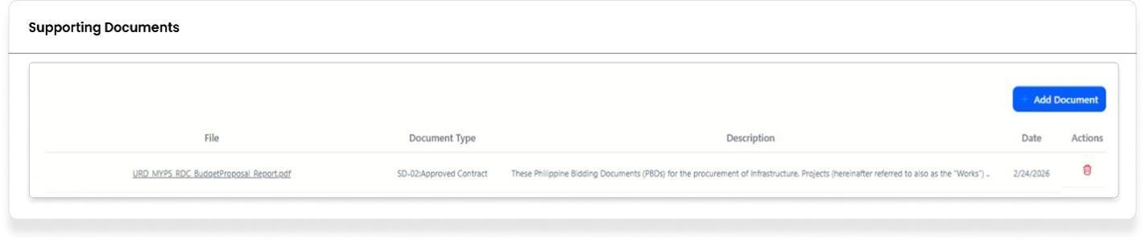
Purpose
The Supporting Documents feature allows users to upload, manage, and delete documents related to a project. This feature is crucial for organizing and tracking essential documents like contracts, reports, or other supporting materials required for project implementation.
Who Uses This
This screen is available to authorized MYPS users with access to the module.
Prerequisites
- You must be logged into your MYPS account.
- You must have permission to upload or delete supporting documents.
- The project must already exist in the system.
Field Reference
No. | Fields/Blocks/Objects | Description | Values / Actions
UI-UX-0060-01 | FILE | This column lists the name of the uploaded document. | Configurable via Supporting Documents. The name of the uploaded document (e.g., file name/title).
UI-UX-0060-02 | DOCUMENT TYPE | This column categorizes the document. | Configurable via Document type. Example Annexes 1 - 5, Approved Contract, BP 202 if ( SD-17 is different).
UI-UX-0060-03 | DESCRIPTION | This column provides a brief explanation or context for the document. | A brief explanation or context for the document.
UI-UX-0060-04 | DATE | This column records the date when the document was added or created. | A date stamp indicating when the document was added or created.
UI-UX-0060-05 | ACTIONS/DELETE | Removes the Supporting Document from the list (soft delete/archive). Shown only when deletable and user is authorized. | Action to remove or delete the document record.
UI-UX-0060-06 | ADD DOCUMENTS | Allow users to upload or add new supporting documents to the system. | Action to upload or add new supporting documents.

Step-by-Step: Manage Supporting Documents
- Open the Supporting Documents Page
  - Launch your browser and go to the MYPS Web URL provided by your office.
  - Navigate to the Supporting Documents section of the project.
- View Existing Documents
  - The page will display a list of all uploaded supporting documents with their details:
    - File Name: The name of the uploaded document.
    - Document Type: The type/category of the document.
    - Description: A brief explanation or context for the document.
    - Date: The date the document was uploaded or created.
- Upload a New Document
  - To add a new document, click the + Add Document button.
  - In the File field, select the document from your local drive.
  - In the Document Type dropdown, select the appropriate category for the document (e.g., “Approved Contract”, “Bid Documents”).
  - In the Description field, provide a brief description of the document’s contents (e.g., “SDO-approved Contract for infrastructure project”).
  - Once all fields are complete, click Save to upload the document.
- Delete a Document
  - To remove a document, click the Delete icon next to the document you want to remove.
  - A confirmation message will appear to confirm the deletion.
  - Click Confirm to delete the document. The document will be soft-deleted (archived) but not permanently removed.
- Review Uploaded Documents
  - After uploading or deleting documents, review the updated list to ensure everything is correct.
  - You can always edit the document details (e.g., description) by clicking on the document name and making changes.
On Success
- The document will be successfully uploaded and displayed in the Supporting Documents section.
- A confirmation message will appear once the document has been added or removed successfully.

Common Outcomes & What to Do
Message / Situation | What It Means | What To Do
“Document uploaded successfully” | The file was saved to the project record. | Verify that it appears in the list with the correct type and description.
“Required field missing” | One or more required inputs were left blank. | Complete the missing field, especially File, Document Type, or Description, then try again.
“Unsupported file type” | The selected file format is not accepted. | Upload a file in the allowed format based on your office rules.

Add Documents (UI-UX-0061)
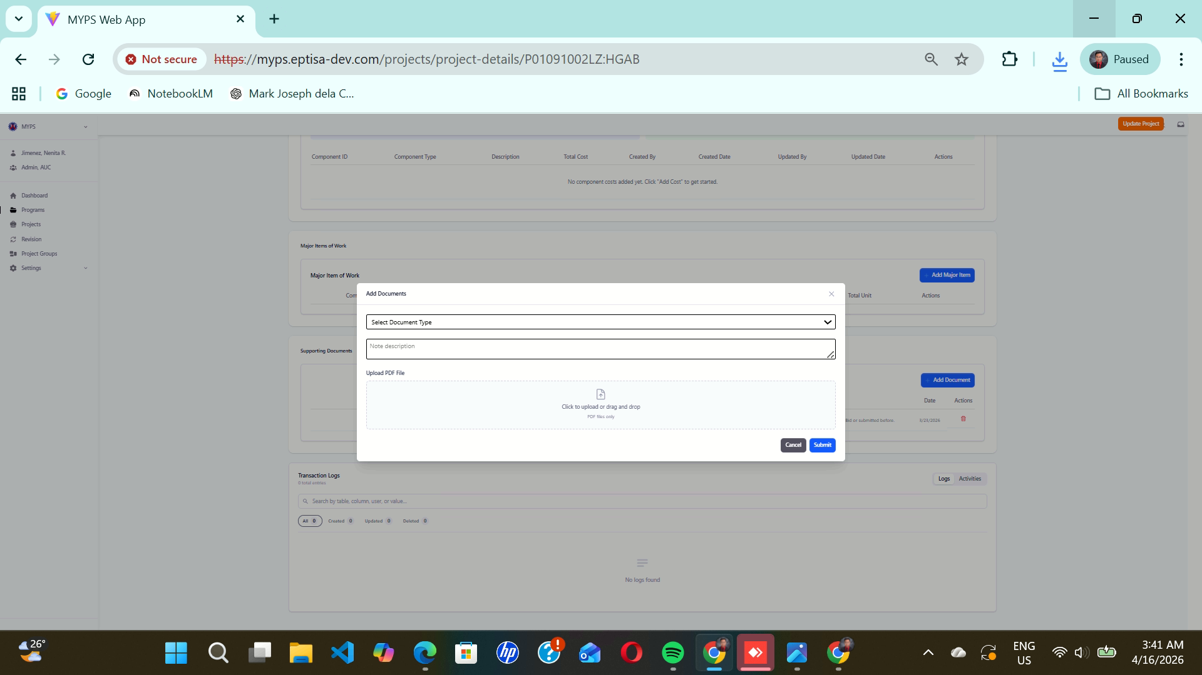
Purpose
This feature allows users to upload and categorize supporting documents into the system, including adding descriptions and selecting document types.
Who uses this
This screen is available to authorized MYPS users with access to the module.

Prerequisites
- You are logged into the system.
- You have the necessary permissions to upload documents.
Field Reference
No. | Fields/Blocks/Objects | Description | Values / Actions
UI-UX-0061- 01 | SELECT DOCUMENT TYPE | Allows the user to select the document category or type being uploaded. | Identifies each stage of the  Select Document type of Annexes 1 - 5 , Approved Contract , BP 202 (if SD- 17 is different), Canvass of Materials, etc.
UI-UX-0061- 02 | NOTE DESCRIPTION | A text area for entering notes or a brief explanation about the uploaded document. | Text Input; For balance of works components created after termination, the description will have " - balance of works" appended to it.
UI-UX-0061- 03 | UPLOAD PDF File | The file upload section for attaching the document. Only PDF file formats are accepted. Users can click to upload or drag and drop files. | Upload Location; The User must direct the popup to the location of the scanned document, and the document will be uploaded on the Planning Service server.
UI-UX-0061- 04 | CANCEL | closes the form without saving. | Button “Cancel”; Discards changes.
UI-UX-0061- 05 | SUBMIT | saves and uploads the document with the provided details. | Button “Submit”; Save and upload the Document type with the provided details.

Step-by-step: Add Documents
- Open the Add Documents screen
  - Navigate to the section of the application where you can upload documents.
- Select Document Type
  - Click on the Select Document Type dropdown field.
  - Choose the appropriate category for the document being uploaded (e.g., Annexes 1-5, SD-17, Approved Contract).
  - Example valid entries: Annexes 1-5, BP 202, SD-17.
- Enter a Description
  - Click the Note Description field.
  - Type a brief explanation or notes about the document being uploaded (e.g., "Flood Control Checklist for SD-25PWI").
  - This field is optional, but it helps provide context for the document.
- Upload the Document
  - Click the Upload PDF File area.
  - You can either click to browse for the document on your computer or drag and drop the PDF file into the area.
  - Ensure that the document is in PDF format.
  - Example valid file: Manual_on_RC_Planning.pdf
  - Invalid file: Manual_on_RC_Planning.docx (non-PDF file type).
- Submit the Document
  - Once the document is uploaded and the description is added (if necessary), click the Submit button to save and upload the document.
  - A confirmation message will appear once the document is successfully uploaded.
- Cancel the Process (if needed)
  - If you wish to cancel the process and discard any changes, click the Cancel button.
  - The form will close without saving any of the entered details.

On Success
- After clicking Submit, the document will be uploaded to the system and categorized under the selected document type.
- The document will appear in the system with the associated description and document type

Common Outcomes & What to Do
Message / Situation | What it Means | What You Should Do
“Document successfully uploaded.” | The document has been successfully uploaded.
  Verify the document appears in the document list.
“Invalid file format.” | The uploaded document is not a PDF file. | Ensure the document is in PDF format and re-upload.
“Document type or description required.” |  | Fill in the Select Document Type and Note Description fields.
  Missing required fields for document type or description.

Update Project (UI-UX-0062)
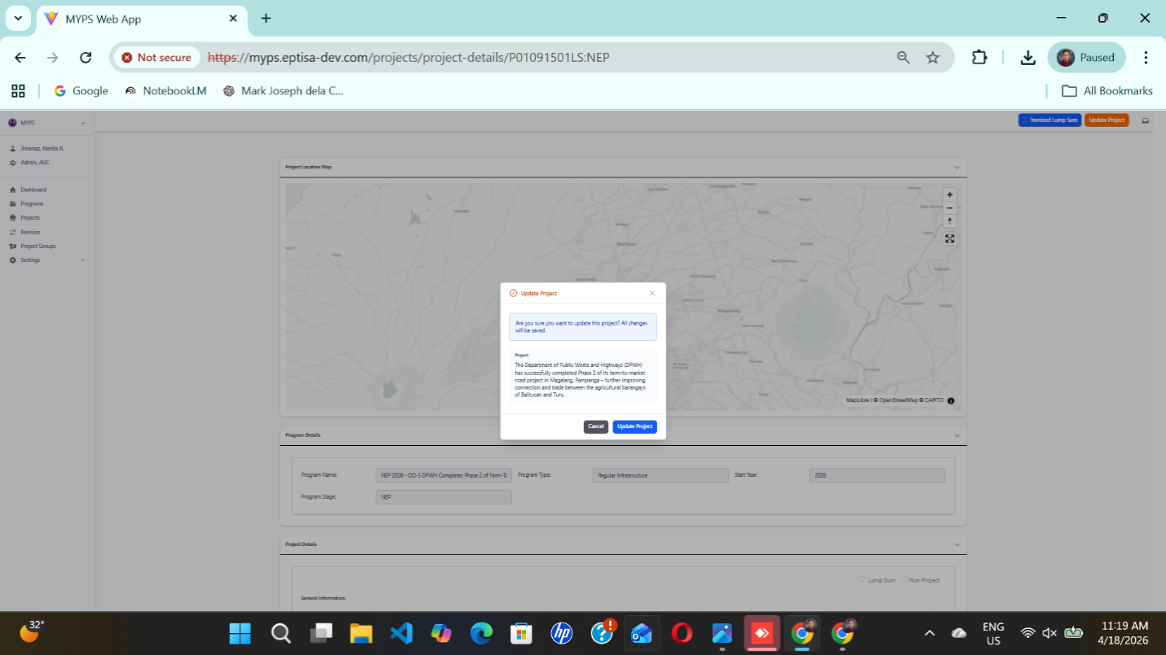
Purpose
The Update Project screen is used to save and apply changes made to an existing Project record in MYPS Web. When editing a Project's details, this screen prompts users to confirm their updates before saving them into the system.
Who uses this
This screen is available to authorized MYPS users with access to the module.
Prerequisites
Before using this screen, ensure that:
- You are signed in to your MYPS account.
- You have permission to access Project Details and Update Project functions.
- The Project you are updating already exists in MYPS.
- You have reviewed and confirmed the changes you want to apply.
- Your browser session and network connection are active.

Field Reference
No. | Fields/Blocks/Objects | Description | Values / Actions
UI-UX-0062-01 | UPDATE PROJECT | Button used to confirm and save changes to the current project record. | Clicking Update Project will validate and apply the changes made to the project.
UI-UX-0062-02 | CANCEL BUTTON | Closes the update confirmation modal without saving. | Clicking Cancel will discard any changes and return the user to the previous page.
UI-UX-0062-03 | CONFIRMATION MESSAGE | A prompt that asks if the user is sure about updating the project. | Displays the project ID and a reminder that changes will be saved to the project.

Step-by-step: Update Project
1. Open the Project record
- Sign in to MYPS Web.
- Go to Projects → Project List.
- Select the project you want to update.
- Click View/Edit to open the Project details.
2. Edit the Project details
- Review the current Project details.
- Make any necessary changes to fields such as Program Name, Start Year, Category, Description, and any other editable fields.
3. Review the changes
- Double-check the changes you’ve made.
- Make sure that all required fields are filled and that the project data is accurate.
4. Confirm the updates
- After reviewing the changes, click Update Project.
- A confirmation dialog will appear, asking if you are sure about updating the project with the changes.
5. Confirm the update
- Click Update Project in the confirmation dialog to save the changes.
- If you decide not to apply the changes, click Cancel to discard the changes and return to the Project page.
6. Verify the updated Project
- After the update is applied, return to the Project record and verify that the changes have been successfully saved.
On success
- The Project record is updated successfully.
- The system applies the changes and saves them to the Project record.
- The updated Project details are now visible in MYPS Web.
Common Outcomes & What to Do
Message / Situation | What It Means | What To Do
Changes saved successfully | The Project details were updated correctly. | Verify the updated information on the Project page.
Changes not saved | The system encountered an issue and could not apply the changes. | Check for error messages, revalidate input fields, and try again.
Permission denied | Your role does not allow editing this Project. | Contact your MYPS administrator for appropriate permissions.

Transaction Logs (UI-UX-0063)
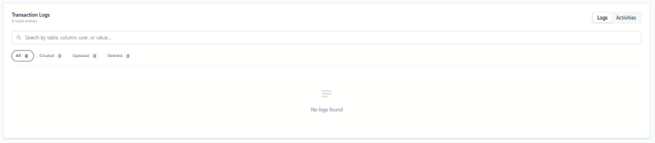
Purpose
The Transaction Logs section allows authorized users to view, filter, and search all recorded actions related to the selected program or project. This helps monitor changes, track updates, and maintain an audit trail for accountability.
Who uses this
This screen is available to authorized MYPS users with access to the module.
Prerequisites
Before using this section:
- You must be logged in to MYPS Web.
- You must have access to the program or project being monitored.
- Network or VPN access is available if required.
Field Reference
No. | Fields/Blocks/Objects | Description | Values / Actions
UI-UX-0063-01 | TRANSACTION LOGS | Displays the transaction logs section for the selected program or project. | Section showing all recorded logs and activities related to the selected record.
UI-UX-0063-02 | TOTAL ENTRIES | Displays the total number of log entries available in the section. | Numeric value representing the total number of logs (e.g., 0 total entries).
UI-UX-0063-03 | SEARCH LOGS FIELD | Search field used to filter logs by table, column, user, or value. | Text input; placeholder: “Search by table, column, user, or value...”. User may type keywords to filter log results.
UI-UX-0063-04 | FILTER / ALL | Filter button used to display all transaction log records. | Button labeled “All”; shows all available logs regardless of action type.
UI-UX-0063-05 | FILTER / CREATED | Filter button used to display created records only. | Button labeled “Created”; shows logs for created entries only.
UI-UX-0063-06 | FILTER / UPDATED | Filter button used to display updated records only. | Button labeled “Updated”; shows logs for updated entries only.
UI-UX-0063-07 | FILTER / DELETED | Filter button used to display deleted records only. | Button labeled “Deleted”; shows logs for deleted entries only.
UI-UX-0063-08 | LOGS BUTTON | Button for viewing detailed transaction logs. | Button labeled “Logs”; action opens or keeps the user in the detailed transaction log view.
UI-UX-0063-09 | ACTIVITIES BUTTON | Button for viewing activities related to the selected program or project. | Button labeled “Activities”; action switches to the activity log view.
UI-UX-0063-10 | LOG DISPLAY AREA | Main area where transaction log results are displayed. | Displays matching transaction logs based on selected filters or search criteria.
UI-UX-0063-11 | EMPTY STATE MESSAGE | Message displayed when no logs are available. | Displays “No logs found” when there are no matching or existing log records.
Step-by-Step Procedure
- Open the Transaction Logs section
Navigate to the program or project record and locate the Transaction Logs panel.
- Review total entries
Check TOTAL ENTRIES to understand the number of logged actions.
- Search logs
Enter keywords in SEARCH LOGS FIELD to filter results by table, column, user, or value.
- Apply filters
Click All, Created, Updated, or Deleted to display only the relevant entries.
- Switch views
Use LOGS BUTTON or ACTIVITIES BUTTON to toggle between detailed logs and activity overview.
- View log details
Examine the LOG DISPLAY AREA for timestamped changes, user actions, and affected records.
- Empty state handling
If No logs found is displayed, verify the selected filters or search criteria.
On success
- All log entries display correctly based on filters.
- Users can search and filter logs efficiently.
- Detailed changes and activities are visible in the log area

Common Outcomes & What to Do
Message / Situation | What It Means | What To Do
No logs found | No matching or existing log entries | Check search keywords and filters
Filtered results empty | No records match selected filter | Adjust filter or select All

Revisions & Modifications (User Procedures)
The Web-based MYPS introduces a more structured way of recording and tracking changes to projects compared to the legacy VB desktop client. Instead of embedding free-text notes or ad-hoc flags, each change is captured as a modification record linked to a Program, Project, funding year, and an explicit revision type. The new ERD models modifications as first-class entities, and the Web UI exposes dedicated screens to search, create, and validate these records.
This section explains, from an end-user perspective, how to understand modification types, work with the Modification List (UI-UX-0064), create new modification entries and maintain the associated validation dates, categories, and reasons.

Project Details Revision (UI-UX-0064)

Revision Entry Point and Submission Requirements
Use the current production label consistently. The test script references the yellow “View Revision” button followed by “Revise Project.” If the application displays “Modify” or “Request Revision” for another role or stage, document that as an alternate label only in the relevant role/stage context.
Submission requires Date of Approval, a supporting PDF approval document, and the certification checkbox. After successful submission, the system generates a Transaction ID for tracking.

Purpose
Allows authorized users to view the detailed revision history and available revision actions for a selected project. Users can inspect project changes, revisions applied, and access options to initiate new revisions if authorized.
Who uses this
This screen is available to authorized MYPS users with access to the module.
Prerequisites
- User must be signed in to MYPS Web.
- User must have permission to view project revisions.
- The project must exist and have associated revisions.
Field Reference
No. | Fields/Blocks/Objects | Description | Values / Actions
UI-UX-0064-01 | PROJECT LOCATION MAP | Displays the map view of the selected project location. | Interactive map panel; may display project location and geometry. If no mapped data exists, system shows “No map data available.”
UI-UX-0064-02 | MAP CONTROLS | Controls for navigating the map display. | Buttons for zoom in, zoom out, and map navigation/view controls.
UI-UX-0064-03 | REVISE PROJECT BUTTON | Main action button used to open the list of available revision types for the selected project. | Button labeled “Revise Project”; click to open revision options.
UI-UX-0064-04 | REVISION TYPE DROPDOWN MENU | Displays the list of revision actions that may be applied to the project. | Dropdown list of revision options such as Additional Funding, Adjustment, Change in Authority to Implement, Change in Funding, Change of Creditor, Expired Funding, For Savings – Partial Unutilized Balance, Mode of Implementation, Modification, Multi-Year Costing Changes, Non-Implementable, and Termination.
Step-by-Step: Viewing Project Details Revision
- Access Project Revisions
- Navigate to Projects → Select the project to view → Click View Revisions.
- Explore Project Location Map
- The interactive map displays the project’s location.
- Use Map Controls to zoom, pan, or adjust the map view.
- If no data exists, the map will display “No map data available.”
- View Revision Options
- Click Revise Project to access the dropdown of available revision types.
- Select a revision type to view more details or initiate changes (if authorized).
- Review Revision Details
- The selected revision type expands the form to show all relevant fields, history, and constraints.
- Check associated project components, funding, and effective dates.
Common Outcomes & What to Do
Message / Situation | What it Means | Action
“No map data available” | Project location is not yet mapped | Confirm project coordinates; contact GIS admin if needed
Revision dropdown empty | User lacks permission or project has no revision actions | Verify role access; contact MYPS admin
Revision cannot be saved | Validation errors or required fields missing | Complete all mandatory fields; check for funding or stage conflicts

Additional Funding (UI-UX-0065)
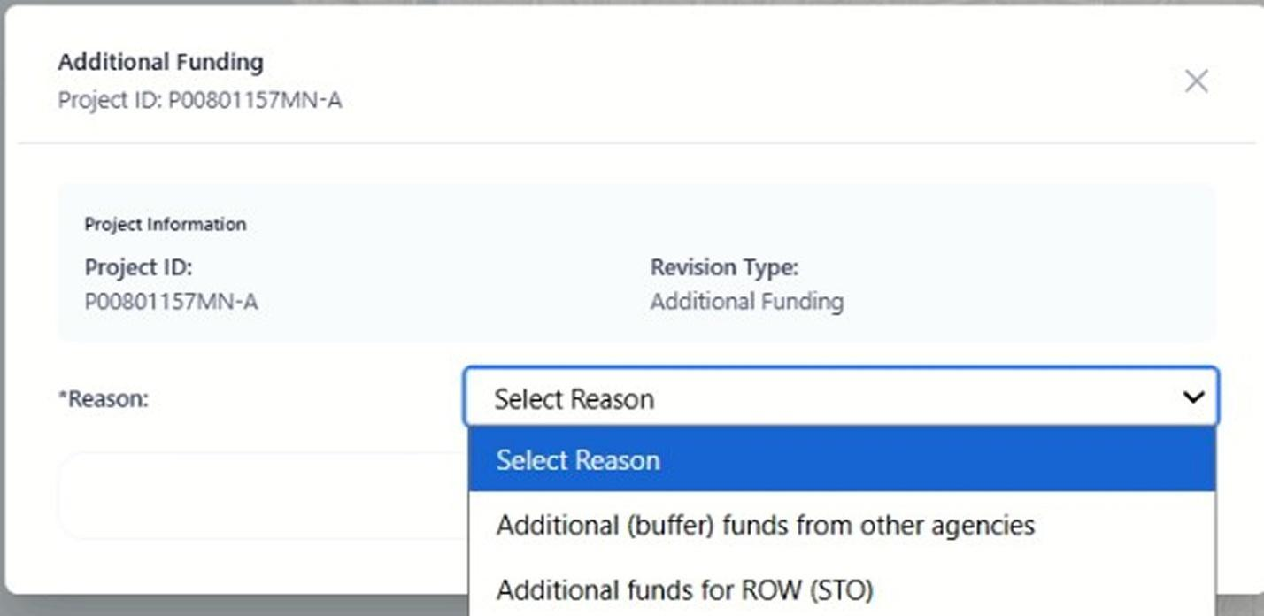
Purpose
The Revision Additional Funding feature allows users to apply for additional funding for an existing project. This functionality is crucial for requesting extra resources either for additional project requirements or for unforeseen expenses, such as funding from other agencies or funds for Right of Way (ROW).
Who Uses This
This screen is available to authorized MYPS users with access to the module.
Prerequisites
- You must be logged into your MYPS account.
- You must have permission to request revisions for additional funding.
- The project must already be created in the system.

Field Reference
No. | Fields/Blocks/Objects | Description | Values / Actions
UI-UX-0065-01 | PROJECT ID | Displays the unique identifier for the project. | Value: P00801157MN-A (Example project ID).
UI-UX-0065-02 | REVISION TYPE | Specifies the type of revision being applied. | Value: Additional Funding (indicating a funding revision).
UI-UX-0065-03 | REASON | Allows the user to select the reason for requesting additional funding. | Options: 1. "Additional (buffer) funds from other agencies" 2. "Additional funds for ROW (STO)"
Step-by-Step: Request Revision Additional Funding
- Open the Revision Additional Funding Page
  - Launch your browser and go to the MYPS Web URL provided by your office.
  - Navigate to the Revision section under the Programs menu.
- Enter Project ID
  - The Project ID field will automatically display the unique identifier for the project (e.g., P00801157MN-A).
  - Ensure that the correct project ID is shown, or manually enter the ID if necessary.
- Select Revision Type
  - In the Revision Type dropdown, ensure that Additional Funding is selected. This is automatically set for funding-related revisions.
- Select the Reason for Additional Funding
  - Click on the Reason dropdown.
  - Choose one of the following options:
    - Additional (buffer) funds from other agencies: Select this option if the funding request is for buffer funds from external agencies.
    - Additional funds for ROW (STO): Choose this option if the funds are specifically for Right of Way (ROW) costs.
- Submit the Revision Request
  - After selecting the Reason, click the Submit button to request the additional funding revision.
  - A confirmation message will appear once the request is successfully submitted.
On Success
- The revision request will be submitted successfully.
- You will be redirected to the project page, where the Revision Type and Reason for the funding will be updated accordingly.
Common Outcomes & What to Do
Message / Situation | What it Means | What You Should Do
"Request submitted successfully." | The additional funding request has been submitted. | Review the updated project details to ensure the funding request is correct.
“Field is required.” | A required field was left empty. | Complete the mandatory fields and submit again.

Revision Additional Funding - Additional (buffer) funds from other agencies (UI-UX-0066)
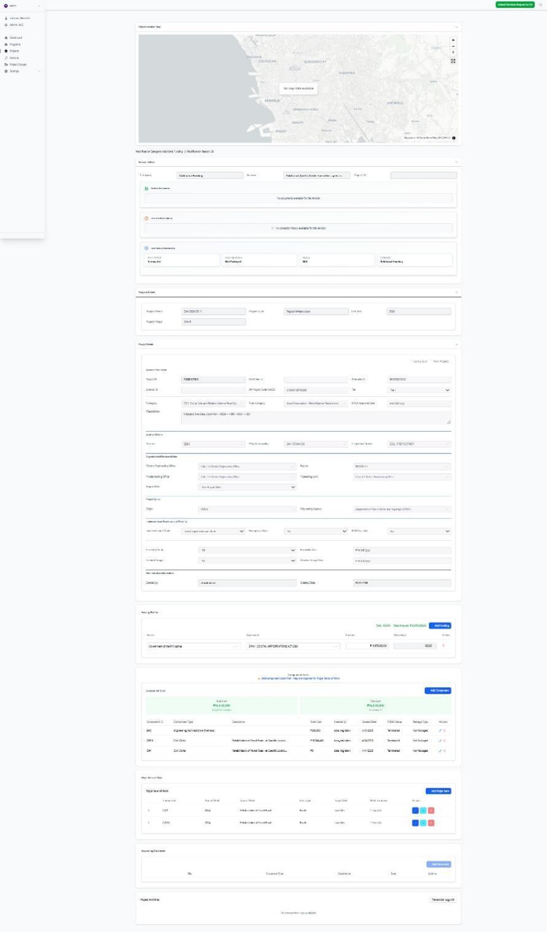

Purpose
This screen allows authorized users to submit a Revision Additional Funding request for a selected project when additional or buffer funds from other agencies are needed. This revision is used to record, validate, and submit funding-related changes while preserving the project’s revision history, supporting documents, cost information, and workflow status.
Who uses this
This screen is available to authorized MYPS users with access to the module.
Prerequisites
Before using this screen, ensure that:
- You are signed in to MYPS Web.
- You have permission to access the Revision and Additional Funding functions.
- The selected project already exists in MYPS.
- The project is eligible for an Additional Funding revision.
- The funding need is supported by an approved or valid basis from another agency.
- Required supporting documents are ready for upload, if required by office procedure.

Field reference
No. | Fields / Blocks / Objects | Description | Values / Actions
UI-UX-0066-01 | PROJECT LOCATION MAP | Displays the mapped location of the selected project. | View-only or interactive map panel; may display No map data available if no spatial data exists.
UI-UX-0066-02 | CATEGORY | Displays the revision category being applied to the project. | Read-only or preselected value: Additional Funding.
UI-UX-0066-03 | REASON | Displays the selected reason for the additional funding request. | Selected reason: Additional (buffer) funds from other agencies.
UI-UX-0066-04 | PROJECT ID | Displays the unique identifier of the selected project. | Auto-populated project ID; must match the intended project before submission.
UI-UX-0066-05 | REVISION DOCUMENTS | Area for attaching supporting documents for the additional funding request. | Upload supporting files such as approval documents, funding certifications, memoranda, or agency endorsements.
UI-UX-0066-06 | FOR CORRECTION HISTORY | Displays previous correction comments or returned revision notes. | View-only history/log section.
UI-UX-0066-07 | FULL REVISION PERMISSIONS | Displays status and rule-based sections available for review. | View-only or partially editable depending on user role and permissions.
UI-UX-0066-08 | PCMA STATUS | Displays the current PCMA-related status of the selected project. | Status display field; review before submitting.
UI-UX-0066-09 | PACKAGE STATUS | Displays the current packaging status of the project. | Status display field, such as packaged, not packaged, or system-configured equivalent.
UI-UX-0066-10 | STATUS | Displays the current workflow status of the revision record. | Status display field, such as draft, under review, approved, returned, rejected, or N/A.
UI-UX-0066-11 | CATEGORY STATUS | Displays the category classification/status for the revision. | Status display; shown under the Additional Funding context.
UI-UX-0066-12 | PROGRAM DETAILS | Displays the program information linked to the selected project. | View-only section showing details such as Program Name, Program Type, Start Year, and Program Stage.
UI-UX-0066-13 | PROJECT DETAILS | Displays administrative and descriptive project information. | View-only or controlled fields depending on revision permissions.
UI-UX-0066-14 | FUNDING PROFILE | Displays funding-related details for the project. | May include funding source, funding year, amount, fund source, or related financial data.
UI-UX-0066-15 | ADD FUNDING | Allows the user to add or update a funding profile entry, if enabled. | Button action; opens or activates funding entry controls depending on permissions.
UI-UX-0066-16 | COMPONENT COST | Displays project component cost information. | Table/list showing component name, component type, cost, and related values.
UI-UX-0066-17 | ADD COMPONENT | Allows the user to add a component cost entry, if enabled. | Button action; opens the component cost entry form or row.
UI-UX-0066-18 | MAJOR ITEM OF WORK | Displays major item of work records linked to the project/component. | Table/list showing type of work, target values, unit, location, and related work details.
UI-UX-0066-19 | ADD ITEM OF WORK | Allows the user to add a major item of work, if enabled. | Button action; opens the major item of work form or row.
UI-UX-0066-20 | SUPPORTING DOCUMENTS | Displays documents attached to the project or revision. | View, upload, or manage documents depending on permissions.
UI-UX-0066-21 | PROJECT ACTIVITIES | Displays activity or transaction-related information for the project. | View-only log or activity section.
UI-UX-0066-22 | SUBMIT REVISION REQUEST TO CO | Submits the completed additional funding request to Central Office for review. | Button action; submits the revision into the next workflow step.
Step-by-step: Submit a Revision Additional Funding request for Additional (buffer) funds from other agencies
1. Open the Revision module
Sign in to MYPS Web. From the left navigation menu, go to the Revision module. Open the selected project record where an Additional Funding revision will be prepared.
2. Confirm the screen context
Review the revision details area. Confirm that the Category is Additional Funding and that the Reason is Additional (buffer) funds from other agencies.
3. Review the Project Location Map
Check the Project Location Map at the top of the screen. Confirm that the displayed location corresponds to the selected project. If the map shows No map data available, proceed only if map validation is not required for the funding revision, or coordinate with GIS/system support if location validation is needed.
4. Verify the Project ID
Check the Project ID field. Confirm that the displayed project ID matches the intended project. Do not proceed if the wrong project record is opened.
5. Review revision documents
In the Revision Documents area, upload or verify supporting documents required for the additional funding request. These may include:
- Approved funding request or memorandum
- Certification or endorsement from the funding agency
- Supporting cost estimate
- Budget/funding approval document
- Other official project or agency reference documents
6. Review correction history
Open or review the For Correction History section. Check whether the request was previously returned for correction. If comments are present, address them before resubmitting the request.
7. Check revision and project statuses
Review the status fields under Full Revision Permissions, including:
- PCMA Status
- Package Status
- Status
- Category Status
Make sure the project and revision are in a condition that allows an Additional Funding request to proceed.
8. Review Program Details
Go to the Program Details section. Confirm that the selected project is linked to the correct program. Review values such as Program Name, Program Type, Start Year, and Program Stage.
9. Review Project Details
Go to the Project Details section. Review the project description, category, location, implementing office, and other identifiers. Confirm that the funding revision applies to the correct project record.
10. Review or update Funding Profile
Go to the Funding Profile section. Review the existing funding information and confirm whether the additional funding source, amount, year, or related funding data must be added or updated.
If the Add Funding button is enabled, click it and enter the required funding information. Use only approved funding values and official source references.
11. Review Component Cost
Go to the Component Cost section. Review the component cost entries and confirm that the additional funding is properly reflected against the applicable project component.
If the Add Component button is enabled, add or update the relevant component cost details according to the approved funding basis.
12. Review Major Item of Work
Go to the Major Item of Work section. Confirm that the work items, target values, units, and locations remain consistent with the revised funding profile and component cost information.
If additional work items are required and the Add Item of Work button is enabled, encode the required details based on the approved project documents.
13. Review Supporting Documents
Check the Supporting Documents section. Confirm that all necessary documents are uploaded and correctly associated with the project or revision request.
14. Review Project Activities
Review the Project Activities section to check transaction history, recent actions, or other activity logs related to the project.
15. Submit the request
After reviewing all details, documents, statuses, funding entries, component cost, and major items of work, click Submit Revision Request to CO. Wait for the confirmation message or updated workflow status.
On success
- The Additional Funding revision request is saved successfully.
- The request is submitted to Central Office for review.
- The selected reason, Additional (buffer) funds from other agencies, is recorded against the revision.
- Uploaded supporting documents are attached to the revision record.
- Funding profile, component cost, and related work item data are retained for review.
- The revision workflow status updates accordingly.
Common Outcomes & What to Do
Message / Situation | What It Means | What To Do
Required field missing | One or more required fields or documents were not completed. | Complete the missing fields or upload the required documents, then submit again.
Invalid funding amount | The entered funding value is blank, zero, negative, or not accepted by the system. | Recheck the approved funding amount and enter a valid numeric value.
Invalid project status | The current project, package, or PCMA condition does not allow this revision to proceed. | Review PCMA Status, Package Status, and workflow status before resubmitting.
No map data available | No spatial data is linked to the project. | Continue only if mapping is not required, or coordinate with GIS support.

Attach the Approved Revision Document - Additional (buffer) funds from other agencies (UI-UX-0067)
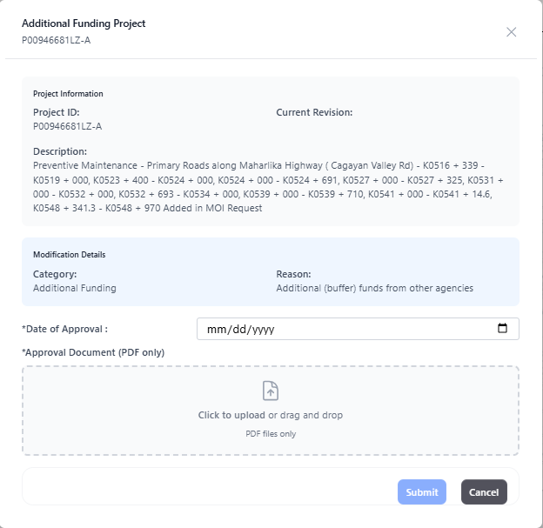
Purpose
The Additional Funding Project screen allows an authorized user to record an approved revision for a project under the Additional Funding category. This screen is used when a project receives additional (buffer) funds from other agencies and the approved supporting document must be attached before submission.
Who uses this
This screen is available to authorized MYPS users with access to the module.
Prerequisites
Before using this screen, ensure that:
- You are logged in to your MYPS account.
- You have permission to access project revision or modification functions.
- The target project already exists in MYPS.
- The revision type has been identified as Additional Funding.
- The approved revision document is available in PDF format.
- You know the approved Date of Approval.
- Your browser session and network connection are active.
Field Reference
No. | Fields/Blocks/Objects | Description | Values / Actions
UI-UX-0067-01 | PROJECT ID | Unique identifier of the project being revised. | Display value. Read-only on this screen.
UI-UX-0067-02 | CURRENT REVISION | Shows the current revision reference or status of the selected project. | Display value. If blank or not populated, confirm during UI validation/UAT.
UI-UX-0067-03 | DESCRIPTION | Full description of the selected project. | Display value. Read-only on this screen.
UI-UX-0067-04 | CATEGORY | Shows the revision category applied to the project. | Displayed as Additional Funding. Read-only in the provided screen.
UI-UX-0067-05 | REASON | Shows the reason for the selected revision category. | Displayed as Additional (buffer) funds from other agencies. Read-only in the provided screen.
UI-UX-0067-06 | DATE OF APPROVAL | Date when the revision or funding approval was approved. | Required. Date entry in mm/dd/yyyy format. Calendar picker icon is available.
UI-UX-0067-07 | APPROVAL DOCUMENT (PDF ONLY) | Upload field for the approved revision document. | Required. Accepts PDF files only. User may click to upload or drag and drop a file.
UI-UX-0067-08 | UPLOAD AREA | Drag-and-drop zone for the approval document. | Click to upload or drag and drop a PDF file.
UI-UX-0067-09 | SUBMIT | Saves and submits the additional funding revision entry. | Click to submit the completed form.
UI-UX-0067-10 | CANCEL | Closes the screen without submitting the revision. | Click to cancel the action.

Step-by-step: Record an Additional Funding Project revision
1. Open the Additional Funding Project screen
Access the revision or modification workflow for the selected project, then open Additional Funding Project (UI-UX-0052).
2. Review the Project Information panel
Check the Project ID, Current Revision, and Description to confirm that you are working on the correct project.
3. Review the Modification Details panel
Verify that the Category is Additional Funding and that the Reason is Additional (buffer) funds from other agencies.
4. Enter the Date of Approval
Click the Date of Approval field and enter the approved date in mm/dd/yyyy format, or select the date using the calendar icon.
Example valid entry: 04/17/2026
Invalid entry: 17/04/2026 if the system expects month/day/year
5. Upload the approved revision document
In the Approval Document (PDF only) area, click the upload box or drag and drop the file into the upload zone.
Use only the approved supporting document in PDF format.
6. Review the encoded information
Make sure the project details are correct, the approval date is complete, and the PDF file has been attached successfully.
7. Submit the revision
Click Submit to record the additional funding project revision.
8. Cancel if needed
If you do not want to continue, click Cancel to leave the screen without submitting.
On success
After successful submission:
- The additional funding revision is recorded for the selected project.
- The uploaded approval document is attached to the revision record.
- The project’s revision history or revision list may reflect the newly submitted entry, depending on the workflow and permissions configured in MYPS.
Common Outcomes & What to Do
Message / Situation | What It Means | What To Do
Required field missing | One or more required fields were left blank. | Complete all required fields before clicking Create Road.
Invalid Road ID format | The entered Road ID does not follow the required format. | Re-enter the Road ID so it starts with FR, contains 5 digits, and ends with the correct island code.
Duplicate Road ID | The Road ID may already exist in the system. | Check the entered ID and use a unique Road ID.

Adjustment (UI-UX-0068)
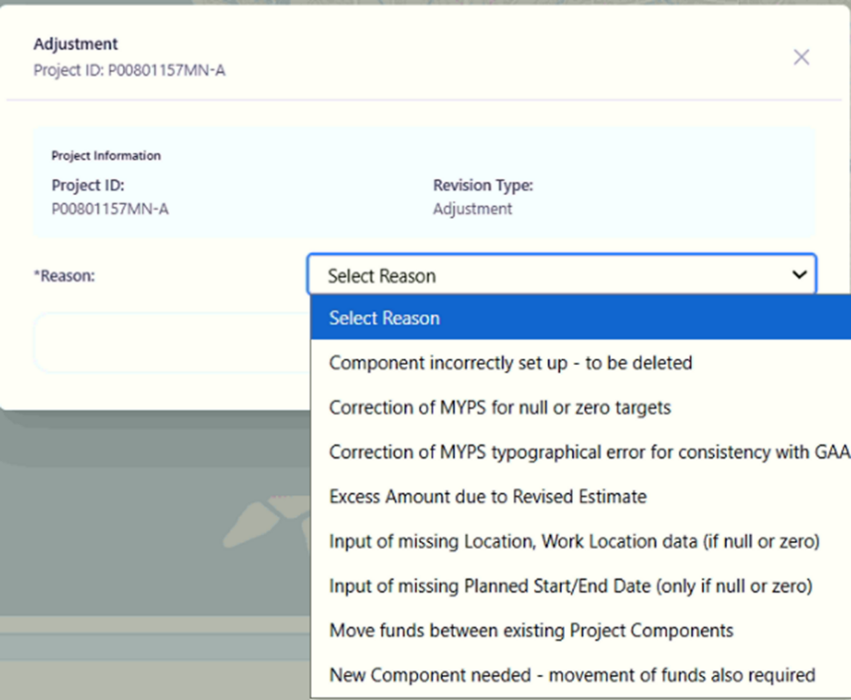

Purpose
The Adjustment feature allows users to make revisions or adjustments to an existing project. This includes applying adjustments for reasons such as correcting project setup issues, revising estimated amounts, and correcting missing data.
Who Uses This
This screen is available to authorized MYPS users with access to the module.
Prerequisites
- You must be logged into your MYPS account.
- You must have permission to apply adjustments to project details.
- The project must already be created in the system.
Field Reference
No. | Fields/Blocks/Objects | Description | Values / Actions
UI-UX-0070-01 | PROJECT ID | Displays the unique identifier for the project requiring adjustment. | Example: P00801157MN-A. Auto-populated based on the selected project.
UI-UX-0070-02 | REVISION TYPE | Specifies the type of revision being applied to the project. | Value: Adjustment.
UI-UX-0070-03 | REASON |  | Drop-down options:  1. "Component incorrectly set up - to be deleted"  2. "Correction of MYPS for null or zero targets"  3. "Correction of MYPS typographical error for consistency with GAA"  4. "Excess Amount due to Revised Estimate"  5. "Input of missing Location, Work Location data (if null or zero)"  6. "Input of missing Planned Start/End Date (only if null or zero)"  7. "Move funds between existing Project Components"  8. "New Component needed - movement of funds also required"
  Allows the user to select the reason for the adjustment.
Step-by-Step: Apply Adjustment
- Open the Adjustment Page
  - Launch your browser and go to the MYPS Web URL provided by your office.
  - Navigate to the Adjustment section under the Projects menu.
- Enter the Project ID
  - The Project ID field will automatically display the unique identifier for the project (e.g., P00801157MN-A).
  - Ensure that the correct project ID is shown. This is auto-populated based on the selected project.
- Select the Revision Type
  - The Revision Type is pre-set as Adjustment, indicating that you are requesting a revision to the project details.
  - This field cannot be edited.
- Select the Reason for Adjustment
  - Click the Reason dropdown.
  - Select one of the following options:
    - Component incorrectly set up - to be deleted: Select this if a project component was incorrectly configured and needs to be removed.
    - Correction of MYPS for null or zero targets: Choose this if you need to fix any null or zero values in the MYPS system.
    - Correction of MYPS typographical error for consistency with GAA: Select this for fixing typographical errors.
    - Excess Amount due to Revised Estimate: Choose this if there’s a need to adjust the amount due to a revised estimate.
    - Input of missing Location, Work Location data: Use this if location data was missing or incorrect.
    - Input of missing Planned Start/End Date: Select this if the start or end dates are missing.
    - Move funds between existing Project Components: Choose this if funding needs to be reallocated between components.
    - New Component needed - movement of funds also required: Select this if a new component is required, along with fund movement.
- Submit the Adjustment Request
  - After selecting the Reason for the adjustment, click the Submit button to apply the revision.
  - A confirmation message will appear once the request is successfully submitted.
On Success
- The adjustment request will be successfully submitted.
- The project will be updated with the revision, and the Reason for the adjustment will be displayed in the project details.
Common Outcomes & What to Do
Message / Situation | What it Means | What You Should Do
“Adjustment request submitted successfully.” | The adjustment has been successfully recorded. | Review the updated project details to ensure the revision is correct.
“Field is required.” | A required field was left empty. | Fill in the mandatory fields and submit again.
“Invalid date format.” | The date entered is not in the correct format. | Re-enter the date in MM/DD/YYYY format.

Revision Adjustment – Component incorrectly set up - to be deleted (UI-UX-0069)
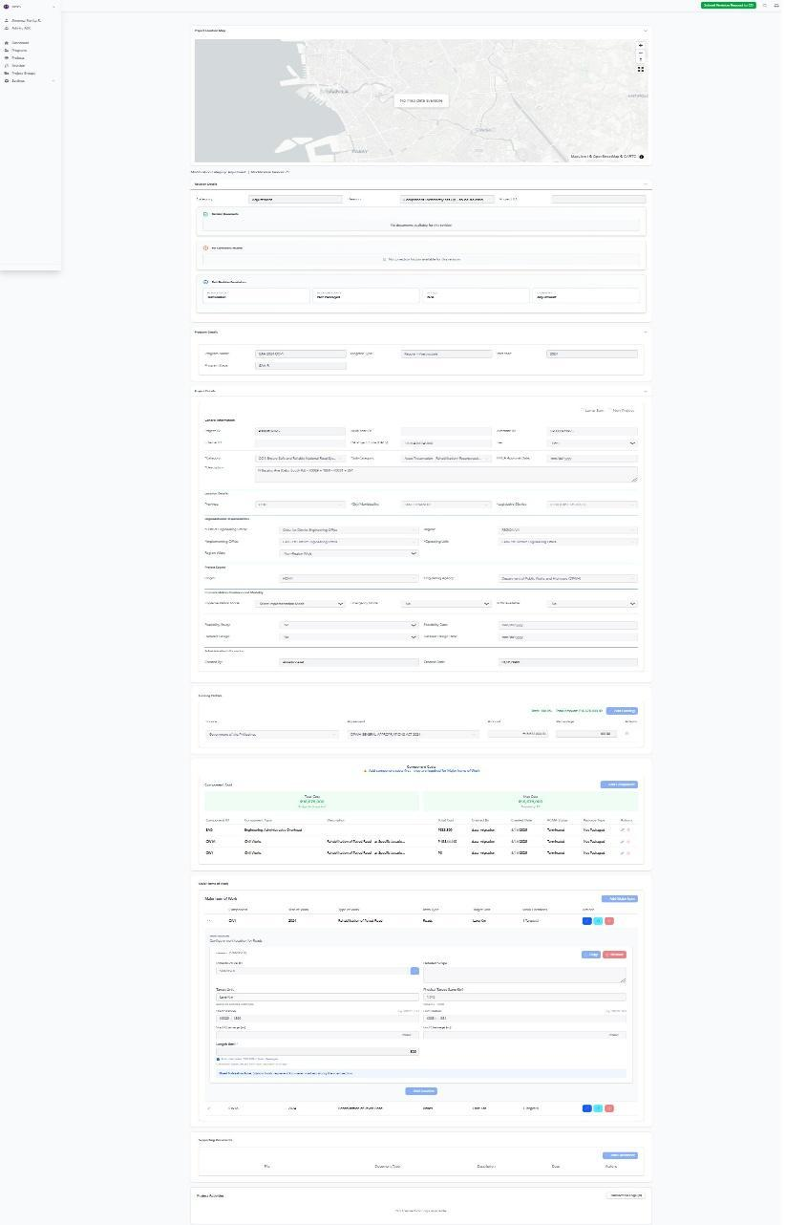

Purpose
This screen allows authorized users to prepare, review, and submit an Adjustment revision request for a selected project when a component was set up incorrectly and needs to be deleted from the project record. This adjustment is used to correct project component setup issues in MYPS while preserving proper revision control, status checking, and review workflow. “Component incorrectly set up - to be deleted” is listed as one of the valid Adjustment reasons in the Web-based MYPS references. Under the legacy MYPS rules, Adjustment is intended for minor corrections or completion of missing data that do not change what is reported in the GAA, and approved changes are reflected in PCMA through publishing.
Who uses this
This screen is available to authorized MYPS users with access to the module.
Prerequisites
Before using this screen, ensure that:
- You are signed in to the MYPS Web application.
- You have permission to access Revision and Adjustment functions.
- The selected project already exists in MYPS.
- The project is eligible for an Adjustment request.
- The component identified for deletion was incorrectly set up and the correction is justified.
- Supporting documents, if required by office procedure, are ready for upload.
Field Reference
No. | Fields/Blocks/Objects | Description | Values / Actions
UI-UX-0071-01 | PROJECT LOCATION MAP | Displays the mapped location of the selected project. | View-only or interactive map panel; may display No map data available if no spatial data exists.
UI-UX-0071-02 | MODIFICATION CATEGORY | Displays the selected revision type summary. | View-only summary; value is Adjustment.
UI-UX-0071-03 | MODIFICATION REASON | Displays the selected reason summary for the current adjustment. | View-only summary; value is Component incorrectly set up - to be deleted.
UI-UX-0071-04 | CATEGORY | Type of revision being applied. | Read-only or preselected field; value is Adjustment.
UI-UX-0071-05 | REASON | Specific reason for the adjustment request. | Selected reason: Component incorrectly set up - to be deleted.
UI-UX-0071-06 | PROJECT ID | Unique identifier for the selected project. | Auto-populated project ID; must match the intended project before submission.
UI-UX-0071-07 | REVISION DOCUMENTS | Area for attaching supporting files related to the adjustment request. | File upload area for memoranda, endorsements, or supporting attachments.
UI-UX-0071-08 | FOR CORRECTION HISTORY | Displays previous correction comments or returned revision notes. | View-only history/log section.
UI-UX-0071-09 | FULL REVISION PERMISSIONS | Displays revision-related status and rule sections available for review. | View-only or partially interactive depending on permissions.
UI-UX-0071-10 | PCMA STATUS | Current project status in PCMA. | Status display field.
UI-UX-0071-11 | PACKAGE STATUS | Current package lifecycle status. | Status display field.
UI-UX-0071-12 | STATUS | Current workflow status of the revision record. | Status display such as draft, under review, approved, rejected, or N/A.
UI-UX-0071-13 | CATEGORY STATUS | Displays the category classification within the revision summary block. | Status display; shown as Adjustment in this screen context.
UI-UX-0071-14 | PROJECT DETAILS RULE | Rule/reference section for project-level editable or reviewable data. | Review labels, permitted fields, and add/delete actions if enabled.
UI-UX-0071-15 | COMPONENT COST RULE | Rule/reference section for component cost-related checks. | Review-only or controlled action area depending on permissions.
UI-UX-0071-16 | COMPONENT COST YEAR RULE | Rule/reference section for yearly component cost checks. | Review-only or controlled action area depending on permissions.
UI-UX-0071-17 | MAJOR ITEM OF WORK RULE | Rule/reference section for major work item checks. | Review-only or controlled action area depending on permissions.
UI-UX-0071-18 | MAJOR ITEM LOCATION RULE | Rule/reference section for work location checks. | Review-only or controlled action area depending on permissions.
UI-UX-0071-19 | FUNDING PROFILE RULE | Rule/reference section for funding profile checks. | Review-only or controlled action area depending on permissions.
UI-UX-0071-20 | PROGRAM DETAILS | Displays the related program information for the selected project. | View-only section showing values such as Program Name, Program Type, Start Year, and Program Stage.
UI-UX-0071-21 | PROJECT DETAILS | Displays project-level administrative, category, and location information. | View-only or controlled fields depending on revision permissions.
UI-UX-0071-22 | SUBMIT REVISION REQUEST TO CO | Submits the completed adjustment request to Central Office for review. | Button action; submits the revision request into the next workflow step.
Step-by-step: Submit an Adjustment request for component incorrectly set up - to be deleted
1. Open the Revision module
Sign in to MYPS Web.
Go to the Revision module from the left navigation menu.
Open the selected project revision record for adjustment.
2. Confirm the screen context
Review the summary line above the form.
Confirm that the Modification Category is Adjustment.
Confirm that the Modification Reason is Component incorrectly set up - to be deleted.
3. Review the Project Location Map
Check the Project Location Map at the top of the screen.
Confirm that the map corresponds to the selected project location.
If the map shows No map data available, continue only if mapping is not required for this adjustment, or coordinate with GIS or system support if validation is needed.
4. Verify the Category and Reason
In the CATEGORY field, confirm that the value is Adjustment.
In the REASON field, confirm that the selected reason is Component incorrectly set up - to be deleted.
Use this reason only when an existing project component was created or configured incorrectly and must be removed from the MYPS record.
5. Verify the Project ID
Check the PROJECT ID field.
Confirm that the displayed project ID matches the intended project.
Do not proceed if the wrong project record is opened.
6. Upload supporting documents
In REVISION DOCUMENTS, upload any required supporting files.
These may include:
correction memorandum
approved instruction to remove the component
supporting justification note
comparison of incorrect and corrected setup
other endorsed project documents
7. Review correction history
Open or review the FOR-CORRECTION HISTORY section.
Check whether the request was previously returned or commented on.
Apply the required corrections before resubmitting.
If no previous correction exists, the system may show that no correction history is available for the revision.
8. Review current statuses
Check the revision summary area and confirm the current status information:
PCMA STATUS
PACKAGE STATUS
STATUS
CATEGORY STATUS
Make sure the project and revision are in a condition that allows submission of the adjustment request.
9. Review applicable rule sections
Review the visible rule/reference areas before submission:
Project Details Rule
Component Cost Rule
Component Cost Year Rule
Major Item of Work Rule
Major Item Location Rule
Funding Profile Rule
For this type of request, confirm that removing the incorrect component will not violate project structure, cost consistency, work item validation, or funding controls.
10. Review Program Details
Go to the Program Details section at the bottom of the screen.
Confirm the related program information, such as:
Program Name
Program Type
Start Year
Program Stage
Make sure the project is linked to the correct program record.
11. Review Project Details
Go to the Project Details section.
Review the project description, category, location, implementing office, and related identifiers.
Confirm that the component proposed for deletion belongs to the correct project record.
12. Check component deletion eligibility
Before submitting, confirm that the component can be deleted under current project conditions.
Based on legacy MYPS rules, component deletion is generally permitted only under eligible project and PCMA conditions, especially when the project is Not Yet Started and Not Packaged. More restricted conditions may block deletion.
13. Submit the request
After reviewing all fields and attachments, click Submit Revision Request to CO.
Wait for the confirmation message or updated workflow status.
Example inputs
Valid reason selection
Component incorrectly set up - to be deleted
Valid supporting document examples
approved component deletion memorandum
endorsed correction note
project setup correction reference
supporting internal review document
Appropriate use case examples
an incorrect project component was created by mistake
a duplicate or invalid component was added during setup
On success
The adjustment request is saved successfully.
The request is submitted to Central Office for review.
The revision workflow status updates accordingly.
Common Outcomes & What to Do
Message / Situation | What It Means | What To Do
Required field missing | One or more required items were not completed. | Complete the missing fields or upload the required supporting documents, then submit again.
Invalid project status | The current project or package condition does not allow this adjustment to proceed. | Review the PCMA Status, Package Status, and revision status before proceeding.
No map data available | No spatial data is currently linked to the project. | Continue only if mapping is not required for this adjustment, or coordinate with GIS support.

Attach the Approved Revision Document - Component incorrectly set up - to be deleted (UI-UX-0070)
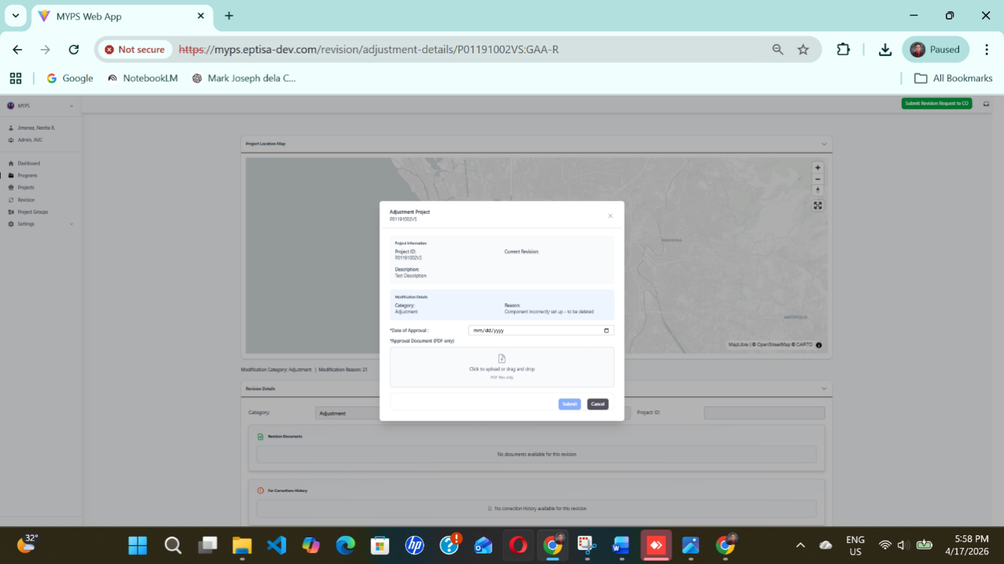
Purpose
This screen allows an authorized user to record the approval date and attach the approved supporting document for a submitted revision. In the D48 structure, attach document Approved Revision Document is a separate step before the later revision-type sections, while Adjustment is its own revision category.
Who uses this
This screen is available to authorized MYPS users with access to the module.
Prerequisites
Before using this screen, ensure that:
- you are logged in to MYPS Web
- the correct project revision record is already open
- the revision type has already been identified as Adjustment
- the reason is Component incorrectly set up - to be deleted
- the approved supporting document is available in PDF format
- you know the correct Date of Approval
Field Reference
No. | Fields/Blocks/Objects | Description | Allowed values / Actions
UI-UX-0072-01 | PROJECT ID | Unique identifier of the project being revised. | Display value; read-only.
UI-UX-0072-02 | CURRENT REVISION | Shows the current revision reference or status. | Display value; read-only.
UI-UX-0072-03 | DESCRIPTION | Full description of the selected project. | Display value; read-only.
UI-UX-0072-04 | CATEGORY | Shows the revision category applied to the project. | Displayed as Adjustment; read-only in this context.
UI-UX-0072-05 | REASON | Shows the selected reason for the revision. | Displayed as Component incorrectly set up - to be deleted; read-only in this context.
UI-UX-0072-06 | DATE OF APPROVAL | Date when the approved revision document was approved. | Required; date entry in mm/dd/yyyy format.
UI-UX-0072-07 | APPROVAL DOCUMENT (PDF ONLY) | Upload field for the approved revision document. | Required; accepts PDF only.
UI-UX-0072-08 | UPLOAD AREA | Drag-and-drop or click-to-upload zone. | Click to upload or drag and drop a PDF file.
UI-UX-0072-09 | SUBMIT | Saves and submits the revision document entry. | Click to submit the completed form.
UI-UX-0072-10 | CANCEL | Closes the modal without submitting. | Click to cancel the action.

Step-by-step: Attach the Approved Revision Document for an Adjustment
- Open the revision record
Access the selected project’s revision workflow and open the approval-document modal for the current revision. Confirm that the revision context is an Adjustment.
- Review the project information
Check the Project ID, Current Revision, and Description. Make sure you are working on the correct project before uploading any file.
- Verify the revision context
Confirm that:
  - Category is Adjustment
  - Reason is Component incorrectly set up - to be deleted
This reason is one of the listed Adjustment options in the UI/UX references.
- Enter the Date of Approval
Click Date of Approval and enter the correct approval date in mm/dd/yyyy format.
Example valid entry: 04/17/2026
Example invalid entry: 17/04/2026 if the field expects month/day/year.
The Auto Recovered D48 draft explicitly uses mm/dd/yyyy for this approval-document flow.
- Upload the approved document
In Approval Document (PDF only), click the upload area or drag and drop the file. Upload only the approved supporting document in PDF format. The D45 and D46 upload definitions state that document upload accepts PDF and supports click-to-upload or drag-and-drop behavior.
- Review the encoded information
Make sure:
  - the project details are correct
  - the approval date is complete
  - the uploaded file is the correct approved document
  - the revision reason remains Component incorrectly set up - to be deleted
- Submit the document entry
Click Submit to save and attach the approved revision document to the project’s revision record.
- Cancel if needed
If you do not want to continue, click Cancel to close the modal without saving changes.
On Success
After successful submission:
- the approval date is recorded
- the approved PDF document is attached to the revision record
- the revision history may reflect the newly submitted document, depending on workflow permissions and configuration
Common Outcomes & What to Do
Message / Situation | What It Means | What To Do
Required field missing | One or more required fields were left blank. | Complete all required fields before clicking Submit.
Invalid date format | The date entered does not match the required format. | Re-enter the date in mm/dd/yyyy format.
Invalid file type | The uploaded file is not a PDF. | Upload a valid PDF file only.

Change in Authority to Implement (UI-UX-0071)
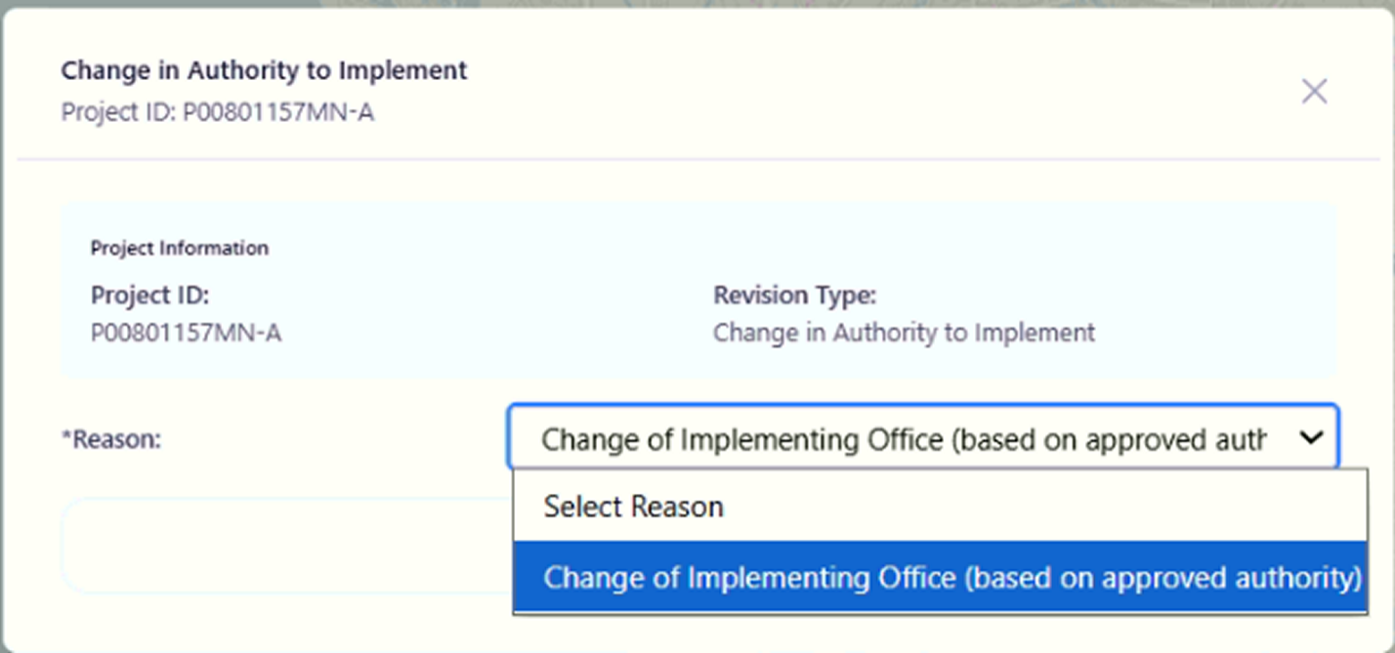
Purpose
The Change in Authority to Implement feature allows authorized users to request a change in the implementing office for a project. This revision is applied when there is a need to update or modify the authority responsible for implementing the project, typically due to approved authority changes.
Who Uses This
This screen is available to authorized MYPS users with access to the module.
Prerequisites
- You must be logged into your MYPS account.
- You must have permission to apply a change in authority for project implementation.
- The project must already be created in the system.
Field Reference
No. | Fields/Blocks/Objects | Description | Values / Actions
UI-UX-0073-01 | PROJECT ID | Displays the unique identifier for the project undergoing revision. | Example: P00801157MN-A. Auto-populated based on the selected project.
UI-UX-0073-02 | REVISION TYPE | Specifies the type of revision being applied to the project. | Value: Change in Authority to Implement.
UI-UX-0073-03 | REASON | Allows the user to select the reason for the change in authority to implement. | Options: 1. "Change of Implementing Office (based on approved authority)"

Step-by-Step: Apply Change in Authority to Implement
- Open the Change in Authority to Implement Page
  - Launch your browser and go to the MYPS Web URL provided by your office.
  - Navigate to the Change in Authority to Implement section under the Projects menu.
- Enter the Project ID
  - The Project ID field will automatically display the unique identifier for the selected project (e.g., P00801157MN-A).
  - Ensure the correct project ID is displayed, or manually enter it if necessary.
- Select the Revision Type
  - The Revision Type is automatically set to Change in Authority to Implement, indicating that the request is for changing the project’s implementing authority.
  - This field cannot be edited.
- Select the Reason for the Change
  - Click on the Reason dropdown.
  - Choose the reason for the change in implementing authority:
    - Change of Implementing Office (based on approved authority): This option is used when the change is due to an approved authority change.
- Submit the Revision Request
  - After selecting the Reason, click the Submit button to apply the revision.
  - A confirmation message will appear once the request is successfully submitted.
On Success
- The change request will be successfully submitted.
- The project details will be updated, and the Reason for the change in authority will be reflected in the project details.
Common Outcomes & What to Do
Message / Situation | What it Means | What You Should Do
“Request submitted successfully.” | The change request has been successfully recorded. | Review the updated project details to ensure the revision is correct.
“Field is required.” | A required field was left empty. | Complete the mandatory fields and submit again.
“Invalid date format.” | The date entered is not in the correct format. | Re-enter the date in MM/DD/YYYY format.

Change in Funding (UI-UX-0072)
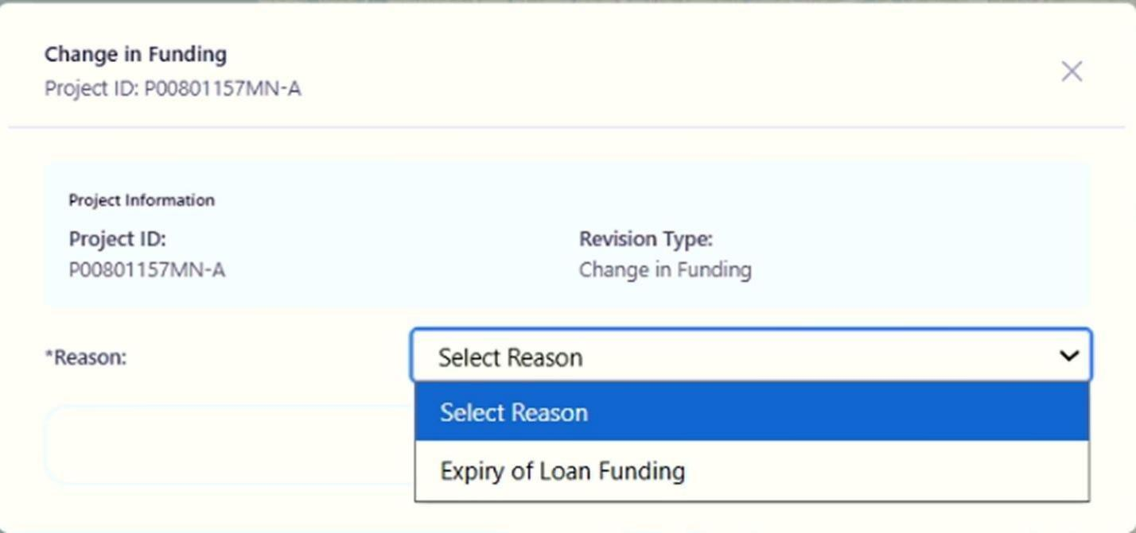

Purpose
The Change in Funding feature allows authorized users to request a revision related to changes in funding for a project. This revision is specifically used when there is a need to update or modify the funding for a project, such as an expiration of loan funding.
Who Uses This
This screen is available to authorized MYPS users with access to the module.
Prerequisites
- You must be logged into your MYPS account.
- You must have permission to apply a change in funding for a project.
- The project must already be created in the system.

Field Reference
No. | Fields/Blocks/Objects | Description | Values / Actions
UI-UX-0072-01 | PROJECT ID | Displays the unique identifier for the project. | Example: P00801157MN-A. Auto-populated based on the selected project.
UI-UX-0072-02 | REVISION TYPE | Specifies the type of revision being applied. | Value: Change in Funding
UI-UX-0072-03 | REASON | Allows the user to select the reason for the change in funding. | Options: 1. Expiry of Loan Funding (Additional options may be available, but only one is visible in this image).
Step-by-Step: Request Change in Funding
- Open the Change in Funding Page
  - Launch your browser and go to the MYPS Web URL provided by your office.
  - Navigate to the Change in Funding section under the Projects menu.
- Enter the Project ID
  - The Project ID field will automatically display the unique identifier for the selected project (e.g., P00801157MN-A).
  - Ensure that the correct project ID is shown. This is auto-populated based on the selected project.
- Select the Revision Type
  - The Revision Type is automatically set to Change in Funding, indicating that the request is for modifying project funding.
  - This field cannot be edited.
- Select the Reason for Change in Funding
  - Click on the Reason dropdown.
  - Select one of the following options:
    - Expiry of Loan Funding: Choose this option when the loan funding for the project has expired and a revision is necessary to adjust the funding.
- Submit the Revision Request
  - After selecting the Reason, click the Submit button to apply the funding change request.
  - A confirmation message will appear once the request is successfully submitted.
On Success
- The change request will be successfully submitted.
- The project details will be updated with the Reason for the funding change.
Common Outcomes & What to Do
Message / Situation | What it Means | What You Should Do
“Request submitted successfully.” | The change request has been successfully recorded. | Review the updated project details to ensure the revision is correct.
“Field is required.” | A required field was left empty. | Complete the mandatory fields and submit again.
“Invalid date format.” | The date entered is not in the correct format. | Re-enter the date in MM/DD/YYYY format.

Change of Creditor (UI-UX-0073)
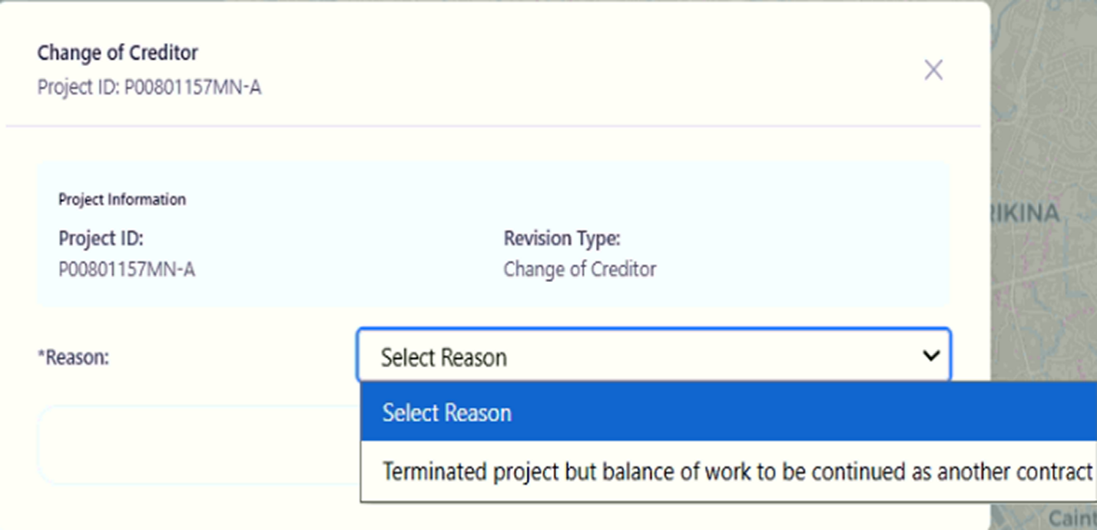
Purpose
The Change of Creditor feature allows authorized users to request a change of creditor for a project. This revision is typically required when a project transitions to a new creditor or if there is a need to adjust the existing creditor details for the project.
Who Uses This
This screen is available to authorized MYPS users with access to the module.
Prerequisites
- You must be logged into your MYPS account.
- You must have permission to apply a change of creditor for a project.
- The project must already be created in the system.
Field Reference
No. | Fields/Blocks/Objects | Description | Values / Actions
UI-UX-0073-01 | PROJECT ID | Displays the unique identifier for the project requiring a funding change. | Value: P00801157MN-A. Auto-populated based on the selected project.
UI-UX-0073-02 | REVISION TYPE | Specifies the type of revision being applied to the project. | Value: Change in Funding.
UI-UX-0073-03 | REASON | Allows the user to select the reason for the change in funding. | Dropdown options: 1. “Terminated project but balance of work to be continued as another contract.”
Step-by-Step: Request Change of Creditor
- Open the Change of Creditor Page
  - Launch your browser and go to the MYPS Web URL provided by your office.
  - Navigate to the Change of Creditor section under the Projects menu.
- Enter the Project ID
  - The Project ID field will automatically display the unique identifier for the selected project (e.g., P00801157MN-A).
  - Ensure the correct project ID is displayed. This is auto-populated based on the selected project.
- Select the Revision Type
  - The Revision Type is automatically set to Change of Creditor, indicating that this revision is for updating creditor information.
  - This field cannot be edited.
- Select the Reason for Change of Creditor
  - Click on the Reason dropdown.
  - Choose the appropriate reason for the change:
    - Terminated project but balance of work to be continued as another contract: Select this option when the project is terminated, but the remaining work will be completed under another contract.
- Submit the Revision Request
  - After selecting the Reason, click the Submit button to apply the creditor change request.
  - A confirmation message will appear once the request is successfully submitted.
On Success
- The change request will be successfully submitted.
- The project details will be updated with the Reason for the change of creditor.
Common Outcomes & What to Do
Message / Situation | What it Means | What You Should Do
“Request submitted successfully.” | The change request has been successfully recorded. | Review the updated project details to ensure the revision is correct.
“Field is required.” | A required field was left empty. | Complete the mandatory fields and submit again.
“Invalid date format.” | The date entered is not in the correct format. | Re-enter the date in MM/DD/YYYY format.

Expired Funding (UI-UX-0074)
Purpose
The Expired Funding feature allows authorized users to request a revision when a project has not commenced and the allocated funding has expired. This functionality helps to document and manage projects that no longer have active funding due to delays or other issues.
Who Uses This
This screen is available to authorized MYPS users with access to the module.
Prerequisites
You must be logged into your MYPS account.
You must have permission to apply a revision for expired funding.
The project must already be created in the system.
Field Reference
No. | Fields/Blocks/Objects | Description | Values / Actions
UI-UX-0074-01 | PROJECT ID | Displays the unique identifier for the project undergoing revision. | Value: P00801157MN-A. Auto-populated based on the selected project.
UI-UX-0074-02 | REVISION TYPE | Specifies the type of revision being applied to the project. | Value: Expired Funding.
UI-UX-0074-03 | REASON | Allows the user to select the reason for the expired funding. | Options: 1. "Project does not commence and funding has expired"
Step-by-Step: Request Expired Funding Revision
- Launch your browser and go to the MYPS Web URL provided by your office.
- Navigate to the Expired Funding section under the Projects menu.
- Enter the Project ID
- The Project ID field will automatically display the unique identifier for the selected project (e.g., P00801157MN-A).
- Ensure that the correct project ID is displayed. This is auto-populated based on the selected project.
- Select the Revision Type
The Revision Type is automatically set to Expired Funding, indicating that this revision is for expired project funding.
This field cannot be edited.
- Select the Reason for Expired Funding
- Click on the Reason dropdown.
- Select Project does not commence and funding has expired from the list of available reasons.
- Submit the Revision Request
- After selecting the Reason, click the Submit button to apply the expired funding revision request.
- A confirmation message will appear once the request is successfully submitted.
On Success
- The revision request will be successfully submitted.
- The project details will be updated, and the Reason for the expired funding revision will be reflected in the project.
Common Outcomes & What to Do
Message / Situation | What it Means | What You Should Do
“Request submitted successfully.” | The expired funding revision request has been successfully recorded. | Review the updated project details to ensure the revision is correct.
“Field is required.” | A required field was left empty. | Complete the mandatory fields and submit again.
“Invalid date format.” | The date entered is not in the correct format. | Re-enter the date in MM/DD/YYYY format.

For Savings – Partial Unutilized Balance (UI-UX-0075)
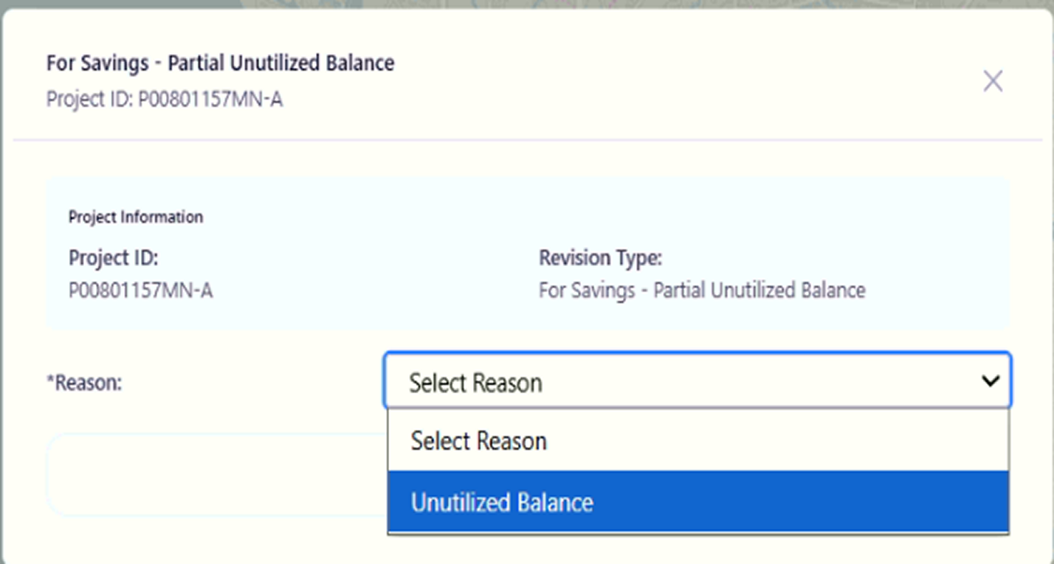
Purpose
The For Savings – Partial Unutilized Balance feature allows authorized users to request a revision based on savings from the unutilized balance of the project. This is typically required when a portion of the project’s allocated funds is not fully utilized and needs to be revised or reallocated.
Who Uses This
This screen is available to authorized MYPS users with access to the module.
Prerequisites
You must be logged into your MYPS account.
You must have permission to request a savings revision.
The project must already be created in the system.

Field Reference
No. | Fields/Blocks/Objects | Description | Values / Actions
UI-UX-0075-01 | PROJECT ID | Displays the unique identifier for the project requiring savings revision. | Example: P00801157MN-A. This is auto-populated based on the selected project.
UI-UX-0075-02 | REVISION TYPE | Specifies the type of revision being applied to the project. | Value: For Savings - Partial Unutilized Balance.
UI-UX-0075-03 | REASON | Allows the user to select the reason for requesting the savings revision. | Options: 1. "Unutilized Balance"
Step-by-Step: Request For Savings – Partial Unutilized Balance
- Open the For Savings – Partial Unutilized Balance Page
Launch your browser and go to the MYPS Web URL provided by your office.
Navigate to the For Savings – Partial Unutilized Balance section under the Projects menu.
- Enter the Project ID
The Project ID field will automatically display the unique identifier for the selected project (e.g., P00801157MN-A).
Ensure the correct project ID is displayed. This is auto-populated based on the selected project.
- Select the Revision Type
The Revision Type is automatically set to For Savings – Partial Unutilized Balance, indicating that the revision is based on unutilized funds.
This field cannot be edited.
- Select the Reason for the Revision
Click on the Reason dropdown.
Select Unutilized Balance as the reason for the revision.
- Submit the Revision Request
After selecting the Reason, click the Submit button to request the revision based on the unutilized balance.
A confirmation message will appear once the request is successfully submitted.

On Success
The revision request will be successfully submitted.
The project details will be updated with the Reason for the savings revision.

Common Outcomes & What to Do
Message / Situation | What it Means | What You Should Do
“Request submitted successfully.” | The revision request has been successfully recorded. | Review the updated project details to ensure the revision is correct.
“Field is required.” | A required field was left empty. | Complete the mandatory fields and submit again.
“Invalid date format.” | The date entered is not in the correct format. | Re-enter the date in MM/DD/YYYY format.

Mode of Implementation (UI-UX-0076)
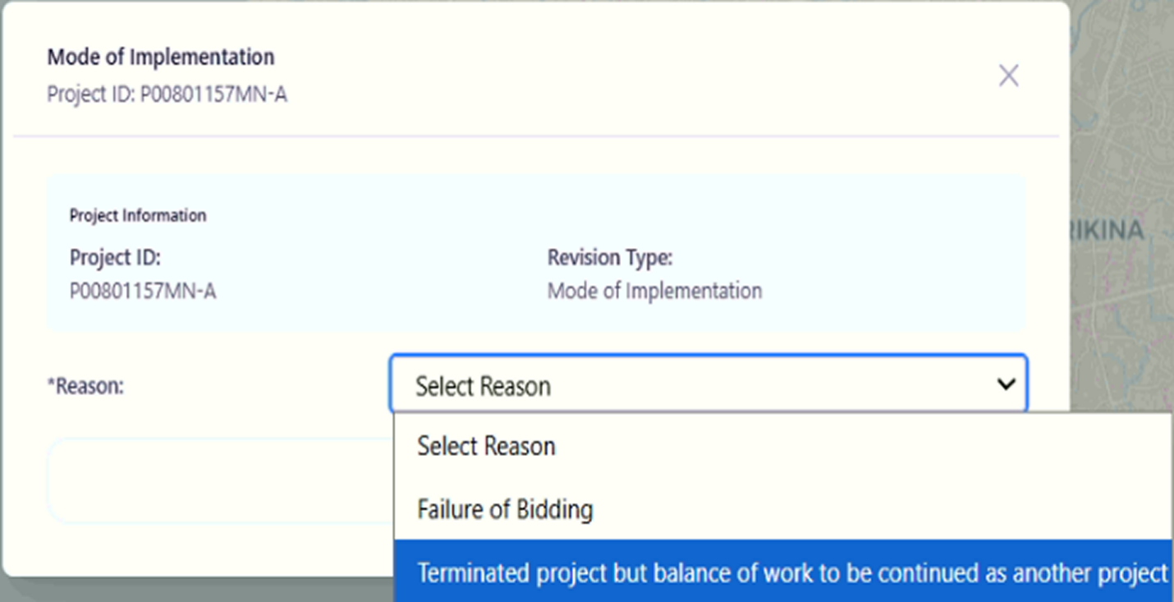
Purpose
The Mode of Implementation feature allows authorized users to request a revision related to how a project will be implemented. This revision may be used when bidding fails or when a terminated project has a remaining balance of work that must be continued under another project.
Who Uses This
This screen is available to authorized MYPS users with access to the module.
Prerequisites
You must be logged into your MYPS account.
You must have permission to request a Mode of Implementation revision.
The project must already be created in the system.
Field Reference
No. | Fields/Blocks/Objects | Description | Values / Actions
UI-UX-0076-01 | PROJECT ID | Displays the unique identifier for the project. | Value: P00801157MN-A (Example project ID).
UI-UX-0076-02 | REVISION TYPE | Specifies the type of revision being applied to the project. | Value: Mode of Implementation.
UI-UX-0076-03 | REASON | Allows the user to select the reason for requesting the mode of implementation revision. | Dropdown options: 1. “Failure of Bidding” 2. “Terminated project but balance of work to be continued as another project.”
Step-by-Step: Request Mode of Implementation Revision
1. Open the Mode of Implementation Page
Launch your browser and go to the MYPS Web URL provided by your office.
Navigate to the Mode of Implementation section under the project revision options.
2. Verify the Project ID
The Project ID field automatically displays the unique identifier for the selected project, such as P00801157MN-A.
Confirm that the displayed Project ID is correct before proceeding.
3. Review the Revision Type
The Revision Type is automatically set to Mode of Implementation.
This field indicates that the revision request is related to project implementation mode and cannot be edited.
4. Select the Reason for Revision
Click the Reason dropdown and select the appropriate option:
Failure of Bidding — Select this when the project requires revision because the bidding process failed.
Terminated project but balance of work to be continued as another project — Select this when a project has been terminated but the remaining balance of work must be continued under another project.
5. Submit the Revision Request
After selecting the correct reason, click the Submit button to request the revision.
A confirmation message will appear once the request is successfully submitted.
On Success
The revision request will be successfully submitted.
The project details will be updated with the Reason for the mode of implementation revision.
Common Outcomes & What to Do
Message / Situation | What it Means | What You Should Do
“Request submitted successfully.” | The revision request has been successfully recorded. | Review the updated project details to ensure the revision is correct.
“Field is required.” | A required field was left empty. | Complete the mandatory fields and submit again.

Modification (UI-UX-0077)
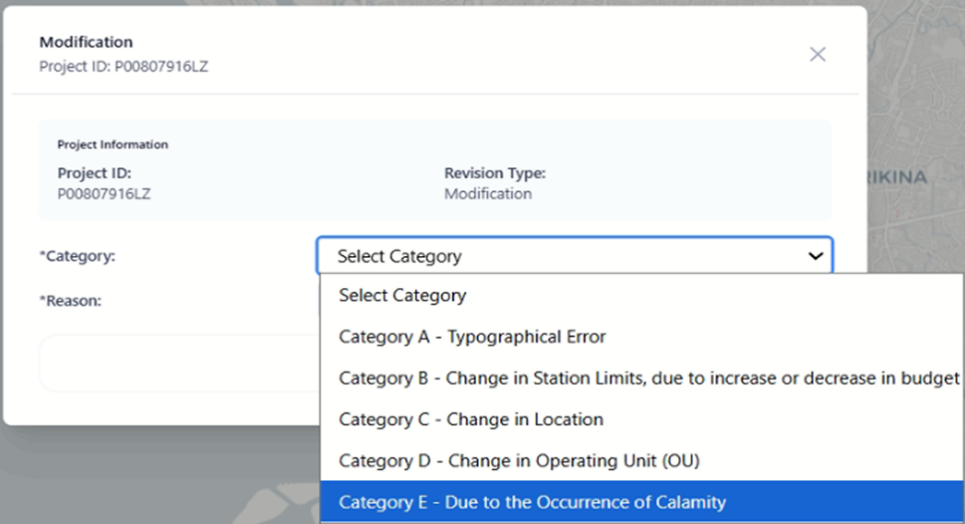
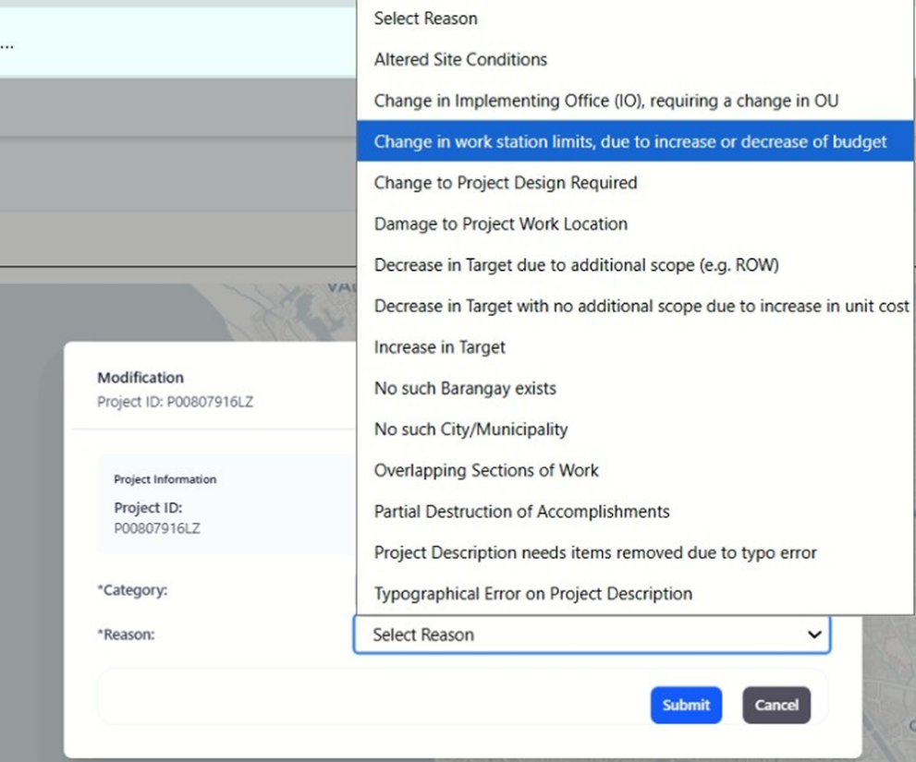

Purpose
The Modification feature allows authorized users to apply modifications to an existing project. This includes various reasons for modification, such as changes in the project's scope, budget, or execution due to unforeseen events or adjustments. The functionality is essential for keeping project details accurate and updated in the system.
Who Uses This
This screen is available to authorized MYPS users with access to the module.
Prerequisites
- You must be logged into your MYPS account.
- You must have permission to request a modification for a project.
- The project must already be created in the system.

Field Reference
No. | Fields/Blocks/Objects | Description | Values / Actions
UI-UX-0077-01 | PROJECT ID | Displays the unique identifier for the project undergoing modification. | Example: P00807916LZ. Auto-populated based on the selected project.
UI-UX-0077-02 | REVISION TYPE | Specifies the type of revision being applied to the project. | Value: Modification.
UI-UX-0077-03 | CATEGORY | Allows the user to select the category for the modification. | Options: - "Category A - Typographical Error" - "Category B - Change in Station Limits, due to increase or decrease in budget" - "Category C - Change in Location" - "Category D - Change in Operating Unit (OU)" - "Category E - Due to the Occurrence of Calamity"
UI-UX-0077-04 | REASON | Allows the user to select the reason for the modification. | Options: - "Altered Site Conditions" - "Change in Implementing Office (IO), requiring a change in OU" - "Change in work station limits, due to increase or decrease of budget" - "Change to Project Design Required" - "Damage to Project Work Location" - "Decrease in Target due to additional scope (e.g. ROW)" - "No such Barangay exists" - "Typographical Error on Project Description"
Step-by-Step: Request Modification
- Open the Modification Page
  - Launch your browser and go to the MYPS Web URL provided by your office.
  - Navigate to the Modification section under the Projects menu.
- Enter the Project ID
  - The Project ID field will automatically display the unique identifier for the selected project (e.g., P0080791612).
  - Ensure that the correct project ID is shown. This is auto-populated based on the selected project.
- Select the Revision Type
  - The Revision Type is automatically set to Modification, indicating that this revision is for modifying project details.
  - This field cannot be edited.
- Select the Category for Modification
  - Click on the Category dropdown.
  - Choose one of the following options:
    - Category A: Typographical Error
    - Category B: Change in Station Limits (due to increase or decrease in budget)
    - Category C: Change in Location
    - Category D: Change in Operating Unit (OU)
    - Category E: Due to the Occurrence of Calamity
- Select the Reason for the Modification
  - Click on the Reason dropdown.
  - Choose one of the following options:
    - Altered Site Conditions: For modifications due to changes in site conditions.
    - Change in Implementing Office (IO): When the project requires a change in the office responsible for implementation.
    - Change in Work Description: When the project’s work description needs updating.
    - Change in Project Work Location: If there is a change in the project’s location.
    - Increase in Target Due to Additional Scope: When the project’s scope and target need to be increased.
    - No Such Changes within PCMA: When no changes are observed within the Project and Contract Management Application (PCMA).
    - Decreasing Services of Work: When the scope or service of the project work is being reduced.
    - Partial Deduction of Accomplishments: If a deduction in accomplishments needs to be made.
    - Correction of Data entered into MYPS: When there is an error in the data entered into the system.
    - Typographical Error in Project Description: If there’s a typographical error in the project description.
- Submit the Modification Request
  - After selecting the Category and Reason, click the Submit button to apply the modification.
  - A confirmation message will appear once the request is successfully submitted.
On Success
- The modification request will be successfully submitted.
- The project details will be updated with the selected Category and Reason for modification.
Common Outcomes & What to Do
Message / Situation | What it Means | What You Should Do
“Modification request submitted successfully.” | The modification request has been successfully recorded. | Review the updated project details to ensure the revision is correct.
“Field is required.” | A required field was left empty. | Complete the mandatory fields and submit again.
“Invalid date format.” | The date entered is not in the correct format. | Re-enter the date in MM/DD/YYYY format.

Revision Modification Category A - Typographical Error – Project Description needs items removed due to typo error (UI-UX-0078)
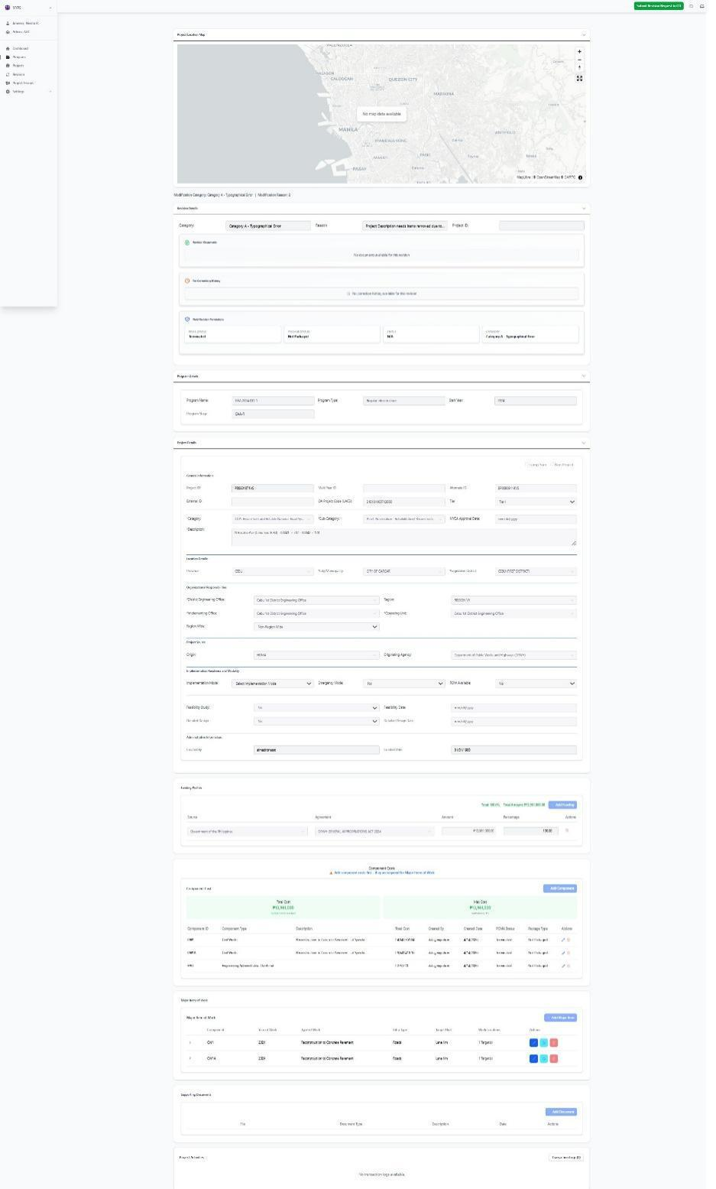

Purpose
This screen allows authorized users to prepare, review, and submit a Modification request for a selected project when the project description contains text that must be removed due to a typographical error. This request falls under Modification – Category A: Typographical Error. In MYPS, a Modification is used for approved changes to project data in the GAA with Revisions workflow, and the system records the reason, supporting approval reference, and the resulting field changes for audit trail and publishing to PCMA. The uploaded MYPS references show that Modification includes Category A - Typographical Error, and that project description is one of the fields that may be corrected through a modification workflow. The revision rules also list “Project Description needs items removed due to typo error” as a valid reason
Who uses this
This screen is available to authorized MYPS users with access to the module.
Prerequisites
Before using this screen, ensure that:
- You are signed in to the MYPS Web application.
- You have permission to access Revision and Modification functions.
- The selected project already exists in MYPS.
- The project is in the appropriate GAA with Revisions workflow or equivalent revision stage.
- The modification has an approved basis or supporting authority.
- The project description contains text that must be removed because of a typographical error.
- Supporting documents, if required by office procedure, are ready for upload.

Field Reference
No. | Fields/Blocks/Objects | Description | Allowed values / Actions
UI-UX-0078-01 | PROJECT LOCATION MAP | Displays the mapped location of the selected project. | View-only or interactive map panel; may display No map data available if no spatial data exists.
UI-UX-0078-02 | REVISION TYPE / MODIFICATION TYPE | Displays the selected revision type summary. | View-only summary; value is Modification.
UI-UX-0078-03 | CATEGORY | Displays the modification category applied to the request. | Selected value: Category A - Typographical Error.
UI-UX-0078-04 | REASON | Displays the specific reason for the current modification. | Selected reason: Project Description needs items removed due to typo error.
UI-UX-0078-05 | PROJECT ID | Unique identifier for the selected project. | Auto-populated project ID; must match the intended project before submission.
UI-UX-0078-06 | REVISION DOCUMENTS | Area for attaching supporting files related to the modification request. | File upload area for memoranda, approved references, or related attachments.
UI-UX-0078-07 | FOR CORRECTION HISTORY | Displays previous correction comments or returned revision notes. | View-only history/log section.
UI-UX-0078-08 | FULL REVISION PERMISSIONS | Displays revision-related status and rule sections available for review. | View-only or partially interactive depending on permissions.
UI-UX-0078-09 | PCMA STATUS | Current project status in PCMA. | Status display field.
UI-UX-0078-10 | PACKAGE STATUS | Current package lifecycle status. | Status display field.
UI-UX-0078-11 | STATUS | Current workflow status of the modification record. | Status display such as draft, under review, approved, rejected, or N/A.
UI-UX-0078-12 | CATEGORY STATUS | Displays the active category within the revision summary block. | Status display; shown as Category A - Typographical Error in this context.
UI-UX-0078-13 | PROJECT DETAILS RULE | Rule/reference section for project-level editable or reviewable data. | Review labels and permitted fields if enabled.
UI-UX-0078-14 | COMPONENT COST RULE | Rule/reference section for component cost-related checks. | Review-only or controlled action area depending on permissions.
UI-UX-0078-15 | COMPONENT COST YEAR RULE | Rule/reference section for yearly component cost checks. | Review-only or controlled action area depending on permissions.
UI-UX-0078-16 | MAJOR ITEM OF WORK RULE | Rule/reference section for major work item checks. | Review-only or controlled action area depending on permissions.
UI-UX-0078-17 | MAJOR ITEM LOCATION RULE | Rule/reference section for work location checks. | Review-only or controlled action area depending on permissions.
UI-UX-0078-18 | FUNDING PROFILE RULE | Rule/reference section for funding profile checks. | Review-only or controlled action area depending on permissions.
UI-UX-0078-19 | PROGRAM DETAILS | Displays the related program information for the selected project. | View-only section showing values such as Program Name, Program Type, Start Year, and Program Stage.
UI-UX-0078-20 | PROJECT DETAILS | Displays project-level administrative, category, location, and description information. | View-only or controlled fields depending on revision permissions.
UI-UX-0078-21 | SUBMIT REVISION REQUEST TO CO | Submits the completed modification request to Central Office for review. | Button action; submits the request into the next workflow step.
Step-by-step: Submit a Modification request for Category A – Typographical Error
1. Open the Revision module
- Sign in to MYPS Web.
- Go to the Revision module from the left navigation menu.
- Open the selected project revision record for modification.
- Locate the instance of the project in the corresponding GAA with Revisions stage, if applicable.
2. Confirm the screen context
- Review the summary line above the form.
- Confirm that the Revision Type is Modification.
- Confirm that the Category is Category A - Typographical Error.
- Confirm that the Reason is Project Description needs items removed due to typo error.
- Do not proceed if the wrong category or reason is shown.
3. Review the Project Location Map
- Check the Project Location Map at the top of the screen.
- Confirm that the map corresponds to the selected project location.
- If the map shows No map data available, continue only if map validation is not required for this modification, or coordinate with GIS or system support if needed. The uploaded revision guides use the same warning pattern for missing map data.
4. Verify the Project ID
- Check the PROJECT ID field.
- Confirm that the displayed project ID matches the intended project.
- Do not proceed if the wrong project record is opened.
5. Review the current project details
- Go to the Project Details section.
- Review the current Project Description and confirm which text must be removed.
- Confirm that the requested change is limited to deletion of erroneous words, phrases, or duplicated items caused by a typo.
- The legacy MYPS guidance states that under a modification, project description is one of the fields that should be checked and edited as necessary.
6. Edit the project description
- In the editable Project Description field, remove only the text that is incorrect due to the typographical error.
- Keep the rest of the description consistent with the approved project scope and official references.
- Do not introduce unrelated wording changes.
Example
- Current description: Rehabilitation of Road Section with Slope Protection works
- Corrected description: Rehabilitation of Road Section with Slope Protection works
7. Upload supporting documents
In REVISION DOCUMENTS, upload any required supporting files.
These may include:
- approved correction memorandum
- endorsed validation note
- scanned approved document reference
- project description correction notes
- other endorsed project documents
- The MYPS references state that modification workflows require storing the approval date and approved document reference, and that document support is part of the process.
8. Record the approved basis, if required
- If the screen or workflow requires it, record the Approval Date and the reference or hyperlink to the approved document.
- Use the approved office record as the basis for the typographical correction.
- MYPS legacy guidance states that for a modification, the user records the approval date and URL to approved documents before making the approved changes.
9. Review correction history
- Open or review the FOR-CORRECTION HISTORY section.
- Check whether the request was previously returned or commented on.
- Apply the required corrections before resubmitting.
- If no previous correction exists, the system may show that no correction history is available.
10. Review current statuses
Check the revision summary area and confirm the current status information:
- PCMA STATUS
- PACKAGE STATUS
- STATUS
- CATEGORY STATUS
11. Review applicable rule sections
Review the visible rule/reference areas before submission:
- Project Details Rule
- Component Cost Rule
- Component Cost Year Rule
- Major Item of Work Rule
- Major Item Location Rule
- Funding Profile Rule
12. Review Program Details and Project Details again
Go to the Program Details section and confirm the related program information, such as:
- Program Name
- Program Type
- Start Year
- Program Stage
Return to Project Details and confirm that the corrected project description now matches the approved wording.
13. Validate the modification
Before submitting, confirm that:
- the change is truly a typographical correction
- the project description only has items removed because of a typo error
- the corrected wording is supported by official project records
- the request does not introduce changes beyond the approved correction scope
14. Submit the request
- After reviewing all fields and attachments, click Submit Revision Request to CO.
- Wait for the confirmation message or updated workflow status.
- After the approved modification is saved, MYPS tracks the changed fields and the approved modification may later be published to PCMA.

Example inputs
Valid category selection
Category A - Typographical Error
Valid reason selection
Project Description needs items removed due to typo error
Valid use case examples
duplicate word must be removed from project description
incorrect extra phrase must be deleted from the description
description contains unintended text entered because of a typo
On success
- The modification request is saved successfully.
- The request is submitted to Central Office for review.
- The revision workflow status updates accordingly.
- Uploaded supporting documents are attached to the revision record.

Common Outcomes & What to Do
Message / Situation | What It Means | What To Do
Required field missing | One or more required items were not completed. | Complete the missing fields or upload the required supporting documents, then submit again.
Invalid category or reason | The selected modification setup does not match the intended correction. | Recheck the category and reason before proceeding.
Invalid project status | The current project or package condition does not allow this modification to proceed. | Review the PCMA Status, Package Status, and revision status before proceeding.

Attach the Approved Revision Document - Category A - Typographical Error – Project Description needs items removed due to typo error (UI-UX-0079)
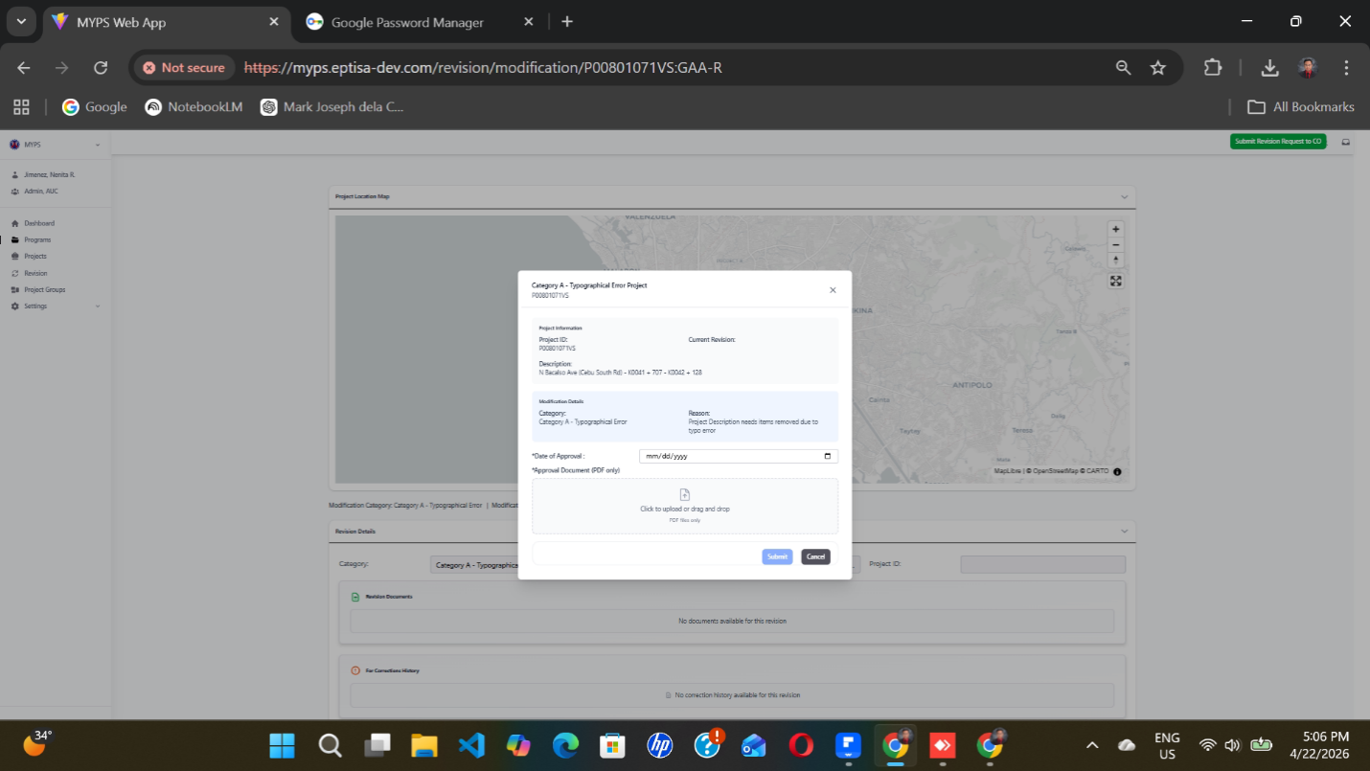
Purpose
This screen allows an authorized user to attach the approved revision document for an existing Modification request under Category A - Typographical Error. It is used when the reason is Project Description needs items removed due to typo error and the approved supporting document must be recorded before submission or final processing. MYPS revision workflows require recording the approval date and storing the approved document reference as part of the audit trail for approved changes.
Who uses this
This screen is available to authorized MYPS users with access to the module.
Prerequisites
Before using this modal:
- You must be signed in to MYPS Web.
- You must have access to the selected project under the Revision or Modification workflow.
- A modification request for the project must already exist.
- The selected category must be Category A - Typographical Error.
- The selected reason must be Project Description needs items removed due to typo error.
- You must have the approved revision document available in PDF format.
- Your role must permit uploading or submitting approved revision documents.

Field Reference
No. | Fields/Blocks/Objects | Description | Allowed values / Actions
UI-UX-0079-01 | PROJECT ID | Unique identifier of the project being revised. | Display value. Read-only on this screen.
UI-UX-0079-02 | CURRENT REVISION | Shows the current revision reference or status of the selected project. | Display value. If blank or not populated, confirm during UI validation/UAT.
UI-UX-0079-03 | DESCRIPTION | Full description of the selected project. | Display value. Read-only on this screen.
UI-UX-0079-04 | CATEGORY | Shows the revision category applied to the project. | Displayed as Category A - Typographical Error. Read-only.
UI-UX-0079-05 | REASON | Shows the reason for the selected revision category. | Displayed as Project Description needs items removed due to typo error. Read-only.
UI-UX-0079-06 | DATE OF APPROVAL | Date when the revision approval was approved. | Required. Date entry in MM/DD/YYYY format. Calendar picker icon is available.
UI-UX-0079-07 | APPROVED DOCUMENT (PDF ONLY) | Upload field for the approved revision document. | Required. Accepts PDF files only. User may click to upload or drag and drop a file.
UI-UX-0079-08 | UPLOAD AREA | Drag-and-drop zone for the approval document. | Click to upload or drag and drop a PDF file.
UI-UX-0079-09 | SUBMIT | Saves and submits the approved revision document entry. | Button labeled Submit.
UI-UX-0079-10 | CANCEL | Closes the modal without saving. | Button labeled Cancel.
Step-by-step: Attach the approved revision document
1. Open the modification record
- Sign in to MYPS Web.
- Open the selected project under the Revision or Modification workflow.
- Open the modal for attaching the approved revision document.
2. Review the project information
- Check the Project ID.
- Review the Current Revision field.
- Review the Description to confirm that the correct project is selected.
3. Confirm the modification details
- Check that Category is Category A - Typographical Error.
- Check that Reason is Project Description needs items removed due to typo error.
- Do not proceed if the wrong category or reason is shown. The request should match the approved modification being documented.
4. Enter the Date of Approval
In Date of Approval, enter the approval date in MM/DD/YYYY format.
You may use the calendar picker if available.
Example valid entry:
04/18/2026
Invalid entry example:
18/04/2026 if the system expects month/day/year.
5. Upload the approved document
- In Approved Document (PDF only), upload the approved revision document.
- You may click the upload area or drag and drop the file.
- Make sure the file is in PDF format only.
- The uploaded file should be the official approved reference for the typographical correction.
6. Review the encoded information
- Make sure the project details are correct.
- Confirm that the approval date is complete.
- Confirm that the PDF file has been attached successfully.
7. Submit or cancel
- Click Submit to save the approval date and uploaded approved document.
- Click Cancel if you do not want to continue.
- After submission, the document becomes part of the project’s revision record for later review and audit.
On success
- The approved revision document is uploaded successfully.
- The Date of Approval is saved.
- The project record is updated with the attached document for future reference.
- The revision request is submitted to the appropriate office for review or approval.
Common Outcomes & What to Do
Message / Situation | What It Means | What To Do
Required field missing | One or more mandatory fields were not completed. | Complete all required fields, especially Date of Approval and Approved Document.

Multi-Year Costing Changes (UI-UX-0080)
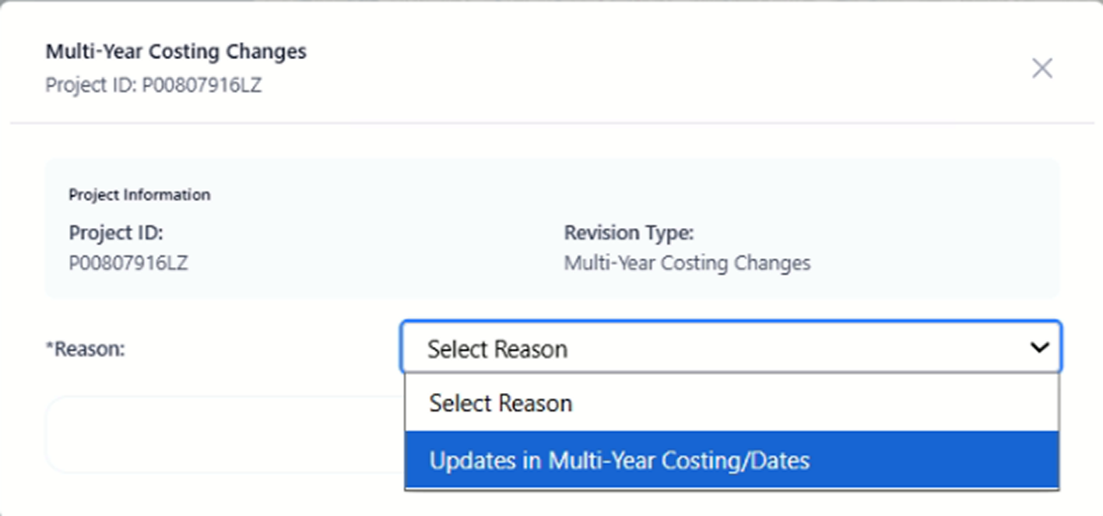
Purpose
The Multi-Year Costing Changes feature allows authorized users to apply revisions to multi-year costing or dates for a project. This functionality helps to adjust project budgets, costing allocations, or timelines that span multiple years.
Who Uses This
This screen is available to authorized MYPS users with access to the module.
Prerequisites
You must be logged into your MYPS account.
You must have permission to apply multi-year costing changes.
The project must already be created in the system.

Field Reference
No. | Fields/Blocks/Objects | Description | Values / Actions
UI-UX-0080-01 | PROJECT ID | Displays the unique identifier for the project undergoing revision. | Value: P00807916LZ (Example project ID).
UI-UX-0080-02 | REVISION TYPE | Specifies the type of revision being applied to the project. | Value: Multi-Year Costing Changes.
UI-UX-0080-03 | REASON | Allows the user to select the reason for the multi-year costing changes. | Options: 1. "Updates in Multi-Year Costing/Dates"

Step-by-Step: Request Multi-Year Costing Changes
Open the Multi-Year Costing Changes Page
Launch your browser and go to the MYPS Web URL provided by your office.
Navigate to the Multi-Year Costing Changes section under the Projects menu.
Enter the Project ID
The Project ID field will automatically display the unique identifier for the selected project (e.g., P0080791612).
Ensure the correct project ID is displayed. This is auto-populated based on the selected project.
Select the Revision Type
The Revision Type is automatically set to Multi-Year Costing Changes, indicating that this revision is for modifying multi-year cost allocations or dates.
This field cannot be edited.
Select the Reason for Revision
Click on the Reason dropdown.
Select Updates in Multi-Year Costing/Dates as the reason for the revision.
Submit the Revision Request
After selecting the Reason, click the Submit button to request the multi-year costing change.
A confirmation message will appear once the request is successfully submitted.

On Success
The revision request will be successfully submitted.
The project details will be updated with the Reason for the multi-year costing changes.

Common Outcomes & What to Do
Message / Situation | What it Means | What You Should Do
“Request submitted successfully.” | The revision request has been successfully recorded. | Review the updated project details to ensure the revision is correct.
“Field is required.” | A required field was left empty. | Complete the mandatory fields and submit again.

Non-Implementable (UI-UX-0081)
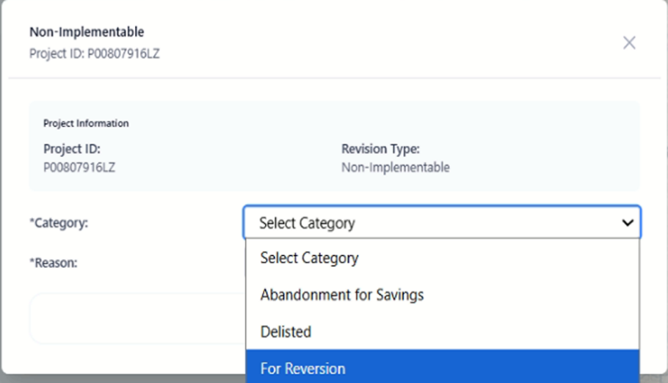
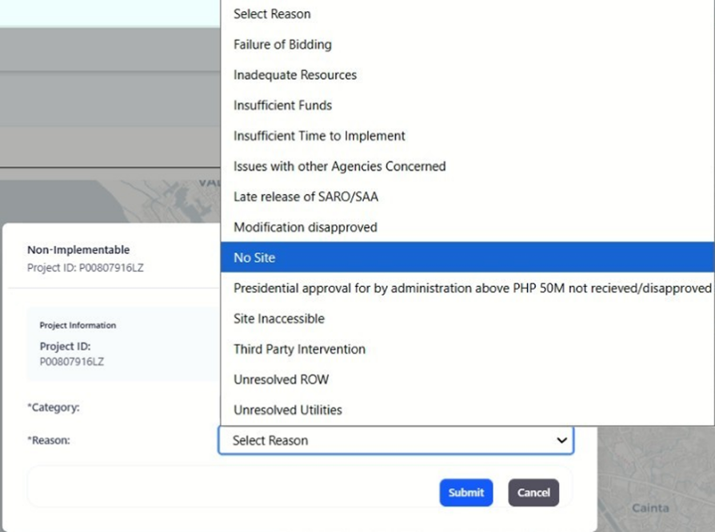
Purpose
The non-implementable feature allows authorized users to mark a project as non-implementable. This feature is used when a project cannot proceed due to reasons such as insufficient funding, failure in bidding, or other external issues that prevent the project from being executed.
Who Uses This
This screen is available to authorized MYPS users with access to the module.
Prerequisites
You must be logged into your MYPS account.
You must have permission to mark a project as non-implementable.
The project must already be created in the system.
Field Reference
No. | Fields/Blocks/Objects | Description | Values / Actions
UI-UX-0081-01 | PROJECT ID | Displays the unique identifier for the project. | Example: P00807916LZ (Auto-populated based on the selected project).
UI-UX-0081-02 | REVISION TYPE | Specifies the type of revision being applied to the project. | Value: Non-Implementable.
UI-UX-0081-03 | CATEGORY | Allows the user to select the category for the non-implementable project. | Options: - "Abandonment for Savings" - "Delisted" - "For Reversion"
UI-UX-0081-04 | REASON | Allows the user to select the reason for the project being marked non-implementable. | Options: - "Failure of Bidding" - "Inadequate Resources" - "Insufficient Funds" - "Insufficient Time to Implement" - "Issues with other Agencies Concerned" - "Late release of SARO/SAA" - "Modification disapproved" - "No Site" - "Presidential approval for projects above PHP 50M not received/disapproved" - "Site Inaccessible" - "Third Party Intervention" - "Unresolved ROW" - "Unresolved Utilities"

Step-by-Step: Mark Project as non-implementable
Open the Non-Implementable Page
Launch your browser and go to the MYPS Web URL provided by your office.
Navigate to the non-implementable section under the Projects menu.
Enter the Project ID
The Project ID field will automatically display the unique identifier for the selected project (e.g., P0080791612).
Ensure that the correct project ID is displayed. This is auto-populated based on the selected project.
Select the Revision Type
The Revision Type is automatically set to non-implementable, indicating that the revision is for marking the project as non-implementable.
This field cannot be edited.
Select the Category for Non-Implementable Project
Click on the Category dropdown.
Choose one of the following options:
Abandonment for Savings: Select this if the project is being abandoned for savings.
Deleted: Choose this if the project needs to be deleted from the system.
For Reversion: Select this if the project will be reverted back for further review.

Select the Reason for Non-Implement ability
Click on the Reason dropdown.
Choose one of the following options:
Failure of Bidding: If the project failed due to unsuccessful bidding.
Insufficient Resources: If there are insufficient resources to continue the project.
Insufficient Funds: If the project lacks the necessary funding.
Issues with Other Agencies Concerned: If there are issues with other involved agencies.
Late Release of SARO/SVP: If the SARO or SVP was released late, affecting the project.
Modification Disapproved: If a modification request was disapproved.
No Site: If no suitable site was found for the project.
Presidential Approval for Projects Above PHP 500M Not Received/Disapproved: If the project is awaiting or was denied presidential approval.
Site Inaccessible: If the site is inaccessible for the project.
Third Party Intervention: If third-party interference prevents the project from moving forward.
Unresolved ROW: If Right of Way (ROW) issues are unresolved.
Unresolved Utilities: If utility issues are preventing project implementation.
Submit the Non-Implementable Request
After selecting the Category and Reason, click the Submit button to mark the project as non-implementable.
A confirmation message will appear once the request is successfully submitted.
On Success
The project will be marked as non-implementable.
The project details will be updated with the Category and Reason for non-implement ability.

Common Outcomes & What to Do
Message / Situation | What it Means | What You Should Do
“Request submitted successfully.” | The project has been marked as non-implementable. | Review the updated project details to ensure the revision is correct.

Termination (UI-UX-0082)
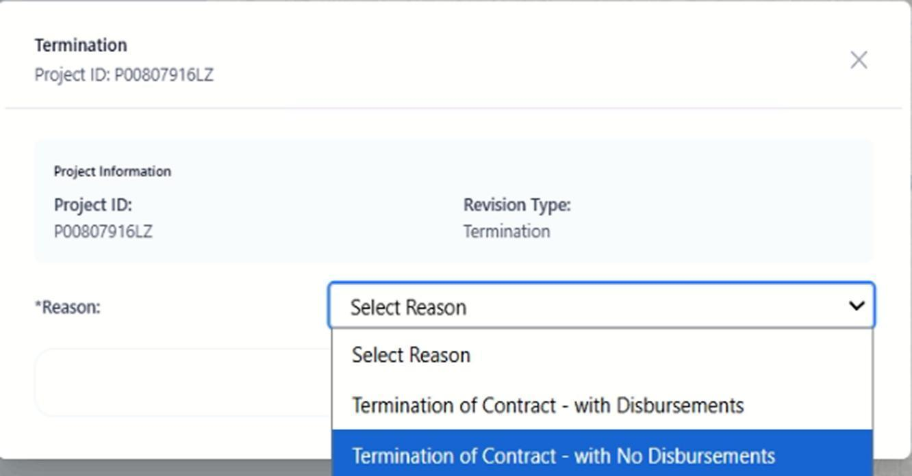
Purpose
The Termination feature allows authorized users to request the termination of a project. This function is used when a project needs to be formally ended, either due to completed goals or external factors, with or without financial disbursements.
Who Uses This
This screen is available to authorized MYPS users with access to the module.

Prerequisites
- You must be logged into your MYPS account.
- You must have permission to apply a termination to a project.
- The project must already be created in the system.
Field Reference
No. | Fields/Blocks/Objects | Description | Values / Actions
UI-UX-0082-01 | PROJECT ID | Displays the unique identifier for the project. | Example: P00807916LZ (Auto-populated based on the selected project).
UI-UX-0082-02 | REVISION TYPE | Specifies the type of revision being applied to the project. | Value: Termination.
UI-UX-0082-03 | REASON | Allows the user to select the reason for the termination. | Options: 1. "Termination of Contract - with Disbursements" 2. "Termination of Contract - with No Disbursements"
Step-by-Step: Request Termination
- Open the Termination Page
  - Launch your browser and go to the MYPS Web URL provided by your office.
  - Navigate to the Termination section under the Projects menu.
- Enter the Project ID
  - The Project ID field will automatically display the unique identifier for the selected project (e.g., P008079161Z).
  - Ensure the correct project ID is displayed. This is auto-populated based on the selected project.
- Select the Revision Type
  - The Revision Type is automatically set to Termination, indicating that the request is to end the project.
  - This field cannot be edited.
- Select the Reason for Termination
  - Click on the Reason dropdown.
  - Choose one of the following options:
    - Termination of Contract - with Disbursements: Select this if the contract is terminated but disbursements are still due.
    - Termination of Contract - with No Disbursements: Select this if the contract is terminated and no further disbursements are needed.
- Submit the Termination Request
  - After selecting the Reason, click the Submit button to apply the termination.
  - A confirmation message will appear once the request is successfully submitted.
On Success
- The termination request will be successfully submitted.
- The project details will be updated with the Reason for the termination
Common Outcomes & What to Do
Message / Situation | What it Means | What You Should Do
“Request submitted successfully.” | The termination request has been successfully recorded. | Review the updated project details to ensure the termination is correctly applied.
“Field is required.” | A required field was left empty. | Complete the mandatory fields and submit again.
“Invalid date format.” | The date entered is not in the correct format. | Re-enter the date in MM/DD/YYYY format.

Modification / Revision Approval (UI-UX-0083)

Role-Based Approval Routing
Requester / scenario | Reviewer / expected route
DEO-submitted revision | Routed to RPC or the configured regional reviewer.
RO-submitted revision | Routed to CO reviewer.
CO-reviewed revision | May require PS Admin final approval, correction, or rejection if configured.
Returned for correction | Requester updates the revision, uploads the corrected approval document if needed, checks certification, and resubmits.
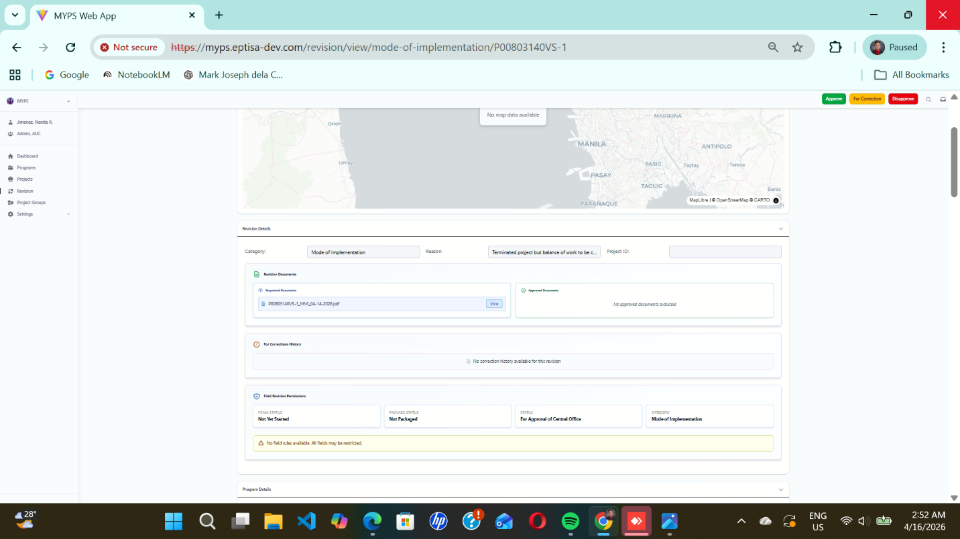
Purpose
The Modification / Revision Approval screen allows authorized reviewers and approvers to review and decide on a submitted project modification or revision request, such as a Mode of Implementation revision. From this screen, users can verify the revision details, review submitted and approved documents, check correction history, confirm the project’s PCMA status, package status, workflow status, and related program information before taking action.

Who uses this
This screen is available to authorized MYPS users with access to the module.
Prerequisites
Before using this screen, ensure that:
- You are signed in to the MYPS Web application.
- You have permission to review or approve modification/revision requests.
- A revision request has already been submitted by the requesting office or user.
- Supporting documents, if any, have already been uploaded by the requester.
Field Reference
No. | Fields/Blocks/Objects | Description | Values / Actions
UI-UX-0083-01 | PROJECT LOCATION MAP | Displays the map view of the selected project location for the revision under review. | Interactive map panel; if no spatial data is available, system displays “No map data available.”
UI-UX-0083-02 | APPROVE BUTTON | Approves the submitted modification or revision request. | Button labeled “Approve”; clicking approves the revision subject to user authority and validation.
UI-UX-0083-03 | FOR CORRECTION BUTTON | Returns the revision request for correction before approval. | Button labeled “For Correction”; clicking sends the request back for revision/correction.
UI-UX-0083-04 | DISAPPROVE BUTTON | Rejects the submitted modification or revision request. | Button labeled “Disapprove”; clicking rejects the revision request.
UI-UX-0083-05 | REVISION DETAILS SECTION | Displays the summary details of the current revision request. | Expandable section containing category, reason, and project reference information.
UI-UX-0083-06 | CATEGORY | Specifies the revision type currently being reviewed. | Read-only text/dropdown value, e.g., Mode of Implementation.
UI-UX-0083-07 | REASON | Displays the stated reason for the revision request. | Read-only text field showing the reason entered by the requester.
UI-UX-0083-08 | PROJECT ID | Displays the unique identifier of the project under revision. | Read-only alphanumeric project ID.
UI-UX-0083-09 | REVISION DOCUMENTS | Displays uploaded supporting documents submitted with the revision request. | Attachment list with file name and View action for opening the document.
UI-UX-0083-10 | APPROVED DOCUMENTS | Displays approval-related documents if any have already been attached or issued. | Attachment area; may display “No approved documents available.” when empty.
UI-UX-0083-11 | FOR CORRECTION HISTORY | Shows the correction history for the revision request. | Read-only history/log panel; may display “No correction history available for this revision.”
UI-UX-0083-12 | FINAL REVISION PARTICULARS | Displays the final summarized particulars of the revision for approval review. | Read-only section containing status fields relevant to approval.
UI-UX-0083-13 | PCMA STATUS | Indicates the current project status in PCMA. | Read-only status value, e.g., Not Yet Started.
UI-UX-0083-14 | PACKAGE STATUS | Indicates the status of the package associated with the revision. | Read-only status value, e.g., Not Packaged.
UI-UX-0083-15 | STATUS | Displays the current workflow status of the revision request. | Read-only status value, e.g., For Approval of Central Office.
UI-UX-0083-16 | CATEGORY (FINAL) | Displays the confirmed revision category in the final particulars section. | Read-only value, e.g., Mode of Implementation.
UI-UX-0083-17 | VALIDATION / WARNING MESSAGE | Displays warning or validation messages related to fields and approval restrictions. | Read-only system message, e.g., “No field rules available. All fields may be restricted.”
UI-UX-0083-18 | PROGRAM DETAILS SECTION | Displays the program information associated with the project revision. | Expandable read-only section showing program-level details.
Step-by-step: Review and process a modification / revision request
1. Open the approval screen
- Sign in to MYPS Web.
- Go to the Revision module.
- Open the submitted revision request that is pending your review.
- The Modification / Revision Approval screen will load.

2. Review the Project Location Map
- Check the Project Location Map at the top of the screen.
- Confirm that the location shown corresponds to the project under review.
- If the message “No map data available.” appears, continue review based on the available records, or coordinate with the GIS/admin team if location validation is required.

3. Expand and review the Revision Details section
Check the Revision Details section and verify the following:
- Category
- Reason
- Project ID
Make sure the revision type and stated reason are appropriate for the submitted request.

4. Review the supporting documents
Under Revision Documents:
- check the list of attached supporting files,
- click View to open and read each document,
- confirm that the attachments are complete, relevant, and valid.
If the request requires approval documentation and none is yet attached under Approved Documents, note this during your review.

5. Review correction history
Check the For Correction History panel.
- If the revision was previously returned for correction, review the remarks and updates.
- If the system displays “No correction history available for this revision.”, the request may be under first review.

6. Review final revision particulars
In the Final Revision Particulars section, review:
- PCMA Status
- Package Status
- Status
- Category (Final)
These fields help determine whether the revision is in the correct workflow stage for approval.

7. Read validation and warning messages
Look at the Validation / Warning Message area.
- Review any system warnings before taking action.
- If the system displays a message such as “No field rules available. All fields may be restricted.”, proceed carefully and base your decision on the supporting records and approval rules.

8. Review Program Details
Expand the Program Details section.
- Confirm that the program information matches the project being revised.
- Use this section to validate program-level context before approval.
- Step-by-step: Approve the revision
9. Approve the request
Click Approve only after confirming that:
- the revision category is correct,
- the reason is acceptable,
- required supporting documents are complete,
- project and status fields are valid,
- there are no blocking warnings or unresolved issues.
10. Confirm approval result
After clicking Approve:
- the request should move to the approved workflow state,
- status values may update,
- the decision becomes part of the audit trail.
Step-by-step: Return the request for correction
11. Send back for correction
Click For Correction if:
- information is incomplete,
- the supporting documents are missing or unclear,
- the reason is insufficient,
- the request needs clarification or revision before approval.

12. Confirm correction routing
After clicking For Correction:
- the request is returned to the requesting user or office,
- the revision enters correction workflow,
- the action is recorded in the correction history.
Step-by-step: Disapprove the revision
13. Disapprove the request
Click Disapprove if:
- the request is invalid,
- the revision is not allowable,
- supporting evidence is insufficient,
- the request should not proceed under current rules or status.
14. Confirm rejection result
After clicking Disapprove:
- the revision request is rejected,
- the workflow status is updated,
- the rejection is logged in the system.
On success
Depending on the action selected:
- Approve updates the request to an approved workflow status.
- For Correction returns the request for revision.
- Disapprove rejects the request and stops further processing unless refiled or otherwise allowed.
Common Outcomes & What to Do
Message / Situation | What It Means | What To Do
“No map data available.” | No spatial data is linked to the project. | Continue review if map validation is not required, or coordinate with GIS/admin.
“No approved documents available.” | No approval document has been attached yet. | Check if an approved document is required before deciding.

Revision List (UI-UX-0084)
Purpose
The Revision List screen allows users to view the revision history of projects recorded in MYPS. It shows the type of revision, project ID, reason, date, status, and an action to open more detailed information about the selected revision.
This screen helps users review project changes and track what revisions have been recorded for a project.
Who uses this
This screen is available to authorized MYPS users with access to the module.
Prerequisites
Before using this screen, ensure that:
- You are logged in to the MYPS Web application.
- You have permission to view revision history for projects.
- The project already exists in the system.
Field reference
No. | Fields/Blocks/Objects | Description | Values / Actions
UI-UX-0084-01 | REVISION TYPE | Specifies the type of revision made to the project. | Value: GAA 2027 - South province building project (Example revision type).
UI-UX-0084-02 | PROJECT ID | Displays the unique identifier for the project. | Example: P01155611LZ.
UI-UX-0084-03 | REASON | Describes the reason for the revision in the project. | Value: Highway expansion and improvement project for Region IV-A.
UI-UX-0084-04 | DATE | Shows the date when the revision was made. | Value: 3/15/2024.
UI-UX-0084-05 | STATUS | Indicates the status of the revision. | Value: Major Modification.
UI-UX-0084-06 | ACTION | Provides the option to view further details of the revision. | Action Button: "View" – Clicking this button opens
Step-by-step: View Revision List
- Open the Revision List page
Launch your browser and go to the MYPS Web URL provided by your office.
- Navigate to the Revision List screen
Open the Revision List section under the appropriate MYPS project or revision menu.
- View the list of revisions
Review the records displayed on the screen. Each row shows the revision details for a project.
- Check the Revision Type
Review the REVISION TYPE column to identify the type or context of the recorded revision.
- Check the Project ID
Confirm the PROJECT ID for the revision you want to review.
- Review the Reason
Read the REASON field to understand why the revision was recorded.
- Review the Date and Status
Check the DATE and STATUS fields to confirm when the revision was made and what type of revision it is.
- Open the revision details
Click the View button under the ACTION column for the selected revision.
- Review the detailed revision information
The system opens the detailed view for that revision. Review the recorded changes, reason, and any associated information shown by the system.
On success
- The Revision List screen loads and displays recorded project revisions.
- The selected revision record can be opened using the View button.
- Detailed information for the chosen revision is shown successfully.
Common Outcomes & What to Do
Message / Situation | What It Means | What To Do
“Revision details displayed successfully.” | The selected revision details were opened successfully. | Review the displayed information and confirm the revision details are correct.

Project Groups
Project Groups allow planners and reviewers to bundle related projects—for example, by corridor, funding source, or thematic thrust—without changing their underlying Program/Project structure. In the Web version, group management is handled through a dedicated set of screens:
- UI-UX-0087 – Project Groups (list and search)
- UI-UX-0088 – Add Project Group
- UI-UX-0089 – Project Groups Details
- UI-UX-0090 – Add Project to Group
- UI-UX-0091 – Delete Project Group
Behind the scenes, each Group is a first-class entity in the new ERD with its own identifier, metadata, and a many-to-many relationship to Projects. This replaces ad-hoc spreadsheets or coded

Project Groups (UI-UX-0085)

Exact Project ID Requirement
When adding projects to a project group, enter the exact Project ID. Partial matches should not be documented unless the current production UI supports them. Removing a project from a group does not delete the project record; it only unlinks the project from that group.
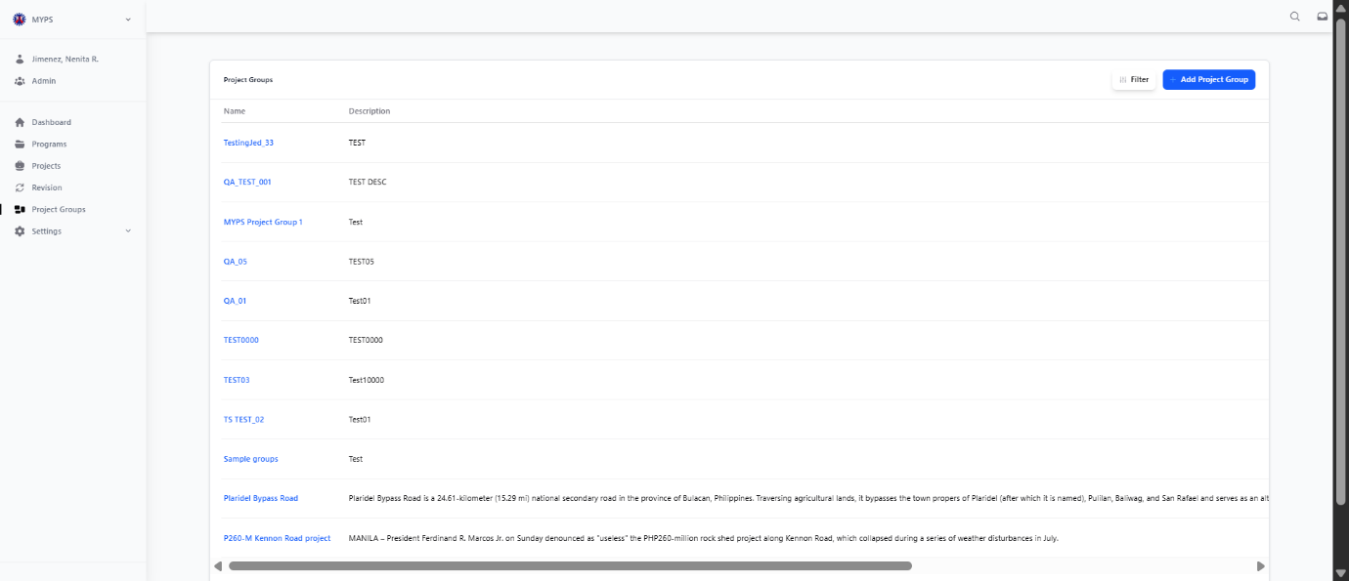
Purpose
Manage project groups by creating, viewing, filtering, and deleting records for each project group under the organization.
Who uses this
This screen is available to authorized MYPS users with access to the module.
Prerequisites
- User must be logged in with proper permissions to manage project groups.
- A stable internet connection.
- Access to the Project Groups page.

Field reference
No. | Fields/Blocks/Objects | Description | Values / Actions
UI-UX-0085- 01 | NAME | The title or official name of the project group. | Alphanumeric + punctuation; 5–200 chars; The title of the group. Project Group names must be unique. (for example, GAA 2025 SSP.)
UI-UX-0085-02 | DESCRIPTION | Summary or scope of the project group. | Alphanumeric + punctuation; 5–200 chars; A description explaining the scope or objective.
UI-UX-0085- 03 | NUMBER OF PROJECTS | Total count of projects under each group. | Numeric; 5–200 chars; The quantitative measure of associated projects.
UI-UX-0085- 04 | USER GROUP | Indicates which user group manages the project group. | Alphanumeric + punctuation; 5–200 chars; The associated administrative or access group (for example DPD Admin.)
UI-UX-0085- 05 | CREATED DATE | Date when the project group record was created. | Numeric in MM/DD/YYYY format; Range: Month: 01-12, Day: 01-31, Year: 1990–2100; required.
UI-UX-0085- 06 | CREATED BY | Name of the user (and department) who created the record. | User identification.
UI-UX-0085- 07 | ADD PROJECT | Opens a form/modal for creating a new project group record. | Button “Add Project”; Action to initiate the creation of a new group.
UI-UX-0085- 08 | FILTER | Used to filter or search for project groups. | Button “Filter”; Action/input to search or filter the list.
UI-UX-0085- 09 | ACTIONS/VIEW | Opens the Project Group in view/edit mode depending on user permissions. | Button “View”; Action to view or edit the group.
UI-UX-0085- 10 | ACTIONS/DELETE | Removes the Project Group from the list (soft delete/archive). Shown only when deletable and user is authorized. | Button “Delete”; Action to remove or delete the group.
UI-UX-0085- 11 | PAGINATION | Navigation for browsing through multiple project group pages. | Button “Page”; Navigation control.

Step-by-step: Manage Project Groups
- Access the Project Groups Page
  - After logging in, navigate to the Project Groups section from the main navigation menu.
  - You will be redirected to the Project Groups page, which displays a list of all existing project groups.
- Add a New Project Group
  - Click on the Add Project button at the top-right corner of the page.
  - This will open a form/modal where you can enter the Project Group Name, Description, and other necessary details.
  - Click Submit to create the new project group.
- Filter Project Groups
- To search or filter the list of project groups, click the Filter button.
- Input your desired search criteria (e.g., project name, user group).
- Click Apply Filter to narrow down the list based on the selected filter.
- View a Project Group
- In the Actions column of each project group, click the View button.
- This will open the selected project group in view/edit mode depending on your user permissions.
- Delete a Project Group
- In the Actions column of each project group, click the Delete button to remove the project group from the list.
- Deletion is soft (archive) unless the user has permission to fully delete it.
- Navigate Between Pages of Project Groups
- If there are more than one page of project groups, use the Pagination controls at the bottom of the list.
- Click Next or Previous to move between pages, or use the page number input to jump to a specific page.
On success
- After successfully creating, viewing, or deleting a project group, the relevant action will be reflected in the list, and a confirmation message will appear if applicable.

Common Outcomes & What to Do
Message / Situation | What it Means | What You Should Do
“Project Group Created.” | The new project group was successfully created. | Verify the project group is listed correctly.
“Project Group Deleted.” | The selected project group was removed. | Refresh the list to ensure it is no longer listed.
"Filter results found." | The filter successfully narrowed down the list. | Review the filtered results.

Add New Project Groups (UI-UX-0086)
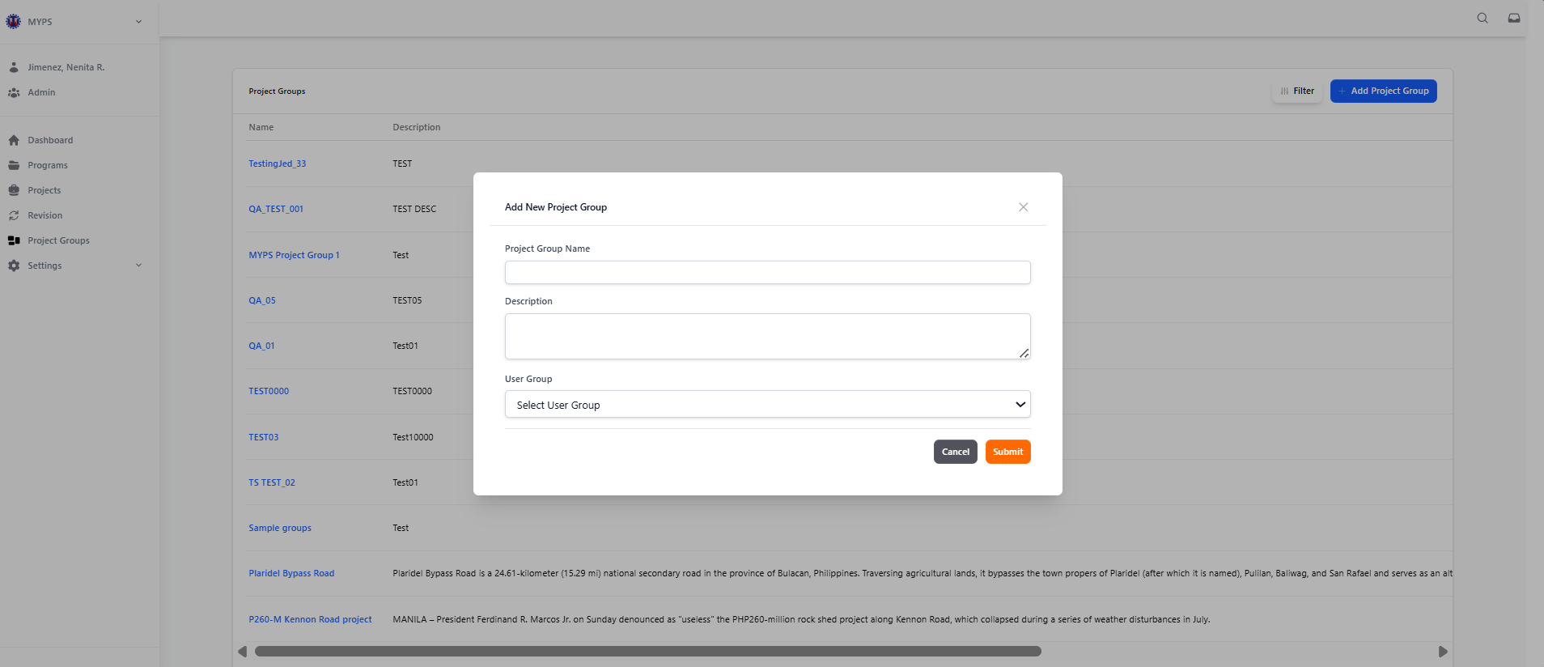
Purpose
Allows users to create and define new project groups for categorizing related projects under a common group or initiative.
Who uses this
This screen is available to authorized MYPS users with access to the module.
Prerequisites
- User must have administrative access or appropriate permissions to create new project groups.
- A stable internet connection is required.
- Access to the "Add New Project Group" form.
Field reference
No. | Fields/Blocks/Objects | Description | Values / Actions
UI-UX-0086-01 | PROJECT GROUP NAME | Allows users to create, define, and manage project group names used to categorize related projects under a common group or initiative. | Text Input; The name must be unique.
UI-UX-0086-02 | DESCRIPTION | Summary or scope of the project group. | Text Input; A description explaining the scope or objective.
UI-UX-0086-03 | USER GROUP | Allows administrators to assign or manage user groups associated with specific project groups. This functionality defines which user groups have access, editing rights, or viewing permissions for particular project groups. | Identifies each stage of the  User Group/Role Sample Type of Admin or Administrators, IO (Implementing Office), CO (Central Office), Ops (Operations), Planner, Reviewer, Viewer, Engineer, Project Coordinators, Read Only User.
UI-UX-0086-04 | SUBMIT | Executes and saves the Project Group. | Button” Submit”; Action to save the new Project Group record.
UI-UX-0086-05 | CANCEL | Cancels the operation and closes the form. | Button” Cancel”; Action to discard the new Project Group.
Step-by-step: Add a New Project Group
- Open the Add New Project Group Form
  - On the Project Groups page, click the Add Project button. This will open the "Add New Project Group" form where you can define the details of the new project group.
- Enter the Project Group Name
  - In the Project Group Name field, type a unique name for the project group. The name should be concise and reflective of the project’s objective.
  - Ensure the name is unique, as duplicate names are not allowed.
Example valid entry: GAA 2025 SSP
Invalid entry: GAA 2025 SSP Project (too long, exceeds character limit)
- Provide a Description
  - In the Description field, input a brief summary or scope of the project group. This description should provide enough context to explain the group’s purpose and scope.
Example valid entry: "Project group for overseeing road construction under the GAA 2025 budget."
Invalid entry: Leaving the field empty or irrelevant text.
- Select a User Group
  - In the User Group dropdown, select the appropriate group that will manage the project. This could be an admin group, a planning group, or other relevant users.
Example valid selection: DPD Admin
Invalid selection: Leaving the dropdown as "Select User Group" or selecting the wrong user group.
- Submit the New Project Group
  - After entering the details, click the Submit button to create and save the new project group.
  - A confirmation message will appear indicating the project group was successfully created.
- Cancel the Operation (if needed)
  - If you decide not to create the project group, click the Cancel button. This will discard the changes and close the form without saving any information.
  - All entered data will be lost.
On success
- After successful submission, the new project group will appear in the Project Groups list with its name, description, and associated user group.
- A success notification will confirm the project group creation.
Common Outcomes & What to Do
Message / Situation | What it Means | What You Should Do
“Project Group Created Successfully.” | The new project group has been added. | Verify the project group is listed and correctly saved
"Please enter a valid Project Group Name." | The name is either already used or invalid. | Change the name to a unique and valid entry.

Project Groups Details (UI-UX-0087)
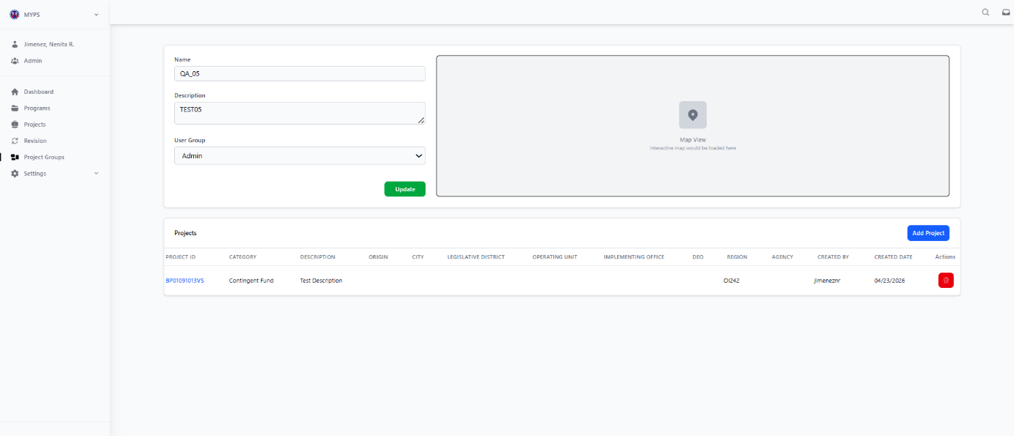
Purpose
Allows users to view and edit details of existing project groups, including basic information, location, and associated administrative data.
Who uses this
This screen is available to authorized MYPS users with access to the module.
Prerequisites
- User must have access rights to view and edit project groups.
- A stable internet connection is required.
- Access to the Project Groups page, with at least one project group to edit.
Field Reference
No. | Fields/Blocks/Objects | Description | Values / Actions
UI-UX-0087-01 | NAME | Allows editing the official name or code of the project group. | Editable text input; Project Group names must be unique.
UI-UX-0087-02 | DESCRIPTION | Allows editing a brief description or title of the project group, explaining its scope or main objective. | Editable text input. Text description detailing the project group.
UI-UX-0087-03 | USER GROUP | The user role or administrative group assigned to manage this project group. | Identifies each stage of the  User Group Type of Programming Division (PD), Development Planning Division (DPD), Road Program Office (RPO), etc.
UI-UX-0087-04 | MAP SECTION | Displays a map showing the project’s general geographic location. | Visual display of project location.
UI-UX-0087-05 | UPDATE BUTTON | Saves any modifications made to the project group information. | Button “Update”; Action to save changes.
UI-UX-0087-06 | PROJECT ID | Unique system-generated identifier for the project. | Text message; Listed as clickable links. (A Project ID is a unique identifier assigned by the user upon entry into MYPS, for example, P01155611LZ)
UI-UX-0087-07 | CATEGORY | General classification or type of the project. | Text message; Identifies each stage of the Category type of OO-1, OO-2, Regular Infrastructure, Foreign Assisted Projects, Local Program (LP), Trust Fund etc.
UI-UX-0087-08 | DESCRIPTION | Short summary or details of the project. | Text message; Short description of the project scope or purpose. (This is also known as the Name of the Project, e.g., ‘Cebu South Road Project’)”
UI-UX-0087-09 | ORIGIN | The source or proposing department. | Text message: Identifies each stage of the Origin type of Airport Road Analysis (ARA), BIP, Bridge Management Systems (BMS), Bridges Management Cluster etc.
UI-UX-0087-10 | CITY | The specific city or municipality. | Text message; The location where the project is done.
UI-UX-0087-11 | LEGISLATIVE DISTRICT | The political or legislative district of the project site. | Text message; Legislative District type of Legislative district of Bulacan,  Legislative district of Pampanga, Legislative district of Tarlac, Legislative district of Pangasinan, etc.
UI-UX-0087-12 | OPERATING UNIT | The administrative unit operating the project. | Text message; Operating Unit type of Agusan del Norte District Engineering Office, Aklan District Engineering Office etc.
UI-UX-0087-13 | IMPLEMENTING OFFICE | The actual unit implementing or executing the project. | Text message; Agusan del Norte District Engineering Office.
UI-UX-0087-14 | DEO | Select the District Engineering Office responsible for the project revision. Usually, pre-filled based on user account. | Text message; Butuan City DEO, Agusan del Norte DEO, Negros Occidental 4th, Negros Occidental 2nd, Negros Oriental 1st.
UI-UX-0087-15 | REGION | Identifies the regional office under which the District Engineering Office (DEO) operates. | Text message; Autonomous region in Muslim Mindanao (ARMM), Region IV-A, Metro Manila, Central Office (CO), Region (General Designation).
UI-UX-0087-16 | AGENCY | Identifies the main implementing government agency responsible for the project. This ensures the project modification is properly attributed to the correct department. | Text message; Department of Budget and Management (DBM), National Economic and Development Authority (NEDA), National Disaster Risk Reduction and Management Council (NDRRMC), etc.
UI-UX-0087-17 | CREATED BY | Identifies the user or personnel who initially created or encoded the project or revision record in the system. This field provides accountability and traceability for system entries. | Creator's identification.
UI-UX-0087-18 | CREATED DATE | Indicates the exact date and time when the project record or revision entry was first created in the system. This is automatically generated by the system upon record creation. | 4-digit numeric (YYYY); range 1990–2100; required.
UI-UX-0087-19 | ADD PROJECT BUTTON | Adds a new project entry under this project group. | Button “Add Project”; Action to add a new project to the group.

Step-by-step: View/Edit Project Group
- Open the View/Edit Project Group Form
  - Navigate to the Project Groups page.
  - Click on the View/Edit button in the Actions column for the desired project group.
- Edit Project Group Name
  - In the Project Group Name field, modify the name if necessary. The name must remain unique.
Example valid entry: GAA 2025 SSP
Invalid entry: GAA 2025 SSP Project (too long or duplicate name).
- Edit the Description
  - In the Description field, update the project’s description. This should clearly explain the scope and objectives of the project group.
Example valid entry: "Group overseeing the construction of roads under the GAA 2025 budget."
Invalid entry: Leaving the field blank.
- Select/Modify User Group
  - In the User Group dropdown, select or modify the user group responsible for the project.
  - This defines the group’s access and permissions.
Example valid selection: DPD Admin
Invalid selection: Leaving it empty or selecting an incorrect group.
- View/Modify Other Fields
  - Update the Category, Origin, City, Legislative District, and other fields as necessary.
  - Ensure that all changes are accurate and correspond to the project details.
- View the Map Section
  - The Map Section will display the geographic location of the project.
  - If the location is incorrect, update the related fields (e.g., City, Region) to reflect the accurate location.
- Save Changes
  - After making the necessary changes, click the Update button to save the modified project group.
  - A confirmation message will appear indicating that the changes were saved successfully.
- Add a New Project (if needed)
  - To add a new project to the group, click the Add Project button.
  - This will open a new form for entering project details under the selected project group.
- Cancel the Operation
  - If you do not wish to save any changes, click the Cancel button to discard your modifications. The form will close without saving changes.
On success
- After successful update, the system will display the updated project group details.
- A success notification will confirm the changes have been saved.

Common Outcomes & What to Do
Message / Situation | What it Means | What You Should Do
“Project Group Updated Successfully.” | The project group was updated. | Verify the changes and ensure the information is accurate.
"Invalid Project Name." | The project group name is invalid or a duplicate. | Change the name to a unique one and resubmit.

Add Project to Group (UI-UX-0088)
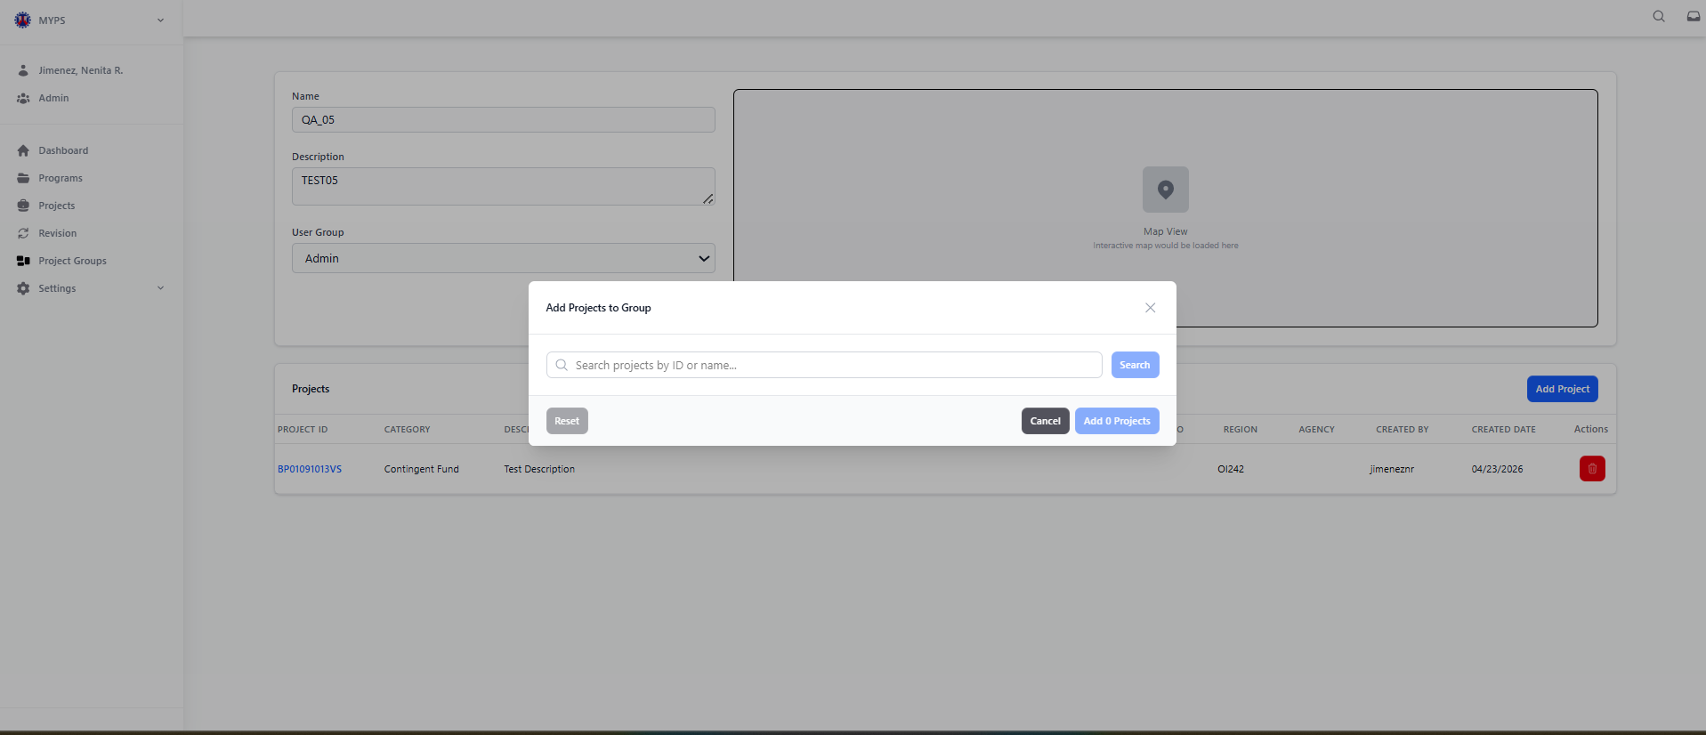
Purpose
Allows users to search for projects and add them to a specific project group.
Who uses this
This screen is available to authorized MYPS users with access to the module.
Prerequisites
- User must be logged in and have permission to add projects to a group.
- The user must have access to an existing project group to add projects.
- A stable internet connection is required.

Field reference
No. | Fields/Blocks/Objects | Description | Values / Actions
UI-UX-0088-01 | SEARCH FIELD | Allows the user to find projects by typing a keyword, project ID, or project name. | Text Input; User input for keyword, ID, or name search.
UI-UX-0088-02 | SEARCH BUTTON | Executes the search query to display matching project results. | Button “Search” Action button to execute search.
UI-UX-0088-03 | RESULT LIST (Dynamic) | Displays projects matching the search input. Each result can be selected for grouping. | Text Input; List of selectable project records.
UI-UX-0088-04 | RESET BUTTON | Clears all current search filters and selected projects. | Button “Reset” Action to clear filters and selections.
UI-UX-0088-05 | CANCEL BUTTON | Closes the modal without saving or adding any projects. | Button “Cancel” Action to close the modal and discard unsaved changes.
UI-UX-0088-06 | ADD PROJECTS BUTTON | Confirms and adds the selected projects into the chosen project group. The number in the button (e.g., “Add 0 Projects”) dynamically updates based on the number of selected projects. | Button “Add Project” Action to confirm and save the selected projects to the group.

Step-by-step: Add Project to Group
- Open the Add Project to Group Modal
  - Navigate to the appropriate project group and click the Add Project button. This will open the "Add Project to Group" modal.
- Search for Projects
  - In the Search Field, enter a keyword, project ID, or project name related to the projects you want to add.
  - Click the Search button to execute the query. The Result List will display projects that match the search criteria.
Example search: Enter "GAA 2025 Road Construction" to find relevant projects.
Invalid search: Entering a project ID or name that doesn't exist or using incomplete search terms.
- Select Projects from the Result List
  - Browse the Result List and select the projects you want to add to the group.
  - Each result in the list is selectable and can be added to the project group.
- Reset Search Filters
  - If needed, click the Reset button to clear all filters and selections from the search, allowing you to start a new search.
- Add the Selected Projects
  - After selecting the projects, click the Add Projects button to confirm and add the selected projects to the group.
  - The button will dynamically update to show the number of projects selected (e.g., "Add 3 Projects").
  - Once the projects are successfully added, a confirmation message will appear
- Cancel the Operation
  - If you do not wish to add any projects or if you change your mind, click the Cancel button to close the modal without saving or adding any projects.
  - This will discard any selections made.
On success
- The selected projects will be added to the project group and the updated list of projects will be reflected.
- A confirmation message will appear indicating the successful addition of projects.

Common Outcomes & What to Do
Message / Situation | What it Means | What You Should Do
“Projects Added Successfully.” | The selected projects were successfully added to the group. | Verify the added projects are listed in the group.
“No Projects Found.” | No projects matched the search query. | Check the search terms and try again with different keywords.

Delete Project Groups (UI-UX-0089)
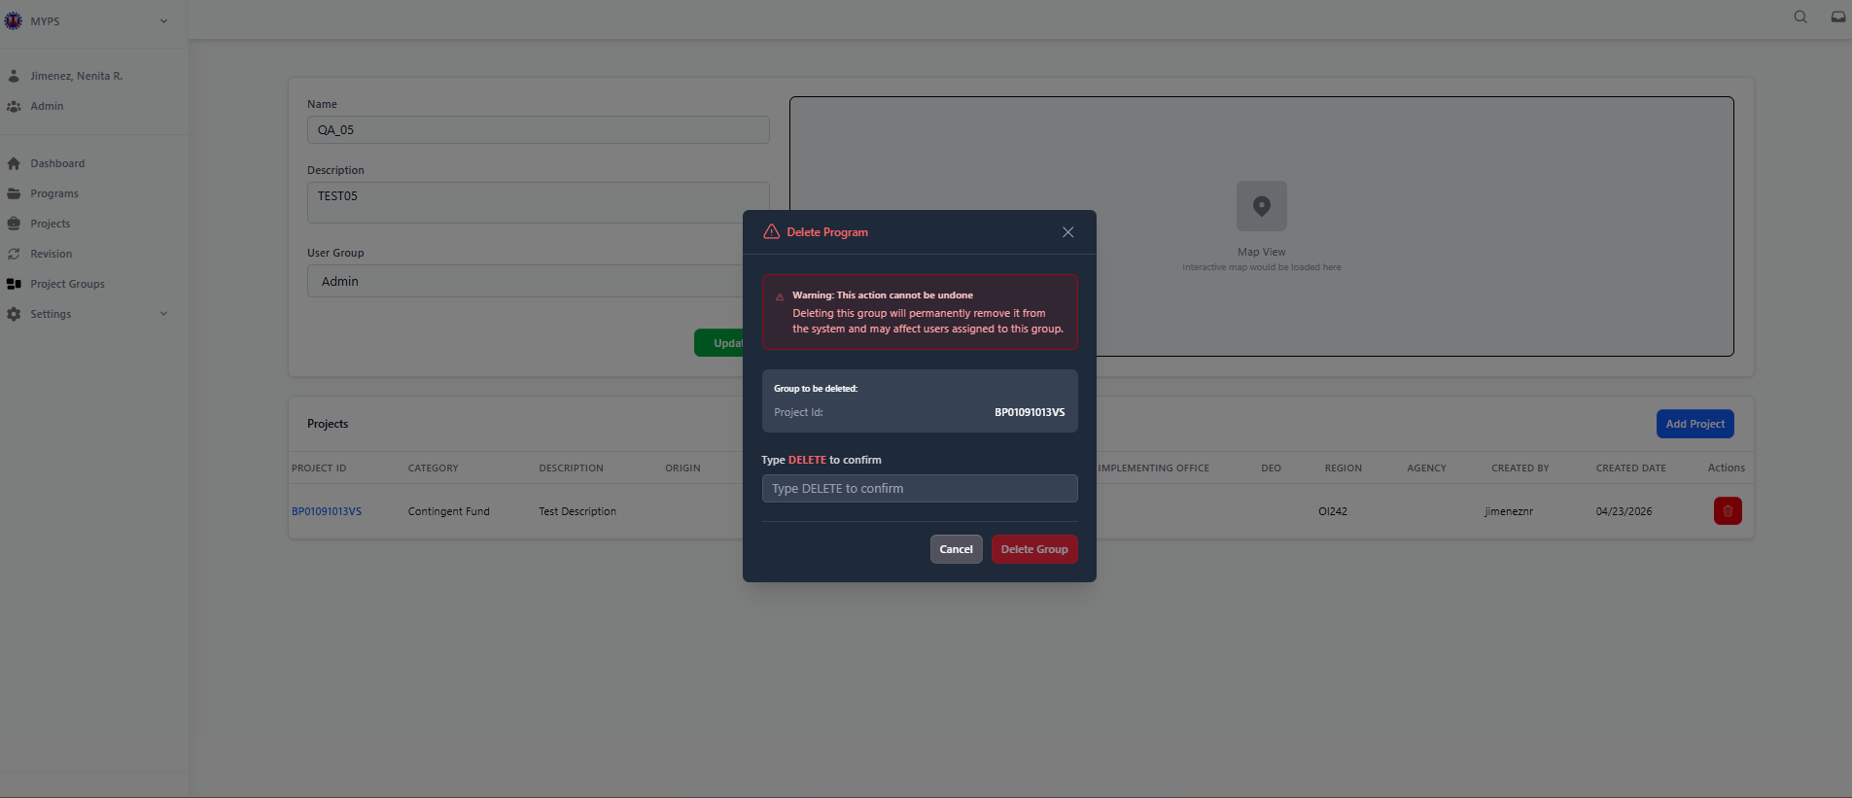
Purpose
Allows users to delete a project group. This action removes the group from the system and may affect users assigned to the group.
Who uses this
This screen is available to authorized MYPS users with access to the module.
Prerequisites
- User must be logged in with administrative permissions to delete project groups.
- The project group must exist in the system.
- The user must confirm the deletion by typing "DELETE."
Field reference
No. | Fields/Blocks/Objects | Description | Values / Actions
UI-UX-0089-01 | TITLE | Indicates the purpose of the dialog box. | Text message;(Value not explicitly stated, but implies "Delete Project Group Confirmation" or similar).
UI-UX-0089-02 | WARNING MESSAGE BLOCK | Displays a critical warning to the current user that the deletion may affect other users. | Text message; Warning message (Value not explicitly stated).
UI-UX-0089-03 | GROUP TO BE DELETED | Specifies which project group is being deleted. | Text message; Value is the specific project group identifier.
UI-UX-0089-04 | GROUP NAME TO BE DELETED | Shows the name of the group selected for deletion. | Text message; Value is the name of the group.
UI-UX-0089-05 | CONFIRMATION INSTRUCTION TEXT | Instructs the user to type a specific word to confirm deletion. | Instruction text (Value not explicitly stated).
UI-UX-0089-06 | CONFIRMATION INPUT FIELD | Text field where the user types the confirmation keyword to proceed. | User input (keyword confirmation).
UI-UX-0089-07 | CANCEL BUTTON | Button to abort or close the deletion. | Button “Cancel” Action: Abort or Close.
UI-UX-0089-08 | DELETE BUTTON | Confirms the deletion of the selected program. | Button “Delete” Action: Confirms deletion.
Step-by-step: Delete Project Group
- Open the Delete Project Group Modal
- Navigate to the Project Groups page.
- Select the project group you wish to delete. Click on the Delete button in the Actions column to open the Delete Project Group confirmation modal.
- Review the Warning Message
- The Warning Message Block will appear with a critical warning:
“Warning: This action cannot be undone. Deleting this group will permanently remove it from the system and may affect users assigned to this group.”
- Review this message carefully to understand the implications of deleting the project group.
- Confirm the Group to be Deleted
- The Group to be Deleted section will display the name of the project group you are about to delete.
- Verify that this is the correct project group.
- Type "DELETE" to Confirm
- In the Confirmation Input Field, type the word "DELETE" exactly as instructed to confirm the deletion of the project group.
Example valid entry: DELETE
Invalid entry: Any other input (e.g., "Delete", "delete", or leaving the field empty).
- Cancel the Deletion (if needed)
- If you decide not to delete the project group, click the Cancel button to abort the action and close the modal.
- This will discard all changes and return you to the Project Groups page.
- Confirm Deletion
- If the word "DELETE" is typed correctly, click the Delete button to confirm the deletion of the project group.
- A confirmation message will appear, and the project group will be permanently removed from the system.
On success
- The selected project group will be deleted from the system, and it will no longer appear in the Project Groups list.
- A success notification will appear, confirming that the project group has been deleted.
Common Outcomes & What to Do
Message / Situation | What it Means | What You Should Do
“Project Group Deleted Successfully.” | The project group was successfully deleted. | Verify that the project group is no longer listed.
"Type DELETE to confirm." | You did not type "DELETE" in the confirmation field. | Type "DELETE" exactly in the confirmation field and click Delete.

Settings Code Tables
This is the main entry point for managing reference and option lists used across the system. These tables control standardized values used in programs, projects, funding, revisions, and infrastructure records.
The settings - Code Tables module (accessed via UI-UX-0034) is the central administration point for managing the system's reference and lookup data. These tables maintain standardized values that ensure consistency across programs, projects, funding profiles, revisions, and infrastructure records.
Managed System Code Tables
Authorized users manage a wide range of reference data, including:
Project Details: Category Management, Thrust (PAP) Management, Agency Management, and Project Origin.
Costs and Work: Component Cost Types, Major Work Categories, Types of Work, and Infrastructure Types.
Funding: Funding Source Organizations and Funding Agreements.
Revisions: Categories, Reasons, Statuses, Rules, and Validation Dates.
Administrative Areas: Regions, Provinces, Cities/Municipalities, Legislative Districts, and District Engineering Offices (DEOs)

Code Tables Project Details Category Management (UI-UX-0090)
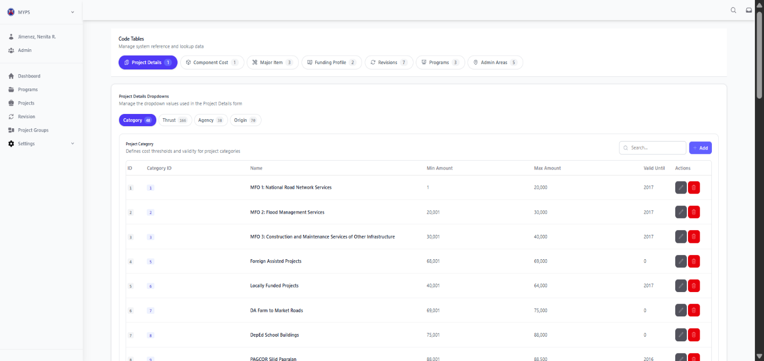
Purpose
The Code Tables Project Details Category Management screen allows authorized users to manage the Project Category reference records used in the Project Details form. It is used to maintain category names, amount ranges, validity settings, and related lookup values so that project encoding stays consistent across MYPS. Access to this function is through Settings - Code Tables in the left-side navigation.

Who Uses This
This screen is available to authorized MYPS users with access to the module.

Prerequisites
Before using this screen, ensure that:
- You are logged in to the MYPS Web application.
- Your account has permission to access Settings - Code Tables.
Field Reference
No. | Fields/Blocks/Objects | Description | Values / Actions
UI-UX-0090-01 | ID | System-generated reference number for each category record displayed in the list. | Numeric, unique, read-only; used for internal record identification.
UI-UX-0090-02 | CATEGORY ID | Secondary identifier or code assigned to the category for reference within the code table. | Numeric/alphanumeric reference value; displayed as a unique category code; read-only or system-defined.
UI-UX-0090-03 | NAME | Official name of the project category. | Text value showing the category title, such as project classification names used throughout the system.
UI-UX-0090-04 | MIN AMOUNT | Minimum allowable amount associated with the category. | Numeric currency value; defines the lower amount threshold for the category.
UI-UX-0090-05 | MAX AMOUNT | Maximum allowable amount associated with the category. | Numeric currency value; defines the upper amount threshold for the category.
UI-UX-0090-06 | VALID UNTIL | Indicates the validity period or expiration setting of the category record. | Numeric/date-based value showing until when the category remains valid; may display 0 if no expiration is currently set.
UI-UX-0090-07 | ACTIONS/EDIT | Allows modification of an existing category record. | Edit icon/button; opens the selected category in edit mode, subject to user access rights.
UI-UX-0090-08 | ACTIONS/DELETE | Allows removal or deactivation of an existing category record. | Delete icon/button; triggers delete/archive action, usually with confirmation and subject to authorization.
UI-UX-0090-09 | ADD NEW CATEGORY | Button used to create a new project category record. | Action button “+ Add”; opens a form or modal for entering a new category.
UI-UX-0090-10 | SEARCH | Search field used to locate a specific category from the list. | Search input with placeholder “Search...”; filters the displayed records based on the entered keyword.
UI-UX-0090-11 | PAGE RECORDS | Displays the total number of category records currently shown or available in the list. | Read-only text such as “25 record(s)”; updates depending on the current data set or applied search/filter.

Step-by-step: Use Category Management
1. Open Code Tables
- Sign in to MYPS Web.
- From the left-side navigation, open Settings.
- Click Code Tables.
2. Open the Project Details group
- In the Code Tables page, go to the Project Details group.
- Select the Category tab
3. View the category list
- Review the table of category records.
- Each row displays:
  - ID
  - Category ID
  - Name
  - Min Amount
  - Max Amount
  - Valid Until
  - available actions
4. Search for a category
- Click the Search field.
- Type a keyword, category code, or part of the category name.
- Wait for the table to refresh and show matching records.
Example searches:
- Locally Funded
- Trust Fund
- MFO
5. Add a new category
- Click + Add.
- Enter the required category information in the add form or modal.
- Fill in the category name and other required values such as amount range and validity.
- Save the record.
6. Edit an existing category
- Find the category you want to update.
- Click the Edit icon under Actions/Edit.
- Update the editable fields.
- Save the changes.
7. Delete or deactivate a category
- Find the record you want to remove or deactivate.
- Click the Delete icon under Actions/Delete.
- Review the confirmation prompt.
- Confirm the action if you are certain.
8. Review the record count
- Check the Page Records display at the bottom of the table.
- Confirm the number of visible records after searching, adding, editing, or deleting.
Example Inputs
- Example valid category entry
- Category ID: 26
- Name: Regional Infrastructure Support
- Min Amount: 100000
- Max Amount: 500000
- Valid Until: 2027
Example search input
- Road
- Foreign
- Locally
On Success
- The category record is added successfully and appears in the list.
- Updated records display the latest saved values.
- Deleted or deactivated records are removed from the active view, depending on system behavior.
- The page record count updates accordingly.
Common Outcomes & What to Do
Message / Situation | What it Means | What You Should Do
“Category added successfully” | The new category record was saved. | Review the table and confirm the new record appears correctly.
“Category updated successfully” | The selected record was edited and saved. | Verify the updated values in the table.

Code Tables Project Details Thrust Management (UI-UX-0091)
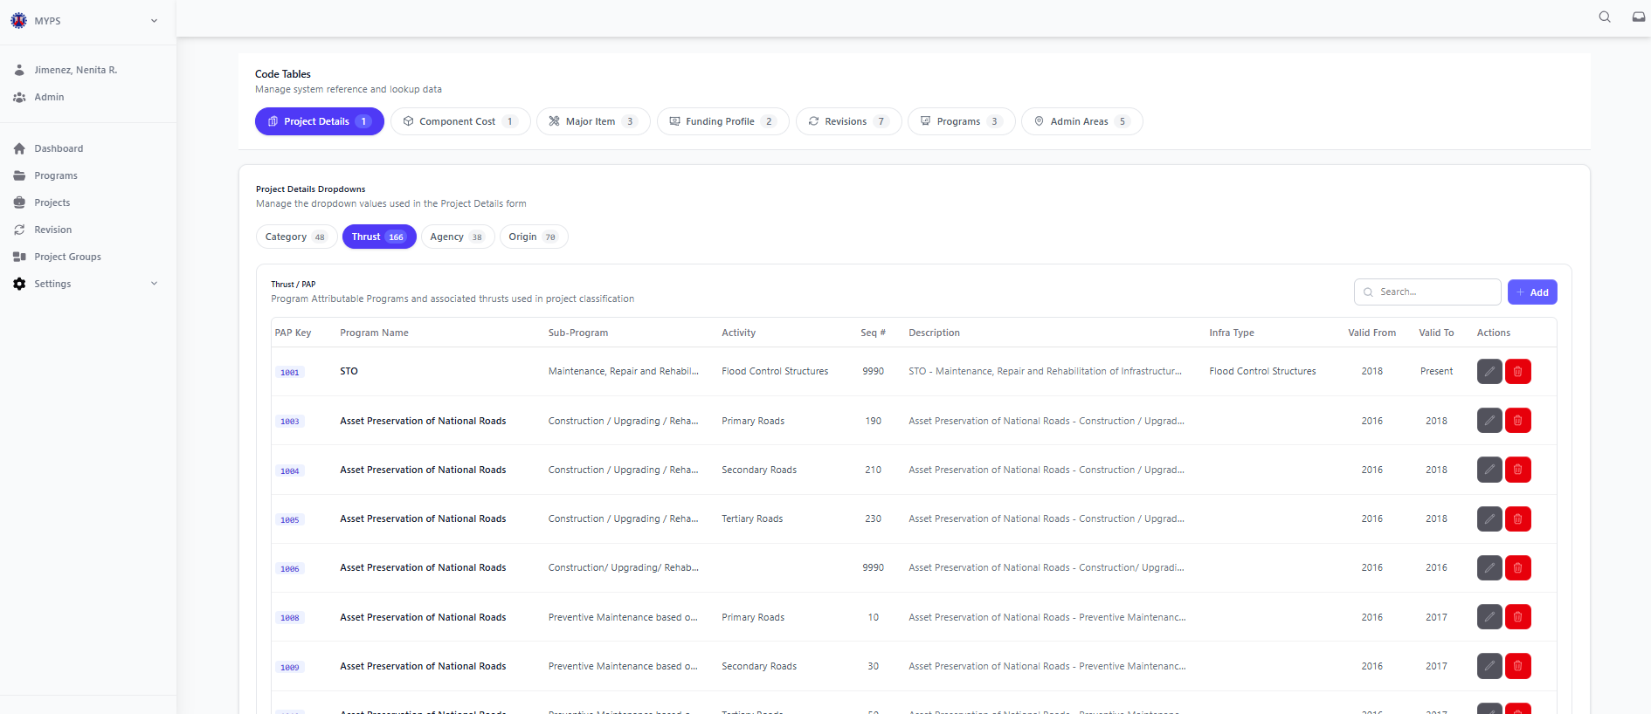
Purpose
The Code Tables Project Details Thrust Management screen allows authorized users to manage the Thrust / PAP reference records used in the Project Details form. This function is used to maintain the PAP key, program name, sub-program, activity, sequence number, description, infrastructure type, and validity period of thrust records so they can be used correctly in project classification and encoding.
Who Uses This
This screen is available to authorized MYPS users with access to the module.
Prerequisites
Before using this screen, ensure that:
- You are logged in to the MYPS Web application.
- Your account has permission to access Settings > Code Tables.
Field Reference
No. | Fields/Blocks/Objects | Description | Values / Actions
UI-UX-0091-01 | PAP KEY | Unique reference code assigned to each PAP or thrust record. | Numeric/alphanumeric value displayed in the first column; used as the primary visible reference for the record.
UI-UX-0091-02 | PROGRAM NAME | Official name of the program associated with the PAP entry. | Text value showing the main program title or classification.
UI-UX-0091-03 | SUB-PROGRAM | Specific sub-program under the identified program name. | Text value describing the related sub-program or detailed program grouping.
UI-UX-0091-04 | ACTIVITY | Specific activity classification under the selected program or sub-program. | Text value showing the activity type associated with the PAP/thrust record.
UI-UX-0091-05 | SEQUENCE NO | Sequence number assigned to the PAP or thrust entry for ordering and reference. | Numeric value used to arrange or identify the sequence of entries.
UI-UX-0091-06 | DESCRIPTION | Brief explanation or descriptive label of the PAP or thrust entry. | Text/alphanumeric description summarizing the PAP/thrust record.
UI-UX-0091-07 | INFRA TYPE | Indicates the type of infrastructure associated with the PAP record. | Text value such as infrastructure classification or category used for project grouping.
UI-UX-0091-08 | VALID FROM | Indicates the starting year or effectivity date of the PAP/thrust record. | Numeric/date-based value showing when the record becomes valid.
UI-UX-0091-09 | VALID TO | Indicates the ending year or expiration date of the PAP/thrust record. | Numeric/date-based value showing until when the record remains valid; may display terms such as Present.
UI-UX-0091-10 | ACTIONS/EDIT | Allows modification of an existing PAP or thrust record. | Edit icon/button; opens the selected record in edit mode, subject to user access rights.
UI-UX-0091-11 | ACTIONS/DELETE | Allows removal or deactivation of an existing PAP or thrust record. | Delete icon/button; triggers delete/archive action, usually with confirmation and subject to authorization.
UI-UX-0091-12 | ADD NEW THRUST | Button used to create a new PAP or thrust record. | Action button “+ Add”; opens a form or modal for entering a new thrust/PAP record.
UI-UX-0091-13 | SEARCH | Search field used to locate a specific PAP or thrust record from the list. | Search input with placeholder “Search...”; filters the displayed records based on the entered keyword.
UI-UX-0091-14 | PAGE RECORDS | Displays the total number of PAP or thrust records currently shown or available in the list. | Read-only text such as “164 record(s)”; updates depending on the current data set or applied search/filter.
Step-by-step: Use Thrust Management
1. Open Code Tables
- From the left-side navigation, open Settings.
- Click Code Tables.
2. Open the Project Details group
- In the Code Tables page, go to the Project Details group.
- Select the Thrust tab.
3. View the thrust list
- Review the list of available thrust/PAP records.
- Each row may display:
  - PAP Key
  - Program Name
  - Sub-Program
  - Activity
  - Sequence No
  - Description
  - Infra Type
  - Valid From
  - Valid To
  - Action buttons
4. Search for a thrust record
- Click the Search field.
- Type a keyword, PAP key, program name, activity, or description.
- Review the filtered results shown in the table.
Example search entries:
- Asset Preservation
- STO
- Flood
- Primary Roads
5. Add a new thrust record
- Click + Add.
- Enter the required thrust/PAP information in the form or modal.
- Fill in the appropriate values such as:
  - PAP Key
  - Program Name
  - Sub-Program
  - Activity
  - Sequence No
  - Description
  - Infra Type
  - Valid From
  - Valid To
- Save the new record.
6. Edit an existing thrust record
- Find the thrust record you want to update.
- Click the Edit icon under Actions/Edit.
- Modify the permitted fields as needed.
- Save the changes.
7. Delete or deactivate a thrust record
- Find the row you want to remove or deactivate.
- Click the Delete icon under Actions/Delete.
- Review the confirmation prompt.
- Confirm the action only if you are certain.
8. Review the record count
- Check the Page Records text at the bottom of the table.
- Confirm the number of visible records after searching, adding, editing, or deleting.
Example Inputs
Example valid thrust record
- PAP Key: 5000
- Program Name: Asset Preservation of National Roads
- Sub-Program: Preventive Maintenance based on...
- Activity: Primary Roads
- Sequence No: 10
- Description: Asset Preservation of National Roads - Preventive Maintenance...
- Infra Type: Primary Roads
- Valid From: 2016
- Valid To: 2017
Example search inputs
- Preventive
- Secondary Roads
- Rehabilitation
- 5000
On Success
- The new thrust/PAP record is added successfully and appears in the list.
- Updated records reflect the newly saved values.
- Deleted or deactivated records are removed from the active display, depending on system behavior.
- The page record count updates accordingly.
Common Outcomes & What to Do
Message / Situation | What it Means | What You Should Do
“Thrust record added successfully” | The new PAP/thrust record was saved. | Review the table and confirm the new record appears correctly.
“Thrust record updated successfully” | The selected record was edited and saved. | Verify the updated values in the table.
“Required field missing” | One or more mandatory fields were left blank. | Complete all required fields, then save again.

Code Tables Project Details Agency Management (UI-UX-0092)
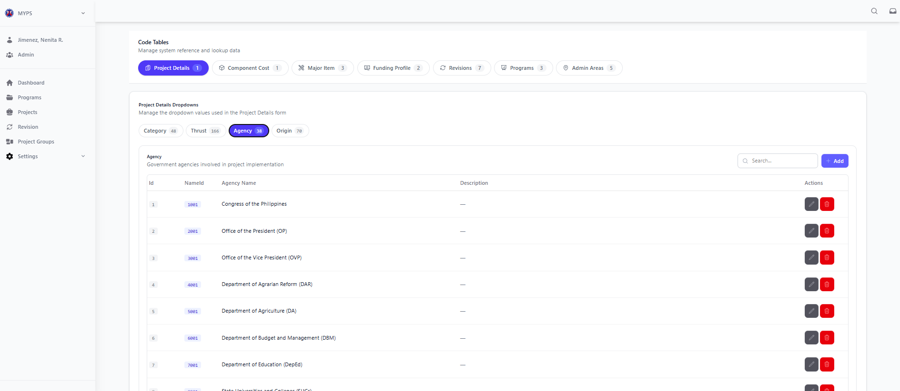
Purpose
The Code Tables Project Details Agency Management screen allows authorized users to manage the Agency reference records used in the Project Details form. This screen is used to maintain the list of government agencies involved in project implementation so users can select the correct agency during project encoding and review.
Who Uses This
This screen is available to authorized MYPS users with access to the module.
Prerequisites
Before using this screen, ensure that:
- You are logged in to the MYPS Web application.
- You have permission to access Settings > Code Tables.
Field Reference
No. | Fields/Blocks/Objects | Description | Values / Actions
UI-UX-0092-01 | ID | System-generated reference number for each agency record displayed in the list. | Numeric, unique, read-only; used for internal record identification.
UI-UX-0092-02 | NAME ID | Secondary identifier or code assigned to the agency for reference within the code table. | Numeric/alphanumeric reference value; displayed as a unique agency code; read-only or system-defined.
UI-UX-0092-03 | AGENCY NAME | Official name of the government agency involved in project implementation. | Text value showing the full agency name, such as Autonomous Region in Muslim Mindanao (ARMM), Budgetary Support to Government Corporations, Civil Service Commission (CSC), etc.
UI-UX-0092-04 | DESCRIPTION | Brief explanation or additional details about the agency record. | Text/alphanumeric description; may be blank if no description is currently provided.
UI-UX-0092-05 | ACTIONS/EDIT | Allows modification of an existing agency record. | Edit icon/button; opens the selected agency in edit mode, subject to user access rights.
UI-UX-0092-06 | ACTIONS/DELETE | Allows removal or deactivation of an existing agency record. | Delete icon/button; triggers delete/archive action, usually with confirmation and subject to authorization.
UI-UX-0092-07 | ADD NEW AGENCY | Button used to create a new agency record. | Action button “+ Add”; opens a form or modal for entering a new agency.
UI-UX-0092-08 | SEARCH | Search field used to locate a specific agency from the list. | Search input with placeholder “Search…”; filters displayed records based on the entered keyword.
UI-UX-0092-09 | PAGE RECORDS | Displays the total number of agency records currently shown or available in the list. | Read-only text such as “36 record(s)”; updates depending on the current dataset or applied search/filter.

Step-by-step: Use Agency Management
1. Open Code Tables
- From the left-side navigation, click Settings.
- Select Code Tables.
2. Open the Project Details group
- In the Code Tables page, select the Project Details tab.
- Click the Agency sub-tab.
3. View the agency list
- Review the displayed list of agency records.
- Each row may contain:
  - ID
  - Name ID
  - Agency Name
  - Description
  - Action buttons for edit and delete
4. Search for an agency record
- Click the Search field.
- Type a keyword, code, or part of the agency name.
- Review the filtered list.
Example search entries:
- Congress
- DAR
- Department of Education
- CSC
5. Add a new agency record
- Click + Add.
- Enter the required agency information in the form or modal.
- Complete the fields such as:
  - Name ID
  - Agency Name
  - Description (if applicable)
- Click Save.
6. Edit an existing agency record
- Locate the row you want to update.
- Click the Edit icon under Actions/Edit.
- Modify the allowed fields.
- Save the changes.
7. Delete or deactivate an agency record
- Locate the agency record you want to remove or deactivate.
- Click the Delete icon under Actions/Delete.
- Review the confirmation prompt.
- Confirm the action only if authorized and certain.
8. Review the record count
- Check the Page Records display at the bottom of the list.
- Confirm the total visible records after search or update actions.
Example Inputs
- Example valid agency record
- Name ID: 6002
- Agency Name: Department of Budget and Management (DBM)
- Description: National government agency for budget preparation and management
Example search inputs
- Budget
- Education
- Office of the President
- DAR
On Success
- The new agency record is saved successfully and appears in the list.
- Updated records display the latest saved values.
- Deleted or deactivated records are removed from the active display, depending on system behavior.
- The page record count updates accordingly.
Common Outcomes & What to Do
Message / Situation | What it Means | What You Should Do
“Agency record added successfully” | The new agency record was saved. | Review the table and confirm the new record appears correctly.
“Agency record updated successfully” | The selected agency record was edited and saved. | Verify the updated values in the table.

Code Tables Project Details Origin Management (UI-UX-0093)
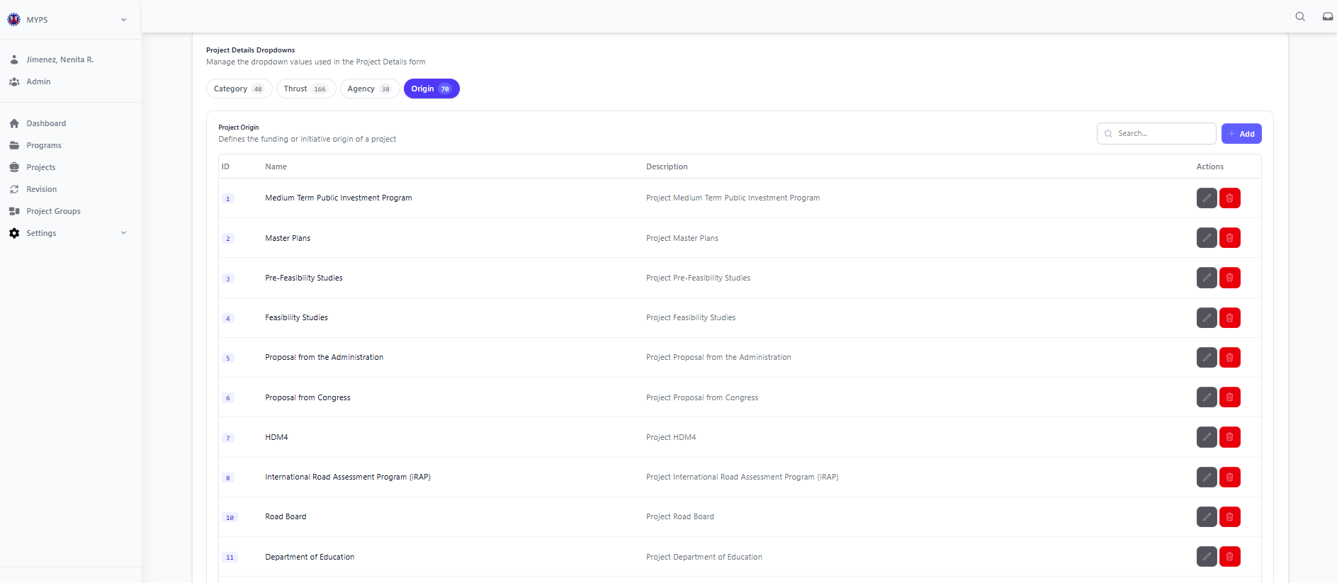
Purpose
The Code Tables Project Details Origin Management screen allows authorized users to manage the Project Origin reference records used in the Project Details form. This screen is used to maintain the list of project origin entries, such as planning or proposal sources, so users can apply consistent origin values during project encoding.
Who Uses This
This screen is available to authorized MYPS users with access to the module.
Prerequisites
Before using this screen, ensure that:
- You are logged in to the MYPS Web application.
- You have permission to access Settings > Code Tables.
Field Reference
No. | Fields/Blocks/Objects | Description | Values / Actions
UI-UX-0093-01 | ID | Unique identifier for the project origin, auto-generated or manually entered based on system settings. | Text field to input or auto-generate the Origin ID (e.g., "OBUILD001").
UI-UX-0093-02 | NAME | Required field; name of the project origin (e.g., "Medium Term Public Investment Program", "Master Plans"). | Text input field to define the name of the origin.
UI-UX-0093-03 | DESCRIPTION | Brief description of the project origin's purpose or context (e.g., "Project Medium Term Public Investment Program"). | Text input field for entering the description.
UI-UX-0093-04 | ADD PROJECT ORIGIN | Button to create a new entry for a project origin. | Button labeled “Add”; opens the form or modal for creating a new project origin entry.
UI-UX-0093-05 | ACTIONS / EDIT | Button used to modify an existing project origin record. | Button/icon for Edit; when clicked, opens the selected project origin record for updating.
UI-UX-0093-06 | ACTIONS / DELETE | Button used to remove or deactivate an existing project origin record. | Button/icon for Delete; when clicked, removes the selected project origin record or prompts the user for confirmation before deletion.
Step-by-step: Use Origin Management
1. Open Code Tables
- Sign in to MYPS Web.
- From the left-side navigation, click Settings.
- Select Code Tables.
2. Open the Project Details group
- In the Code Tables page, select the Project Details tab.
- Click the Origin sub-tab.
3. View the origin list
- Review the displayed list of project origin records.
- Each row may contain:
  - ID
  - Name
  - Description
  - action buttons for Edit and Delete
4. Search for a project origin
- Click the Search field at the upper-right section of the table.
- Type a keyword, origin ID, or part of the origin name or description.
- Review the filtered results.
Example search entries:
- Master Plans
- Medium Term
- Congress
- OBUILD001
5. Add a new project origin
- Click Add.
- Enter the required information in the form or modal.
- Complete the fields such as:
  - ID
  - Name
  - Description
- Click Save.
6. Edit an existing project origin
- Locate the record you want to update.
- Click Edit under Actions.
- Modify the allowed fields.
- Save the changes.
7. Delete a project origin
- Locate the record you want to remove.
- Click Delete under Actions.
- Review the confirmation prompt.
- Confirm the action only if you are authorized and certain.
8. Review the updated list
- After adding, editing, or deleting a record, review the table.
- Confirm that the list reflects the latest update.
Example Inputs
Example valid project origin entry
- ID: OBUILD001
- Name: Medium Term Public Investment Program
- Description: Project Medium Term Public Investment Program
Example additional entry
- ID: OPLAN002
- Name: Master Plans
- Description: Project Master Plans
On Success
- The new project origin record is saved successfully and appears in the list.
- Updated records display the latest saved values.
- Deleted records are removed from the active list, depending on system behavior.
- The screen refreshes to show the latest data.
Common Outcomes & What to Do
Message / Situation | What it Means | What You Should Do
“Project origin added successfully” | The new origin record was saved. | Review the list and confirm the new record appears correctly.
“Project origin updated successfully” | The selected record was edited and saved. | Verify the updated values in the table.
“Required field missing” | One or more mandatory fields were left blank. | Complete all required fields, especially Name, then save again.

Code Tables Component Cost Type Management (UI-UX-0094)
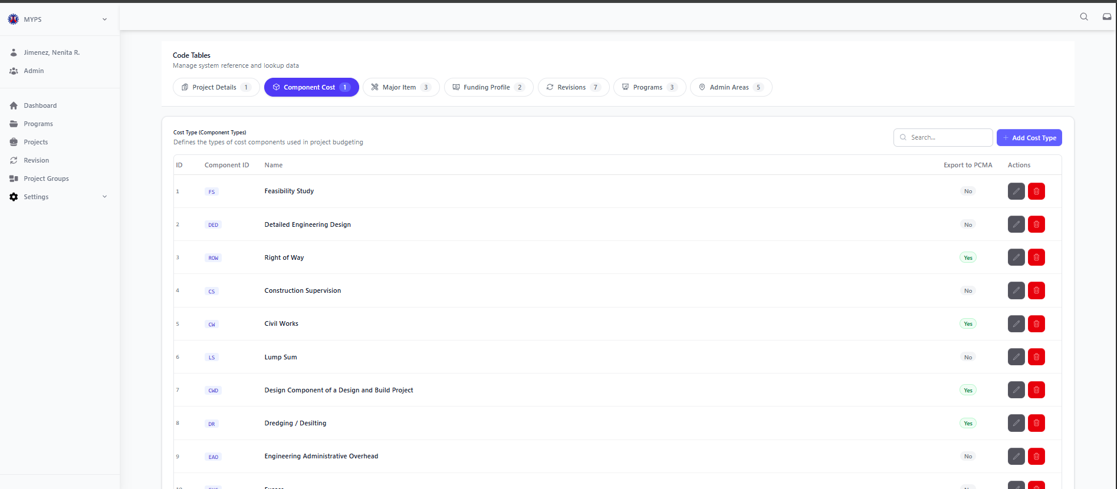
Purpose
The Code Tables Component Cost Type Management screen allows authorized users to manage the component cost type reference records used in project budgeting and component costing. This screen is used to maintain the list of component cost types, their short codes, official names, and whether they are included in publishing to PCMA.
Who Uses This
This screen is available to authorized MYPS users with access to the module.
Prerequisites
Before using this screen, ensure that:
- You are logged in to the MYPS Web application.
- You have permission to access Settings > Code Tables.

Field Reference
No. | Fields/Blocks/Objects | Description | Values / Actions
UI-UX-0094-01 | ID | System-generated reference number for each component cost type record displayed in the list. | Numeric, unique, read-only; used for internal record identification.
UI-UX-0094-02 | COMPONENT ID | Short code assigned to the component cost type for reference and classification. | Alphanumeric code; displayed as a unique component identifier such as CONST, ROW, DD, GE, PM, ENV, MISC, SA.
UI-UX-0094-03 | NAME | Official name of the component cost type. | Text value showing the component type name, such as Construction Cost, Right of Way, Detailed Design, Geohazard, Project Management, Environmental Compliance, Miscellaneous, Social Advocacy.
UI-UX-0094-04 | EXPORT TO PCMA | Indicates whether the component cost type is included in publishing to PCMA. | Boolean/flag value; typically displayed as Yes or No.
UI-UX-0094-05 | ACTIONS/EDIT | Allows modification of an existing component cost type record. | Edit icon/button; opens the selected component cost type in view/edit mode depending on user permissions.
UI-UX-0094-06 | ACTIONS/DELETE | Allows removal or deactivation of an existing component cost type record. | Delete icon/button; removes the cost type from the list through soft delete/archive, subject to authorization.
UI-UX-0094-07 | ADD NEW COST TYPE | Button used to create a new component cost type record. | Action button “+ Add”; opens a form or modal where the user can input and save a new cost type record.
UI-UX-0094-08 | SEARCH | Search field used to locate a specific component cost type from the list. | Search input with placeholder “Search...”; filters displayed records based on the entered keyword or ID.
UI-UX-0094-09 | PAGE RECORDS | Displays the total number of component cost type records currently shown or available in the list. | Read-only text such as “8 record(s) found”; updates depending on the current dataset or applied search/filter.
Step-by-step: Use Component Cost Type Management
1. Open Code Tables
- Sign in to MYPS Web.
- From the left-side navigation, click Settings.
- Select Code Tables.
2. Open the Component Cost tab
- In the Code Tables page, click the Component Cost tab.
- Wait for the Cost Type (Component Type) list to load.
3. View the component cost type list
- Review the displayed records.
- Each row may contain:
  - ID
  - Component ID
  - Name
  - Export to PCMA
  - action buttons for Edit and Delete
4. Search for a component cost type
- Click the Search field.
- Type a keyword, component code, or part of the component name.
- Review the filtered results.
Example search entries:
- ROW
- Design
- Civil
- EAO
5. Add a new cost type
- Click + Add Cost Type.
- Enter the required information in the form or modal.
- Complete the fields such as:
  - Component ID
  - Name
  - Export to PCMA
- Click Save.
6. Edit an existing cost type
- Locate the record you want to update.
- Click the Edit icon under Actions/Edit.
- Modify the allowed fields.
- Save the changes.
7. Delete or deactivate a cost type
- Locate the record you want to remove or deactivate.
- Click the Delete icon under Actions/Delete.
- Review the confirmation prompt.
- Confirm the action only if authorized and certain.
8. Review the updated list
- After adding, editing, or deleting a record, review the table.
- Confirm that the changes appear correctly.
- Check the record count shown in Page Records.
Example Inputs
Example valid component cost type entry
- Component ID: ROW
- Name: Right of Way
- Export to PCMA: Yes
Example additional entry
- Component ID: ENV
- Name: Environmental Compliance
- Export to PCMA: No
Example search inputs
- Feasibility
- DD
- Civil Works
- Project Management

On Success
- The new component cost type record is saved successfully and appears in the list.
- Updated records display the latest saved values.
- Deleted or archived records are removed from the active list, depending on system behavior.
- The record count updates based on the current filtered results.
Common Outcomes & What to Do
Message / Situation | What it Means | What You Should Do
“Cost type added successfully” | The new component cost type record was saved. | Review the list and confirm the new record appears correctly.
“Cost type updated successfully” | The selected record was edited and saved. | Verify the updated values in the table.
“Required field missing” | One or more mandatory fields were left blank. | Complete all required fields, especially Component ID and Name, then save again.

Code Tables Major Work Category Management (UI-UX-0095)

Purpose
The Code Tables Major Item Work Category Management screen allows authorized users to manage the major work category reference records used for classifying project work under specific infrastructure types. This screen is used to maintain the valid relationship between an Infrastructure Type and its corresponding Work Category.
Who Uses This
This screen is available to authorized MYPS users with access to the module.
Prerequisites
Before using this screen, ensure that:
- You are logged in to the MYPS Web application.
- You have permission to access Settings > Code Tables.

Field Reference
No. | Fields/Blocks/Objects | Description | Values / Actions
UI-UX-0095-01 | ID | System-generated reference number for each major work category record displayed in the list. | Numeric, unique, read-only; used for internal record identification.
UI-UX-0095-02 | INFRASTRUCTURE TYPE | Identifies the infrastructure classification to which the work category belongs. | Text value/tag showing the infrastructure type, such as Accessibility Facility, Bridges, Drainage Protection Works, Drainage Structures along Roads, or Flood Control Structures.
UI-UX-0095-03 | WORK CATEGORY | Specifies the valid major work category for the selected infrastructure type. | Text value showing the work category, such as Construction, Rehabilitation/Major Repair, Replacement, Retrofitting/Strengthening, Widening, or Upgrading.
UI-UX-0095-04 | ACTIONS/EDIT | Allows modification of an existing major work category record. | Edit icon/button; opens the selected record in edit mode, subject to user access rights.
UI-UX-0095-05 | ACTIONS/DELETE | Allows removal or deactivation of an existing major work category record. | Delete icon/button; triggers delete/archive action, usually with confirmation and subject to authorization.
UI-UX-0095-06 | ADD NEW MAJOR WORK CATEGORY | Button used to create a new major work category record. | Action button “+ Add”; opens a form or modal for entering a new major work category.
UI-UX-0095-07 | SEARCH | Search field used to locate a specific major work category record from the list. | Search input with placeholder “Search...”; filters displayed records based on the entered keyword.
UI-UX-0095-08 | PAGE RECORDS | Displays the total number of major work category records currently shown in the list. | Read-only text such as “46 record(s) found”; updates depending on the current dataset or applied search/filter.

Step-by-step: Use Major Work Category Management
1. Open Code Tables
- Sign in to MYPS Web.
- From the left-side navigation, click Settings.
- Select Code Tables.
2. Open the Major Item group
- In the Code Tables page, click the Major Item tab.
- Select the Work Category sub-tab.
3. View the major work category list
- Review the displayed records.
- Each row may contain:
  - ID
  - Infrastructure Type
  - Work Category
  - action buttons for Edit and Delete
4. Search for a major work category
- Click the Search field.
- Type a keyword related to the infrastructure type or work category.
- Review the filtered list.
Example search entries:
- Bridges
- Construction
- Flood Control
- Widening
5. Add a new major work category
- Click + Add.
- Enter the required information in the form or modal.
- Complete the fields such as:
  - Infrastructure Type
  - Work Category
- Click Save.
6. Edit an existing major work category
- Locate the record you want to update.
- Click the Edit icon under Actions/Edit.
- Modify the allowed fields.
- Save the changes.
7. Delete or deactivate a major work category
- Locate the record you want to remove or deactivate.
- Click the Delete icon under Actions/Delete.
- Review the confirmation prompt.
- Confirm the action only if authorized and certain.
8. Review the updated list
- After adding, editing, or deleting a record, review the table.
- Confirm that the latest changes are reflected correctly.
- Check the record count shown in Page Records.
Example Inputs
- Example valid major work category entry
- Infrastructure Type: Bridges
- Work Category: Replacement
- Example additional entry
- Infrastructure Type: Flood Control Structures
- Work Category: Rehabilitation/Major Repair
- Example search inputs
- Upgrading
- Accessibility Facility
- Construction
- Drainage
On Success
After successfully adding, editing, or deleting a record:
- The changes are saved and displayed in the list.
- The updated record count in Page Records reflects the new total.
Common Outcomes & What to Do
Message / Situation | What It Means | What To Do
Required field missing | One or more required fields were left blank. | Complete all required fields before clicking Save or Delete.

Code Tables Type of Work Management (UI-UX-0096)
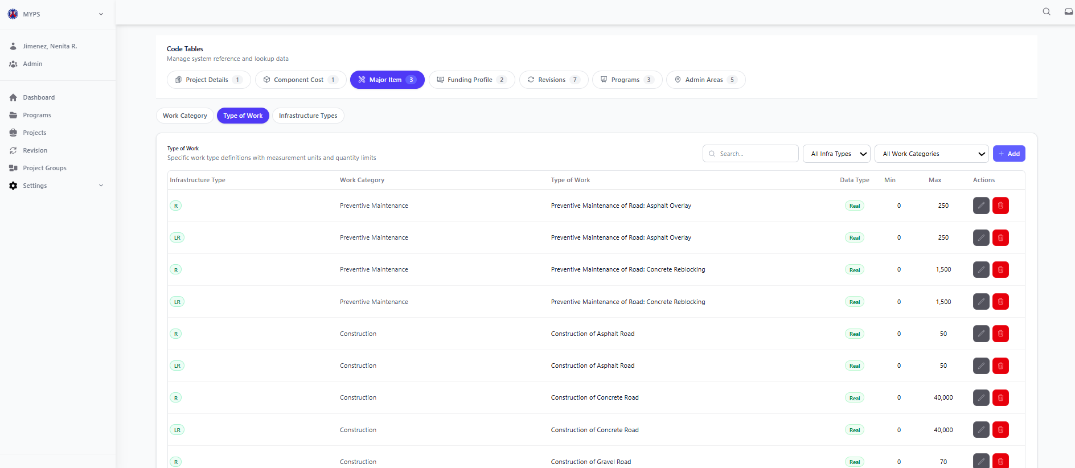
Purpose
The Code Tables Type of Work Management screen allows authorized users to manage the Type of Work reference records used in MYPS. This screen is used to maintain the valid relationship between Infrastructure Type, Work Category, and Type of Work, including the allowed unit of measure, data type, and quantity limits.
Who Uses This
This screen is available to authorized MYPS users with access to the module.
Prerequisites
Before using this screen, ensure that:
- You are logged in to the MYPS Web application.
- You have permission to access Settings > Code Tables.
Field Reference
No. | Fields/Blocks/Objects | Description | Values / Actions
UI-UX-0096-01 | INFRASTRUCTURE TYPE | Identifies the infrastructure classification to which the type of work belongs. | Text value/tag showing the infrastructure type, such as Accessibility Facility or Bridges.
UI-UX-0096-02 | WORK CATEGORY | Specifies the major work category associated with the selected infrastructure type. | Text value such as Construction or Rehabilitation/Major Repair.
UI-UX-0096-03 | TYPE OF WORK | Defines the specific type of work under the selected infrastructure type and work category. | Text value showing the work definition, such as Construction of Accessibility Facility, Rehabilitation/Major Repair of Accessibility Facility, Construction of Bridge, or Construction of Concrete Bridge.
UI-UX-0096-04 | UNIT OF MEASURE | Indicates the measurement basis used for the selected type of work. | Text value such as Number of Units, Square meters, or Lane Km.
UI-UX-0096-05 | DATA TYPE | Specifies the data format allowed for quantity input of the selected type of work. | Value shown as Integer or Real.
UI-UX-0096-06 | MIN | Defines the minimum allowable quantity for the selected type of work. | Numeric lower limit; may display a number such as 1 or may be blank/dash if no minimum is set.
UI-UX-0096-07 | MAX | Defines the maximum allowable quantity for the selected type of work. | Numeric upper limit; may display values such as 40, 100, 1,000, 10,000, 13,000, 50,000, or 60,000, depending on configuration.
UI-UX-0096-08 | ACTIONS/EDIT | Allows modification of an existing type of work record. | Edit icon/button; opens the selected type of work in edit mode, subject to user access rights.
UI-UX-0096-09 | ACTIONS/DELETE | Allows removal or deactivation of an existing type of work record. | Delete icon/button; triggers delete/archive action, usually with confirmation and subject to authorization.
UI-UX-0096-10 | ADD NEW TYPE OF WORK | Button used to create a new type of work record. | Action button “+ Add”; opens a form or modal for entering a new type of work definition.
UI-UX-0096-11 | SEARCH | Search field used to locate a specific type of work record from the list. | Search input with placeholder “Search...”; filters displayed records based on the entered keyword.
UI-UX-0096-12 | PAGE RECORDS | Displays the current visible range and total number of type of work records in the dataset. | Read-only text such as “20 record(s) found” in your screenshot, or configured record summary text in the system.
UI-UX-0096-13 | PAGINATION | Allows navigation between pages of the Type of Work list. | Navigation controls such as Previous, Page 1 of n, and Next.
Step-by-step: Use Type of Work Management
1. Open Code Tables
- Sign in to MYPS Web.
- From the left-side navigation, click Settings.
- Select Code Tables.
2. Open the Major Item group
- In the Code Tables page, click the Major Item tab.
- Select the Type of Work sub-tab.
3. View the type of work list
- Review the displayed records.
- Each row may contain:
  - Infrastructure Type
  - Work Category
  - Type of Work
  - Unit of Measure
  - Data Type
  - Min
  - Max
  - action buttons for Edit and Delete
4. Search for a type of work
- Click the Search field.
- Type a keyword related to the type of work you want to find.
- Review the filtered list.
Example search entries:
- Concrete
- Overlay
- Rehabilitation
- Bridge
5. Add a new type of work
- Click + Add.
- Enter the required information in the form or modal.
- Complete the fields such as:
  - Infrastructure Type
  - Work Category
  - Type of Work
  - Unit of Measure
  - Data Type
  - Min
  - Max
- Click Save.
6. Edit an existing type of work
- Locate the record you want to update.
- Click the Edit icon under Actions/Edit.
- Modify the allowed fields.
- Save the changes.
7. Delete or deactivate a type of work
- Locate the record you want to remove or deactivate.
- Click the Delete icon under Actions/Delete.
- Review the confirmation prompt.
- Confirm the action only if authorized and certain.
8. Use pagination
- If the list contains multiple pages, use the Pagination controls to move between pages.
- Review the record count shown in Page Records to confirm the current result set.
9. Review the updated list
- After adding, editing, or deleting a record, review the table.
- Confirm that the latest changes are reflected correctly.
- Example Inputs
- Example valid type of work entry
- Infrastructure Type: Bridges
- Work Category: Construction
- Type of Work: Construction of Concrete Bridge
- Unit of Measure: Number of Units
- Data Type: Integer
- Min: 0
- Max: 100
- Example additional entry
- Infrastructure Type: Roads
- Work Category: Preventive Maintenance
- Type of Work: Preventive Maintenance of Road: Asphalt Overlay
- Unit of Measure: Lane Km
- Data Type: Real
- Min: 0
- Max: 250
Example search inputs
- Asphalt
- Concrete
- Overlay
- Preventive
On Success
- The new type of work record is saved successfully and appears in the list.
- Updated records display the latest saved values.
- Deleted or archived records are removed from the active list, depending on system behavior.
- The record count updates based on the current filtered or paged results.
Common Outcomes & What to Do
Message / Situation | What it Means | What You Should Do
“Type of work added successfully” | The new record was saved. | Review the list and confirm the new record appears correctly.
“Type of work updated successfully” | The selected record was edited and saved. | Verify the updated values in the table.

Code Tables Major Items Infrastructure Types (UI-UX-0097)
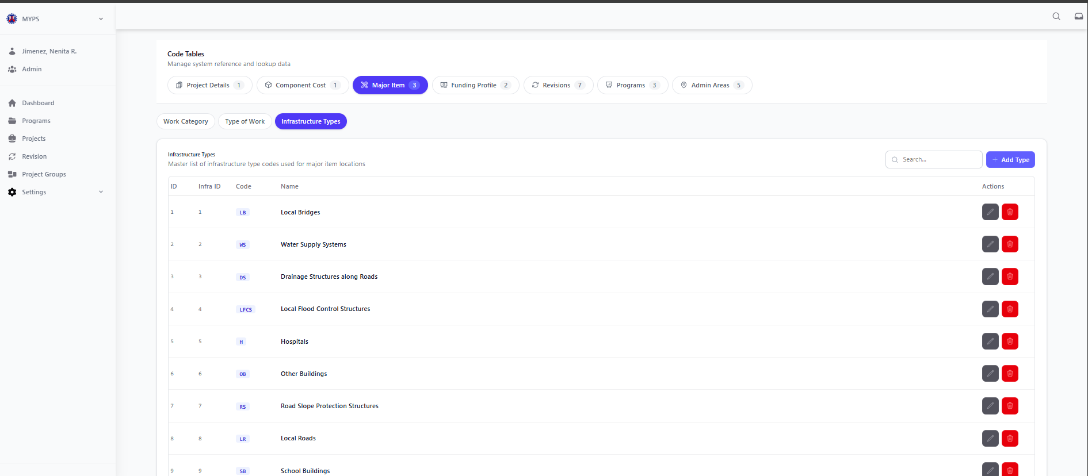
Purpose
The Major Items Infrastructure Types screen allows authorized users to manage the Infrastructure Type reference records used for major item locations in MYPS. This screen is used to maintain the list of infrastructure types, their numeric reference IDs, short codes, and official names so that major items are classified consistently across the system.
Who Uses This
This screen is available to authorized MYPS users with access to the module.
Prerequisites
Before using this screen, ensure that:
- You are logged in to the MYPS Web application.
- You have permission to access Settings > Code Tables.
Field Reference
No. | Fields/Blocks/Objects | Description | Values / Actions
UI-UX-0097-01 | ID | System-generated reference number for each infrastructure type record displayed in the list. | Numeric, unique, read-only; used for internal record identification.
UI-UX-0097-02 | INFRA ID | Numeric identifier assigned to the infrastructure type. | Numeric reference value such as 1, 2, 3, 4; read-only or system-defined.
UI-UX-0097-03 | CODE | Short code representing the infrastructure type. | Alphanumeric code such as AF, CS, DPW, DSR, FCS, H, LB, LFCS, LR, MPB, NI, OB.
UI-UX-0097-04 | NAME | Official name of the infrastructure type used for major item locations. | Text value showing the infrastructure type name, such as Accessibility Facility, Consultancy, Drainage Protection Works, Hospitals, Local Roads, or Other Buildings.
UI-UX-0097-05 | ACTIONS/EDIT | Allows modification of an existing infrastructure type record. | Edit icon/button; opens the selected infrastructure type in edit mode, subject to user access rights.
UI-UX-0097-06 | ACTIONS/DELETE | Allows removal or deactivation of an existing infrastructure type record. | Delete icon/button; triggers delete/archive action, usually with confirmation and subject to authorization.
UI-UX-0097-07 | ADD NEW INFRASTRUCTURE TYPE | Button used to create a new infrastructure type record. | Action button “+ Add”; opens a form or modal for entering a new infrastructure type.
UI-UX-0097-08 | SEARCH | Search field used to locate a specific infrastructure type from the list. | Search input with placeholder “Search...”; filters displayed records based on the entered keyword.
UI-UX-0097-09 | PAGE RECORDS | Displays the total number of infrastructure type records currently shown in the list. | Read-only text such as “20 record(s) found”; updates depending on the current dataset or applied search/filter.

Step-by-step: Use Infrastructure Types Management
1. Open Code Tables
- Sign in to MYPS Web.
- From the left-side navigation, click Settings.
- Select Code Tables.
2. Open the Major Item group
- In the Code Tables page, click the Major Item tab.
- Select the Infrastructure Types sub-tab.
3. View the infrastructure type list
- Review the displayed records.
- Each row may contain:
  - ID
  - Infra ID
  - Code
  - Name
  - action buttons for Edit and Delete
4. Search for an infrastructure type
- Click the Search field.
- Type a keyword, code, or part of the infrastructure type name.
- Review the filtered list.
Example search entries:
- Local Roads
- LB
- Hospitals
- Drainage
5. Add a new infrastructure type
- Click + Add.
- Enter the required information in the form or modal.
- Complete the fields such as:
  - Infra ID
  - Code
  - Name
- Click Save.
6. Edit an existing infrastructure type
- Locate the record you want to update.
- Click the Edit icon under Actions/Edit.
- Modify the allowed fields.
- Save the changes.
7. Delete or deactivate an infrastructure type
- Locate the record you want to remove or deactivate.
- Click the Delete icon under Actions/Delete.
- Review the confirmation prompt.
- Confirm the action only if authorized and certain.
8. Review the updated list
- After adding, editing, or deleting a record, review the table.
- Confirm that the latest changes are reflected correctly.
- Check the record count shown in Page Records.
Example Inputs
Example valid infrastructure type entry
- Infra ID: 8
- Code: LR
- Name: Local Roads
Example additional entry
- Infra ID: 10
- Code: OB
- Name: Other Buildings
Example search inputs
- LB
- Water Supply
- Local
- Hospitals
On Success
- The new infrastructure type record is saved successfully and appears in the list.
- Updated records display the latest saved values.
- Deleted or archived records are removed from the active list, depending on system behavior.
- The record count updates based on the current filtered results.

Common Outcomes & What to Do
Message / Situation | What it Means | What You Should Do
“Infrastructure type added successfully” | The new record was saved. | Review the list and confirm the new record appears correctly.
“Infrastructure type updated successfully” | The selected record was edited and saved. | Verify the updated values in the table.

Code Tables Funding Profile Agreement (UI-UX-0098)
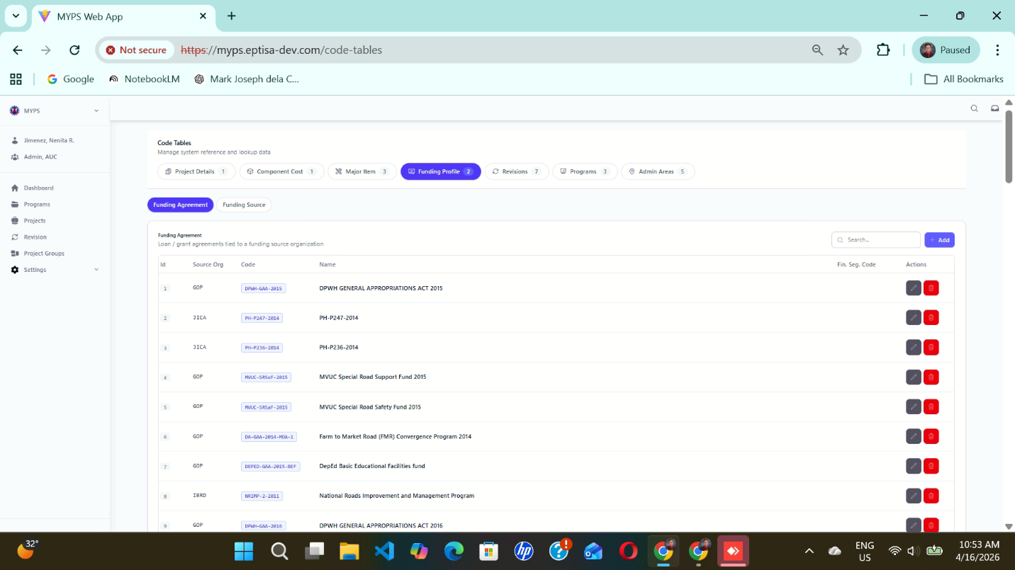
Purpose
The Code Tables Funding Profile Agreement screen allows authorized users to manage the Funding Agreement reference records used in MYPS. This screen is used to maintain the list of funding agreements, their source organizations, assigned codes, names, and related financial separation references so they can be selected correctly in funding profile setup and project budgeting.
Who Uses This
This screen is available to authorized MYPS users with access to the module.
Prerequisites
Before using this screen, ensure that:
- You are logged in to the MYPS Web application.
- You have permission to access Settings > Code Tables.

Field Reference
No. | Fields/Blocks/Objects | Description | Values / Actions
UI-UX-0098-01 | ID | Unique identifier for each funding agreement record. | Numeric value; system-generated record ID.
UI-UX-0098-02 | SOURCE ORG | Displays the source organization associated with the funding agreement. | Text value; e.g., GOP, JICA, IBRD.
UI-UX-0098-03 | CODE | Displays the code assigned to the funding agreement. | Text/alphanumeric value; e.g., agreement or funding code.
UI-UX-0098-04 | NAME | Displays the full name or title of the funding agreement. | Text value; e.g., DPWH GENERAL APPROPRIATIONS ACT 2015.
UI-UX-0098-05 | FIN. SEP CODE | Displays the financial separation code or related financial reference code. | Text/alphanumeric value; may be blank or populated depending on record setup.
UI-UX-0098-06 | SEARCH | Search field used to filter funding agreement records. | Text input; enter keyword/code/name to filter the list.
UI-UX-0098-07 | ADD FUNDING AGREEMENT | Button used to create a new funding agreement entry. | Button labeled “Add”; opens the form or modal for adding a new funding agreement.
UI-UX-0098-08 | ACTIONS / EDIT | Button used to modify an existing funding agreement record. | Edit icon/button; opens the selected record for updating.
UI-UX-0098-09 | ACTIONS / DELETE | Button used to remove an existing funding agreement record. | Delete icon/button; removes the selected record or prompts for confirmation before deletion.

Step-by-step: Use Funding Agreement Management
1. Open Code Tables
- Sign in to MYPS Web.
- From the left-side navigation, click Settings.
- Select Code Tables.
2. Open the Funding Profile group
- In the Code Tables page, click the Funding Profile tab.
- Select the Funding Agreement sub-tab.
3. View the funding agreement list
- Review the displayed funding agreement records.
- Each row may contain:
  - ID
  - Source Org
  - Code
  - Name
  - Fin. Sep Code
  - action buttons for Edit and Delete
4. Search for a funding agreement
- Click the Search field.
- Type a keyword, source organization, code, or part of the agreement name.
- Review the filtered results.
Example search entries:
- GOP
- JICA
- 2015
- FMR
5. Add a new funding agreement
- Click Add.
- Enter the required information in the form or modal.
- Complete the fields such as:
  - Source Org
  - Code
  - Name
  - Fin. Sep Code if applicable
- Click Save.
6. Edit an existing funding agreement
- Locate the record you want to update.
- Click the Edit icon under Actions.
- Modify the allowed fields.
- Save the changes.
7. Delete a funding agreement
- Locate the record you want to remove.
- Click the Delete icon under Actions.
- Review the confirmation prompt.
- Confirm the action only if authorized and certain.
8. Review the updated list
- After adding, editing, or deleting a record, review the table.
- Confirm that the latest changes are reflected correctly.
Example Inputs
- Example valid funding agreement entry
- Source Org: GOP
- Code: DPWH-GAA-2015
- Name: DPWH GENERAL APPROPRIATIONS ACT 2015
- Fin. Sep Code: GAA-2015
- Example additional entry
- Source Org: JICA
- Code: PH-247-2014
- Name: PH-247-2014
- Fin. Sep Code: JICA-247
- Example search inputs
- DPWH
- Special Road Safety
- PH-236
- GOP
On Success
- The new funding agreement record is saved successfully and appears in the list.
- Updated records display the latest saved values.
- Deleted records are removed from the active list, depending on system behavior.
- The table refreshes to show the latest data.
Common Outcomes & What to Do
Message / Situation | What it Means | What You Should Do
“Funding agreement added successfully” | The new record was saved. | Review the list and confirm the new record appears correctly.
“Funding agreement updated successfully” | The selected record was edited and saved. | Verify the updated values in the table.

Code Tables Funding Profile Source (UI-UX-0099)
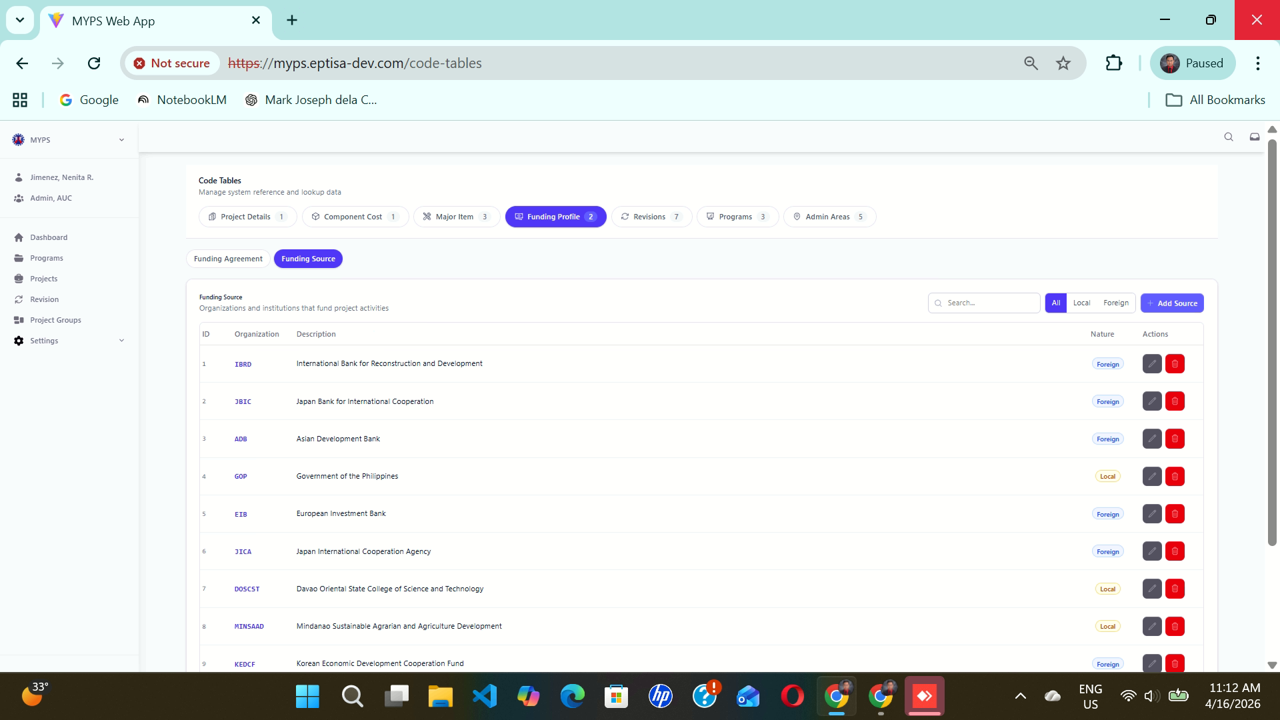
Purpose
The Code Tables Funding Profile Source screen allows authorized users to manage the Funding Source reference records used in MYPS. This screen is used to maintain the list of funding organizations and institutions that fund project activities, including whether the source is classified as Local or Foreign.
Who Uses This
This screen is available to authorized MYPS users with access to the module.
Prerequisites
Before using this screen, ensure that:
- You are logged in to the MYPS Web application.
- You have permission to access Settings > Code Tables.

Field Reference
No. | Fields/Blocks/Objects | Description | Values / Actions
UI-UX-0099-01 | ID | Unique identifier for each funding source record. | Numeric value; system-generated ID.
UI-UX-0099-02 | ORGANIZATION | Displays the short code or name of the funding organization. | Text value; e.g., IBRD, JBIC, ADB, GOP, JICA.
UI-UX-0099-03 | DESCRIPTION | Displays the full name or description of the funding organization. | Text value; e.g., International Bank for Reconstruction and Development.
UI-UX-0099-04 | SEARCH | Search field used to filter funding source records. | Text input; enter keyword or organization name/code to filter the list.
UI-UX-0099-05 | ALL FILTER | Filter button to display all funding source records. | Button labeled “All”; shows both local and foreign sources.
UI-UX-0099-06 | LOCAL FILTER | Filter button to display only local funding sources. | Button labeled “Local”; filters records tagged as local.
UI-UX-0099-07 | FOREIGN FILTER | Filter button to display only foreign funding sources. | Button labeled “Foreign”; filters records tagged as foreign.
UI-UX-0099-08 | ADD SOURCE | Button used to create a new funding source entry. | Button labeled “Add Source”; opens the form or modal for adding a new funding source.
UI-UX-0099-09 | NATURE | Indicates whether the funding source is local or foreign. | Tag/value such as Local or Foreign.
UI-UX-0099-10 | ACTIONS / EDIT | Button used to modify an existing funding source record. | Edit icon/button; opens the selected funding source for updating.
UI-UX-0099-11 | ACTIONS / DELETE | Button used to remove an existing funding source record. | Delete icon/button; removes the selected record or prompts for confirmation before deletion.
Step-by-step: Use Funding Source Management
1. Open Code Tables
- Sign in to MYPS Web.
- From the left-side navigation, click Settings.
- Select Code Tables.
2. Open the Funding Profile group
- In the Code Tables page, click the Funding Profile tab.
- Select the Funding Source sub-tab.
3. View the funding source list
- Review the displayed funding source records.
- Each row may contain:
  - ID
  - Organization
  - Description
  - Nature
  - action buttons for Edit and Delete
4. Search for a funding source
- Click the Search field.
- Type a keyword, source code, or organization name.
- Review the filtered results.
Example search entries:
- ADB
- JICA
- Government
- Bank
5. Filter the funding source list
Use the filter buttons to narrow the displayed records:
- Click All to show both local and foreign funding sources.
- Click Local to display only funding sources tagged as local.
- Click Foreign to display only funding sources tagged as foreign.
6. Add a new funding source
- Click Add Source.
- Enter the required information in the form or modal.
- Complete the fields such as:
  - Organization
  - Description
  - Nature
- Click Save.
7. Edit an existing funding source
- Locate the record you want to update.
- Click the Edit icon under Actions / Edit.
- Modify the allowed fields.
- Save the changes.
8. Delete a funding source
- Locate the record you want to remove.
- Click the Delete icon under Actions / Delete.
- Review the confirmation prompt.
- Confirm the action only if authorized and certain.
9. Review the updated list
- After adding, editing, deleting, or filtering records, review the table.
- Confirm that the list reflects the correct and latest result set.

On Success
After successfully adding, editing, or deleting a record:
- The changes are saved and displayed in the list.
- The updated record count in Page Records reflects the new total

Common Outcomes & What to Do
Message / Situation | What it Means | What You Should Do
“Funding source added successfully” | The new record was saved. | Review the list and confirm the new record appears correctly.
“Funding source updated successfully” | The selected record was edited and saved. | Verify the updated values in the table.

Code Tables Revisions Categories (UI-UX-0100)
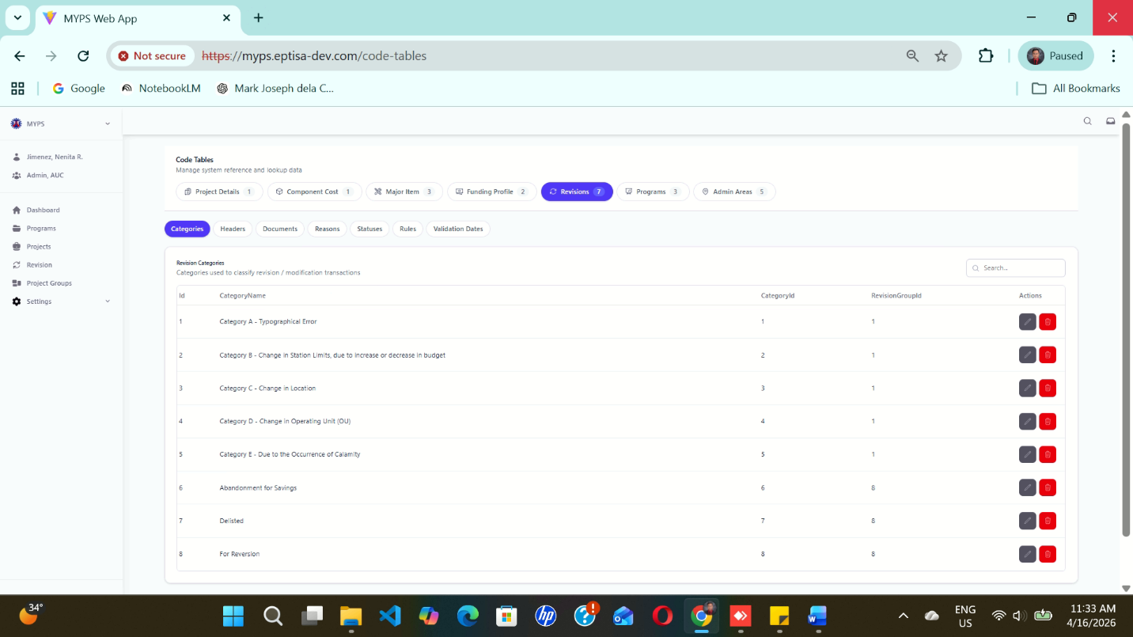
Purpose
The Code Tables Revisions Categories screen allows authorized users to manage the revision category reference records used in MYPS. This screen is used to maintain the list of revision categories, their assigned category IDs, and their related revision group IDs so that revision and modification transactions are classified consistently.
Who Uses This
This screen is available to authorized MYPS users with access to the module.
Prerequisites
Before using this screen, ensure that:
- You are logged in to the MYPS Web application.
- You have permission to access Settings > Code Tables.

Field Reference
No. | Fields/Blocks/Objects | Description | Values / Actions
UI-UX-0100-01 | ID | Unique identifier for each revision category record. | Numeric value; system-generated ID.
UI-UX-0100-02 | CATEGORY NAME | Displays the name of the revision category. | Text value; e.g., Category A - Typographical Error.
UI-UX-0100-03 | CATEGORY ID | Displays the assigned category code or reference number. | Numeric value linked to the revision category.
UI-UX-0100-04 | REVISION GROUP ID | Displays the group identifier associated with the revision category. | Numeric value representing the related revision group.
UI-UX-0100-05 | SEARCH | Search field used to filter revision category records. | Text input; enter keyword or category name to filter the list.
UI-UX-0100-06 | ACTIONS / EDIT | Button used to modify an existing revision category record. | Edit icon/button; opens the selected revision category for updating.
UI-UX-0100-07 | ACTIONS / DELETE | Button used to remove an existing revision category record. | Delete icon/button; removes the selected record or prompts for confirmation before deletion.
UI-UX-0100-08 | CATEGORIES TAB | Active tab used to display and manage revision category records. | Selected tab; shows the list of revision categories.
UI-UX-0100-09 | HEADERS TAB | Tab used to switch to revision headers management. | Click to open Headers records.
UI-UX-0100-10 | DOCUMENTS TAB | Tab used to switch to revision documents management. | Click to open Documents records.
UI-UX-0100-11 | REASONS TAB | Tab used to switch to revision reasons management. | Click to open Reasons records.
UI-UX-0100-12 | STATUSES TAB | Tab used to switch to revision statuses management. | Click to open Statuses records.
UI-UX-0100-13 | RULES TAB | Tab used to switch to revision rules management. | Click to open Rules records.
UI-UX-0100-14 | VALIDATION DATES TAB | Tab used to switch to revision validation dates management. | Click to open Validation Dates records.
UI-UX-0100-15 | REVISIONS TAB | Main code table category for managing revision-related reference data. | Active parent tab for revision code tables.
Step-by-step: Use Revision Categories Management
1. Open Code Tables
- Sign in to MYPS Web.
- From the left-side navigation, click Settings.
- Select Code Tables.
2. Open the Revisions group
- In the Code Tables page, click the Revisions tab.
- Confirm that the Categories sub-tab is selected.
3. View the revision category list
- Review the displayed revision category records.
- Each row may contain:
  - ID
  - Category Name
  - Category ID
  - Revision Group ID
  - action buttons for Edit and Delete
4. Search for a revision category
- Click the Search field.
- Type a keyword, category name, or related text.
- Review the filtered results.
Example search entries:
- Typographical
- Category B
- Change in Location
- Savings
5. Edit an existing revision category
- Locate the record you want to update.
- Click the Edit icon under Actions / Edit.
- Modify the allowed fields.
- Save the changes.
6. Delete a revision category
- Locate the record you want to remove.
- Click the Delete icon under Actions / Delete.
- Review the confirmation prompt.
- Confirm the action only if authorized and certain.
7. Switch to other revision code tables
Use the sub-tabs to move between related revision code-table sections:
- Headers
- Documents
- Reasons
- Statuses
- Rules
- Validation Dates
Click the needed tab to open and manage that record set.
8. Review the updated list
- After editing or deleting a record, review the table.
- Confirm that the latest changes are reflected correctly.
Example Inputs
Example revision category records
- Category Name: Category A - Typographical Error
- Category ID: 1
- Revision Group ID: 1
- Category Name: Category C - Change in Location
- Category ID: 3
- Revision Group ID: 1
- Category Name: Abandonment for Savings
- Category ID: 6
- Revision Group ID: 8

Example search inputs
- Location
- Reversion
- Operating Unit
- Calamity

On Success
- Updated revision category records are saved successfully and displayed in the list.
- Deleted records are removed from the active list, depending on system behavior.
- The screen refreshes to show the latest data.
- Switching tabs opens the selected revision reference section successfully.

Common Outcomes & What to Do
Message / Situation | What it Means | What You Should Do
“Revision category updated successfully” | The selected record was edited and saved. | Verify the updated values in the list.
“Revision category deleted successfully” | The selected record was removed or archived. | Review the list and confirm the record no longer appears as active.

Code Tables Revisions Headers (UI-UX-0101)
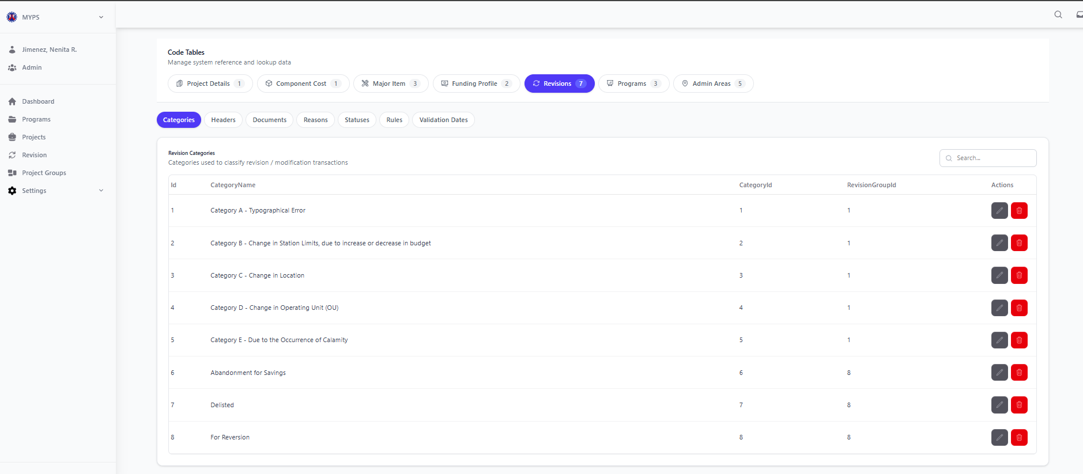
Purpose
The Code Tables Revisions Headers screen allows authorized users to manage the revision header reference records used in MYPS. This screen is used to maintain the list of revision names and their corresponding revision group IDs so that revision transactions are labeled and grouped correctly across the system.
Who Uses This
This screen is available to authorized MYPS users with access to the module.
Prerequisites
Before using this screen, ensure that:
- You are logged in to the MYPS Web application.
- You have permission to access Settings > Code Tables.
Field Reference
No. | Fields/Blocks/Objects | Description | Values / Actions
UI-UX-00101-01 | ID | Unique identifier for each revision header record. | Numeric value; system-generated ID.
UI-UX-00101-02 | REVISION NAME | Displays the name of the revision header. | Text value; e.g., Additional Funding, Adjustment, Change in Authority to Implement.
UI-UX-00101-03 | REVISION GROUP ID | Displays the group identifier associated with the revision header. | Numeric value representing the related revision group.
UI-UX-00101-04 | SEARCH | Search field used to filter revision header records. | Text input; enter keyword or revision name to filter the list.
UI-UX-00101-05 | ACTIONS / EDIT | Button used to modify an existing revision header record. | Edit icon/button; opens the selected revision header for updating.
UI-UX-00101-06 | ACTIONS / DELETE | Button used to remove an existing revision header record. | Delete icon/button; removes the selected record or prompts for confirmation before deletion.
UI-UX-00101-07 | CATEGORIES TAB | Tab used to switch to revision categories management. | Click to open Categories records.
UI-UX-00101-08 | HEADERS TAB | Active tab used to display and manage revision header records. | Selected tab; shows the list of revision headers.
UI-UX-00101-09 | DOCUMENTS TAB | Tab used to switch to revision documents management. | Click to open Documents records.
UI-UX-00101-10 | REASONS TAB | Tab used to switch to revision reasons management. | Click to open
Step-by-step: Use Revision Headers Management
1. Open Code Tables
- Sign in to MYPS Web.
- From the left-side navigation, click Settings.
- Select Code Tables.
2. Open the Revisions group
- In the Code Tables page, click the Revisions tab.
- Select the Headers sub-tab.
3. View the revision header list
- Review the displayed revision header records.
- Each row may contain:
  - ID
  - Revision Name
  - Revision Group ID
  - action buttons for Edit and Delete
4. Search for a revision header
- Click the Search field.
- Type a keyword, revision name, or related text.
- Review the filtered results.
Example search entries:
- Additional Funding
- Adjustment
- Mode of Implementation
- Expired Funding
5. Edit an existing revision header
- Locate the record you want to update.
- Click the Edit icon under Actions / Edit.
- Modify the allowed fields.
- Save the changes.
6. Delete a revision header
- Locate the record you want to remove.
- Click the Delete icon under Actions / Delete.
- Review the confirmation prompt.
- Confirm the action only if authorized and certain.
7. Switch to other revision code tables
Use the sub-tabs to move between related revision code-table sections:
- Categories
- Documents
- Reasons
- Statuses
- Rules
- Validation Dates
8. Review the updated list
- After editing or deleting a record, review the table.
- Confirm that the latest changes are reflected correctly.
Example Inputs
- Example revision header records
- Revision Name: Additional Funding
- Revision Group ID: 10
- Revision Name: Adjustment
- Revision Group ID: 6
- Revision Name: Change in Funding
- Revision Group ID: 12
Example search inputs
- Mode
- Funding
- Adjustment
- Creditor
On Success
- Updated revision header records are saved successfully and displayed in the list.
- Deleted records are removed from the active list, depending on system behavior.
- The screen refreshes to show the latest data.
- Switching tabs opens the selected revision reference section successfully.
Common Outcomes & What to Do
Message / Situation | What it Means | What You Should Do
“Revision header updated successfully” | The selected record was edited and saved. | Verify the updated values in the list.

Code Tables Revisions Documents (UI-UX-0102)
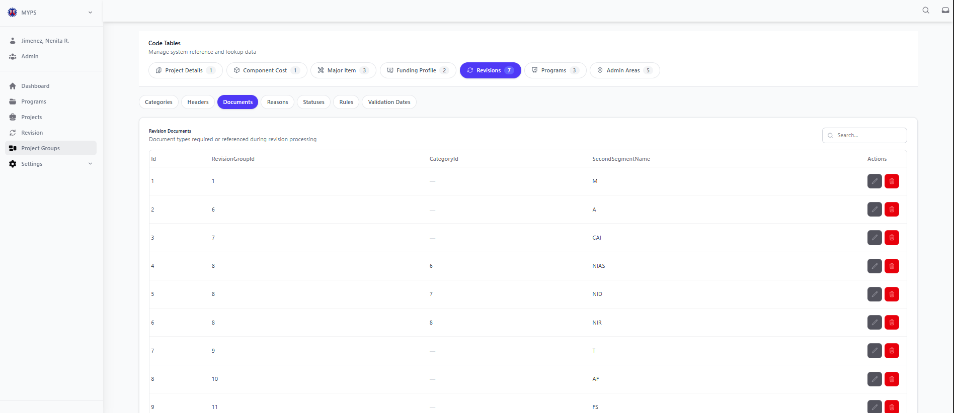
Purpose
The Code Tables Revisions Documents screen allows authorized users to manage the document requirements used during revision processing in MYPS. This screen is used to maintain the list of required or referenced document codes linked to a Revision Group ID and, where applicable, a Category ID.
Who Uses This
This screen is available to authorized MYPS users with access to the module.
Prerequisites
Before using this screen, ensure that:
- You are logged in to the MYPS Web application.
- You have permission to access Settings > Code Tables.

Field Reference
No. | Fields/Blocks/Objects | Description | Values / Actions
UI-UX-0102-01 | ID | Unique identifier for each revision document record. | Numeric value; system-generated ID.
UI-UX-0102-02 | REVISION GROUP ID | Displays the revision group associated with the document requirement. | Numeric value representing the related revision group.
UI-UX-0102-03 | CATEGORY ID | Displays the related category identifier, if applicable. | Numeric value or blank/dash when no category-specific assignment is set.
UI-UX-0102-04 | SECOND SEGMENT NAME | Displays the short document code or segment name used in revision processing. | Text/alphanumeric value such as M, A, CAI, NIAS, NID, NIR, I, AF, or PS.
UI-UX-0102-05 | SEARCH | Search field used to filter revision document records. | Text input; enter keyword, document code, or related value to filter the list.
UI-UX-0102-06 | ACTIONS / EDIT | Button used to modify an existing revision document record. | Edit icon/button; opens the selected revision document record for updating.
UI-UX-0102-07 | ACTIONS / DELETE | Button used to remove an existing revision document record. | Delete icon/button; removes the selected record or prompts for confirmation before deletion.
UI-UX-0102-08 | CATEGORIES TAB | Tab used to switch to revision categories management. | Click to open Categories records.
UI-UX-0102-09 | HEADERS TAB | Tab used to switch to revision headers management. | Click to open Headers records.
UI-UX-0102-10 | DOCUMENTS TAB | Active tab used to display and manage revision document records. | Selected tab; shows the list of revision documents.
UI-UX-0102-11 | REASONS TAB | Tab used to switch to revision reasons management. | Click to open Reasons records.
UI-UX-0102-12 | STATUSES TAB | Tab used to switch to revision statuses management. | Click to open Statuses records.
UI-UX-0102-13 | RULES TAB | Tab used to switch to revision rules management. | Click to open Rules records.
UI-UX-0102-14 | VALIDATION DATES TAB | Tab used to switch to revision validation dates management. | Click to open Validation Dates records.
Step-by-step: Use Revision Documents Management
1. Open Code Tables
- Sign in to MYPS Web.
- From the left-side navigation, click Settings.
- Select Code Tables.
2. Open the Revisions group
- In the Code Tables page, click the Revisions tab.
- Select the Documents sub-tab.
3. View the revision documents list
- Review the displayed revision document records.
- Each row may contain:
  - ID
  - Revision Group ID
  - Category ID
  - Second Segment Name
  - action buttons for Edit and Delete
4. Search for a revision document record
- Click the Search field.
- Type a keyword, document code, revision group number, or category number.
- Review the filtered results.
Example search entries:
- CAI
- AF
- 11
- NIR
5. Edit an existing revision document record
- Locate the record you want to update.
- Click the Edit icon under Actions / Edit.
- Modify the allowed fields.
- Save the changes.
6. Delete a revision document record
- Locate the record you want to remove.
- Click the Delete icon under Actions / Delete.
- Review the confirmation prompt.
- Confirm the action only if authorized and certain.
7. Switch to other revision code tables
Use the sub-tabs to move between related revision code-table sections:
- Categories
- Headers
- Reasons
- Statuses
- Rules
- Validation Dates
Click the needed tab to open and manage that record set.
8. Review the updated list
- After editing or deleting a record, review the table.
- Confirm that the latest changes are reflected correctly.
Example Inputs
Example revision document records
- Revision Group ID: 1
- Category ID: -
- Second Segment Name: M
- Revision Group ID: 7
- Category ID: -
- Second Segment Name: CAI
- Revision Group ID: 8
- Category ID: 6
- Second Segment Name: NIAS
Example search inputs
- CAI
- AF
- PS
- 8
On Success
- Updated revision document records are saved successfully and displayed in the list.
- Deleted records are removed from the active list, depending on system behavior.
- The screen refreshes to show the latest data.
- Switching tabs opens the selected revision reference section successfully.
Common Outcomes & What to Do
Message / Situation | What it Means | What You Should Do
“Revision document updated successfully” | The selected record was edited and saved. | Verify the updated values in the list.
“Revision document deleted successfully” | The selected record was removed or archived. | Review the list and confirm the record no longer appears as active.

Code Tables Revisions Reasons (UI-UX-0103)
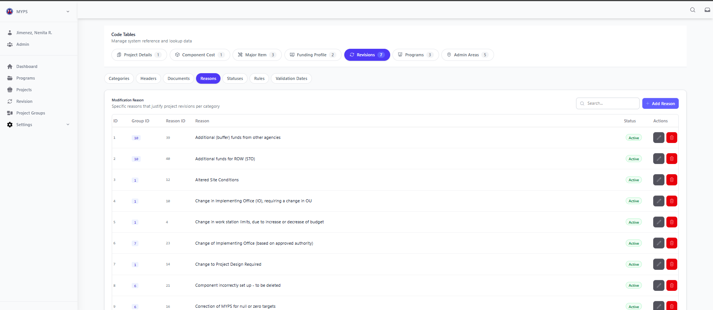
Purpose
The Code Tables Revisions Reasons screen allows authorized users to manage the revision reason reference records used in MYPS. This screen is used to maintain the list of specific reasons that justify project revisions, grouped under the appropriate revision group, so that revision requests are classified consistently during processing.
Who Uses This
This screen is available to authorized MYPS users with access to the module.
Prerequisites
Before using this screen, ensure that:
- You are logged in to the MYPS Web application.
- You have permission to access Settings > Code Tables.
Field Reference
No. | Fields/Blocks/Objects | Description | Values / Actions
UI-UX-0103-01 | ID | Unique identifier for each revision reason record. | Numeric value; system-generated ID.
UI-UX-0103-02 | GROUP ID | Displays the group identifier associated with the revision reason. | Numeric value representing the related revision group.
UI-UX-0103-03 | REASON ID | Displays the assigned identifier or code for the revision reason. | Numeric value linked to the revision reason record.
UI-UX-0103-04 | REASON | Displays the specific justification or explanation for the revision. | Text value; e.g., Additional (buffer) funds from other agencies, Altered Site Conditions, Change in implementing office, etc.
UI-UX-0103-05 | STATUS | Indicates whether the revision reason is active or inactive in the system. | Status tag/value such as Active or system-configured equivalent.
UI-UX-0103-06 | SEARCH | Search field used to filter revision reason records. | Text input; enter keyword or reason text to filter the list.
UI-UX-0103-07 | ADD REASON | Button used to create a new revision reason entry. | Button labeled Add Reason; opens the form or modal for adding a new reason.
UI-UX-0103-08 | ACTIONS / EDIT | Button used to modify an existing revision reason record. | Edit icon/button; opens the selected revision reason for updating.
UI-UX-0103-09 | ACTIONS / DELETE | Button used to remove an existing revision reason record. | Delete icon/button; removes the selected record or prompts for confirmation before deletion.
UI-UX-0103-10 | CATEGORIES TAB | Tab used to switch to revision categories management. | Click to open Categories records.
UI-UX-0103-11 | HEADERS TAB | Tab used to switch to revision headers management. | Click to open Headers records.
UI-UX-0103-12 | DOCUMENTS TAB | Tab used to switch to revision documents management. | Click to open Documents records.
UI-UX-0103-13 | REASONS TAB | Active tab used to display and manage revision reason records. | Selected tab; shows the list of revision reasons.
UI-UX-0103-14 | STATUSES TAB | Tab used to switch to revision statuses management. | Click to open Statuses records.
UI-UX-0103-15 | RULES TAB | Tab used to switch to revision rules management. | Click to open Rules records.
UI-UX-0103-16 | VALIDATION DATES TAB | Tab used to switch to revision validation dates management. | Click to open Validation Dates records.
Step-by-step: Use Revision Reasons Management
1. Open Code Tables
- Sign in to MYPS Web.
- From the left-side navigation, click Settings.
- Select Code Tables.
2. Open the Revisions group
- In the Code Tables page, click the Revisions tab.
- Select the Reasons sub-tab.
3. View the revision reason list
- Review the displayed revision reason records.
- Each row may contain:
  - ID
  - Group ID
  - Reason ID
  - Reason
  - Status
  - action buttons for Edit and Delete
4. Search for a revision reason
- Click the Search field.
- Type a keyword, phrase, or part of the reason text.
- Review the filtered results.
Example search entries:
- buffer
- site conditions
- implementing office
- ROW
5. Add a new revision reason
- Click Add Reason.
- Enter the required information in the form or modal.
- Complete the fields such as:
  - Group ID
  - Reason ID
  - Reason
  - Status
- Click Save.
6. Edit an existing revision reason
- Locate the record you want to update.
- Click the Edit icon under Actions / Edit.
- Modify the allowed fields.
- Save the changes.
7. Delete a revision reason
- Locate the record you want to remove.
- Click the Delete icon under Actions / Delete.
- Review the confirmation prompt.
- Confirm the action only if authorized and certain.
8. Switch to other revision code tables
Use the sub-tabs to move between related revision code-table sections:
- Categories
- Headers
- Documents
- Statuses
- Rules
- Validation Dates
9. Review the updated list
- After adding, editing, or deleting a record, review the table.
- Confirm that the latest changes are reflected correctly.
Example Inputs
Example revision reason records
- Group ID: 10
- Reason ID: 39
- Reason: Additional (buffer) funds from other agencies
- Status: Active
- Group ID: 1
- Reason ID: 12
- Reason: Altered Site Conditions
- Status: Active
- Group ID: 7
- Reason ID: 23
- Reason: Change of Implementing Office (based on approved authority)
- Status: Active
Example search inputs
- Additional
- Office
- Design
- Budget
On Success
- The new revision reason record is saved successfully and appears in the list.
- Updated records display the latest saved values.
- Deleted records are removed from the active list, depending on system behavior.
- The screen refreshes to show the latest data.
- Switching tabs opens the selected revision reference section successfully.
Common Outcomes & What to Do
Message / Situation | What it Means | What You Should Do
“Revision reason added successfully” | The new record was saved. | Review the list and confirm the new record appears correctly.
“Revision reason updated successfully” | The selected record was edited and saved. | Verify the updated values in the list.
“Revision reason deleted successfully” | The selected record was removed or archived. | Review the list and confirm the record no longer appears as active.

Code Tables Revisions Statuses (UI-UX-0104)
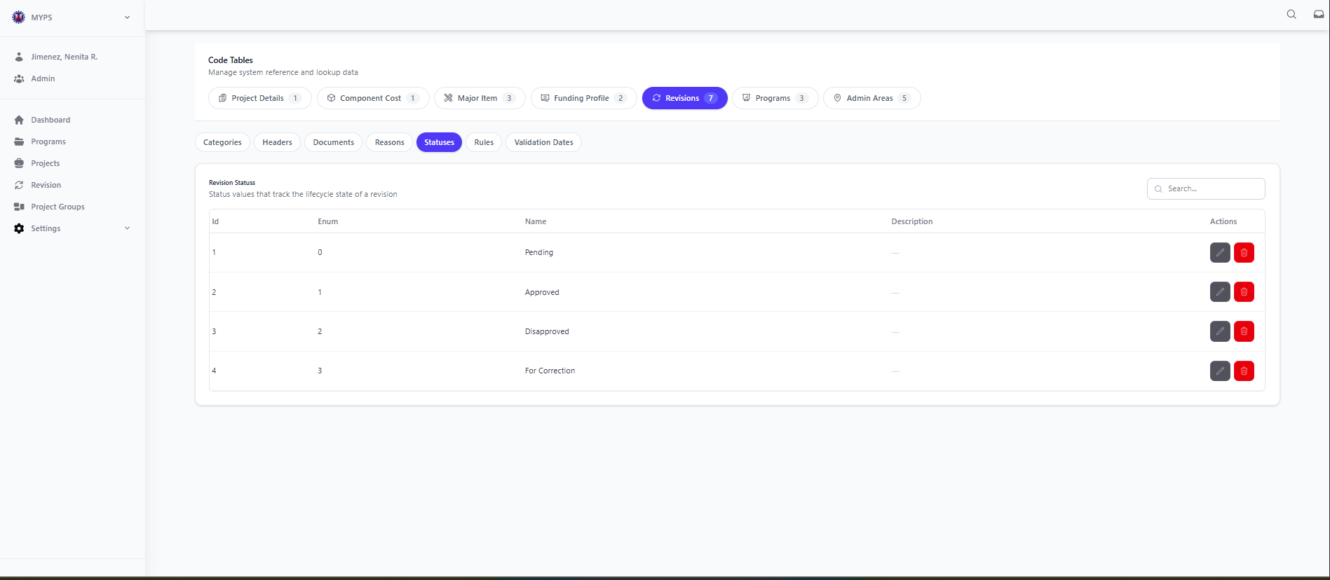
Purpose
The Code Tables Revisions Statuses screen allows authorized users to manage the revision status reference records used in MYPS. This screen is used to maintain the lifecycle status values applied to revision transactions, such as Pending, Approved, Disapproved, and For Correction.
Who Uses This
This screen is available to authorized MYPS users with access to the module.
Prerequisites
Before using this screen, ensure that:
- You are logged in to the MYPS Web application.
- You have permission to access Settings > Code Tables.
Field Reference
No. | Fields/Blocks/Objects | Description | Values / Actions
UI-UX-0104-01 | ID | Unique identifier for each revision status record. | Numeric value; system-generated ID.
UI-UX-0104-02 | ENUM | Displays the numeric or coded value associated with the revision status. | Numeric/system value such as 0, 1, 2, or 3.
UI-UX-0104-03 | NAME | Displays the status name used in revision processing. | Text value such as Pending, Approved, Disapproved, or For Correction.
UI-UX-0104-04 | DESCRIPTION | Displays a brief description of the revision status. | Text field; may be blank or system-defined depending on setup.
UI-UX-0104-05 | SEARCH | Search field used to filter revision status records. | Text input; enter keyword or status name to filter the list.
UI-UX-0104-06 | ACTIONS / EDIT | Button used to modify an existing revision status record. | Edit icon/button; opens the selected revision status for updating.
UI-UX-0104-07 | ACTIONS / DELETE | Button used to remove an existing revision status record. | Delete icon/button; removes the selected record or prompts for confirmation before deletion.
UI-UX-0104-08 | CATEGORIES TAB | Tab used to switch to revision categories management. | Click to open Categories records.
UI-UX-0104-09 | HEADERS TAB | Tab used to switch to revision headers management. | Click to open Headers records.
UI-UX-0104-10 | DOCUMENTS TAB | Tab used to switch to revision documents management. | Click to open Documents records.
UI-UX-0104-11 | REASONS TAB | Tab used to switch to revision reasons management. | Click to open Reasons records.
UI-UX-0104-12 | STATUSES TAB | Active tab used to display and manage revision status records. | Selected tab; shows the list of revision statuses.
UI-UX-0104-13 | RULES TAB | Tab used to switch to revision rules management. | Click to open Rules records.
UI-UX-0104-14 | VALIDATION DATES TAB | Tab used to switch to revision validation dates management. | Click to open Validation Dates records.
Step-by-step: Use Revision Statuses Management
1. Open Code Tables
- Sign in to MYPS Web.
- From the left-side navigation, click Settings.
- Select Code Tables.
2. Open the Revisions group
- In the Code Tables page, click the Revisions tab.
- Select the Statuses sub-tab.
3. View the revision status list
- Review the displayed revision status records.
- Each row may contain:
  - ID
  - Enum
  - Name
  - Description
  - action buttons for Edit and Delete
4. Search for a revision status
- Click the Search field.
- Type a keyword, status name, or enum value.
- Review the filtered results.
Example search entries:
- Pending
- Approved
- For Correction
- 1
5. Edit an existing revision status
- Locate the record you want to update.
- Click the Edit icon under Actions / Edit.
- Modify the allowed fields.
- Save the changes.
6. Delete a revision status
- Locate the record you want to remove.
- Click the Delete icon under Actions / Delete.
- Review the confirmation prompt.
- Confirm the action only if authorized and certain.
7. Switch to other revision code tables
Use the sub-tabs to move between related revision code-table sections:
- Categories
- Headers
- Documents
- Reasons
- Rules
- Validation Dates
Click the needed tab to open and manage that record set.
8. Review the updated list
- After editing or deleting a record, review the table.
- Confirm that the latest changes are reflected correctly.
Example Inputs
Example revision status records
- Enum: 0
- Name: Pending
- Enum: 1
- Name: Approved
- Enum: 2
- Name: Disapproved
- Enum: 3
- Name: For Correction
Example search inputs
- Approved
- Pending
- Correction
- 2
On Success
- Updated revision status records are saved successfully and displayed in the list.
- Deleted records are removed from the active list, depending on system behavior.
- The screen refreshes to show the latest data.
- Switching tabs opens the selected revision reference section successfully.
Common Outcomes & What to Do
Message / Situation | What it Means | What You Should Do
“Revision status updated successfully” | The selected record was edited and saved. | Verify the updated values in the list.
“Revision status deleted successfully” | The selected record was removed or archived. | Review the list and confirm the record no longer appears as active.
“Required field missing” | One or more mandatory fields were not completed. | Complete all required fields, then save again.

Code Tables Revisions Rules (UI-UX-0105)
Purpose
The Code Tables Revisions Rules screen allows authorized users to manage the revision field permission rules used in MYPS. This screen is used to define which fields can be edited for a specific revision reason, based on the project’s PCMA Status and Package Status.
Who Uses This
This screen is available to authorized MYPS users with access to the module.
Prerequisites
Before using this screen, ensure that:
- You are logged in to the MYPS Web application.
- You have permission to access Settings > Code Tables.

Field Reference
No. | Fields/Blocks/Objects | Description | Values / Actions
UI-UX-0105-01 | ID | Unique identifier for each revision rule record. | Numeric value; system-generated ID.
UI-UX-0105-02 | REASON | Displays the revision reason associated with the rule. | Text value; e.g., Typographical Error on Project Description, Project Description needs items removed due to typo error.
UI-UX-0105-03 | PCMA STATUS | Displays the PCMA project status condition tied to the rule. | Status tag/value such as Not yet started, Completed, Terminated, or On-going.
UI-UX-0105-04 | PACKAGE STATUS | Displays the package status condition tied to the rule. | Status tag/value such as Packaged or Not Packaged.
UI-UX-0105-05 | FIELD RULES | Displays the configured field rule set for the selected record. | Link/action such as View Rules; opens the field-level permissions or allowed edit settings.
UI-UX-0105-06 | SEARCH REASON OR STATUS | Search field used to filter revision rule records. | Text input; enter keyword, reason, or status to filter the list.
UI-UX-0105-07 | ACTIONS / EDIT | Button used to modify an existing revision rule record. | Edit icon/button; opens the selected revision rule for updating.
UI-UX-0105-08 | ACTIONS / DELETE | Button used to remove an existing revision rule record. | Delete icon/button; removes the selected record or prompts for confirmation before deletion.
UI-UX-0105-09 | CATEGORIES TAB | Tab used to switch to revision categories management. | Click to open Categories records.
UI-UX-0105-10 | HEADERS TAB | Tab used to switch to revision headers management. | Click to open Headers records.
UI-UX-0105-11 | DOCUMENTS TAB | Tab used to switch to revision documents management. | Click to open Documents records.
UI-UX-0105-12 | REASONS TAB | Tab used to switch to revision reasons management. | Click to open Reasons records.
UI-UX-0105-13 | STATUSES TAB | Tab used to switch to revision statuses management. | Click to open Statuses records.
UI-UX-0105-14 | RULES TAB | Active tab used to display and manage revision rules. | Selected tab; shows the list of revision field permission rules.
UI-UX-0105-15 | VALIDATION DATES TAB | Tab used to switch to revision validation dates management. | Click to open Validation Dates records.
Step-by-step: Use Revision Rules Management
1. Open Code Tables
- Sign in to MYPS Web.
- From the left-side navigation, click Settings.
- Select Code Tables.
2. Open the Revisions group
- In the Code Tables page, click the Revisions tab.
- Select the Rules sub-tab.
3. View the revision rules list
- Review the displayed revision rule records.
- Each row may contain:
  - ID
  - Reason
  - PCMA Status
  - Package Status
  - Field Rules
  - action buttons for Edit and Delete
4. Search for a revision rule
- Click the Search reason or status... field.
- Type a keyword, reason text, or status value.
- Review the filtered results.
Example search entries:
- Typographical
- Completed
- Packaged
- On-going
5. View field rules
- Locate the record you want to inspect.
- Click View Rules under the Field Rules column.
- Review the configured editable or restricted fields for that rule combination.
6. Edit an existing revision rule
- Locate the record you want to update.
- Click the Edit icon under Actions / Edit.
- Modify the allowed fields or rule settings.
- Save the changes.
7. Delete a revision rule
- Locate the record you want to remove.
- Click the Delete icon under Actions / Delete.
- Review the confirmation prompt.
- Confirm the action only if authorized and certain.
8. Switch to other revision code tables
Use the sub-tabs to move between related revision code-table sections:
- Categories
- Headers
- Documents
- Reasons
- Statuses
- Validation Dates
Click the needed tab to open and manage that record set.
9. Review the updated list
- After viewing, editing, or deleting a record, review the table.
- Confirm that the latest changes are reflected correctly.
Example Inputs
Example revision rule records
- Reason: Typographical Error on Project Description
- PCMA Status: Not yet started
- Package Status: Packaged
- Field Rules: View Rules
- Reason: Typographical Error on Project Description
- PCMA Status: Completed
- Package Status: Not Packaged
- Field Rules: View Rules
- Reason: Project Description needs items removed due to typo error
- PCMA Status: On-going
- Package Status: Packaged
- Field Rules: View Rules
Example search inputs
- Terminated
- Not Packaged
- Description
- Completed
On Success
- Updated revision rule records are saved successfully and displayed in the list.
- Deleted records are removed from the active list, depending on system behavior.
- The screen refreshes to show the latest data.
- Selecting View Rules opens the rule details for review.

Common Outcomes & What to Do
Message / Situation | What it Means | What You Should Do
“Revision rule updated successfully” | The selected record was edited and saved. | Verify the updated values in the list.
“Revision rule deleted successfully” | The selected record was removed or archived. | Review the list and confirm the record no longer appears as active.
“Required field missing” | One or more mandatory fields were not completed. | Complete all required fields, then save again.
- revision reason or status involved
- action attempted (Search, View Rules, Edit, Delete, or Tab switch)
- error message shown

Code Tables Revisions Validated Dates (UI-UX-0106)
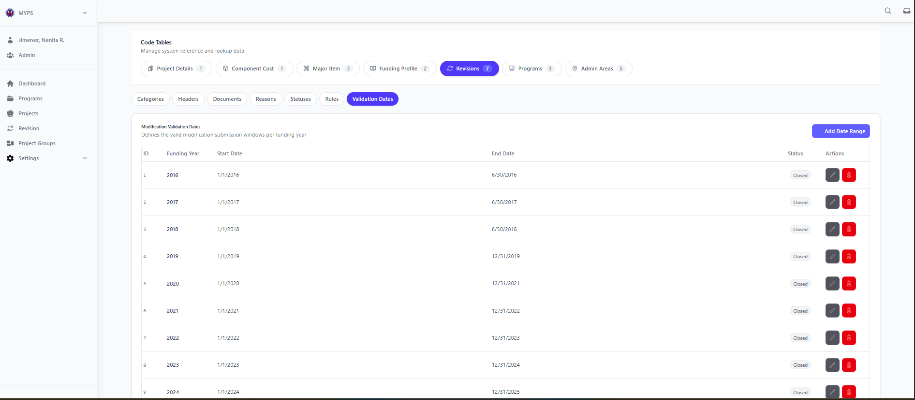
Purpose
The Code Tables Revisions Validation Dates screen allows authorized users to manage the date ranges for valid revision submission windows in MYPS. This screen is used to define the allowable start date, end date, and status of revision filing periods per Funding Year.
Who Uses This
This screen is available to authorized MYPS users with access to the module.
Prerequisites
Before using this screen, ensure that:
- You are logged in to the MYPS Web application.
- You have permission to access Settings > Code Tables.

Field Reference
No. | Fields/Blocks/Objects | Description | Values / Actions
UI-UX-00106-01 | ID | Unique identifier for each validation date record. | Numeric value; system-generated ID.
UI-UX-00106-02 | FUNDING YEAR | Displays the funding year covered by the validation period. | Numeric year value such as 2016, 2017, 2024.
UI-UX-00106-03 | START DATE | Displays the beginning date of the valid revision submission period. | Date value in system format, e.g., 1/1/2024.
UI-UX-00106-04 | END DATE | Displays the ending date of the valid revision submission period. | Date value in system format, e.g., 12/31/2025.
UI-UX-00106-05 | STATUS | Indicates whether the validation date range is currently open or closed for revision submission. | Status tag/value such as Closed or other system-defined status.
UI-UX-00106-06 | ACTIONS / EDIT | Button used to modify an existing validation date record. | Edit icon/button; opens the selected record for updating.
UI-UX-00106-07 | ACTIONS / DELETE | Button used to remove an existing validation date record. | Delete icon/button; removes the selected record or prompts for confirmation before deletion.
UI-UX-00106-08 | ADD DATE RANGE | Button used to create a new validation date range entry. | Button labeled Add Date Range; opens the form or modal for adding a new record.
UI-UX-00106-09 | CATEGORIES TAB | Tab used to switch to revision categories management. | Click to open Categories records.
UI-UX-00106-10 | HEADERS TAB | Tab used to switch to revision headers management. | Click to open Headers records.
UI-UX-00106-11 | DOCUMENTS TAB | Tab used to switch to revision documents management. | Click to open Documents records.
UI-UX-00106-12 | REASONS TAB | Tab used to switch to revision reasons management. | Click to open Reasons records.
UI-UX-00106-13 | STATUSES TAB | Tab used to switch to revision statuses management. | Click to open Statuses records.
UI-UX-00106-14 | RULES TAB | Tab used to switch to revision rules management. | Click to open Rules records.
UI-UX-00106-15 | VALIDATION DATES TAB | Active tab used to display and manage revision validation date records. | Selected tab; shows the list of validation date ranges.
Step-by-step: Use Revision Validation Dates Management
1. Open Code Tables
- Sign in to MYPS Web.
- From the left-side navigation, click Settings.
- Select Code Tables.
2. Open the Revisions group
- In the Code Tables page, click the Revisions tab.
- Select the Validation Dates sub-tab.
3. View the validation date list
- Review the displayed validation date records.
- Each row may contain:
  - ID
  - Funding Year
  - Start Date
  - End Date
  - Status
  - action buttons for Edit and Delete
4. Add a new date range
- Click Add Date Range.
- Enter the required information in the form or modal.
- Complete the fields such as:
  - Funding Year
  - Start Date
  - End Date
  - Status
- Click Save.
5. Edit an existing validation date record
- Locate the record you want to update.
- Click the Edit icon under Actions / Edit.
- Modify the allowed fields.
- Save the changes.
6. Delete a validation date record
- Locate the record you want to remove.
- Click the Delete icon under Actions / Delete.
- Review the confirmation prompt.
- Confirm the action only if authorized and certain.
7. Switch to other revision code tables
Use the sub-tabs to move between related revision code-table sections:
- Categories
- Headers
- Documents
- Reasons
- Statuses
- Rules
Click the needed tab to open and manage that record set.
8. Review the updated list
- After adding, editing, or deleting a record, review the table.
- Confirm that the latest changes are reflected correctly.
Example Inputs
Example validation date records
- Funding Year: 2016
- Start Date: 1/1/2016
- End Date: 6/30/2016
- Status: Closed
- Funding Year: 2021
- Start Date: 1/1/2021
- End Date: 12/31/2022
- Status: Closed
- Funding Year: 2024
- Start Date: 1/1/2024
- End Date: 12/31/2025
- Status: Closed
On Success
- The new validation date record is saved successfully and appears in the list.
- Updated records display the latest saved values.
- Deleted records are removed from the active list, depending on system behavior.
Common Outcomes & What to Do
Message / Situation | What it Means | What You Should Do
“Validation date added successfully” | The new record was saved. | Review the list and confirm the new record appears correctly.
“Validation date updated successfully” | The selected record was edited and saved. | Verify the updated values in the list.
“Validation date deleted successfully” | The selected record was removed or archived. | Review the list and confirm the record no longer appears as active.

Code Tables Program Stage (UI-UX-0107)
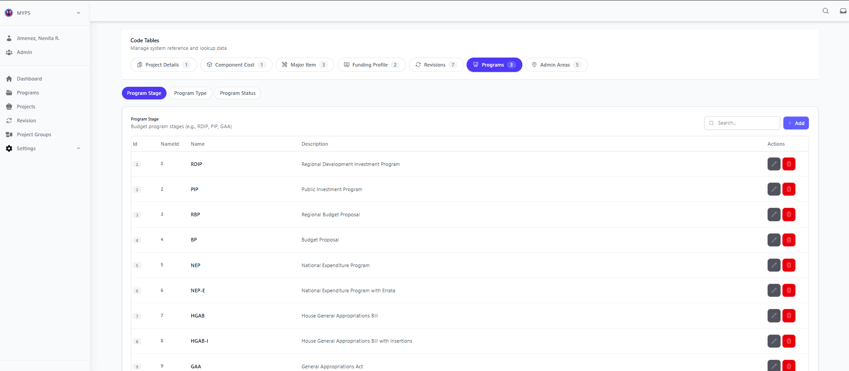
Purpose
The Code Tables Program Stage screen allows authorized users to manage the Program Stage reference records used in MYPS. This screen is used to maintain the list of budget or program stages, such as RDIP, PIP, RBP, BP, NEP, NEP-E, HGAB, HGAB-I, and GAA, so that program records are classified consistently across the system.
Who Uses This
This screen is available to authorized MYPS users with access to the module.
Prerequisites
Before using this screen, ensure that:
- You are logged in to the MYPS Web application.
- You have permission to access Settings > Code Tables.
Field Reference
No. | Fields/Blocks/Objects | Description | Values / Actions
UI-UX-0107-01 | ID | Unique identifier for each program stage record. | Numeric value; system-generated ID.
UI-UX-0107-02 | NAMEID | Displays the short code or stage code assigned to the program stage. | Text/alphanumeric value such as RDIP, PIP, RBP, BP, NEP, NEP-E, HGAB, HGAB-I, GAA.
UI-UX-0107-03 | NAME | Displays the official name of the program stage. | Text value such as Regional Development Investment Program, Public Investment Program, Regional Budget Proposal, or General Appropriations Act.
UI-UX-0107-04 | DESCRIPTION | Displays the description or meaning of the program stage. | Text value describing the stage used in budget/program processing.
UI-UX-0107-05 | SEARCH | Search field used to filter program stage records. | Text input; enter keyword or stage code/name to filter the list.
UI-UX-0107-06 | ADD | Button used to create a new program stage entry. | Button labeled Add; opens the form or modal for adding a new program stage.
UI-UX-0107-07 | ACTIONS / EDIT | Button used to modify an existing program stage record. | Edit icon/button; opens the selected program stage for updating.
UI-UX-0107-08 | ACTIONS / DELETE | Button used to remove an existing program stage record. | Delete icon/button; removes the selected record or prompts for confirmation before deletion.
UI-UX-0107-09 | PROGRAM STAGE TAB | Active tab used to display and manage program stage records. | Selected tab; shows the list of program stages.
UI-UX-0107-10 | PROGRAM TYPE TAB | Tab used to switch to program type management. | Click to open Program Type records.
UI-UX-0107-11 | PROGRAM STATUS TAB | Tab used to switch to program status management. | Click to open Program Status records.
UI-UX-0107-12 | PROGRAMS TAB | Main code table category for managing program-related reference data. | Active parent tab for program code tables.
Step-by-step: Use Program Stage Management
1. Open Code Tables
- Sign in to MYPS Web.
- From the left-side navigation, click Settings.
- Select Code Tables.
2. Open the Programs group
- In the Code Tables page, click the Programs tab.
- Confirm that the Program Stage sub-tab is selected.
3. View the program stage list
- Review the displayed program stage records.
- Each row may contain:
  - ID
  - Name ID
  - Name
  - Description
  - action buttons for Edit and Delete
4. Search for a program stage
- Click the Search field.
- Type a keyword, stage code, or part of the stage name.
- Review the filtered results.
Example search entries:
- RDIP
- PIP
- Budget
- GAA
5. Add a new program stage
- Click Add.
- Enter the required information in the form or modal.
- Complete the fields such as:
  - Name ID
  - Name
  - Description
- Click Save.
6. Edit an existing program stage
- Locate the record you want to update.
- Click the Edit icon under Actions / Edit.
- Modify the allowed fields.
- Save the changes.
7. Delete a program stage
- Locate the record you want to remove.
- Click the Delete icon under Actions / Delete.
- Review the confirmation prompt.
- Confirm the action only if authorized and certain.
8. Switch to other program code tables
Use the sub-tabs to move between related program code-table sections:
- Program Type
- Program Status
Click the needed tab to open and manage that record set.
9. Review the updated list
- After adding, editing, or deleting a record, review the table.
- Confirm that the latest changes are reflected correctly.
Example Inputs
Example program stage records
- Name ID: RDIP
- Name: Regional Development Investment Program
- Description: Budget program stage
- Name ID: PIP
- Name: Public Investment Program
- Description: Budget program stage
- Name ID: GAA
- Name: General Appropriations Act
- Description: Budget program stage
Example search inputs
- NEP
- HGAB
- Proposal
- Appropriations
On Success
- The new program stage record is saved successfully and appears in the list.
- Updated records display the latest saved values.
- Deleted records are removed from the active list, depending on system behavior.
- The screen refreshes to show the latest data.
- Switching tabs opens the selected program reference section successfully.

Common Outcomes & What to Do
Message / Situation | What it Means | What You Should Do
“Program stage added successfully” | The new record was saved. | Review the list and confirm the new record appears correctly.
“Program stage updated successfully” | The selected record was edited and saved. | Verify the updated values in the list.
“Program stage deleted successfully” | The selected record was removed or archived. | Review the list and confirm the record no longer appears as active.

Code Tables Program Type (UI-UX-0108)
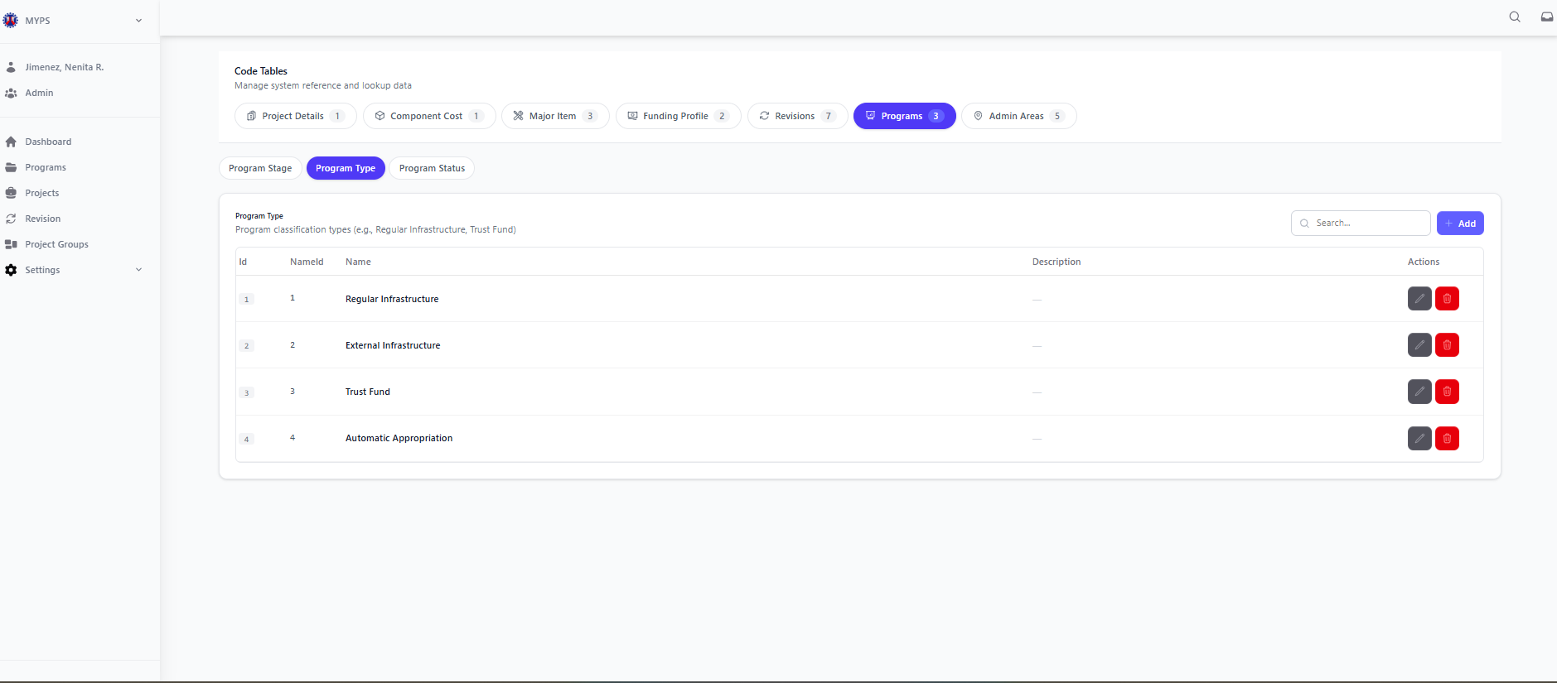
Purpose
The Code Tables Program Type screen allows authorized users to manage the Program Type reference records used in MYPS. This screen is used to maintain the list of valid program classifications, such as Regular Infrastructure, External Infrastructure, Trust Fund, and Automatic Appropriation, so program records are categorized consistently across the system.
Who Uses This
This screen is available to authorized MYPS users with access to the module.
Prerequisites
Before using this screen, ensure that:
- You are logged in to the MYPS Web application.
- You have permission to access Settings > Code Tables.

Field Reference
No. | Fields/Blocks/Objects | Description | Values / Actions
UI-UX-0108-01 | ID | Unique identifier for each program type record. | Numeric value; system-generated ID.
UI-UX-0108-02 | NAMEID | Displays the code or reference number assigned to the program type. | Numeric or system-defined value such as 1, 2, 3, 4.
UI-UX-0108-03 | NAME | Displays the official name of the program type. | Text value such as Regular Infrastructure, External Infrastructure, Trust Fund, or Automatic Appropriation.
UI-UX-0108-04 | DESCRIPTION | Displays the description of the program type. | Text value or blank field depending on configuration.
UI-UX-0108-05 | SEARCH | Search field used to filter program type records. | Text input; enter keyword or program type name to filter the list.
UI-UX-0108-06 | ADD | Button used to create a new program type entry. | Button labeled Add; opens the form or modal for adding a new program type.
UI-UX-0108-07 | ACTIONS / EDIT | Button used to modify an existing program type record. | Edit icon/button; opens the selected program type for updating.
UI-UX-0108-08 | ACTIONS / DELETE | Button used to remove an existing program type record. | Delete icon/button; removes the selected record or prompts for confirmation before deletion.
UI-UX-0108-09 | PROGRAM STAGE TAB | Tab used to switch to program stage management. | Click to open Program Stage records.
UI-UX-0108-10 | PROGRAM TYPE TAB | Active tab used to display and manage program type records. | Selected tab; shows the list of program types.
UI-UX-0108-11 | PROGRAM STATUS TAB | Tab used to switch to program status management. | Click to open Program Status records.
UI-UX-0108-12 | PROGRAMS TAB | Main code table category for managing program-related reference data. | Active parent tab for program code tables.
Step-by-step: Use Program Type Management
1. Open Code Tables
- Sign in to MYPS Web.
- From the left-side navigation, click Settings.
- Select Code Tables.
2. Open the Programs group
- In the Code Tables page, click the Programs tab.
- Select the Program Type sub-tab.
3. View the program type list
- Review the displayed program type records.
- Each row may contain:
  - ID
  - Name ID
  - Name
  - Description
  - action buttons for Edit and Delete
4. Search for a program type
- Click the Search field.
- Type a keyword or part of the program type name.
- Review the filtered results.
Example search entries:
- Regular
- External
- Trust
- Automatic
5. Add a new program type
- Click Add.
- Enter the required information in the form or modal.
- Complete the fields such as:
  - Name ID
  - Name
  - Description
- Click Save.
6. Edit an existing program type
- Locate the record you want to update.
- Click the Edit icon under Actions / Edit.
- Modify the allowed fields.
- Save the changes.
7. Delete a program type
- Locate the record you want to remove.
- Click the Delete icon under Actions / Delete.
- Review the confirmation prompt.
- Confirm the action only if authorized and certain.
8. Switch to other program code tables
Use the sub-tabs to move between related program code-table sections:
- Program Stage
- Program Status
Click the needed tab to open and manage that record set.
9. Review the updated list
- After adding, editing, or deleting a record, review the table.
- Confirm that the latest changes are reflected correctly.
Example Inputs
- Example program type records
- Name ID: 1
- Name: Regular Infrastructure
- Description: Standard infrastructure-funded program type
- Name ID: 2
- Name: External Infrastructure
- Description: Program funded through external sources
- Name ID: 3
- Name: Trust Fund
- Description: Program under trust fund classification
Example search inputs
- Infrastructure
- Trust
- External
- Automatic
On Success
- The new program type record is saved successfully and appears in the list.
- Updated records display the latest saved values.
- Deleted records are removed from the active list, depending on system behavior.
- The screen refreshes to show the latest data.
- Switching tabs opens the selected program reference section successfully.
Common Outcomes & What to Do
Message / Situation | What it Means | What You Should Do
“Program type added successfully” | The new record was saved. | Review the list and confirm the new record appears correctly.
“Program type updated successfully” | The selected record was edited and saved. | Verify the updated values in the list.
“Program type deleted successfully” | The selected record was removed or archived. | Review the list and confirm the record no longer appears as active.
“Required field missing” | One or more mandatory fields were not completed. | Complete all required fields, then save again.

Code Tables Program Status (UI-UX-0109)
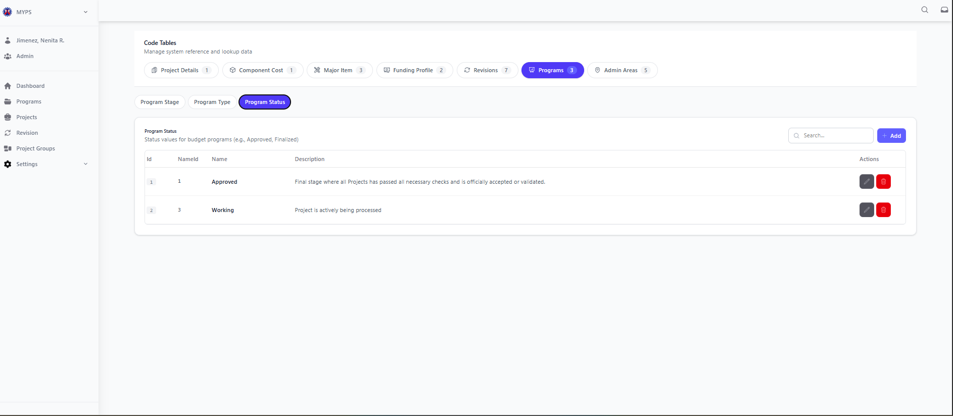
Purpose
The Code Tables Program Status screen allows authorized users to manage the Program Status reference records used in MYPS. This screen is used to maintain the list of valid program statuses, such as Approved and Working, so program records are classified and tracked consistently across the system.
Who Uses This
This screen is available to authorized MYPS users with access to the module.
Prerequisites
Before using this screen, ensure that:
- You are logged in to the MYPS Web application.
- You have permission to access Settings > Code Tables.
Field Reference
No. | Fields/Blocks/Objects | Description | Values / Actions
UI-UX-0109-01 | ID | Unique identifier for each program status record. | Numeric value; system-generated ID.
UI-UX-0109-02 | NAMEID | Displays the code or reference number assigned to the program status. | Numeric or system-defined value such as 1, 2, or other configured values.
UI-UX-0109-03 | NAME | Displays the official name of the program status. | Text value such as Approved or Working.
UI-UX-0109-04 | DESCRIPTION | Displays the description or meaning of the program status. | Text value describing the status, such as final/validated or actively being processed.
UI-UX-0109-05 | SEARCH | Search field used to filter program status records. | Text input; enter keyword or status name to filter the list.
UI-UX-0109-06 | ADD | Button used to create a new program status entry. | Button labeled Add; opens the form or modal for adding a new program status.
UI-UX-0109-07 | ACTIONS / EDIT | Button used to modify an existing program status record. | Edit icon/button; opens the selected program status for updating.
UI-UX-0109-08 | ACTIONS / DELETE | Button used to remove an existing program status record. | Delete icon/button; removes the selected record or prompts for confirmation before deletion.
UI-UX-0109-09 | PROGRAM STAGE TAB | Tab used to switch to program stage management. | Click to open Program Stage records.
UI-UX-0109-10 | PROGRAM TYPE TAB | Tab used to switch to program type management. | Click to open Program Type records.
UI-UX-0109-11 | PROGRAM STATUS TAB | Active tab used to display and manage program status records. | Selected tab; shows the list of program statuses.
UI-UX-0109-12 | PROGRAMS TAB | Main code table category for managing program-related reference data. | Active parent tab for program code tables.
Step-by-step: Use Program Status Management
1. Open Code Tables
- Sign in to MYPS Web.
- From the left-side navigation, click Settings.
- Select Code Tables.
2. Open the Programs group
- In the Code Tables page, click the Programs tab.
- Select the Program Status sub-tab.
3. View the program status list
- Review the displayed program status records.
- Each row may contain:
  - ID
  - Name ID
  - Name
  - Description
  - action buttons for Edit and Delete
4. Search for a program status
- Click the Search field.
- Type a keyword or part of the status name.
- Review the filtered results.
Example search entries:
- Approved
- Working
- Final
- Processed
5. Add a new program status
- Click Add.
- Enter the required information in the form or modal.
- Complete the fields such as:
  - Name ID
  - Name
  - Description
- Click Save.
6. Edit an existing program status
- Locate the record you want to update.
- Click the Edit icon under Actions / Edit.
- Modify the allowed fields.
- Save the changes.
7. Delete a program status
- Locate the record you want to remove.
- Click the Delete icon under Actions / Delete.
- Review the confirmation prompt.
- Confirm the action only if authorized and certain.
8. Switch to other program code tables
Use the sub-tabs to move between related program code-table sections:
- Program Stage
- Program Type
Click the needed tab to open and manage that record set.
9. Review the updated list
- After adding, editing, or deleting a record, review the table.
- Confirm that the latest changes are reflected correctly.
Example Inputs
Example program status records
- Name ID: 1
- Name: Approved
- Description: Final stage where all projects have passed all necessary checks and is officially accepted or validated.
- Name ID: 2
- Name: Working
- Description: Project is actively being processed.
Example search inputs
- Approved
- Working
- Final
- Validated
On Success
- The new program status record is saved successfully and appears in the list.
- Updated records display the latest saved values.
- Deleted records are removed from the active list, depending on system behavior.
- The screen refreshes to show the latest data.
- Switching tabs opens the selected program reference section successfully.
Common Outcomes & What to Do
Message / Situation | What it Means | What You Should Do
“Program status added successfully” | The new record was saved. | Review the list and confirm the new record appears correctly.
“Program status updated successfully” | The selected record was edited and saved. | Verify the updated values in the list.
“Program status deleted successfully” | The selected record was removed or archived. | Review the list and confirm the record no longer appears as active.

Code Tables Admin Areas Regions (UI-UX-0110)
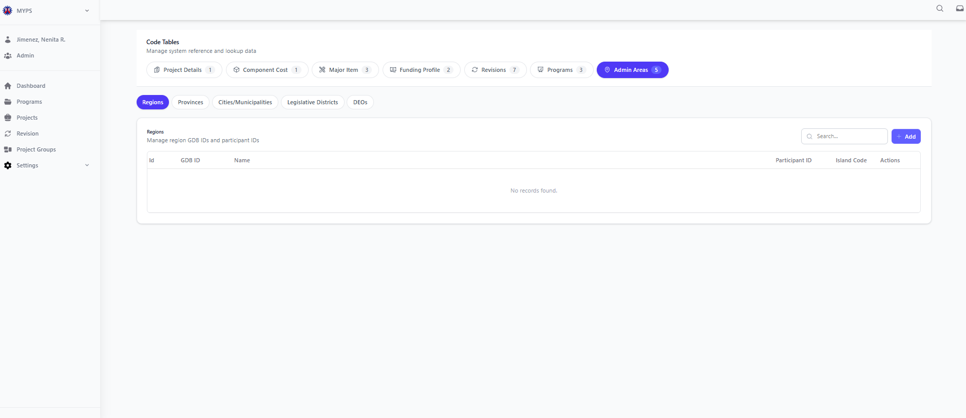
Purpose
The Code Tables Admin Areas Regions screen allows authorized users to manage the Region reference records used in MYPS. This screen is used to maintain the list of regions, including their corresponding GDS ID, Participant ID, and Island Code, so administrative area data remains consistent across the system.
Who Uses This
This screen is available to authorized MYPS users with access to the module.
Prerequisites
Before using this screen, ensure that:
- You are logged in to the MYPS Web application.
- You have permission to access Settings > Code Tables.
Field Reference
No. | Fields/Blocks/Objects | Description | Values / Actions
UI-UX-0110-01 | ID | Unique identifier for each region record. | Numeric value; system-generated ID.
UI-UX-0110-02 | GDS ID | Displays the GDS reference code assigned to the region. | Numeric or alphanumeric code used for regional reference.
UI-UX-0110-03 | NAME | Displays the official name of the region. | Text value showing the region name.
UI-UX-0110-04 | PARTICIPANT ID | Displays the participant ID associated with the region. | Numeric or alphanumeric value used for related mapping/reference.
UI-UX-0110-05 | ISLAND CODE | Displays the island group code associated with the region. | Text or numeric code representing the island grouping.
UI-UX-0110-06 | SEARCH | Search field used to filter region records. | Text input; enter keyword or region name/code to filter the list.
UI-UX-0110-07 | ADD | Button used to create a new region entry. | Button labeled Add; opens the form or modal for adding a new region.
UI-UX-0110-08 | ACTIONS / EDIT | Button used to modify an existing region record. | Edit icon/button; opens the selected region for updating.
UI-UX-0110-09 | ACTIONS / DELETE | Button used to remove an existing region record. | Delete icon/button; removes the selected record or prompts for confirmation before deletion.
UI-UX-0110-10 | REGIONS TAB | Active tab used to display and manage region records. | Selected tab; shows the list of regions.
UI-UX-0110-11 | PROVINCES TAB | Tab used to switch to provinces management. | Click to open Provinces records.
UI-UX-0110-12 | CITIES/MUNICIPALITIES TAB | Tab used to switch to cities and municipalities management. | Click to open Cities/Municipalities records.
UI-UX-0110-13 | LEGISLATIVE DISTRICTS TAB | Tab used to switch to legislative districts management. | Click to open Legislative Districts records.
UI-UX-0110-14 | DEOS TAB | Tab used to switch to DEOs management. | Click to open DEOs records.
UI-UX-0110-15 | ADMIN AREAS TAB | Main code table category for managing administrative area reference data. | Active parent tab for admin area code tables.
Step-by-step: Use Regions Management
1. Open Code Tables
- Sign in to MYPS Web.
- From the left-side navigation, click Settings.
- Select Code Tables.
2. Open the Admin Areas group
- In the Code Tables page, click the Admin Areas tab.
- Confirm that the Regions sub-tab is selected.
3. View the region list
- Review the displayed region records.
- Each row may contain:
  - ID
  - GDS ID
  - Name
  - Participant ID
  - Island Code
  - action buttons for Edit and Delete
If no data is available, the table may show “No records found.”
4. Search for a region
- Click the Search field.
- Type a keyword, GDS ID, region name, participant ID, or island code.
- Review the filtered results.
Example search entries:
- Region XI
- R11
- Mindanao
- GDS
5. Add a new region
- Click Add.
- Enter the required information in the form or modal.
- Complete the fields such as:
  - GDS ID
  - Name
  - Participant ID
  - Island Code
- Click Save.
6. Edit an existing region
- Locate the record you want to update.
- Click the Edit icon under Actions / Edit.
- Modify the allowed fields.
- Save the changes.
7. Delete a region
- Locate the record you want to remove.
- Click the Delete icon under Actions / Delete.
- Review the confirmation prompt.
- Confirm the action only if authorized and certain.
8. Switch to other admin area code tables
Use the sub-tabs to move between related administrative area sections:
- Provinces
- Cities/Municipalities
- Legislative Districts
- DEOs
Click the needed tab to open and manage that record set.
9. Review the updated list
- After adding, editing, or deleting a record, review the table.
- Confirm that the latest changes are reflected correctly.
Example Inputs
Example region entry
- GDS ID: 11
- Name: Region XI
- Participant ID: REG11
- Island Code: MIN
Example search inputs
- Region
- Luzon
- VIS
- Participant
On Success
- The new region record is saved successfully and appears in the list.
- Updated records display the latest saved values.
- Deleted records are removed from the active list, depending on system behavior.
- The screen refreshes to show the latest data.
- Switching tabs opens the selected administrative area section successfully.
Common Outcomes & What to Do
Message / Situation | What it Means | What You Should Do
“Region added successfully” | The new record was saved. | Review the list and confirm the new record appears correctly.
“Region updated successfully” | The selected record was edited and saved. | Verify the updated values in the list.

Code Tables Admin Areas Provinces (UI-UX-0111)
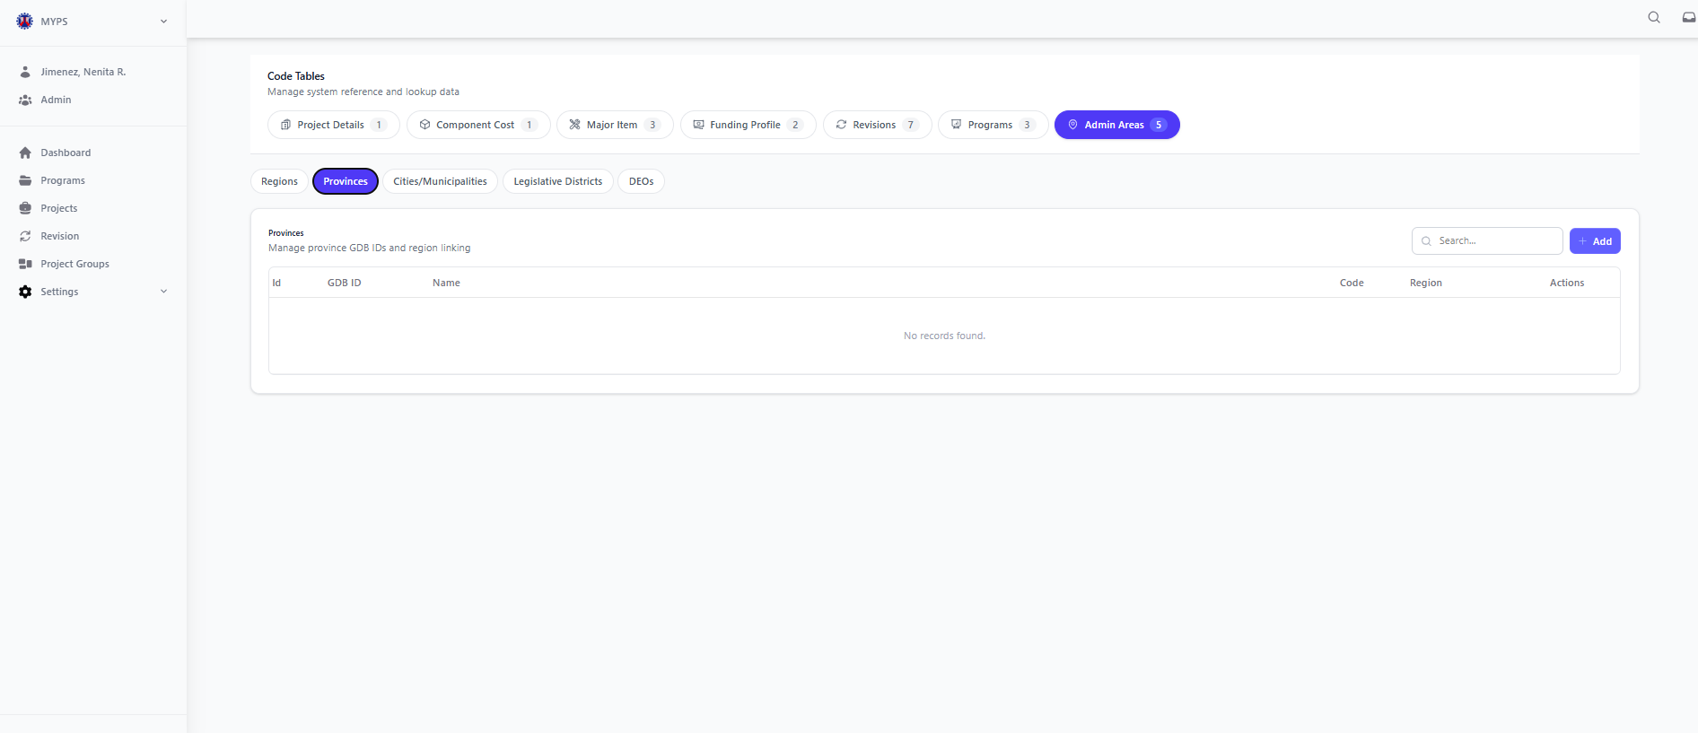
Purpose
The Code Tables Admin Areas Provinces screen allows authorized users to manage the province reference records used in MYPS. This screen is used to maintain the list of provinces together with their corresponding GDS ID, Code, and linked Region, so administrative area records remain accurate and consistent across the system.
Who Uses This
This screen is available to authorized MYPS users with access to the module.
Prerequisites
Before using this screen, ensure that:
- You are logged in to the MYPS Web application.
- You have permission to access Settings > Code Tables.
Field Reference
No. | Fields/Blocks/Objects | Description | Values / Actions
UI-UX-00111-01 | ID | Unique identifier for each province record. | Numeric value; system-generated ID.
UI-UX-00111-02 | GDS ID | Displays the GDS reference code assigned to the province. | Numeric or alphanumeric code used for province reference.
UI-UX-00111-03 | NAME | Displays the official name of the province. | Text value showing the province name.
UI-UX-00111-04 | CODE | Displays the short code assigned to the province. | Text or alphanumeric province code.
UI-UX-00111-05 | REGION | Displays the region linked to the province. | Text value showing the related region name or code.
UI-UX-00111-06 | SEARCH | Search field used to filter province records. | Text input; enter keyword, province name, code, or GDS ID to filter the list.
UI-UX-00111-07 | ADD | Button used to create a new province entry. | Button labeled Add; opens the form or modal for adding a new province.
UI-UX-00111-08 | ACTIONS / EDIT | Button used to modify an existing province record. | Edit icon/button; opens the selected province for updating.
UI-UX-00111-09 | ACTIONS / DELETE | Button used to remove an existing province record. | Delete icon/button; removes the selected record or prompts for confirmation before deletion.
UI-UX-00111-10 | REGIONS TAB | Tab used to switch to regions management. | Click to open Regions records.
UI-UX-00111-11 | PROVINCES TAB | Active tab used to display and manage province records. | Selected tab; shows the list of provinces.
UI-UX-00111-12 | CITIES/MUNICIPALITIES TAB | Tab used to switch to cities and municipalities management. | Click to open Cities/Municipalities records.
UI-UX-00111-13 | LEGISLATIVE DISTRICTS TAB | Tab used to switch to legislative districts management. | Click to open Legislative Districts records.
UI-UX-00111-14 | DEOS TAB | Tab used to switch to DEOs management. | Click to open DEOs records.
UI-UX-00111-15 | ADMIN AREAS TAB | Main code table category for managing administrative area reference data. | Active parent tab for admin area code tables.
Step-by-step: Use Provinces Management
1. Open Code Tables
- Sign in to MYPS Web.
- From the left-side navigation, click Settings.
- Select Code Tables.
2. Open the Admin Areas group
- In the Code Tables page, click the Admin Areas tab.
- Select the Provinces sub-tab.
3. View the province list
- Review the displayed province records.
- Each row may contain:
  - ID
  - GDS ID
  - Name
  - Code
  - Region
  - action buttons for Edit and Delete
If no data is available, the table may show “No records found.”
4. Search for a province
- Click the Search field.
- Type a keyword, province name, province code, GDS ID, or region name.
- Review the filtered results.
Example search entries:
- Davao
- Bukidnon
- REG11
- GDS
5. Add a new province
- Click Add.
- Enter the required information in the form or modal.
- Complete the fields such as:
  - GDS ID
  - Name
  - Code
  - Region
- Click Save.
6. Edit an existing province
- Locate the record you want to update.
- Click the Edit icon under Actions / Edit.
- Modify the allowed fields.
- Save the changes.
7. Delete a province
- Locate the record you want to remove.
- Click the Delete icon under Actions / Delete.
- Review the confirmation prompt.
- Confirm the action only if authorized and certain.
8. Switch to other admin area code tables
Use the sub-tabs to move between related administrative area sections:
- Regions
- Cities/Municipalities
- Legislative Districts
- DEOs
Click the needed tab to open and manage that record set.
9. Review the updated list
- After adding, editing, or deleting a record, review the table.
- Confirm that the latest changes are reflected correctly.
Example Inputs
Example province entry
- GDS ID: 1123
- Name: Davao Oriental
- Code: DAO
- Region: Region XI
Example search inputs
- Oriental
- DAO
- Region XI
- Province
On Success
- The new province record is saved successfully and appears in the list.
- Updated records display the latest saved values.
- Deleted records are removed from the active list, depending on system behavior.
- The screen refreshes to show the latest data.
- Switching tabs opens the selected administrative area section successfully.
Common Outcomes & What to Do
Message / Situation | What it Means | What You Should Do
“Province added successfully” | The new record was saved. | Review the list and confirm the new record appears correctly.
“Province updated successfully” | The selected record was edited and saved. | Verify the updated values in the list.

Code Tables Admin Areas Cities / Municipalities (UI-UX-0112)
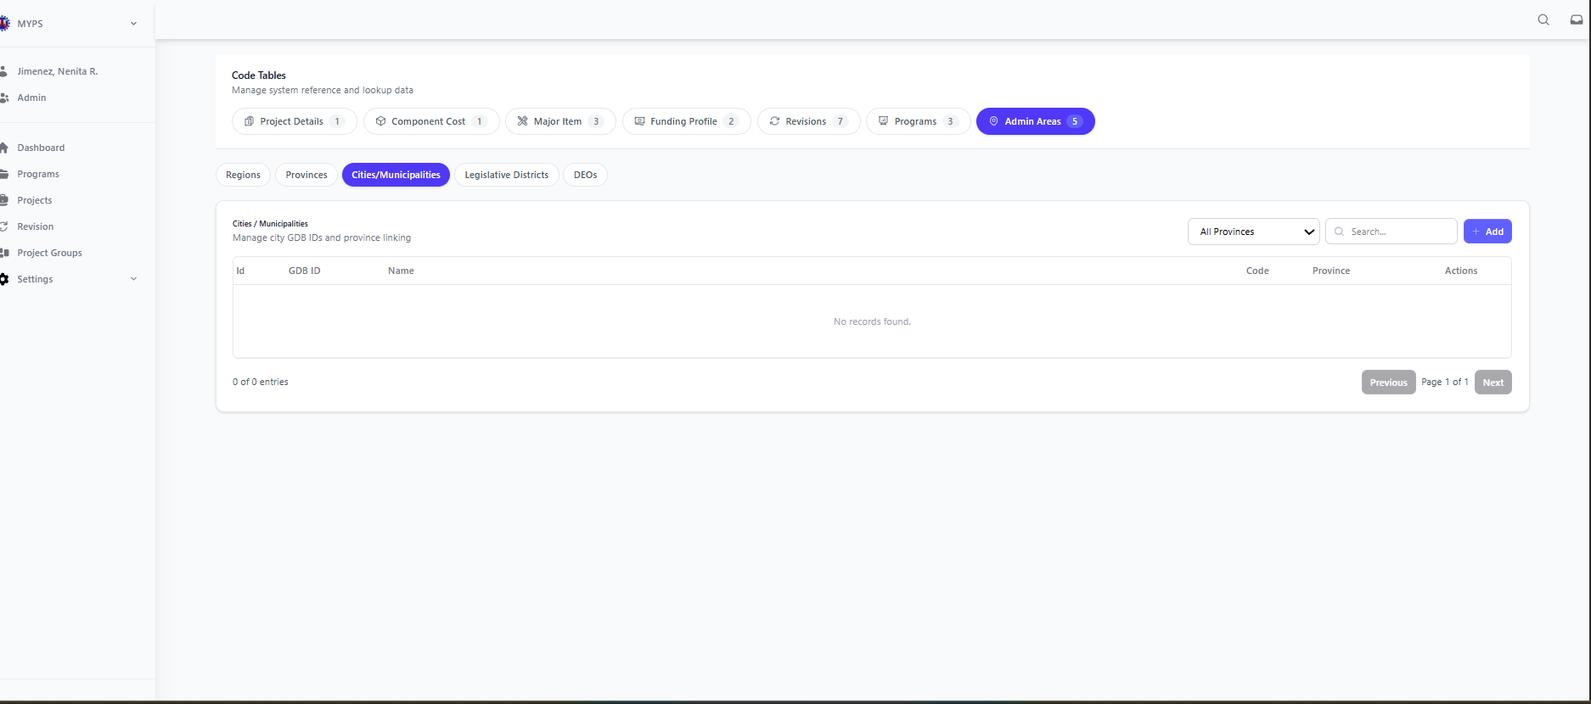
Purpose
The Code Tables Admin Areas Cities / Municipalities screen allows authorized users to manage the City / Municipality reference records used in MYPS. This screen is used to maintain the list of cities and municipalities together with their corresponding GDS ID, Code, and linked Province, so administrative area data remains accurate and consistent across the system.
Who Uses This
This screen is available to authorized MYPS users with access to the module.
Prerequisites
Before using this screen, ensure that:
- You are logged in to the MYPS Web application.
- You have permission to access Settings > Code Tables.
Field Reference
No. | Fields/Blocks/Objects | Description | Values / Actions
UI-UX-00112-01 | ID | Unique identifier for each city/municipality record. | Numeric value; system-generated ID.
UI-UX-00112-02 | GDS ID | Displays the GDS reference code assigned to the city or municipality. | Numeric or alphanumeric code used for city/municipality reference.
UI-UX-00112-03 | NAME | Displays the official name of the city or municipality. | Text value showing the city or municipality name.
UI-UX-00112-04 | CODE | Displays the short code assigned to the city or municipality. | Text or alphanumeric location code.
UI-UX-00112-05 | PROVINCE | Displays the province linked to the city or municipality. | Text value showing the related province name or code.
UI-UX-00112-06 | PROVINCE FILTER | Dropdown used to filter records by province. | Dropdown such as All Provinces or a specific province selection.
UI-UX-00112-07 | SEARCH | Search field used to filter city/municipality records. | Text input; enter keyword, name, code, or GDS ID to filter the list.
UI-UX-00112-08 | ADD | Button used to create a new city/municipality entry. | Button labeled Add; opens the form or modal for adding a new record.
UI-UX-00112-09 | ACTIONS / EDIT | Button used to modify an existing city/municipality record. | Edit icon/button; opens the selected record for updating.
UI-UX-00112-10 | ACTIONS / DELETE | Button used to remove an existing city/municipality record. | Delete icon/button; removes the selected record or prompts for confirmation before deletion.
UI-UX-00112-11 | PAGE RECORDS | Displays the current number of visible entries in the list. | Read-only text such as 0 of 0 entries or similar system count.
UI-UX-00112-12 | PAGINATION | Allows navigation between pages of the city/municipality list. | Navigation controls such as Previous, Page 1 of 1, and Next.
UI-UX-00112-13 | REGIONS TAB | Tab used to switch to regions management. | Click to open Regions records.
UI-UX-00112-14 | PROVINCES TAB | Tab used to switch to provinces management. | Click to open Provinces records.
UI-UX-00112-15 | CITIES/MUNICIPALITIES TAB | Active tab used to display and manage city/municipality records. | Selected tab; shows the list of cities/municipalities.
UI-UX-00112-16 | LEGISLATIVE DISTRICTS TAB | Tab used to switch to legislative districts management. | Click to open Legislative Districts records.
UI-UX-00112-17 | DEOS TAB | Tab used to switch to DEOs management. | Click to open DEOs records.
UI-UX-00112-18 | ADMIN AREAS TAB | Main code table category for managing administrative area reference data. | Active parent tab for admin area code tables.
Step-by-step: Use Cities / Municipalities Management
- Open Code Tables
- Sign in to MYPS Web.
- From the left-side navigation, click Settings.
- Select Code Tables.
- Open the Admin Areas group
- In the Code Tables page, click the Admin Areas tab.
- Select the Cities/Municipalities sub-tab.
- View the city/municipality list
- Review the displayed records.
- Each row may contain:
  - ID
  - GDS ID
  - Name
  - Code
  - Province
  - action buttons for Edit and Delete
If no data is available, the table may show “No records found.”
- Filter by province
- Open the Province Filter dropdown.
- Select All Provinces to show all records.
- Select a specific province to display only cities/municipalities under that province.
- Search for a city or municipality
- Click the Search field.
- Type a keyword, city/municipality name, code, or GDS ID.
- Review the filtered results.
Example search entries:
- Mati
- City
- MUN
- GDS
- Add a new city/municipality
- Click Add.
- Enter the required information in the form or modal.
- Complete the fields such as:
  - GDS ID
  - Name
  - Code
  - Province
- Click Save.
- Edit an existing city/municipality
- Locate the record you want to update.
- Click the Edit icon under Actions / Edit.
- Modify the allowed fields.
- Save the changes.
- Delete a city/municipality
- Locate the record you want to remove.
- Click the Delete icon under Actions / Delete.
- Review the confirmation prompt.
- Confirm the action only if authorized and certain.
- Use pagination
- If the list spans multiple pages, use Previous and Next to move between pages.
- Check the record count to confirm how many entries are currently displayed.
- Switch to other admin area code tables
Use the sub-tabs to move between related administrative area sections:
- Regions
- Provinces
- Legislative Districts
- DEOs
Click the needed tab to open and manage that record set.
- Review the updated list
- After adding, editing, deleting, or filtering a record, review the table.
- Confirm that the latest changes are reflected correctly.
Example Inputs
Example city/municipality entry
- GDS ID: 112501
- Name: City of Mati
- Code: MATI
- Province: Davao Oriental
Example additional entry
- GDS ID: 112402
- Name: Municipality of Banaybanay
- Code: BAN
- Province: Davao Oriental
Example search inputs
- Mati
- Banaybanay
- Davao
- 112501
On Success
- The new city/municipality record is saved successfully and appears in the list.
- Updated records display the latest saved values.
- Deleted records are removed from the active list, depending on system behavior.
- Filters, search, and pagination refresh the displayed list accordingly.
Common Outcomes & What to Do
Message / Situation | What it Means | What You Should Do
“City/Municipality added successfully” | The new record was saved. | Review the list and confirm the new record appears correctly.
“City/Municipality updated successfully” | The selected record was edited and saved. | Verify the updated values in the list.

Code Tables Admin Areas Legislative Districts (UI-UX-0113)
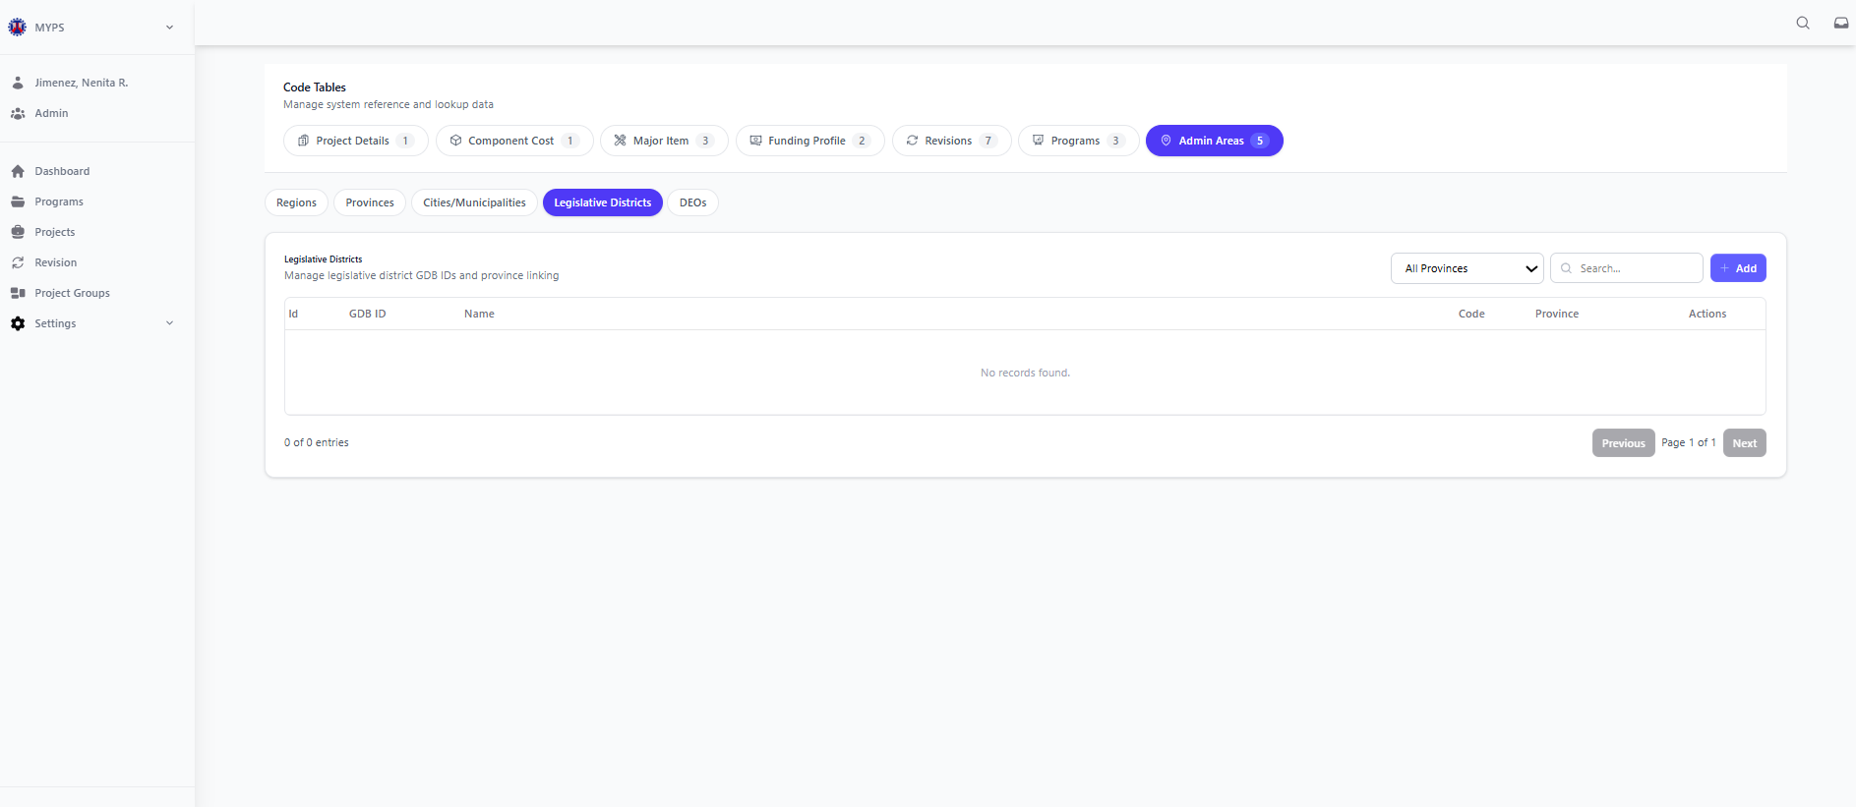
Purpose
The Code Tables Admin Areas Legislative Districts screen allows authorized users to manage the Legislative District reference records used in MYPS. This screen is used to maintain the list of legislative districts and their related administrative references so district-based records remain accurate and consistent across the system.
Who Uses This
This screen is used by authorized MYPS users responsible for maintaining administrative area reference and lookup data, such as:
- Administrators
- PS/IMS users
- Authorized planners or coordinators
- Other users with Code Tables maintenance rights
Prerequisites
Before using this screen, ensure that:
- You are logged in to the MYPS Web application.
- You have permission to access Settings > Code Tables.
Field Reference
No. | Fields/Blocks/Objects | Description | Values / Actions
UI-UX-0113-01 | ID | Unique identifier for each legislative district record. | Numeric value; system-generated ID.
UI-UX-0113-02 | GDS ID | Displays the GDS reference code assigned to the legislative district. | Numeric or alphanumeric code used for district reference.
UI-UX-0113-03 | NAME | Displays the official name of the legislative district. | Text value showing the district name.
UI-UX-0113-04 | CODE | Displays the short code assigned to the legislative district. | Text or alphanumeric district code.
UI-UX-0113-05 | PROVINCE | Displays the province linked to the legislative district. | Text value showing the related province name or code.
UI-UX-0113-06 | REGION | Displays the region linked to the legislative district. | Text value showing the related region name or code.
UI-UX-0113-07 | SEARCH | Search field used to filter legislative district records. | Text input; enter keyword, district name, code, or GDS ID to filter the list.
UI-UX-0113-08 | ADD | Button used to create a new legislative district entry. | Button labeled Add; opens the form or modal for adding a new district.
UI-UX-0113-09 | ACTIONS / EDIT | Button used to modify an existing legislative district record. | Edit icon/button; opens the selected record for updating.
UI-UX-0113-10 | ACTIONS / DELETE | Button used to remove an existing legislative district record. | Delete icon/button; removes the selected record or prompts for confirmation before deletion.
UI-UX-0113-11 | PAGE RECORDS | Displays the current number of visible district entries in the list. | Read-only text such as 0 of 0 entries or similar system count.
UI-UX-0113-12 | PAGINATION | Allows navigation between pages of the legislative district list. | Navigation controls such as Previous, Page 1 of 1, and Next.
UI-UX-0113-13 | REGIONS TAB | Tab used to switch to regions management. | Click to open Regions records.
UI-UX-0113-14 | PROVINCES TAB | Tab used to switch to provinces management. | Click to open Provinces records.
UI-UX-0113-15 | CITIES/MUNICIPALITIES TAB | Tab used to switch to cities and municipalities management. | Click to open Cities/Municipalities records.
UI-UX-0113-16 | LEGISLATIVE DISTRICTS TAB | Active tab used to display and manage legislative district records. | Selected tab; shows the list of legislative districts.
UI-UX-0113-17 | DEOS TAB | Tab used to switch to DEOs management. | Click to open DEOs records.
UI-UX-0113-18 | ADMIN AREAS TAB | Main code table category for managing administrative area reference data. | Active parent tab for admin area code tables.
Step-by-step: Use Legislative Districts Management
1. Open Code Tables
- Sign in to MYPS Web.
- From the left-side navigation, click Settings.
- Select Code Tables.
2. Open the Admin Areas group
- In the Code Tables page, click the Admin Areas tab.
- Select the Legislative Districts sub-tab.
3. View the legislative district list
- Review the displayed district records.
- Each row may contain:
  - ID
  - GDS ID
  - Name
  - Code
  - Province
  - Region
  - action buttons for Edit and Delete
If no data is available, the table may show “No records found.”
4. Search for a legislative district
- Click the Search field.
- Type a keyword, district name, code, GDS ID, province name, or region name.
- Review the filtered results.
Example search entries:
- 1st District
- District
- Davao Oriental
- Region XI
5. Add a new legislative district
- Click Add.
- Enter the required information in the form or modal.
- Complete the fields such as:
  - GDS ID
  - Name
  - Code
  - Province
  - Region
- Click Save.
6. Edit an existing legislative district
- Locate the record you want to update.
- Click the Edit icon under Actions / Edit.
- Modify the allowed fields.
- Save the changes.
7. Delete a legislative district
- Locate the record you want to remove.
- Click the Delete icon under Actions / Delete.
- Review the confirmation prompt.
- Confirm the action only if authorized and certain.
8. Use pagination
- If the list spans multiple pages, use Previous and Next to move between pages.
- Check the record count to confirm how many entries are currently displayed.
9. Switch to other admin area code tables
Use the sub-tabs to move between related administrative area sections:
- Regions
- Provinces
- Cities/Municipalities
- DEOs
Click the needed tab to open and manage that record set.
10. Review the updated list
- After adding, editing, deleting, or searching for a record, review the table.
- Confirm that the latest changes are reflected correctly.
Example Inputs
Example legislative district entry
- GDS ID: 1125-D1
- Name: 1st Legislative District
- Code: LD1
- Province: Davao Oriental
- Region: Region XI
Example additional entry
- GDS ID: 1125-D2
- Name: 2nd Legislative District
- Code: LD2
- Province: Davao Oriental
- Region: Region XI
Example search inputs
- Legislative
- LD1
- District
- Region XI
On Success
- The new legislative district record is saved successfully and appears in the list.
- Updated records display the latest saved values.
- Deleted records are removed from the active list, depending on system behavior.
- Search and pagination refresh the displayed list accordingly.
Common Outcomes & What to Do
Message / Situation | What it Means | What You Should Do
“Legislative district added successfully” | The new record was saved. | Review the list and confirm the new record appears correctly.
“Legislative district updated successfully” | The selected record was edited and saved. | Verify the updated values in the list.
“Legislative district deleted successfully” | The selected record was removed or archived. | Review the list and confirm the record no longer appears as active.

Code Tables Admin Areas DEOs (UI-UX-0114)
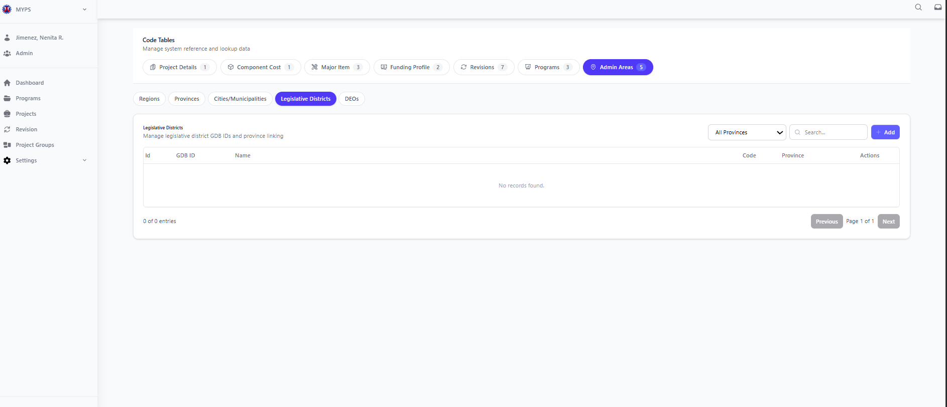
Purpose
The Code Tables Admin Areas DEOs screen allows authorized users to manage the District Engineering Office (DEO) reference records used in MYPS. This screen is used to maintain the list of DEOs together with their corresponding GDS ID, Participant ID, and linked Province and Region, so administrative area data remains accurate and consistent across the system.
Who Uses This
This screen is used by authorized MYPS users responsible for maintaining administrative area reference and lookup data, such as:
- Administrators
- PS/IMS users
- Authorized planners or coordinators
- Other users with Code Tables maintenance rights
Prerequisites
Before using this screen, ensure that:
- You are logged in to the MYPS Web application.
- You have permission to access Settings > Code Tables.
Field Reference
No. | Fields/Blocks/Objects | Description | Values / Actions
UI-UX-00114-01 | ID | Unique identifier for each DEO record. | Numeric value; system-generated ID.
UI-UX-00114-02 | GDS ID | Displays the GDS reference code assigned to the DEO. | Numeric or alphanumeric code used for DEO reference.
UI-UX-00114-03 | PARTICIPANT ID | Displays the participant ID associated with the DEO. | Numeric or alphanumeric value used for mapping or reference.
UI-UX-00114-04 | NAME | Displays the official name of the District Engineering Office. | Text value showing the DEO name.
UI-UX-00114-05 | PROVINCE | Displays the province linked to the DEO. | Text value showing the related province name or code.
UI-UX-00114-06 | REGION | Displays the region linked to the DEO. | Text value showing the related region name or code.
UI-UX-00114-07 | PROVINCE FILTER | Dropdown used to filter DEO records by province. | Dropdown such as All Provinces or a specific province selection.
UI-UX-00114-08 | SEARCH | Search field used to filter DEO records. | Text input; enter keyword, DEO name, GDS ID, or participant ID to filter the list.
UI-UX-00114-09 | ADD | Button used to create a new DEO entry. | Button labeled Add; opens the form or modal for adding a new DEO.
UI-UX-00114-10 | ACTIONS / EDIT | Button used to modify an existing DEO record. | Edit icon/button; opens the selected DEO for updating.
UI-UX-00114-11 | ACTIONS / DELETE | Button used to remove an existing DEO record. | Delete icon/button; removes the selected record or prompts for confirmation before deletion.
UI-UX-00114-12 | PAGE RECORDS | Displays the current number of visible DEO entries in the list. | Read-only text such as 0 of 0 entries or similar system count.
UI-UX-00114-13 | PAGINATION | Allows navigation between pages of the DEO list. | Navigation controls such as Previous, Page 1 of 1, and Next.
UI-UX-00114-14 | REGIONS TAB | Tab used to switch to regions management. | Click to open Regions records.
UI-UX-00114-15 | PROVINCES TAB | Tab used to switch to provinces management. | Click to open Provinces records.
UI-UX-00114-16 | CITIES/MUNICIPALITIES TAB | Tab used to switch to cities and municipalities management. | Click to open Cities/Municipalities records.
UI-UX-00114-17 | LEGISLATIVE DISTRICTS TAB | Tab used to switch to legislative districts management. | Click to open Legislative Districts records.
UI-UX-00114-18 | DEOS TAB | Active tab used to display and manage DEO records. | Selected tab; shows the list of DEOs.
UI-UX-00114-19 | ADMIN AREAS TAB | Main code table category for managing administrative area reference data. | Active parent tab for admin area code tables.
Step-by-step: Use DEOs Management
1. Open Code Tables
- Sign in to MYPS Web.
- From the left-side navigation, click Settings.
- Select Code Tables.
2. Open the Admin Areas group
- In the Code Tables page, click the Admin Areas tab.
- Select the DEOs sub-tab.
3. View the DEO list
- Review the displayed DEO records.
- Each row may contain:
  - ID
  - GDS ID
  - Participant ID
  - Name
  - Province
  - Region
  - action buttons for Edit and Delete
If no data is available, the table may show “No records found.”
4. Filter by province
- Open the Province Filter dropdown.
- Select All Provinces to show all DEO records.
- Select a specific province to display only DEOs under that province.
5. Search for a DEO
- Click the Search field.
- Type a keyword, DEO name, GDS ID, participant ID, province, or region.
- Review the filtered results.
Example search entries:
- Davao Oriental
- DEO
- Participant
- Region XI
6. Add a new DEO
- Click Add.
- Enter the required information in the form or modal.
- Complete the fields such as:
  - GDS ID
  - Participant ID
  - Name
  - Province
  - Region
- Click Save.
7. Edit an existing DEO
- Locate the record you want to update.
- Click the Edit icon under Actions / Edit.
- Modify the allowed fields.
- Save the changes.
8. Delete a DEO
- Locate the record you want to remove.
- Click the Delete icon under Actions / Delete.
- Review the confirmation prompt.
- Confirm the action only if authorized and certain.
9. Use pagination
- If the list spans multiple pages, use Previous and Next to move between pages.
- Check the record count to confirm how many entries are currently displayed.
10. Switch to other admin area code tables
Use the sub-tabs to move between related administrative area sections:
- Regions
- Provinces
- Cities/Municipalities
- Legislative Districts
Click the needed tab to open and manage that record set.
11. Review the updated list
- After adding, editing, deleting, or filtering a record, review the table.
- Confirm that the latest changes are reflected correctly.
Example Inputs
Example DEO entry
- GDS ID: 1125-DEO-01
- Participant ID: DEO1125
- Name: Davao Oriental District Engineering Office
- Province: Davao Oriental
- Region: Region XI
Example additional entry
- GDS ID: 1124-DEO-01
- Participant ID: DEO1124
- Name: Davao del Norte District Engineering Office
- Province: Davao del Norte
- Region: Region XI
Example search inputs
- Davao Oriental
- DEO1125
- District Engineering
- Region XI
On Success
- The new DEO record is saved successfully and appears in the list.
- Updated records display the latest saved values.
- Deleted records are removed from the active list, depending on system behavior.
- Filters, search, and pagination refresh the displayed list accordingly.
Common Outcomes & What to Do
Message / Situation | What it Means | What You Should Do
“DEO added successfully” | The new record was saved. | Review the list and confirm the new record appears correctly.
“DEO updated successfully” | The selected record was edited and saved. | Verify the updated values in the list.

Settings User Management Overview
User Management in the MYPS Web application is a core component of the Settings or MYPS Administration module. It is primarily the responsibility of the MYPS Application User Coordinator (AUC) to manage user accounts, groups, and functional permissions to ensure system security and data integrity.

User Management App Modules (UI-UX-0115)
Purpose
The App Modules screen allows authorized users to view and manage the list of application modules available in MYPS. This screen is used to review module records, check linked controllers and views, and perform administrative actions such as adding modules and synchronizing route or API definitions.
Who Uses This
This screen is available to authorized MYPS users with access to the module.
Prerequisites
Before using this screen, ensure that:
- You are logged in to the MYPS Web application.
- You have permission to access Settings > User Management.
Field Reference
No. | Fields/Blocks/Objects | Description | Values / Actions
UI-UX-0115-01 | APP MODULES TAB | Active tab used to display the list of MYPS application modules. | Selected tab; shows the App Modules inventory list.
UI-UX-0115-02 | USERS TAB | Tab used to switch to user management records. | Click to open the Users list.
UI-UX-0115-03 | USER GROUPS TAB | Tab used to switch to user group management records. | Click to open the User Groups list.
UI-UX-0115-04 | MODULE NAME | Displays the name of the registered MYPS module. | Text value such as Authentication, User Management, InfraManagement, Code Table, Revision, Project, Program, Dashboard.
UI-UX-0115-05 | DESCRIPTION | Displays the functional description of the module. | Text value describing the module, e.g., User authentication or other configured descriptions.
UI-UX-0115-06 | CONTROLLERS | Displays the linked controller count or controller mapping for the module. | Read-only linked value such as 1 / 1 linked or similar system count.
UI-UX-0115-07 | VIEWS | Displays the linked view count or screen mapping for the module. | Read-only linked value such as 2 / 2 linked, 1 / 2 linked, or similar system count.
UI-UX-0115-08 | ACTIONS | Provides row-level maintenance actions for the selected module. | Action icons/buttons such as Edit and Delete, subject to authorization.
UI-UX-0115-09 | SYNC ROUTES | Synchronizes route definitions used by the application. | Button labeled Sync Routes; triggers route synchronization.
UI-UX-0115-10 | SYNC API | Synchronizes API definitions used by the application. | Button labeled Sync API; triggers API synchronization.
UI-UX-0115-11 | ADD MODULE | Opens a form to create a new module record. | Button labeled Add Module; opens the add-module form.
UI-UX-0115-12 | MODULE COUNT | Displays the total number of modules currently shown in the list. | Read-only text such as Showing 1 to 8 of 8 modules.
Step-by-step: Use App Modules
1. Open the App Modules screen
- Sign in to MYPS Web.
- From the left-side navigation, go to Settings.
- Click User Management.
- Select the App Modules tab.
2. Verify the module list
- Review the displayed list of modules.
- Confirm that each row shows:
  - Module Name
  - Description
  - Controllers
  - Views
3. Review the displayed modules
- Check that the expected MYPS modules appear in the list.
- Based on your screenshot, examples include:
  - Authentication
  - User Management
  - InfraManagement
  - Code Table
  - Revision
  - Project
  - Program
  - Dashboard
4. Check the Controllers column
- Review the Controllers value for each module.
- Confirm that each module shows its linked controller count correctly.
5. Check the Views column
- Review the Views value for each module.
- Confirm that each module shows its linked view count correctly.
6. Verify action buttons
Check that the following buttons are visible and clickable:
- Add Module
- Sync Routes
- Sync API
7. Add a module
- Click Add Module.
- Enter the required module details such as:
  - Module Name
  - Description
  - Controllers
  - Views
- Save the new module record.
8. Sync route data
- Click Sync Routes.
- Wait for the synchronization process to complete.
- Confirm that route definitions are updated successfully.
9. Sync API data
- Click Sync API.
- Wait for the synchronization process to complete.
- Confirm that API definitions are updated successfully.
10. Use row-level actions
- For a specific module, use the Actions column if permitted.
- Click the relevant icon to edit or remove the module record.
11. Review the module count
- Check the footer summary below the table.
- Confirm that the number of displayed modules matches the expected count.
Example Inputs
Example module entry
- Module Name: Reports
- Description: Reporting and analytics functions
- Controllers: 1 / 1 linked
- Views: 2 / 2 linked
Example additional entry
- Module Name: Security
- Description: Role and permission administration
- Controllers: 1 / 1 linked
- Views: 1 / 1 linked
On Success
- The App Modules screen loads correctly.
- All expected modules are displayed.
- Each row shows Module Name, Description, Controllers, and Views.
- Add Module, Sync Routes, and Sync API are visible and clickable.
- Route and API synchronization actions complete successfully.
- New modules appear in the list after they are added.

Common Outcomes & What to Do
Message / Situation | What it Means | What You Should Do
“No modules found.” | No module records are currently available, or data did not load. | Refresh the page and verify your access. If the issue continues, report it to support.
“You do not have permission.” | Your account is not allowed to manage app modules. | Contact your MYPS administrator for access verification.
“Sync completed successfully.” | The synchronization request finished successfully. | Review the table and confirm the linked data is updated.

App Modules Check Read-Only Controllers (UI-UX-0116)
Purpose
The Read-Only Controllers function allows authorized users to view the controllers linked to a selected application module in User Management > App Modules. This function is used to verify which controllers are associated with the module while preventing direct editing from the expanded dropdown view.
Who Uses This
This screen is available to authorized MYPS users with access to the module.
Prerequisites
Before using this function, ensure that:
- You are logged in to the MYPS Web application.
- You have permission to access Settings > User Management.
- You are on the App Modules tab.
- The selected module has a Controllers dropdown available.
Field Reference
No. | Fields/Blocks/Objects | Description | Values / Actions
UI-UX-00116-01 | CONTROLLERS DROPDOWN | Expand/collapse control used to display the module’s linked controller list. | Click to expand or collapse the Controllers section.
UI-UX-00116-02 | CONTROLLERS – READ ONLY PANEL | Read-only panel showing controller records associated with the selected module. | Displays controller list for viewing only; editing is disabled in this panel.
UI-UX-00116-03 | CONTROLLER ITEM | Individual controller entry linked to the module. | Displays controller name such as AUTH Controller, Project Controller, etc.
UI-UX-00116-04 | READ-ONLY TOGGLE / INDICATOR | Visual indicator showing controller linkage state. | Toggle or status marker is displayed for review only and cannot be changed from this dropdown.
Step-by-step: Check Read-Only Controllers
1. Open the App Modules screen
- Sign in to MYPS Web.
- Go to Settings.
- Select User Management.
- Click the App Modules tab.
2. Locate the module to inspect
- Review the module list.
- Find the module where you want to inspect the linked controllers.
3. Check the Controllers column
- Look at the Controllers column for the selected module.
- Confirm that a linked count or expandable indicator is displayed.
4. Expand the Controllers dropdown
- Click the dropdown arrow or expand control in the Controllers column.
- Wait for the Controllers & Views – Read Only section to expand.
5. Verify the controller list
- Review the list of controllers shown in the expanded panel.
- Confirm that the following controller names are present as applicable:
  - AuthController
  - GlobalSearchController
  - PISController
  - ProjectGroupController
  - UserManagementController
  - CodeTableController
  - ImportingController
  - ProgramController
  - ReportingController
  - FutureInfraController
  - PCMAController
  - ProjectController
  - RevisionController
6. Confirm read-only behavior
- Verify that the controller list is displayed for viewing only.
- Confirm that controller values cannot be directly edited in the expanded dropdown.
7. Collapse the Controllers panel
- Click the dropdown arrow again to collapse the list after verification.
Expected Results
- The Controllers dropdown expands successfully.
- The Controllers & Views – Read Only label is displayed.
- The controller list is visible and readable.
- The listed controller names appear correctly.
- The controller entries are read-only.
- No inline editing is allowed from the dropdown view.
Common Outcomes & What to Do
Message / Situation | What it Means | What You Should Do
Controllers list does not expand | The dropdown action did not load correctly. | Refresh the page and try again. If the issue continues, report it to support.
No controllers displayed | No linked controller data is available for the selected module, or data failed to load. | Verify the module configuration or contact the administrator.
Read-only list appears | The module’s controller mappings are visible but not editable in this view. | Review the entries only; use edit actions if you are authorized and the system provides that function elsewhere.

App Modules Check Read-Only Views (UI-UX-0117)
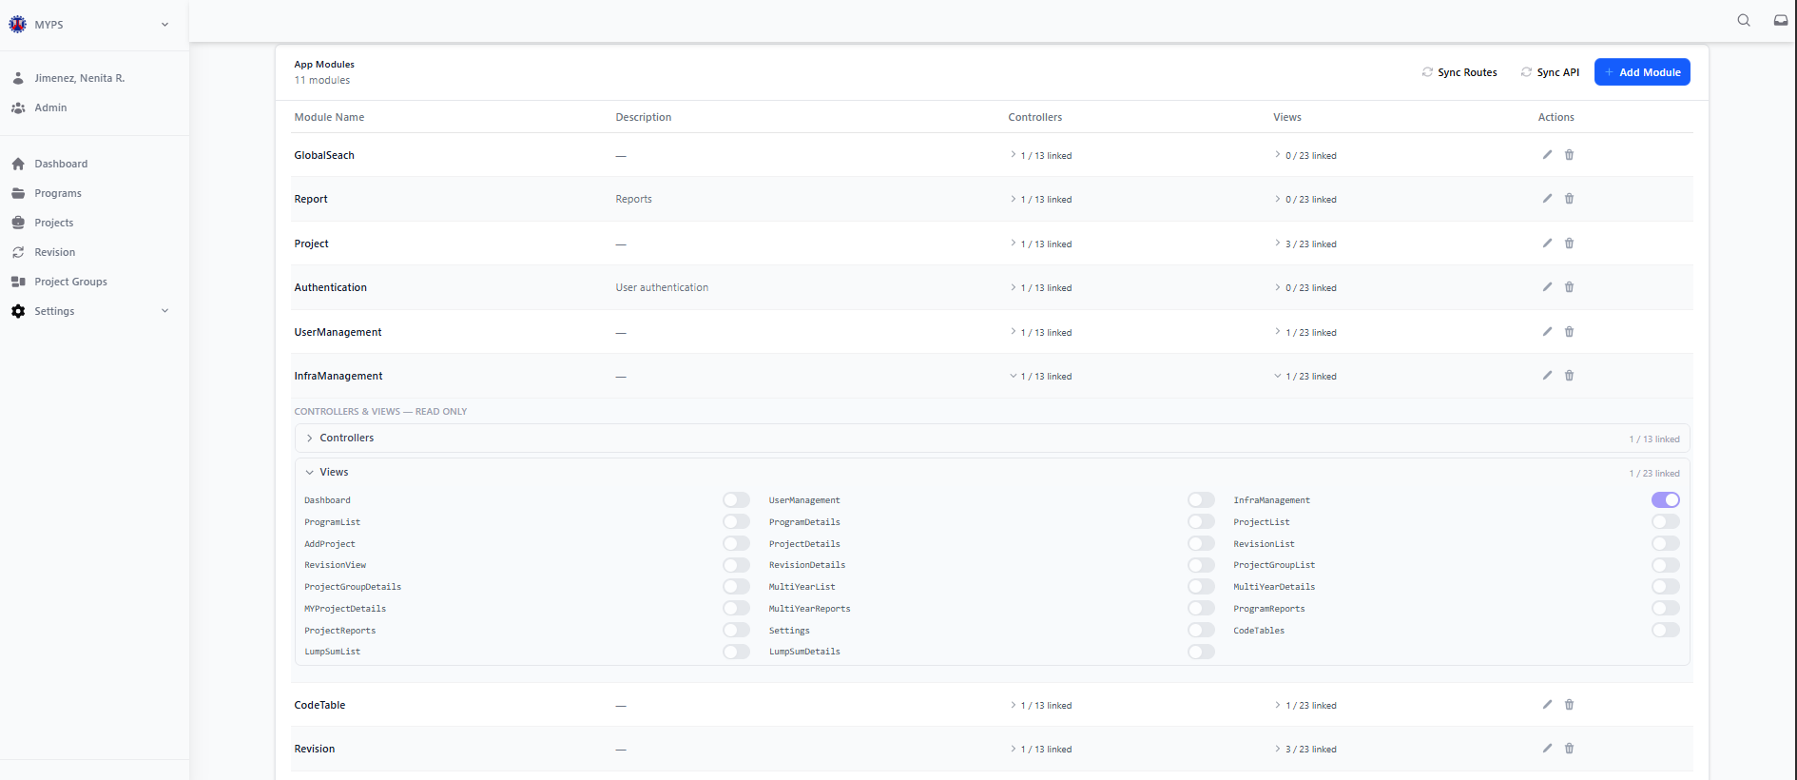
Purpose
The Read-Only Views function allows authorized users to inspect the list of application views linked to a selected module in User Management > App Modules. This function is used to verify the configured view names associated with the module while preventing direct editing from the expanded read-only panel.
Who Uses This
This screen is available to authorized MYPS users with access to the module.
Prerequisites
Before using this function, ensure that:
- You are logged in to the MYPS Web application.
- You have permission to access Settings > User Management.
- You are on the App Modules tab.
- The selected module has a Views dropdown available.
Field Reference
No. | Fields/Blocks/Objects | Description | Values / Actions
UI-UX-0117-01 | VIEWS DROPDOWN | Expand/collapse control used to display the module’s linked view list. | Click to expand or collapse the Views section.
UI-UX-0117-02 | VIEWS – READ ONLY PANEL | Read-only panel showing view records associated with the selected module. | Displays view list for viewing only; editing is disabled in this panel.
UI-UX-0117-03 | VIEW ITEM | Individual view entry linked to the module. | Displays view name such as Dashboard, Program List, Project Details, etc.
UI-UX-0117-04 | READ-ONLY TOGGLE / INDICATOR | Visual indicator showing view linkage state. | Toggle or status marker is displayed for review only and cannot be changed from this dropdown.
Step-by-step: Check Read-Only Views
1. Open the App Modules screen
- Sign in to MYPS Web.
- Go to Settings.
- Select User Management.
- Click the App Modules tab.
2. Locate the module to inspect
- Review the module list.
- Find the module where you want to inspect the linked views.
3. Check the Views column
- Look at the Views column for the selected module.
- Confirm that a linked count or expandable indicator is displayed.
4. Expand the Views dropdown
- Click the dropdown arrow or expand control in the Views column.
- Wait for the Controllers & Views – Read Only section to expand.
5. Verify the view list
- Review the list of views shown in the expanded panel.
- Confirm that the following view names are present as applicable:
  - Dashboard
  - ProgramList
  - AddProject
  - RevisionView
  - ProjectGroupDetails
  - MyProjectDetails
  - ProjectReports
  - LumpSumList
  - UserManagement
  - ProgramDetails
  - ProjectDetails
  - RevisionDetails
  - MultiYearList
  - MultiYearReports
  - Settings
  - LumpSumDetails
  - InfraManagement
  - ProjectLists
  - RevisionList
  - ProjectGroupList
  - MultiYearDetails
  - ProgramReports
  - CodeTables
6. Confirm read-only behavior
- Verify that the view list is displayed for viewing only.
- Confirm that view values cannot be directly edited in the expanded dropdown.
7. Collapse the Views panel
- Click the dropdown arrow again to collapse the list after verification.
Expected Results
- The Views dropdown expands successfully.
- The Controllers & Views – Read Only label is displayed.
- The view list is visible and readable.
- The listed view names appear correctly.
- The view entries are read-only.
- No inline editing is allowed from the dropdown view.

Common Outcomes & What to Do
Message / Situation | What it Means | What You Should Do
Views list does not expand | The dropdown action did not load correctly. | Refresh the page and try again. If the issue continues, report it to support.
No views displayed | No linked view data is available for the selected module, or data failed to load. | Verify the module configuration or contact the administrator.
Read-only list appears | The module’s view mappings are visible but not editable in this view. | Review the entries only; use edit actions if you are authorized and the system provides that function elsewhere.

User Management Users Modules (UI-UX-0118)
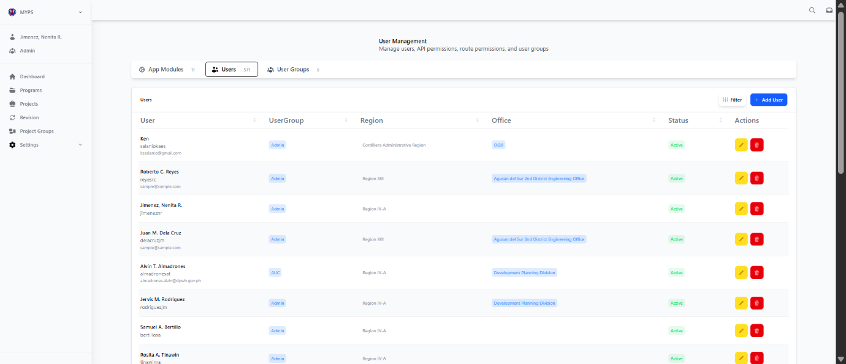

Purpose
The User Management Users screen allows authorized users to view and manage MYPS user accounts. This screen is used to review user records, confirm assigned groups and office context, and perform maintenance actions such as editing or deleting user accounts. The Web-based MYPS manual is intended to provide step-by-step, task-focused guidance for these user-administration functions, while access remains controlled through role-based permissions.
Who Uses This
This screen is available to authorized MYPS users with access to the module.

Prerequisites
Before using this screen, ensure that:
- You are logged in to the MYPS Web application.
- You have permission to access Settings > User Management.
Field Reference
No. | Fields/Blocks/Objects | Description | Values / Actions
UI-UX-0118-01 | USERS TAB | Active tab used to display the list of MYPS users. | Selected tab; shows user records.
UI-UX-0118-02 | USER | Displays the user’s name and, where available, account/email detail. | Text value such as full name and associated account identifier.
UI-UX-0118-03 | USER GROUP | Displays the role/group assigned to the user. | Tag/value such as Admin, AUC, or other configured group.
UI-UX-0118-04 | REGION | Displays the region or regional assignment of the user. | Text value showing the assigned region or office-region context.
UI-UX-0118-05 | OFFICE | Displays the office/unit assigned to the user. | Text value such as Central Office, Development Planning Division, or a DEO office.
UI-UX-0118-06 | STATUS | Displays the current user account status. | Tag/value such as Active or other configured status.
UI-UX-0118-07 | ACTIONS / EDIT | Allows modification of an existing user record. | Edit icon/button; opens the selected user for updating.
UI-UX-0118-08 | ACTIONS / DELETE | Allows removal or deactivation of an existing user record. | Delete icon/button; removes the selected user or prompts for confirmation before deletion.
UI-UX-0118-09 | FILTER | Opens or applies filters for narrowing the user list. | Button labeled Filter; used to refine displayed records.
UI-UX-0118-10 | ADD USER | Opens the form for creating a new user account. | Button labeled Add User; opens the add-user screen or modal.
UI-UX-0118-11 | APP MODULES TAB | Tab used to switch to App Modules management. | Click to open App Modules.
UI-UX-0118-12 | USER GROUPS TAB | Tab used to switch to User Groups management. | Click to open User Groups.
Step-by-step: Use Users Screen
1. Open Users screen
- Sign in to MYPS Web.
- From the left-side navigation, go to Settings.
- Click User Management.
- Select the Users tab.
2. Verify users list
- Review the displayed list of users.
- Ensure all users are shown in the table.
- Confirm that each row displays the following columns:
  - User
  - User Group
  - Region
  - Office
  - Status
  - Actions / Edit
  - Actions / Delete
3. Review user details
- Check the User column for the displayed account name.
- Check the User Group column for the assigned role/group.
- Check the Region and Office columns for the user’s organizational assignment.
- Check the Status column to confirm whether the account is active.
4. Use filter
- Click Filter if you need to narrow the list.
- Apply the available filter criteria.
- Review the filtered results.
5. Add a new user
- Click Add User.
- Enter the required user details in the add-user form.
- Save the new record.
6. Edit an existing user
- Locate the user you want to update.
- Click the Edit icon under Actions / Edit.
- Modify the allowed fields.
- Save the changes.
7. Delete an existing user
- Locate the user you want to remove.
- Click the Delete icon under Actions / Delete.
- Review the confirmation prompt.
- Confirm the action only if authorized and certain.
8. Switch to related tabs
- Use App Modules to review module definitions.
- Use User Groups to review role/group configuration.
Example Values
Example user row
- User: Jimenez, Nenita R.
- User Group: Admin, AUC
- Region: Central Office
- Office: Central Office
- Status: Active
Example additional user row
- User: Alvin T. Almadrones
- User Group: AUC
- Region: Central Office
- Office: Development Planning Division
- Status: Active
Common Outcomes & What to Do
Message / Situation | What it Means | What You Should Do
“No users found.” | No user records are currently displayed, or filters returned no results. | Clear filters, refresh the page, and verify access.
“You do not have permission.” | Your account is not allowed to manage users. | Contact your MYPS administrator for access verification.
“User added successfully.” | The new user record was saved. | Verify that the user appears in the list.

User Management Add User (UI-UX-0119)
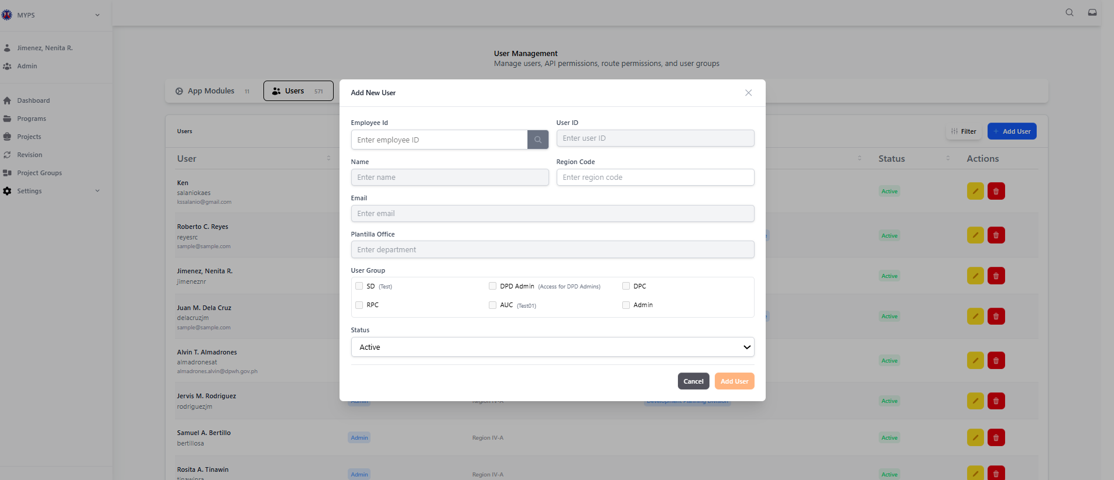
Purpose
The Add User screen allows authorized users to create a new MYPS user account. This screen is used to register user details, assign the proper office and user group, and set the account status before saving the record to the User Management list.
Who Uses This
This screen is available to authorized MYPS users with access to the module.
Prerequisites
Before using this screen, ensure that:
- You are logged in to the MYPS Web application.
- You have permission to access Settings > User Management.
- You are on the Users tab.
- You have authority to create new user accounts.
- The employee details needed for the new user are available.
Field Reference
No. | Fields/Blocks/Objects | Description | Values / Actions
UI-UX-0119-01 | EMPLOYEE ID | A unique identifier for the employee within the HR or personnel system. The search icon may be used to auto-fill user details if integrated with the database. | The search icon associated with this field may be used to auto-fill user details if integrated with the database.
UI-UX-0119-02 | USER ID | The unique username or system login identifier. This field is always disabled. | This ID is used for login. The password required for login must be at least six alphanumeric digits and/or characters (case-sensitive).
UI-UX-0119-03 | NAME | The full name of the user. This field identifies the user within the system. | This field identifies the user within the system.
UI-UX-0119-04 | REGION | Regional office name — always read-only (disabled). | Regional office name.
UI-UX-0119-05 | EMAIL | The user’s official or registered email address for communication and verification. | This field identifies the user within the system.
UI-UX-0119-06 | PLANTILLA OFFICE | Indicates the assigned department or office where the employee belongs in the organizational structure. | The office, department, or division where the employee is officially assigned.
UI-UX-0119-07 | USER GROUP | Defines the access level or role group of the user in the system. User groups determine permission levels. | User groups determine permission levels. These permissions control which commands in the menu and toolbar are available.
UI-UX-0119-08 | STATUS | Specifies whether the user account is Active or Inactive. Inactive users cannot log in to the system. | Inactive users cannot log in to the system. The system supports a feature to disable a MYPS user account.
UI-UX-0119-09 | CANCEL | Discards any entered information and closes the form. | Discards any entered information and closes the form.
UI-UX-0119-10 | ADD USER | Saves the new user record and adds it to the user management list. | Saves the new user record and adds it to the user management list.
Step-by-step: Add a New User
1. Open the Users screen
- Sign in to MYPS Web.
- From the left-side navigation, go to Settings.
- Click User Management.
- Select the Users tab.
2. Open the Add User form
- Click the Add User button at the upper-right of the Users screen.
- Verify that the Add New User modal form opens.
3. Enter the Employee ID
- Click the Employee ID field.
- Type the employee’s ID.
- If the system supports integration, click the Search icon beside the Employee ID field to retrieve employee details automatically.
4. Enter the User ID
- Click the User ID field.
- Type the unique user login ID.
Example:
- jimenez
- auc_admin01
5. Enter the Name
- Click the Name field.
- Type the full name of the user.
Example:
- Jimenez, Nenita R.
6. Enter the Region Code
- Click the Region Code field.
- Type the applicable regional office or administrative area code.
Example:
- CO
- R11
7. Enter the Email
- Click the Email field.
- Type the official or registered email address of the user.
Example:
- njimenez@example.com
8. Enter the Plantilla Office
- Click the Plantilla Office field.
- Type the department, division, or office where the employee is officially assigned.
Example:
- Central Office
- Development Planning Division
9. Select the User Group
- Click the User Group field or dropdown.
- Choose the correct user group for the new account.
Example groups may include:
- Admin
- AUC
- other configured MYPS user groups
10. Set the Status
- Click the Status dropdown.
- Select the appropriate account status.
Typical options:
- Active
- Inactive
11. Save the new user
- Review all entered details.
- Click Add User.
- Wait for the system to save the record and return the new user to the list.
12. Cancel if needed
- If you do not want to save the new user, click Cancel.
- Verify that the modal closes and no new record is created.
On Success
- The new user record is saved successfully.
- The Add User modal closes.
- The new user appears in the Users list.
- The assigned User Group, Region, Office, and Status are displayed correctly.
Common Outcomes & What to Do
Message / Situation | What it Means | What You Should Do
“Required field missing” | One or more mandatory fields were not completed. | Fill in all required fields, then click Add User again.
“User ID already exists” | The entered user ID is already assigned to another account. | Enter a unique User ID and try again.
“Employee not found” | The Employee ID could not be matched in the source data. | Recheck the Employee ID or enter the user details manually if allowed.

User Management Filter User (UI-UX-0120)
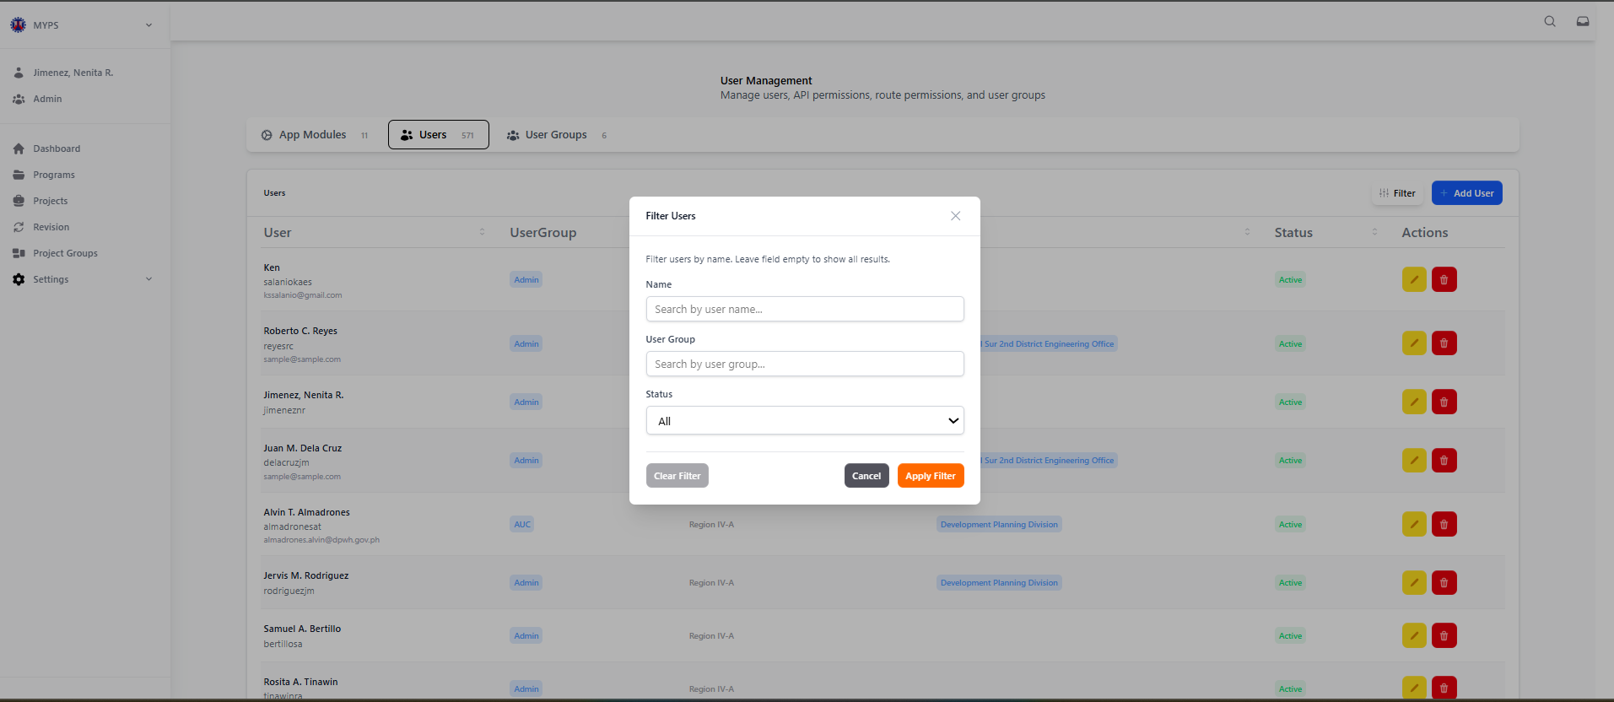
Purpose
Filter and search the Users list in the User Management module by name, user group, or account status, enabling quick identification and management of specific user accounts.
Who uses this
This screen is available to authorized MYPS users with access to the module.
Prerequisites
- Signed in to MYPS Web with a role that has access to User Management.
- Users list is populated in the module.
Field Reference
No. | Fields/Blocks/Objects | Description | Values / Actions
UI-UX-0120-01 | NAME | Allows the user to search for users by their name. | Text input field for searching users by name. Users can leave the field empty to show all results.
UI-UX-0120-02 | USER GROUP | Allows the user to search for users based on their user group. | Text input field for searching users by their group (e.g., Admin, User, etc.).
UI-UX-0120-03 | STATUS | Allows the user to filter users by their status. | Dropdown selection for status, with options such as All, Active, Inactive, etc.
UI-UX-0120-04 | CLEAR FILTER | Clears the current filter settings and resets the search. | Button labeled "Clear Filter"; Action to reset all filter fields.
UI-UX-0120-05 | CANCEL | Closes the filter modal without applying any changes. | Button labeled "Cancel"; Action to close the modal and discard the filter settings.
UI-UX-0120-06 | APPLY FILTER |  | Button labeled "Apply Filter". Updates the Users list according to selected criteria.
  Executes the filter search.
Step-by-Step: Applying Filters
- Open the Filter Users modal
Click the Filter button at the top-right of the Users list.
- Enter Name (optional)
Type part or full name of the user to narrow results.
  - Example: “Jimenez” returns all users with that last name.
  - Leave empty to include all names.
- Enter User Group (optional)
Type the user group to filter by (e.g., Admin, AUC).
  - Leave empty to include all groups.
- Select Status
Choose from the dropdown: All, Active, Inactive.
  - Default is All to show every account regardless of status.
- Apply Filter
Click Apply Filter to update the Users list according to the criteria.
- Clear Filter
Click Clear Filter to reset all fields to their default empty state.
- Cancel
Click Cancel to close the modal without applying any changes.
On Success
- Users list updates to display accounts matching the filter criteria.
- Counts and displayed columns remain consistent with the original list.
Common Outcomes & What to Do
Message / Situation | What it Means | What You Should Do
No results found | No user matches the criteria | Adjust name, group, or status filters and try again
Users list unchanged | Filter not applied or criteria empty | Click Apply Filter again; ensure fields are filled correctly

User Management Update User (UI-UX-0121)
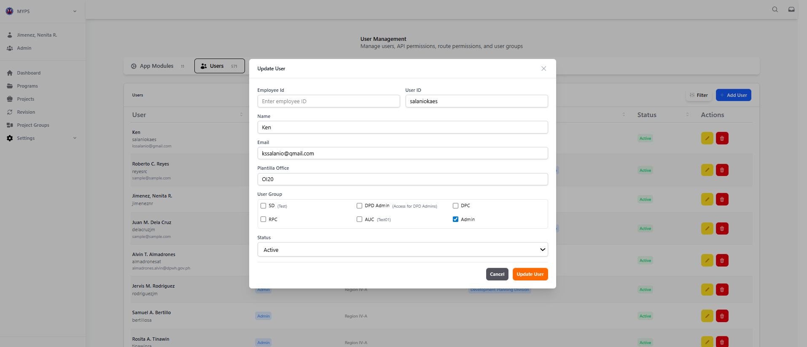
Purpose
Modify existing user account details in the MYPS Web User Management module, including identification, office assignment, user group, and account status.
Who uses this
This screen is available to authorized MYPS users with access to the module.
Prerequisites
- Signed in to MYPS Web with a role that has access to User Management.
- Existing user record must be present in the Users list.
Field Reference
No. | Fields/Blocks/Objects | Description | Values / Actions
UI-UX-0121-01 | EMPLOYEE ID | Unique ID assigned to each employee; used for identification within the system. | Unique ID assigned to each employee; used for identification within the system.
UI-UX-0121-02 | USER ID | System-generated or manually entered unique user identifier. | This ID is used for authentication and access control.
UI-UX-0121-03 | NAME | Full name of the user being updated. | This field identifies the user within the system.
UI-UX-0121-04 | EMAIL | User’s email address for login. | Each user entry can include an email for identification.
UI-UX-0121-05 | PLANTILLA OFFICE | The office, department, or division where the employee is officially assigned. | The office, department, or division where the employee is officially assigned.
UI-UX-0121-06 | USER GROUP | The user group the account belongs to within the system. | This defines the access level or role group (e.g., Admin, Engineer, Viewer) and determines the permissions available to the user.
UI-UX-0121-07 | STATUS | The user’s current status within the system. | Specifies whether the user account is Active or Inactive. The system has a feature to disable a MYPS user account.
UI-UX-0121-08 | CANCEL BUTTON | Discards all changes and closes the form. | Discards all changes and closes the form.
UI-UX-0121-09 | UPDATE USER | Saves entered details and updates the existing user record. | Saves entered details and updates the existing user record.
Step-by-Step: Updating a User
- Open the Update User modal
Click the Edit icon in the Actions column for the desired user in the Users list.
- Modify Employee ID (if allowed)
Enter or verify the Employee ID. Ensure it remains unique.
- Modify User ID (if allowed)
Update the User ID for authentication if necessary.
- Update Name
Enter the full name for display in the system.
- Update Email
Enter or modify the user’s email for or login purposes.
- Update Plantilla Office
Select the correct office, department, or division.
- Update User Group
Assign the user to the correct role group to ensure appropriate permissions.
- Update Status
Select Active to enable login or Inactive to disable the account.
- Apply Changes
Click Update User to save changes. Validation messages will appear if any required field is missing or invalid.
- Cancel Changes
Click Cancel to discard changes and close the modal.
On Success
- User record is updated and reflected in the Users list.
- Permissions, roles, and status are applied immediately as per configuration.
Common Outcomes & What to Do
Message / Situation | What it Means | What You Should Do
“Duplicate Employee ID/User ID” | Another record exists with the same ID | Enter a unique Employee or User ID
Missing required fields | Mandatory data not filled | Complete all required fields highlighted in red

User Management Delete User (UI-UX-0122)
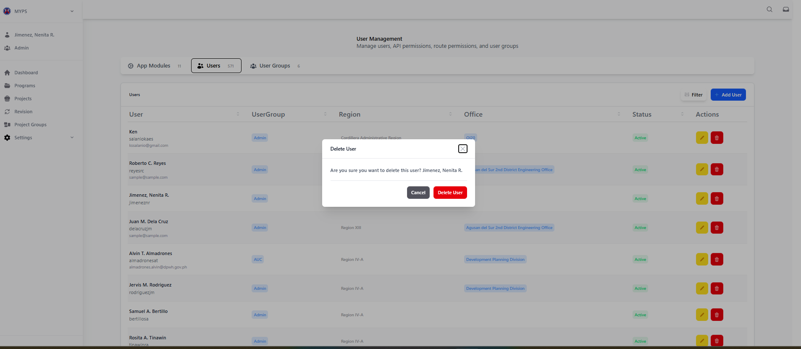
Purpose
Remove an existing user account from the MYPS Web system. This action is permanent and requires confirmation to prevent accidental deletion.
Who uses this
This screen is available to authorized MYPS users with access to the module.
Prerequisites
- Signed in with a role that allows deletion of users.
- Selected user account exists in the Users list.
Field Reference
No. | Fields/Blocks/Objects | Description | Values / Actions
UI-UX-0122-01 | MODAL TITLE / DELETE USER | Title of the confirmation modal for deleting an existing user record. | Read-only heading; displays “Delete User.”
UI-UX-0122-02 | CLOSE BUTTON | Icon button used to close the modal without proceeding with the delete action. | closes the modal and cancels the current confirmation action.
UI-UX-0122-03 | CONFIRMATION MESSAGE | Message asking the user to confirm that the selected user account should be deleted. | Read-only text; example shown: “Are you sure you want to delete this user? Roberto C. Reyes”.
UI-UX-0122-04 | USER NAME / USER TO BE DELETED | Displays the name of the user account that will be affected by the delete action. | Read-only text; shows the selected user’s name for confirmation before deletion.
UI-UX-0122-05 | CANCEL BUTTON | Cancels the delete action and closes the modal without removing the user record. | Button labeled “Cancel”; closes the modal and discards the delete confirmation.
UI-UX-0122-06 | DELETE USER BUTTON | Confirms the delete action and removes the selected user record from the system. | Button labeled “Delete User”; deletes the selected user record, subject to authorization and system rules.
Step-by-Step: Deleting a User
- Open the Delete User modal
Click the Delete (trash icon) in the Actions column of the desired user in the Users list.
- Review User Details
Confirm the User Name shown matches the account you intend to delete.
- Read Confirmation Message
Ensure you understand that deleting the user is permanent and may affect workflows.
- Cancel if needed
  - Click Cancel or Close to exit without deleting.
  - The user account remains unchanged.
- Confirm Deletion
Click Delete User to permanently remove the account.
On Success
- User is removed from the Users list.
- All associated permissions and access rights are revoked.

Common Outcomes & What to Do
Message / Situation | What it Means | What You Should Do
“Deletion not allowed” | User lacks permission or system restriction | Contact MYPS administrator for authorization
“Network error” | Unable to complete deletion | Retry action or refresh page; contact support if persists

User Management User Group (UI-UX-0123)
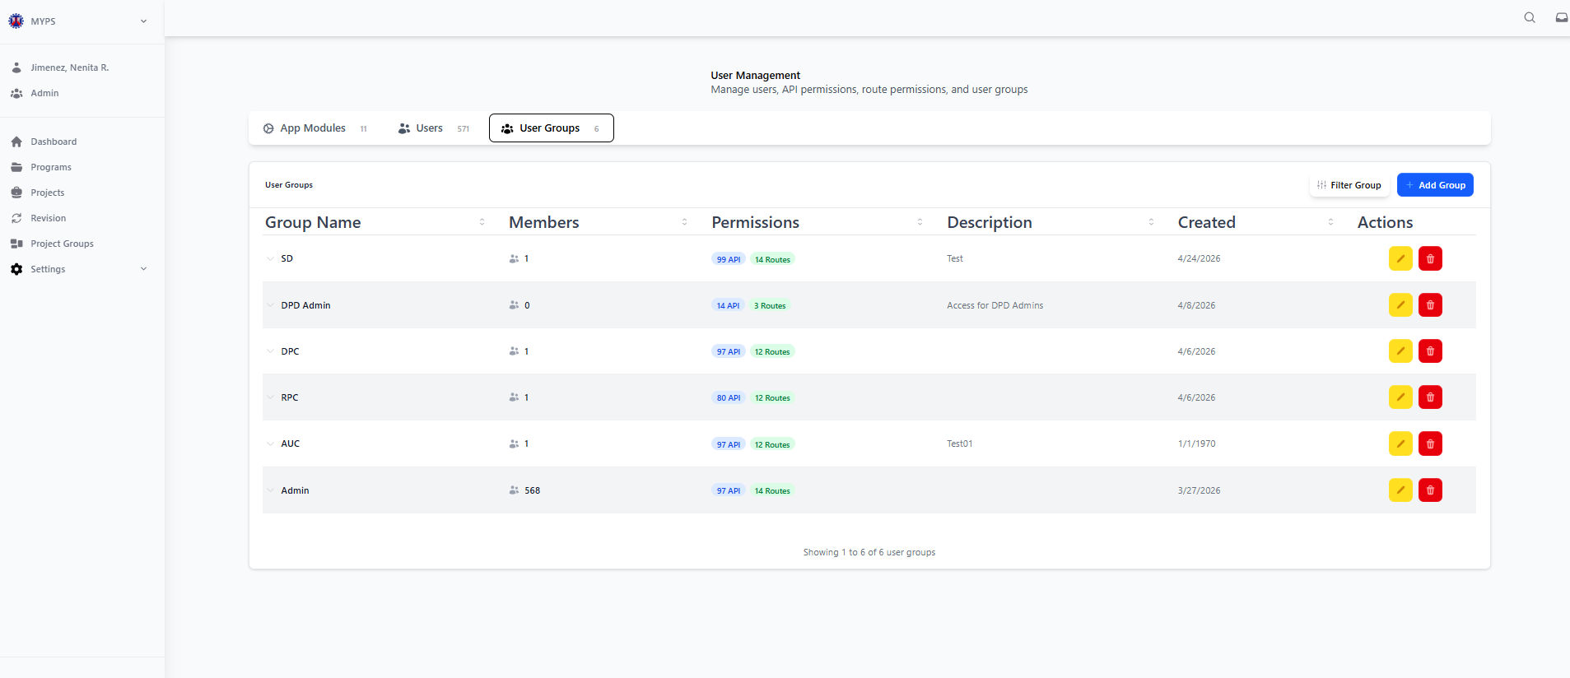
Purpose
Confirm that all user groups are correctly displayed in the User Groups module, and that all associated details are visible and accurate.
Who uses this
This screen is available to authorized MYPS users with access to the module.
Prerequisites
- Signed in with a role that can access User Management.
- User Groups screen is loaded (UI-UX-00115).
Field Reference
No. | Field/Block/Object | Description | Values / Actions
UI-UX-0123-01 | GROUP NAME | Name of the user group | Text input; unique name required
UI-UX-0123-02 | MEMBERS | Number of users assigned to the group | Display-only; count of users
UI-UX-0123-03 | PERMISSIONS | Permissions assigned to the group | Read-only labels; shows roles/functions
UI-UX-0123-04 | DESCRIPTION | Optional description for the group | Free text; max 255 characters
UI-UX-0123-05 | CREATED | Date the group was created | Read-only; auto-generated
UI-UX-0123-06 | ACTIONS – EDIT | Edit group details | Click to open Edit Group modal
UI-UX-0123-07 | ACTIONS – DELETE | Delete the group | Click to open Delete Group confirmation modal
UI-UX-0123-08 | ADD GROUP | Add a new group | Click to open Add Group modal

Step-by-Step: Managing User Groups
- Open User Groups screen
Navigate via Side Navigation → Settings → User Groups.
- View Existing Groups
Review the list of groups with Members, Permissions, and Description.
- Add a New Group
  - Click Add Group.
  - Enter Group Name, optional Description, and assign Permissions.
  - Click Save to create the group.
- Edit a Group
  - Click the Edit icon for the selected group.
  - Modify name, description, or permissions as required.
  - Click Update to save changes.
- Delete a Group
  - Click the Delete icon for the selected group.
  - Confirm deletion in the Delete Group modal.
On Success
- New groups appear in the list.
- Edited group details are updated immediately.
- Deleted groups are removed from the list.
Common Outcomes & What to Do
Message / Situation | What it Means | What You Should Do
“Group name already exists” | Name must be unique | Choose a different name
Cannot delete group | Users still assigned or system restriction | Reassign users or contact admin
Permissions not saving | Input invalid or missing | Verify all required fields and retry

User Group Modules (UI-UX-0124)
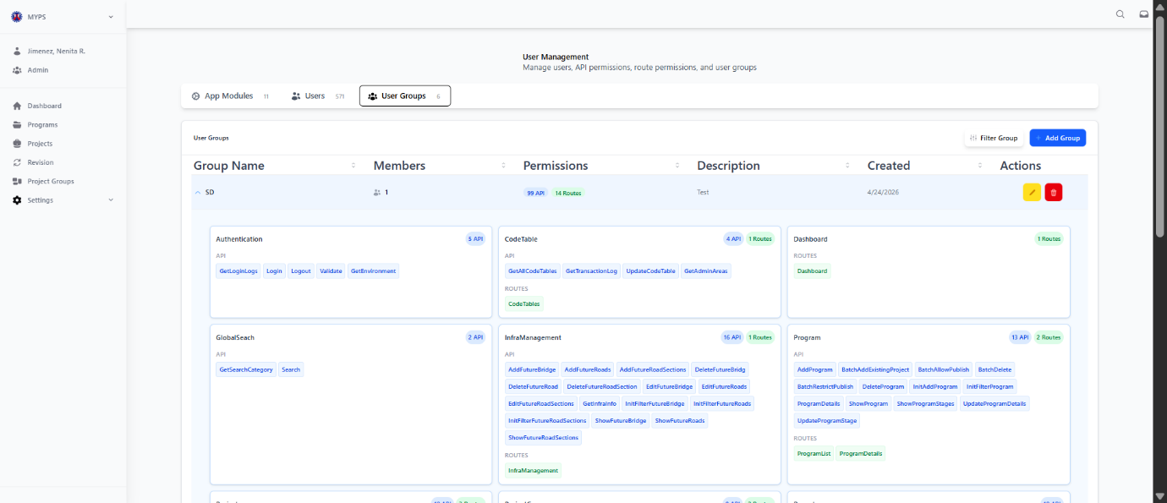

Purpose
Assign or verify module permissions for a user group in MYPS Web, ensuring that all users in the group have appropriate access to system modules and functions.
Who uses this
This screen is available to authorized MYPS users with access to the module.
Prerequisites
- Signed in with a role that has permission to edit user groups.
- User Groups must already exist (UI-UX-00115).
Field Reference
No. | Fields/Blocks/Objects | Description | Values / Actions
UI-UX-0124-01 | GROUP NAME | Name of the selected user group | Dropdown selection: DPD Admin, DPC, RPC, AUC, Admin
UI-UX-0124-02 | MODULE PERMISSIONS | Modules that the group has access to | Checkboxes or toggles for Authentication, Code Tables, Dashboard, Infra Management, Program, Project, Revision, User Management
UI-UX-0124-03 | SAVE / APPLY | Save assigned module permissions | Click to apply changes and update access rights for the group
UI-UX-0124-04 | CANCEL | Discard changes | Click to exit without saving updates
Step-by-Step: Assigning Module Permissions
- Open User Group Modules
Navigate via User Groups (UI-UX-00115) → select a group → click Edit → choose Module Permissions.
- Select Group
Ensure the correct User Group is selected from the dropdown (DPD Admin, DPC, RPC, AUC, Admin).
- Check/Assign Modules
  - Tick the boxes for modules that this group should access:
    - Authentication
    - Code Tables
    - Dashboard
    - Infra Management
    - Program
    - Project
    - Revision
    - User Management
- Save Changes
Click Save / Apply to update module permissions for the group. Validation ensures at least one module is assigned.
- Cancel Changes
Click Cancel to exit without saving modifications.
On Success
- Module permissions are updated and effective for all users in the group.
- The Users in this group will only see modules assigned to their group.
Common Outcomes & What to Do
Message / Situation | What it Means | What You Should Do
Modules not selectable | Group may not have permission or role restriction | Verify user has authorization to modify modules
No modules assigned | Group has no access to any modules | Assign at least one module to avoid access issues
Changes not saved | Network or validation error | Retry saving; contact MYPS administrator if persists

Add New User Group (UI-UX-0125)
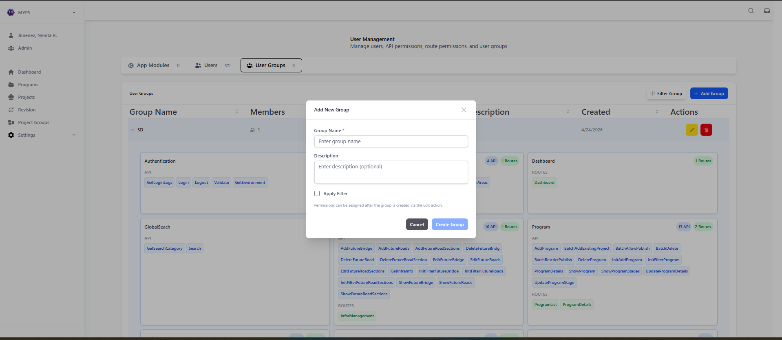
Purpose
Create a new user group in MYPS Web, allowing administrators to manage permissions, roles, and access for multiple users collectively.
Who Uses This
Administrators or authorized personnel responsible for user group management.
Prerequisites
- You must be signed in with a role that has permission to manage user groups.
- Access to the User Groups screen (UI-UX-00115).
Field Reference
No. | Fields/Blocks/Objects | Description | Values / Actions
UI-UX-0125-01 | GROUP NAME | Name for the new group | Text input; mandatory; must be unique
UI-UX-0125-02 | DESCRIPTION | Optional description of the group | Text input; optional; up to 255 characters
UI-UX-0125-03 | CANCEL | Close the dialog | Button; discards input and closes modal
UI-UX-0125-04 | CREATE GROUP | Save the new group | Button; validates fields and adds the group to the User Groups list
Step-by-Step: Add New Group
- Open Add New Group Modal
  - Click the Add Group button on the User Groups screen.
- Enter Group Details
  - Group Name: Type a unique name for the new group.
  - Description: Enter optional descriptive text for the group.
- Save or Cancel
  - Click Create Group to save and add the group.
  - Click Cancel to exit the dialog without saving.
- Verify New Group
  - The new group should appear in the User Groups list.
  - Permissions for the group can be assigned using the Edit action after creation.
Common Outcomes & What to Do
Message / Situation | What it Means | What You Should Do
“Group name already exists” | Name is not unique | Choose a different name
New group does not appear | Modal validation failed or network issue | Retry, ensure required fields are filled correctly, refresh the screen

Filter User Groups (UI-UX-0126)
Purpose
Filter the list of user groups in MYPS Web based on group name or permission name, allowing administrators to quickly locate specific groups and their assigned permissions.
Who uses this
This screen is available to authorized MYPS users with access to the module.

Prerequisites
- Must be signed in with an account that has access to User Groups management.
Field Reference
No. | Fields/Blocks/Objects | Description | Values / Actions
UI-UX-0126-01 | GROUP NAME | Enter the name of the user group to filter | Text input; optional; partial or full name supported
UI-UX-0126-02 | PERMISSION NAME | Enter a permission name to filter groups that include it | Text input; optional; partial or full permission name supported
UI-UX-0126-03 | CLEAR FILTERS | Clears all input fields | Button; resets fields to default empty state
UI-UX-0126-04 | CANCEL | Closes the modal without applying filters | Button; discards input
UI-UX-0126-05 | FILTER GROUP | Executes the search based on entered criteria | Button; updates the User Groups list accordingly
Step-by-Step: Filtering User Groups
- Open Filter User Group Modal
  - Navigate to Settings → User Management → User Groups.
  - Click Filter Group button.
- Enter Filter Criteria
  - Group Name: Type the user group name or partial text.
  - Permission Name: Enter the permission you want to find across groups.
  - Leave fields blank to display all groups.
- Execute Filter
  - Click Filter Group to update the User Groups list.
  - Only matching groups will be displayed.
- Clear or Cancel
  - Click Clear Filters to reset the input fields.
  - Click Cancel to close the modal without filtering.
Common Outcomes & What to Do
Message / Situation | What it Means | What You Should Do
No groups displayed | No matches found for the entered criteria | Adjust group or permission name and retry; use partial matches if necessary
Unexpected results | Criteria may not match naming convention | Verify spelling and known permissions

Update User Group (UI-UX-0127)
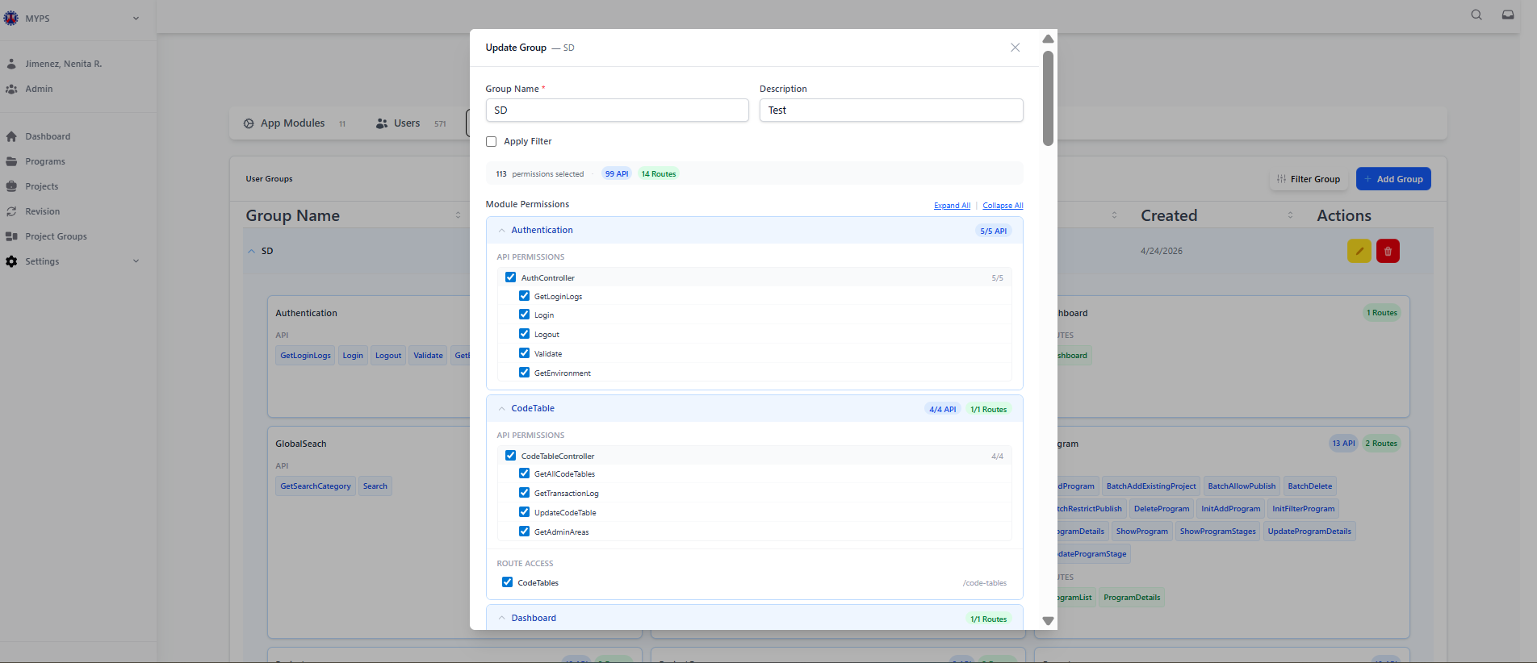
Purpose
The Update Group / Module Permissions screen allows authorized users to review and modify module access assigned to a user group. It is used to manage which modules a selected group can access and which permissions within those modules are enabled.
Who uses this
This screen is available to authorized MYPS users with access to the module.
Prerequisites
You are logged in to your MYPS account.
You have access to the User Management module.
The required user groups already exist in the system.
You have permission to edit user group settings.
Before assigning permissions, verify that the group list includes the following groups:
- DPD Admin
- DPC
- RPC
- AUC
- Admin
Field reference
No. | Fields/Blocks/Objects | Description | Values / Actions
UI-UX-0129-01 | USER GROUP LIST | Displays the available user groups in the system. | Used to review and select the group to manage. Expected groups include DPD Admin, DPC, RPC, AUC, and Admin.
UI-UX-0129-02 | GROUP NAME | Displays the name of each user group. | Text value. Example values: DPD Admin, DPC, RPC, AUC, Admin.
UI-UX-0129-03 | CREATED | Displays the creation date of the group record. | System-displayed date value.
UI-UX-0129-04 | ACTIONS / EDIT | Opens the selected group in the Update Group modal. | Click to edit module permissions for the chosen group.
UI-UX-0129-05 | ACTIONS / DELETE | Removes the selected group after confirmation. | Click to open the delete confirmation process.
UI-UX-0129-06 | FILTER GROUP | Filters or narrows the displayed group list. | Button action. Filtering behavior is based on system configuration.
UI-UX-0129-07 | ADD GROUP | Opens the process for creating a new user group. | Button action to add a new group.
UI-UX-0129-08 | UPDATE GROUP MODAL | Popup window used for editing the selected group's permissions. | Opens after clicking Edit.
UI-UX-0129-09 | APP MODULES TAB | Displays the list of application modules and their permissions. | Select to manage module permissions.
UI-UX-0129-10 | USERS TAB | Displays users associated with the selected group. | Select to view or manage group users, if permitted.
UI-UX-0129-11 | MODULE PERMISSIONS | Main section listing the modules available for permission assignment. | Expand module rows and check or uncheck permissions.
UI-UX-0129-12 | AUTHENTICATION | Module permission group for authentication-related access. | Expand to view available permission checkboxes.
UI-UX-0129-13 | CODETABLE | Module permission group for code table access. | Expand to view available permission checkboxes.
UI-UX-0129-14 | DASHBOARD | Module permission group for dashboard access. | Expand to view available permission checkboxes.
UI-UX-0129-15 | INFRA MANAGEMENT | Module permission group for infrastructure management access. | Expand to view available permission checkboxes.
UI-UX-0129-16 | PROGRAM | Module permission group for program-related access. | Expand to view available permission checkboxes.
UI-UX-0129-17 | PROJECT | Module permission group for project-related access. | Expand to view available permission checkboxes.
UI-UX-0129-18 | REVISION | Module permission group for revision-related access. | Expand to view available permission checkboxes.
UI-UX-0129-19 | USERMANAGEMENT | Module permission group for user management access. | Expand to view available permission checkboxes.
UI-UX-0129-20 | PERMISSION CHECKBOXES | Individual permission items under a selected module. | Check to grant access; uncheck to remove access. Exact permission names depend on system configuration.
UI-UX-0129-21 | CANCEL | Closes the modal without saving any changes made in the current session. | Button action to discard unsaved edits.
UI-UX-0129-22 | SAVE CHANGES | Saves the selected permission updates for the user group. | Button action to apply and store changes.
UI-UX-0129-23 | CLOSE BUTTON | Closes the Update Group modal. | Action closes the popup. Unsaved changes may be lost.
Step-by-step: Review groups and assign module permissions
- Open User Management
Log in to MYPS and open the User Management module.
- Review the available groups
Check the group list and verify that the following groups are present:
  - DPD Admin
  - DPC
  - RPC
  - AUC
  - Admin
- Select the group to update
Locate the target group from the list.
- Open the group for editing
Click the Edit button in the Actions column for the selected group.
The Update Group modal opens.
- Open the App Modules tab
In the modal, make sure the App Modules tab is selected.
- Review the available modules
Confirm that the module list contains:
  - Authentication
  - Code Table
  - Dashboard
  - InfraManagement
  - Program
  - Project
  - Revision
  - UserManagement
- Expand a module
Click a module row to expand it and display its available permission items.
- Select permissions
Tick the checkboxes for the permissions you want to grant to the selected group.
Untick any permission that should not be assigned.
- Repeat for other modules
Expand each needed module and set the required permission checkboxes.
- Review the selected permissions
Double-check that the selected group has the correct access across all required modules.
- Save the changes
Click Save Changes to apply the updated module permissions.
- Verify the update
Confirm that the changes are saved successfully and that the group now reflects the intended access configuration.
Step-by-step: Cancel without saving
- Open the Update Group modal.
- Make any review or tentative changes as needed.
- Click Cancel or the X icon if you do not want to keep the changes.
- The modal closes without saving the current updates.
On success
The selected group’s module permissions are updated and saved in the system. The revised access settings will apply to that group based on the enabled checkboxes.
Common Outcomes & What to Do
Message / Situation | What It Means | What To Do
Changes saved successfully | The selected permissions were saved. | Review the group again if needed to confirm the updated module access.
No changes made | The save action was triggered without modifying any permissions. | Continue only if no updates are needed; otherwise, select or clear the required checkboxes first.
Required module access missing | The selected group may not have been assigned the necessary permissions. | Reopen the group and check the correct module permissions.

Settings Infrastructure Administration Overview
Infrastructure Administration (found under Settings ▸ Infra Management or Structures) is a core module in the MYPS Web application used to manage the physical assets—both existing and future—that projects are linked to. It serves as a bridge between the system's planning functions and the Department’s asset inventory databases

Infrastructure Administration Roads (UI-UX-0128)

Module Name and Infrastructure ID Rules
The formal module name is Infrastructure Administration (RBIA). If the side navigation displays “Settings Infra Management,” document it as the menu label and use Infrastructure Administration (RBIA) as the formal section name.
Record type | ID rule to verify in UI
Future Road | FR + five-digit number + island code, if generated by the system; otherwise enter the full Road ID as required by the test script.
Future Road Section | FS + five-digit number + island code inherited from the parent road, if generated by the system; otherwise enter the full Section Road ID as required.
Future Bridge | FB + five-digit number + island code inherited from the parent section, if generated by the system; otherwise enter the full Bridge ID as required.
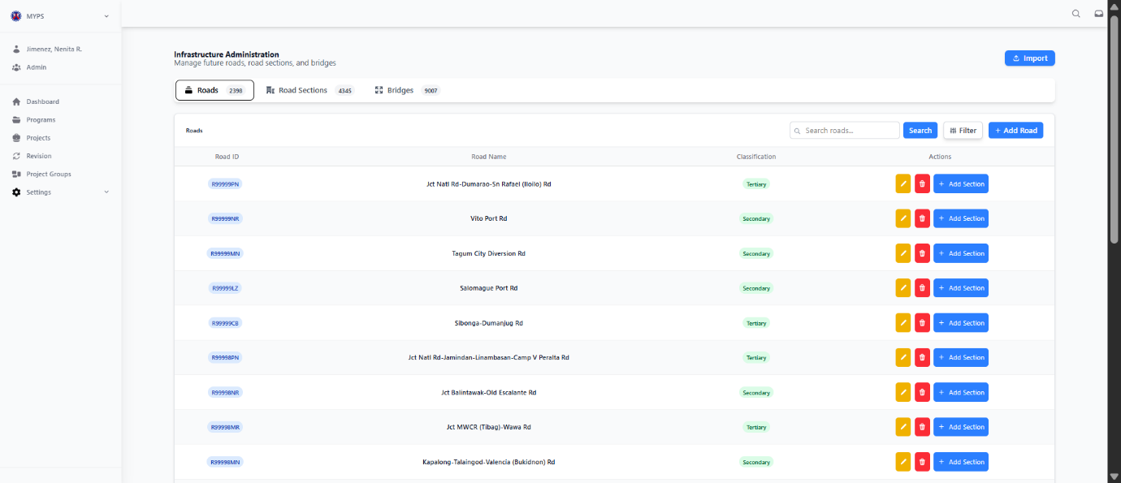
Purpose
The Infrastructure Administration Roads screen allows authorized users to manage road records in the system. It supports viewing the road list, searching and filtering records, importing road network data, adding new roads, editing existing roads, deleting road entries, and adding road sections linked to a selected road.
Who uses this
This screen is available to authorized MYPS users with access to the module.

Prerequisites
You are logged in to your MYPS account.
You have access rights to the Infrastructure Administration module.
Your browser supports the web application and has JavaScript and cookies enabled.
You have the required road information before creating or updating a record.
If importing road network data, the source file or import data must already be prepared based on system requirements.
Field reference
No. | Fields/Blocks/Objects | Description | Allowed values / Actions
UI-UX-0128-01 | ROAD ID | System-generated or manually entered unique identifier for the road record. | Expected format for a Future Road ID starts with F (e.g., FR00205CB).
UI-UX-0128-02 | ROAD NAME | The full descriptive name of the road project. | Expected text value.
UI-UX-0128-03 | CLASSIFICATION | Indicates the type of road. | Selection from predefined categories such as Primary or Secondary.
UI-UX-0128-04 | SEARCH ROAD | Enables quick lookup of roads by name or ID. | Text input used for filtering the list.
UI-UX-0128-05 | SEARCH BUTTON | Executes the search query based on the entered keyword. | Click to run the search.
UI-UX-0128-06 | FILTER | Opens or applies filtering options to refine the road list. | Action to apply filters such as classification or other configured criteria.
UI-UX-0128-07 | IMPORT ROAD NETWORK | Allows importing road network data into the module. | Button action to initiate import of road data. The visible button label appears as Import.
UI-UX-0128-08 | ADD ROAD | Opens the form for creating a new road entry. | Action opens the Add Road form.
UI-UX-0128-09 | ACTIONS / EDIT | Opens the selected road record for editing. | Action opens the Update/Edit Road form.
UI-UX-0128-10 | ACTIONS / DELETE | Removes the selected road record after confirmation. | Action opens a delete confirmation dialog.
UI-UX-0128-11 | ACTIONS / ADD SECTION | Creates a new road section linked to the selected road. | Action opens the Add Road Section dialog or form.
UI-UX-0128-12 | ROADS TAB | Displays the list of road records. | Select to stay in or return to the Roads view.
UI-UX-0128-13 | ROAD SECTIONS TAB | Opens the Road Sections view. | Select to manage road sections.
UI-UX-0128-14 | BRIDGES TAB | Opens the Bridges view. | Select to manage bridge records.

Step-by-Step: Manage Roads
1. Open Infrastructure Administration
Log in to MYPS Web and go to the Infrastructure Administration module. Select the Roads tab to display the list of road records.

2. Search for a Road
Enter a Road ID or Road Name in the Search Road field. Click Search to filter the list and display matching records.
3. Filter the Roads List
Click Filter to refine the list using available criteria such as classification or other configured filters. Apply the selected filter and review the updated list.

4. Import Road Network Data
Click Import or Import Road Network to open the import function. Select or prepare the required road network data according to system requirements, then proceed with the import. After importing, review the list to confirm that the road records were loaded correctly.

5. Add a New Road
Click Add Road to open the road creation form. Enter the required Road ID, Road Name, and Classification, then save the record.

6. Edit an Existing Road
Locate the correct road row and click Edit. Update the required road information, then save the changes. Recheck the row to confirm that the update was applied.

7. Delete a Road
Locate the road record and click Delete. Review the confirmation message carefully before confirming the deletion.

8. Add a Road Section
Locate the correct road row and click Add Section. Complete the road section details and save the new section under the selected road.

Common Outcomes & What to Do
Message / Situation | What It Means | What You Should Do
No matching road found | The search term did not match any road record. | Check the spelling, try another keyword, or clear the search.
Required field missing | One or more required fields were not completed. | Fill in all mandatory fields before saving.
Invalid Road ID format | The Road ID does not follow the expected format. | Re-enter the Road ID using the required format, such as a Future Road ID starting with F or FR.

Infrastructure Administration Add New Future Road (UI-UX-0129)
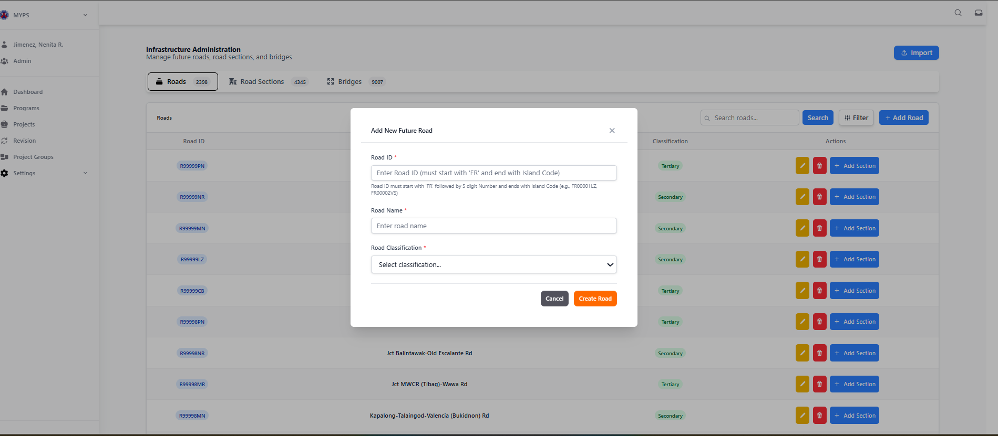
Purpose
The Add New Future Road screen allows authorized users to create a new future road record in the Infrastructure Administration module. It captures the road identifier, road name, and road classification before saving the new road entry into the system.
Who uses this
This screen is available to authorized MYPS users with access to the module.
Prerequisites
You are logged in to your MYPS account.
You have access to the Infrastructure Administration module.
You are on the Roads screen and have opened the Add New Future Road form.
You have the required road information ready, including the correct Road ID format, road name, and classification.
Field reference
No. | Fields/Blocks/Objects | Description | Allowed values / Actions
UI-UX-0129-01 | ROAD ID | A unique identifier for the road record. It must follow the required future road format. | Must start with FR, followed by 5 digits, and end with the island code. Examples: FR00001LZ, FR00002VS.
UI-UX-0129-02 | ROAD NAME | The official name or title of the future road project. | Text input field for entering the road name. Example: Catanduanes Diversion Road.
UI-UX-0129-03 | ROAD CLASSIFICATION | Defines the category or hierarchy of the road within the system. | Dropdown selection from available classifications such as Primary or Secondary.
UI-UX-0129-04 | CANCEL | Closes the form without saving the entered data. | Button action to discard changes and close the modal.
UI-UX-0129-05 | CREATE ROAD | Saves the new road record to the system. | Button action to create and save the road record using the entered details.

Step-by-Step: Add New Future Road
1. Open the Roads Screen
Log in to MYPS Web and go to Infrastructure Administration.
Select the Roads tab.
2. Open the Add New Future Road Form
Click the Add Road button.
The Add New Future Road modal appears over the Roads list.
3. Enter the Road ID
In the Road ID field, enter the future road identifier.
Follow the required format: FR + five digits + island code.
Example: FR00001LZ
4. Enter the Road Name
In the Road Name field, type the official or descriptive road name.
Example: Catanduanes Diversion Road
5. Select the Road Classification
Click the Road Classification dropdown.
Select the appropriate classification from the available options.
6. Create the Road
Review the entered details.
Click Create Road to save the new future road record.
7. Cancel if Needed
Click Cancel if you do not want to save the record.

Common Outcomes & What to Do
Message / Situation | What It Means | What You Should Do
“Field is required.” | One or more required fields were left blank. | Complete the Road ID, Road Name, and Road Classification fields.
“Invalid Road ID format.” | The Road ID does not follow the required format. | Use the format FR + five digits + island code, such as FR00001LZ.
“Road already exists.” | The entered Road ID may already be registered. | Check the Road ID and search the Roads list before creating a new record.

Infrastructure Administration Filter Roads (UI-UX-0130)
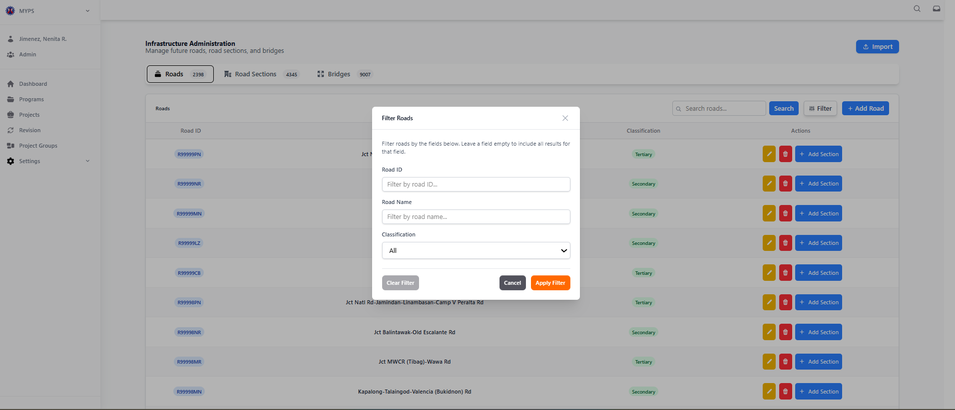
Purpose
The Filter Roads modal allows authorized users to refine the list of roads displayed on the Roads tab. Users can filter by Road ID, Road Name, and Classification to quickly locate specific road records. This supports efficient navigation and management of road data.
Who uses this
This screen is available to authorized MYPS users with access to the module.
Prerequisites
- You are logged in to MYPS and have access to the Infrastructure Administration module.
- You are on the Roads tab within Infrastructure Administration.
- The Roads list contains existing road records to be filtered.
Field reference
No. | Fields/Blocks/Objects | Description | Values / Actions
UI-UX-0130-01 | ROAD ID | Enter a road identifier to filter the table results. | Text input; leave blank to include all IDs.
UI-UX-0130-02 | ROAD NAME | Enter a road name to filter the table results. | Text input; partial or full name allowed; leave blank to include all names.
UI-UX-0130-03 | CLASSIFICATION | Filter by the road’s category. | Dropdown selection; options include All, Primary, Secondary, Tertiary.
UI-UX-0130-04 | CLEAR FILTER | Resets all filter fields to default values. | Button action.
UI-UX-0130-05 | CANCEL | Closes the modal without applying any filter. | Button action.
UI-UX-0130-06 | APPLY FILTER | Applies the selected filter criteria to the road list. | Button action; updates the Roads table based on inputs.

Step-by-Step: Filter Roads
1. Open the Filter Roads Modal
Go to the Infrastructure Administration module.
Open the Roads tab.
Click the Filter button.
The Filter Roads modal appears.

2. Enter Filter Criteria
In the Road ID field, enter the road identifier you want to search for.
In the Road Name field, enter a partial or full road name.
In the Classification dropdown, select the desired classification or leave it as All.

3. Apply the Filter
Click Apply Filter to filter the Roads table using the entered criteria.

4. Clear the Filter
Click Clear Filter if you want to reset all fields and return the filter form to its default state.

5. Cancel the Action
Click Cancel if you want to close the modal without applying any new filter.

6. Review the Filtered Results
After applying the filter, review the Roads table and confirm that the displayed records match the selected criteria.

On Success
The Roads table updates and displays only the records that match the entered Road ID, Road Name, and/or Classification criteria. Users may then proceed with row-level actions such as Edit, Delete, or Add Section, depending on their permissions.

Common Outcomes & What to Do
Message / Situation | What It Means | What You Should Do
No matching records | No roads match the entered filter criteria. | Broaden the filter, check spelling, or click Clear Filter to show all records.
Partial match results appear | Some road records match the entered criteria. | Review the filtered rows and adjust the criteria if needed.
Filter applied successfully | The Roads table was updated based on the selected criteria. | Continue reviewing or managing the filtered road records.

Infrastructure Administration Import Road Network (UI-UX-0131)
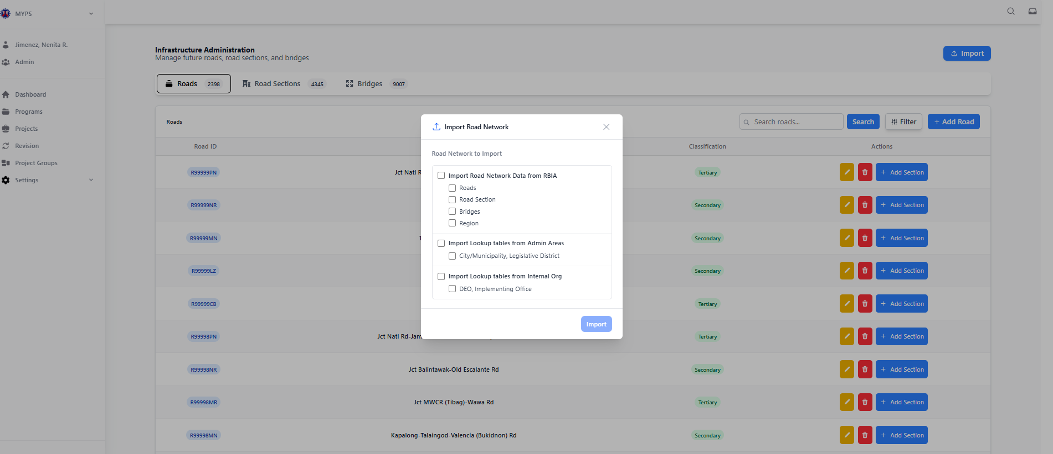
Purpose
The Import Road Network modal allows authorized users to import road network data and related lookup tables into the Infrastructure Administration module. Users can select specific datasets to import, including roads, road sections, bridges, regions, administrative areas, and internal organizational data.
Who uses this
This screen is available to authorized MYPS users with access to the module.
Prerequisites
- Logged in to MYPS with access to Infrastructure Administration.
- Access to the Roads tab.
- The source files or datasets to import must be prepared and available according to system requirements.
- Users should have permission to add or update road network data in the system.

Field reference
No. | Fields/Blocks/Objects | Description | Values / Actions
UI-UX-0131-01 | IMPORT ROAD NETWORK DATA FROM RBIA | Allows selection of datasets from the RBIA to import. | Checkbox options include Roads, Road Section, Bridges, Region.
UI-UX-0131-02 | IMPORT LOOKUP TABLES FROM ADMIN AREAS | Allows import of lookup tables for administrative areas. | Checkbox options include City/Municipality and Legislative District.
UI-UX-0131-03 | IMPORT LOOKUP TABLES FROM INTERNAL ORG | Enables importing lookup tables related to internal organizations. | Checkbox options include DEO and Implementing Office.
UI-UX-0131-04 | IMPORT BUTTON | Starts the import process for the selected datasets. | Button labeled Import.

Step-by-step: Import Road Network
- Open the Roads screen
Navigate to the Infrastructure Administration module and select the Roads tab.
- Open the Import modal
Click the Import button at the top-right of the Roads tab.
The Import Road Network modal appears.
- Select datasets to import
  - Check IMPORT ROAD NETWORK DATA FROM RBIA and select one or more of Roads, Road Section, Bridges, or Region.
  - Check IMPORT LOOKUP TABLES FROM ADMIN AREAS if administrative area tables need importing.
  - Check IMPORT LOOKUP TABLES FROM INTERNAL ORG for internal organization tables.
- Review selections
Confirm that all required datasets are checked correctly.
- Execute the import
Click the Import button to start the import process.
- Wait for completion
Allow the system to process the import. The modal may remain open until the operation completes.
- Verify imported data
Check that the imported records appear in the Roads table and associated lookup tables.
Step-by-step: Cancel import
- Open the Import Road Network modal.
- Click Cancel or the X icon to close the modal without importing any data.
On success
The selected datasets are imported successfully, and the road network and lookup tables are updated. Users can immediately view imported roads, sections, or related tables in the corresponding tables.
Common Outcomes & What to Do
Message / Situation | What It Means | What To Do
No datasets selected | No checkboxes were selected before clicking Import. | Select at least one dataset to import.
Import failed | System encountered an error during import. | Verify source data and try again. Contact support if the issue persists.
Import successful | Selected datasets were successfully imported. | Confirm that the new data appears correctly in the table.

Infrastructure Administration Edit Future Roads (UI-UX-0132)
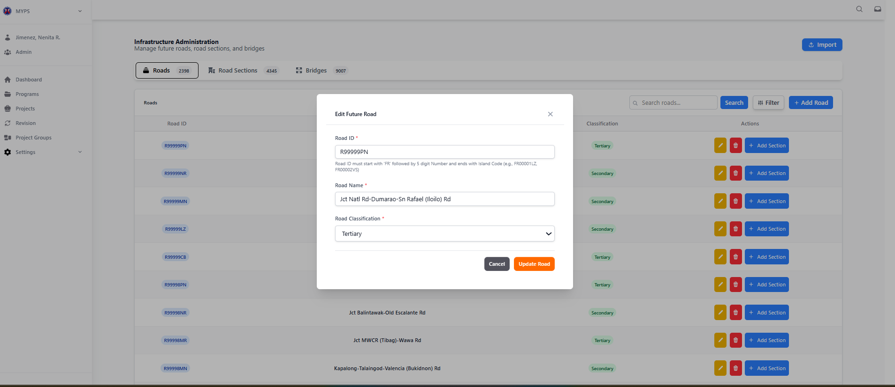
Purpose
The Edit Future Road modal allows authorized users to update the name and classification of an existing road record. The road identifier remains read-only while modifications are made. This ensures accurate maintenance of road information in the Infrastructure Administration module.
Who uses this
This screen is available to authorized MYPS users with access to the module.
Prerequisites
- You are logged in to MYPS with access to the Infrastructure Administration module.
- You are on the Roads tab and have selected a road record to edit.
- You have the necessary permissions to modify road names or classifications.
Field reference
No. | Fields/Blocks/Objects | Description | Values / Actions
UI-UX-00132-01 | ROAD ID | The unique identifier automatically assigned to the road. | Read-only field. Format: starts with FR, e.g., FR100101. Cannot be edited.
UI-UX-00132-02 | ROAD NAME | The official name of the road project. | Editable text field. Example: PLARIDEL BY-PASS ROAD.
UI-UX-00132-03 | ROAD CLASSIFICATION | Specifies the road's classification or category. | Dropdown selection. Options include Primary, Secondary, or Tertiary.
UI-UX-00132-04 | CANCEL | Closes the modal without saving changes. | Button action to discard edits.
UI-UX-00132-05 | UPDATE ROAD | Saves modifications to the road’s name or classification. | Button action to apply changes to the record.

Step-by-step: Edit a road record
- Open the Roads screen
Navigate to Infrastructure Administration → Roads tab.
- Select a road to edit
Click the Edit action button for the desired road row.
The Edit Future Road modal opens.
- Review the Road ID
Confirm the road’s unique identifier. This field is read-only.
- Update the Road Name
Edit the Road Name field as needed to correct or update the official name.
- Update Road Classification
Select the appropriate classification from the Road Classification dropdown.
- Save or cancel changes
  - Click Update Road to save the edits.
  - Click Cancel or the X icon to close the modal without saving.
- Verify the updates
Confirm that the updated road name and classification appear in the Roads table.

On success
The road record reflects the updated name and classification, while the Road ID remains unchanged. The modal closes after a successful update.

Common Outcomes & What to Do
Message / Situation | What It Means | What To Do
Required fields missing | Name or classification not provided. | Complete all required fields before saving.
Invalid classification | Selected value not allowed. | Choose a valid option from the dropdown.
Update successful | Road details saved successfully. | Verify the table shows the updated information.

Infrastructure Administration Delete Future Roads (UI-UX-0133)
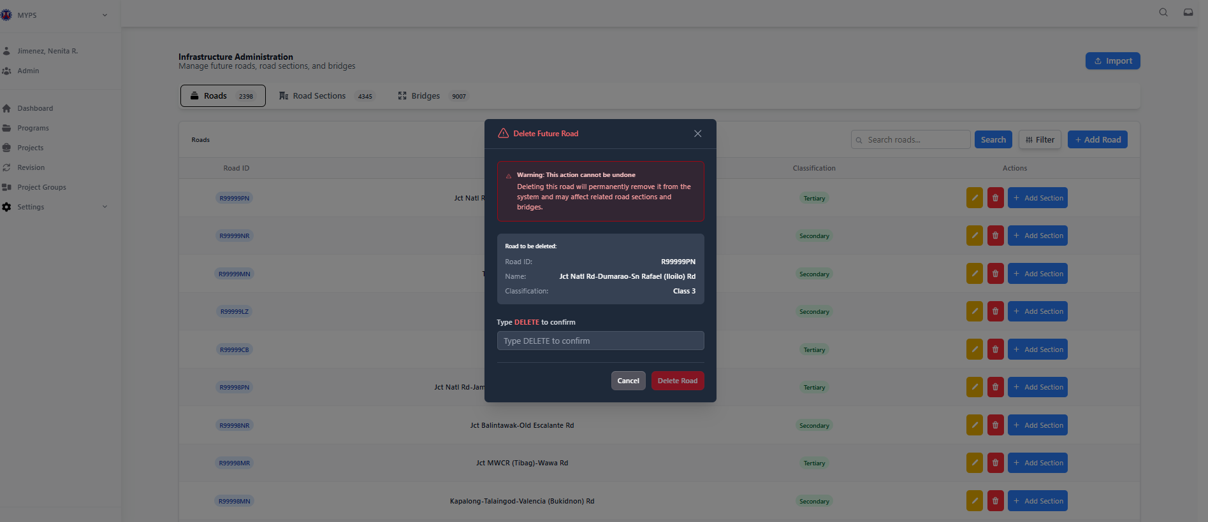
Purpose
Allows authorized users to remove future roads from the system. This operation permanently deletes the selected road and its associated road sections and bridges.
Who uses this
This screen is available to authorized MYPS users with access to the module.
Prerequisites
- Logged in with a MYPS account having delete permissions for infrastructure records
- Confirm that the road is not yet implemented and can be removed without affecting ongoing projects
Field Reference
No. | Field/Block/Object | Description | Values / Actions
UI-UX-0133-01 | ROAD LIST TABLE | Lists all future roads with metadata | Read-only table; sortable columns
UI-UX-0133-02 | DELETE BUTTON | Initiates deletion of selected road | Click opens confirmation modal
UI-UX-0133-03 | WARNING MESSAGE | Alerts user of permanent deletion | Informational; cannot be bypassed
UI-UX-0133-04 | CONFIRMATION INPUT | Requires typing “DELETE” to confirm | Text input; must match exactly
UI-UX-0133-05 | CANCEL BUTTON | Cancels deletion | Closes modal without changes
UI-UX-0133-06 | DELETE ROAD BUTTON | Confirms deletion and removes road | Permanently deletes road and associated sections/bridges

Step-by-Step: Delete a Future Road
- Locate the Road
  - Use search or filter to find the road in the table.
- Initiate Delete
  - Click the Delete button in the Actions column for the road.
- Read the Warning
  - Carefully read the message indicating that deletion is permanent and will remove associated road sections and bridges.
- Type Confirmation
  - In the input box, type DELETE exactly as shown.
- Confirm Deletion
  - Click Delete Road to remove the road.
  - Click Cancel to abort the deletion.
Common Outcomes & What to Do
Message / Situation | What It Means | What You Should Do
Road deleted successfully | Road removed | Verify the road is no longer listed
Wrong confirmation text | DELETE not typed correctly | Re-enter DELETE exactly to enable deletion
Permission denied | User lacks delete privileges | Contact MYPS administrator for access

Infrastructure Administration Add Road Section (UI-UX-0134)
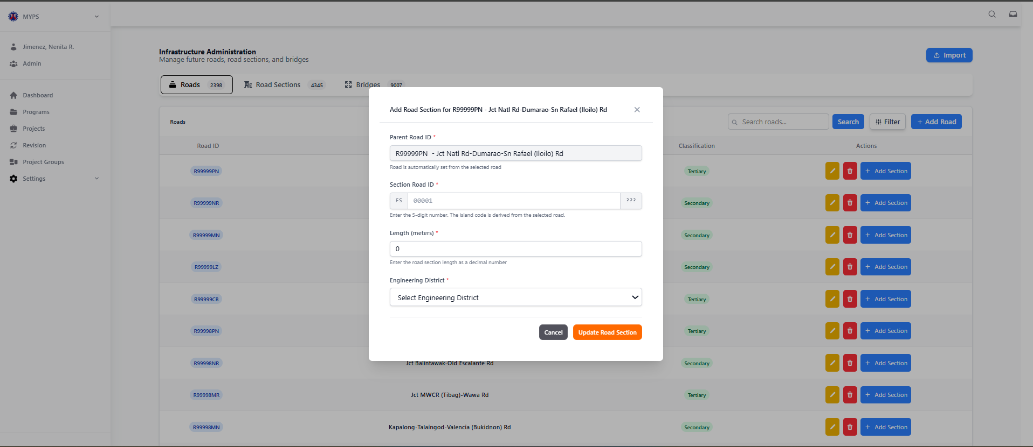
Purpose
Allows authorized users to add a new road section under an existing parent road. This ensures that the road inventory is detailed and includes all segments for planning, monitoring, and GIS integration.
Who Uses This
This screen is available to authorized MYPS users with access to the module.
Prerequisites
- Must be logged into MYPS with permission to add road sections.
- Must select an existing parent road before adding a section.
Field Reference
No. | Field/Block/Object | Description | Values / Actions
UI-UX-0134-01 | PARENT ROAD ID | Displays the parent road where this section will belong | Auto-filled from selected road; read-only
UI-UX-0134-02 | SECTION ROAD ID | Unique identifier for the road section | Required; must start with “FS”; e.g., FS001-001, FS001-002
UI-UX-0134-03 | LENGTH | Length of the road section | Numeric; kilometers; must be >0
UI-UX-0134-04 | ENGINEERING DISTRICT | District responsible for the section | Dropdown; select one from available options
UI-UX-0134-05 | CANCEL | Cancels creation and closes modal | Button: closes dialog without saving
UI-UX-0134-06 | CREATE ROAD SECTION | Adds the new road section | Button: validates inputs and submits form
Step-by-Step: Add Road Section
- Open Add Section Modal
  - Navigate to Infrastructure Administration → Roads.
  - Click Add Section next to the parent road.
- Verify Parent Road ID
  - Confirm the Parent Road ID displayed is correct for the section.
- Enter Section Road ID
  - Type a unique identifier starting with FS. Example: FS001-003.
- Specify Length
  - Enter the length in kilometers. Value must be greater than 0 km.
- Select Engineering District
  - Choose the appropriate district from the dropdown menu.
- Cancel or Create
  - Click Cancel to abort the action.
  - Click Create Road Section to add the section to the system.

Common Outcomes & What to Do
Message / Situation | What It Means | Action
Section added successfully | Record created in database | Verify in the Road Section list
Invalid Section ID | Format not correct or duplicate | Ensure it starts with FS and is unique

Infrastructure Administration Road Section (UI-UX-0135)
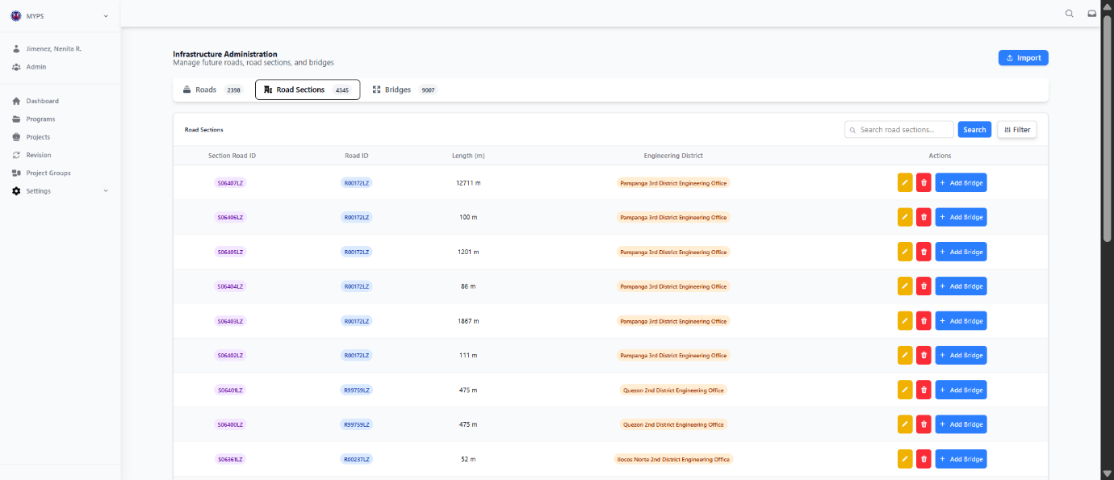

Purpose
Displays the list of all road sections under the Infrastructure Administration module, providing details about each section’s length, parent road, and managing engineering district. Users can also perform actions such as edit, delete, or add associated bridges.
Who Uses This
This screen is available to authorized MYPS users with access to the module.
Prerequisites
- Logged into MYPS Web with permission to view or modify road sections.
- Parent roads already exist in the system.
Field Reference
No. | Field/Block/Object | Description | Values / Actions
UI-UX-0135-01 | SECTION ROAD ID | Unique identifier for each road section | Must start with “FS” for future road sections
UI-UX-0135-02 | ROAD ID | Parent road of the section | Displays the associated main road
UI-UX-0135-03 | LENGTH | Length of the road section and identifies managing district | Numeric, kilometers; required
UI-UX-0135-04 | ENGINEERING DISTRICT | District responsible for maintenance, inspection, and reporting | Dropdown or display-only, depending on role
UI-UX-0135-05 | SEARCH ROAD SECTIONS | Allows search by ID, name, or district | Text input; case-insensitive
UI-UX-0135-06 | SEARCH BUTTON | Executes search query | Click to refresh list according to search criteria
UI-UX-0135-07 | FILTER | Opens filter options by district, classification, or road ID | Multi-select dropdowns or checkboxes
UI-UX-0135-08 | ACTIONS/EDIT | Modify road section details | Opens Edit Section modal
UI-UX-0135-09 | ACTIONS/DELETE | Remove the road section | Opens Delete confirmation modal
UI-UX-0135-10 | ACTIONS/ADD BRIDGE | Link a new bridge to this section | Opens Add Bridge modal

Step-by-Step: Working with Road Sections
- View Road Sections
  - Navigate to Infrastructure Administration → Road Sections.
  - The table displays all existing road sections with their parent road, length, and district.
- Search for a Section
  - Enter keywords in Search Road Sections (ID, name, or district).
  - Click Search Button to filter results.
- Apply Filters
  - Click Filter to select specific districts, classifications, or parent roads.
  - Click Apply to update the table.
  - Click Clear to remove filters.
- Edit a Road Section
  - Click Edit in the Actions column.
  - Modify the fields in the Edit modal and save changes.
- Delete a Road Section
  - Click Delete in the Actions column.
  - Confirm deletion in the modal dialog.
- Add a Bridge to a Section
  - Click Add Bridge in the Actions column.
  - Fill in bridge details and submit.

Common Outcomes & What to Do
Message / Situation | What It Means | Action
Section edited successfully | Changes saved | Verify updated data in list
Section deleted successfully | Record removed | Confirm section no longer appears
No results found | Search/filter returned nothing | Adjust criteria and retry
Invalid input on edit | Validation rules not met | Correct inputs and resubmit

Infrastructure Administration Filter Road Sections (UI-UX-0136)
Purpose
This screen allows users to filter the displayed road sections based on specific criteria, such as Road ID, Section Road ID, and Engineering District.

Who uses this
All authorized MYPS users, especially those in Infrastructure Management, Planners, and Administrators.

Prerequisites
- You must be signed in to MYPS Web.
- You must have the required permissions to view or manage road sections.
- You must be on the "Infrastructure Management" screen.

Field Reference
No. | Field/Block/Objects | Description | Values / Actions
UI-UX-0136-01 | ROAD ID | Filter by parent road ID | Text input; leave empty to include all
UI-UX-0136-02 | SECTION ROAD ID | Filter by section road ID | Text input; leave empty to include all
UI-UX-0136-03 | ENGINEERING DISTRICT | Filter by engineering district | Dropdown; select one or leave as “All Districts”
UI-UX-0136-04 | CLEAR FILTER | Resets all fields | Click to clear entries and selections
UI-UX-0136-05 | CANCEL | Closes filter modal | No changes applied
UI-UX-0136-06 | APPLY FILTER | Applies the filter criteria | Updates the road section list according to entered values
Step-by-Step: Using the Filter Road Sections Modal
- Open the Filter Modal
  - Click the Filter button on the Road Sections page.
- Enter the ROAD ID
  - In the ROAD ID field, type the parent road ID you want to filter by.
  - Example valid entry: "ROAD001".
  - Leave the field empty to include all roads.
- Enter the SECTION ROAD ID
  - In the SECTION ROAD ID field, type the section road ID.
  - Example valid entry: "SR001".
  - Leave the field empty to include all sections.
- Select the ENGINEERING DISTRICT
  - From the ENGINEERING DISTRICT dropdown, select the district to filter by.
  - Example valid entry: "Region III - Pangasinan".
  - Or leave it set to "All Districts" to include all districts.
- Apply the Filter
  - After entering your filter criteria, click Apply Filter to view the filtered road sections.
  - The list will update to show only the road sections that match your filter criteria.
- Clear the Filter
  - If you want to reset all filter fields, click Clear Filter.
- Close the Filter Modal
  - To close the filter modal without applying any changes, click Cancel.
On Success
- The road section list is filtered according to the entered criteria.
- The list of road sections is updated and displayed based on the filter selection.\
On Success
Message / Situation | What it Means | What You Should Do
Filtered results appear | The filter was successfully applied. | Review the filtered road sections.
No matching results | No road sections meet the filter criteria. | Verify the filter criteria or broaden the selection.
Filter button does not respond | Possible session timeout or network issue. | Refresh the page or re-enter the filter criteria.

Infrastructure Administration Edit Future Road Section (UI-UX-0137)
Purpose
Allows authorized users to modify details of an existing future road section, including its parent road, section ID, length, and managing engineering district.
Who Uses This
- Infrastructure administrators
- Project planners
- Regional/District engineers responsible for maintaining accurate road section data
Prerequisites
- Logged in to MYPS Web with permission to edit road sections.
- The road section to be edited must exist in the system.
Field Reference
No. | Field/Block/Objects | Description | Values / Actions
UI-UX-0137-01 | PARENT ROAD ID | The main road this section belongs to | Dropdown; required; select from existing parent roads
UI-UX-0137-02 | SECTION ROAD ID | Unique identifier for this section | Required; must start with FS; example: FS001-002
UI-UX-0137-03 | LENGTH | Length of the road section | Numeric in kilometers; must be >0
UI-UX-0137-04 | ENGINEERING DISTRICT | District responsible for maintenance and reporting | Dropdown; required
UI-UX-0137-05 | CANCEL | Cancels editing | Closes modal without saving changes
UI-UX-0137-06 | UPDATE ROAD SECTION | Saves edits | Validates entries and updates the record in the database

Step-by-Step: Edit a Future Road Section
- Open Edit Modal
  - Navigate to Infrastructure Administration → Road Sections.
  - Click the Edit button in the Actions column for the target section.
- Select Parent Road (if changing)
  - Use the dropdown to select the appropriate parent road.
- Update Section Road ID
  - Edit the Section Road ID if needed.
  - Must remain unique and start with “FS”.
- Edit Length
  - Enter the updated length in kilometers. Must be greater than zero.
- Select Engineering District
  - Choose the responsible district from the dropdown menu.
- Save Changes
  - Click Update Road Section to save edits.
  - Click Cancel to discard changes.

Common Outcomes & What to Do
Message / Situation | What It Means | Action
Section updated successfully | Record modified in database | Verify the updated section in the list
Invalid Section ID | Format incorrect or duplicate | Use a valid FS-prefixed ID

Infrastructure Administration Delete Road Section (UI-UX-0138)
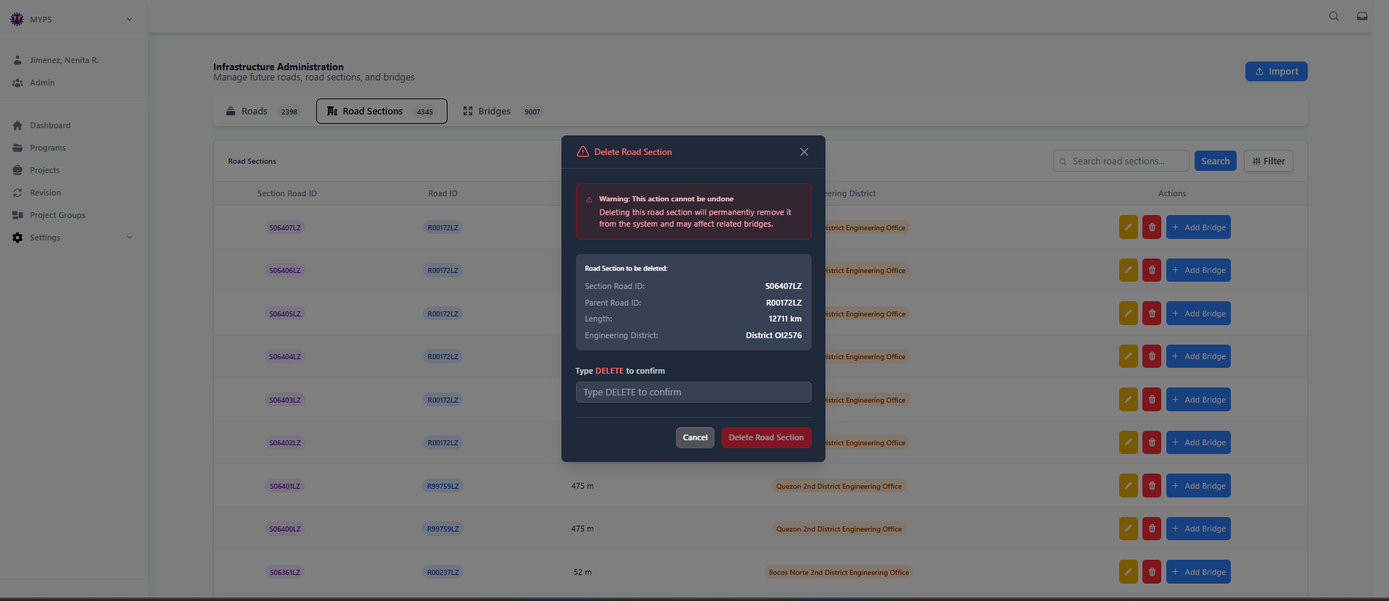
Purpose
Allows authorized users to permanently remove a road section from the system. Deleting a road section also removes any associated bridges or related infrastructure. This action cannot be undone.
Who Uses This
- Infrastructure administrators
- Project planners
- Regional/District engineers responsible for maintaining the road inventory
Prerequisites
- Logged into MYPS Web with delete permissions.
- Target road section must exist in the system.
- Ensure deletion will not impact ongoing projects.
Field Reference
No. | Fields/Blocks/Objects | Description | Values / Actions
UI-UX-0138-01 | WARNING MESSAGE | Informs user that deletion cannot be undone | Static text; attention-grabbing style
UI-UX-0138-02 | SECTION ROAD ID | Road section identifier | Display-only; example: S06407LZ
UI-UX-0138-03 | PARENT ROAD ID | ID of the parent road | Display-only; example: R00172LZ
UI-UX-0138-04 | LENGTH | Length of the section | Display-only; in km or meters
UI-UX-0138-05 | ENGINEERING DISTRICT | District responsible for section | Display-only; example: District Pampanga 3rd DEO
UI-UX-0138-06 | CONFIRMATION INPUT | Requires typing DELETE | Text input; case-sensitive
UI-UX-0138-07 | CANCEL | Cancels deletion | Closes modal
UI-UX-0138-08 | DELETE ROAD SECTION | Executes deletion | Removes section and related bridges permanently

Step-by-Step: Delete Road Section
- Select Road Section
  - Navigate to Infrastructure Administration → Road Sections.
  - Click Delete in the Actions column for the target section.
- Verify Details
  - Confirm Section ID, Parent Road ID, Length, and Engineering District.
- Type Confirmation
  - Enter DELETE in the confirmation input field exactly as shown.
- Execute Deletion
  - Click Delete Road Section to permanently remove the section.
- Cancel Deletion (Optional)
  - Click Cancel to close the modal without deleting.

Common Outcomes & What to Do
Message / Situation | Meaning | Action
Section deleted successfully | Record removed | Verify section no longer appears in list
Invalid confirmation | DELETE not typed correctly | Re-enter DELETE
Permission denied | User lacks delete rights | Request appropriate role from admin

Infrastructure Administration Edit Future Bridge (UI-UX-0139)
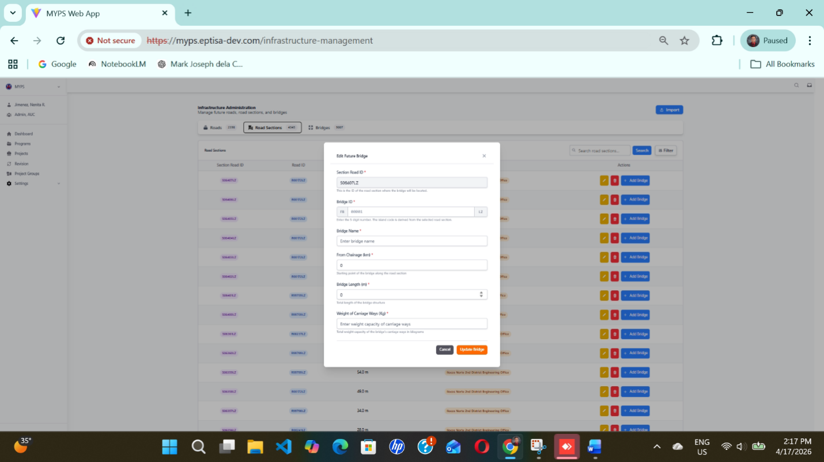
Purpose
Allows authorized users to modify the details of an existing future bridge, including its location, name, dimensions, and weight capacity.

Who Uses This
- Regional/District Engineers
- Infrastructure planners
- MYPS administrators with permission to maintain bridge inventory

Prerequisites
- Logged in with MYPS/DPWH account having edit privileges.
- Target bridge must exist in the system.

Field Reference
No. | Fields/Blocks/Objects | Description | Values / Actions
UI-UX-0139-01 | SECTION ROAD ID | Road section where the bridge is located | Read-only; pre-filled from parent section
UI-UX-0139-02 | BRIDGE ID | Unique identifier | Editable if necessary; follows system convention
UI-UX-0139-03 | BRIDGE NAME | Name of the bridge | Text; required; user-defined
UI-UX-0139-04 | FROM CHAINAGE (m) | Starting point along the road section | Numeric; required; meters
UI-UX-0139-05 | BRIDGE LENGTH (m) | Physical length of the bridge | Numeric; required; meters
UI-UX-0139-06 | WEIGHT OF CARRIAGE WAY (kg) | Weight capacity for vehicles | Numeric; required; kilograms
UI-UX-0139-07 | CANCEL | Aborts editing | Closes modal without saving
UI-UX-0139-08 | UPDATE BRIDGE | Saves changes | Validates input and updates the bridge record in the system

Step-by-Step: Edit Future Bridge
- Open the Edit Modal
  - Navigate to Infrastructure Administration → Road Sections → Bridges.
  - Click Edit next to the bridge to update.
- Verify Section Road ID
  - Ensure the correct parent road section is selected.
- Update Bridge Details
  - Edit Bridge ID if necessary.
  - Enter or modify the Bridge Name.
  - Update From Chainage (starting point), Bridge Length, and Weight of Carriage Way.
- Save Changes
  - Click Update Bridge to save edits.
  - Click Cancel to abort changes.
- Verify
  - Confirm that the updated bridge appears correctly in the bridge list.

Common Outcomes & What to Do
Message / Situation | What It Means | Action
“Bridge updated successfully” | Changes saved to database | Verify display in bridge list
Invalid input | Required field missing or numeric value incorrect | Correct fields and resubmit
Permission denied | User lacks edit privileges | Request access from MYPS Administrator

Infrastructure Administration Bridge (UI-UX-0140)
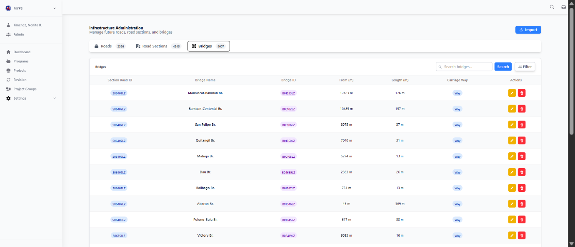
Purpose
Provides a consolidated list of all bridges under the Infrastructure Administration module, enabling users to view, edit, or delete bridge records and review associated road sections.
Who Uses This
- Regional/District Engineers
- Infrastructure planners
- MYPS administrators with bridge management permissions
Prerequisites
- Logged into MYPS Web with sufficient privileges to view bridge data.
- Road sections must exist to associate bridges.
Field Reference
No. | Fields/Blocks/Objects | Description | Values / Actions
UI-UX-0140-01 | SECTION ROAD ID | Parent road section of the bridge | Display-only; auto-filled
UI-UX-0140-02 | BRIDGE NAME | Official or project name | Display-only; read-only
UI-UX-0140-03 | BRIDGE ID | Unique identifier | Display-only; starts with FB
UI-UX-0140-04 | FROM (m) | Starting chainage along section | Display-only; meters
UI-UX-0140-05 | LENGTH (m) | Physical length of the bridge | Display-only; meters
UI-UX-0140-06 | CARRIAGE WAY | Number of lanes | Display-only
UI-UX-0140-07 | ACTIONS / EDIT | Modify bridge details | Opens Edit Bridge modal (UI-UX-00130)
UI-UX-0140-08 | ACTIONS / DELETE | Delete bridge record | Opens Delete Bridge confirmation modal (UI-UX-00132)

Step-by-Step: Working with Bridges
- View All Bridges
  - Navigate to Infrastructure Administration → Bridges.
  - The list/grid displays all bridges, showing key fields for each record.
- Search or Filter Bridges
  - Use the Search Bridges box to filter by bridge name, ID, or section.
  - Click Search to apply.
  - Click Filter to narrow by district, classification, or road ID.
- Edit a Bridge
  - Click the Edit button next to a bridge.
  - The Edit Future Bridge modal (UI-UX-00130) opens for updates.
- Delete a Bridge
  - Click the Delete button.
  - A confirmation modal appears; follow instructions to remove the bridge record permanently.
- Verify Changes
  - Ensure that edits or deletions are reflected in the bridge list.
Common Outcomes & What to Do
Message / Situation | Meaning | Action
“No bridge found” | Search/filter criteria did not match any records | Adjust criteria or clear filters
“Bridge deleted successfully” | Record removed from the system | Confirm removal in list

Infrastructure Administration Edit Future Bridge (UI-UX-0141)
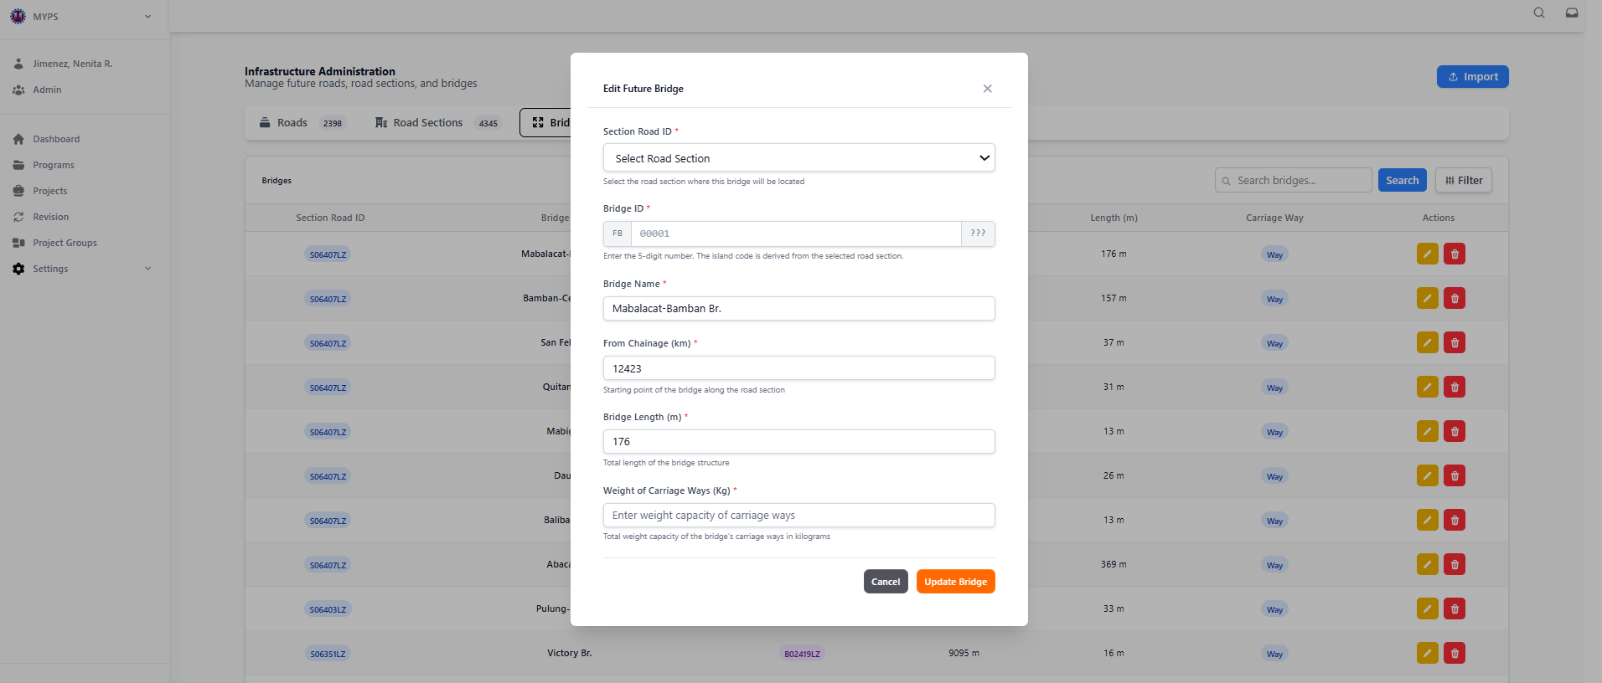
Purpose
Manage existing bridge records linked to road sections. Users can view bridge details, update attributes, or prepare for modifications in a multi-year planning context.
Who Uses This
- ROs/DEOs, RPO/UPMO planners and reviewers
- PS/IMS for oversight
- Authorized Admin users for verification and edits
Prerequisites
- Signed in to MYPS Web (UI-UX-001/002)
- Correct role assigned (Planner, Reviewer, Admin)
- Network/VPN access if required
Field Reference
No. | Fields/Blocks/Objects | Description | Values / Actions
UI-UX-0141-01 | SECTION ROAD ID | Road section where bridge is located | Dropdown selection (e.g., S0635ELZ)
UI-UX-0141-02 | BRIDGE ID | Unique bridge identifier | Editable text (e.g., FB00001), must follow "FB" + 5 digits
UI-UX-0141-03 | BRIDGE NAME | Official name of the bridge | Editable text input (e.g., “Patapat Viaduct”)
UI-UX-0141-04 | FROM CHAINAGE | Starting kilometer point | Numeric input in km (e.g., 168)
UI-UX-0141-05 | BRIDGE LENGTH | Physical length of the bridge | Numeric input in meters (e.g., 12.4)
UI-UX-0141-06 | WEIGHT OF CARRIAGE WAYS | Maximum load capacity | Numeric input in kg (e.g., 100)
UI-UX-0141-07 | CANCEL BUTTON | Discards changes | Closes modal without saving
UI-UX-0141-08 | UPDATE BRIDGE BUTTON | Saves changes | Applies updates to the selected bridge

Step-by-Step: Edit Bridge
- Step-by-Step: Edit Bridge
- Open Bridge Management
  - Navigate via Infrastructure Administration → Bridges.
  - The list of existing bridges appears.
- Locate Bridge
  - Use the Search box or Filters by Section, District, or Road ID.
  - Click Search to refresh the grid.
- Edit Bridge
  - Click Edit next to the desired bridge record.
  - Update fields as required:
    - BRIDGE NAME
    - FROM CHAINAGE
    - BRIDGE LENGTH
    - WEIGHT OF CARRIAGE WAYS
  - Verify all inputs are valid:
    - BRIDGE ID format: FB#####
    - Numeric fields > 0
- Apply Changes
  - Click Update Bridge.
  - Confirm any prompts.
- Cancel Edit
  - Click Cancel to exit without saving.
Common Outcomes & What to Do
Message / Situation | What it Means | Recommended Action
Invalid ID format | BRIDGE ID does not start with "FB" or wrong digits | Correct the ID format
Numeric field invalid | FROM CHAINAGE, LENGTH, or WEIGHT <= 0 | Enter a valid positive number
Update fails | Server or network issue | Retry, refresh page, contact IT if persists

Infrastructure Administration Delete Bridge (UI-UX-0142)
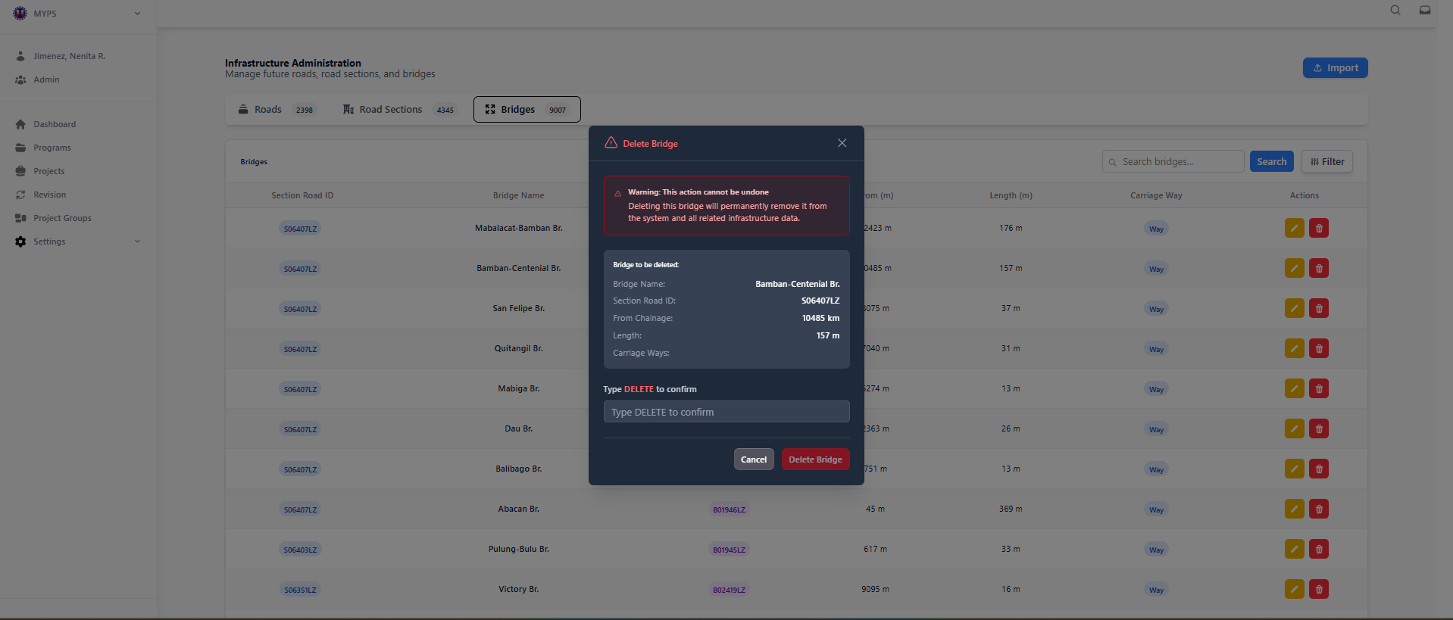
Purpose
Permanently remove a bridge record from the MYPS system, including all related infrastructure data. This ensures that obsolete or incorrect bridge entries are fully deleted.
Who Uses This
- Regional/District Engineers (RO/DEO)
- Infrastructure Administrators
- MYPS planners or reviewers with deletion privileges
Prerequisites
- Logged into MYPS Web with bridge deletion privileges.
- Confirm that the bridge to be deleted is no longer required.
Field Reference
No. | Fields/Blocks/Objects | Description | Values / Actions
UI-UX-0142-01 | BRIDGE NAME | Name of the bridge to be deleted | Display-only; used to verify correct record
UI-UX-0142-02 | SECTION ROAD ID | Road section ID where the bridge is located | Display-only; identifies parent section
UI-UX-0142-03 | FROM CHAINAGE | Starting point along the road section | Display-only; numeric in km
UI-UX-0142-04 | LENGTH | Total bridge length | Display-only; numeric in meters
UI-UX-0142-05 | CARRIAGE WAYS | Number of lanes on the bridge | Display-only; numeric
UI-UX-0142-06 | TYPE DELETE TO CONFIRM | User must type DELETE to confirm | Text input; case-sensitive
UI-UX-0142-07 | CANCEL | Closes modal without deleting | Click to abort action
UI-UX-0142-08 | DELETE BRIDGE | Executes permanent deletion | Click to delete bridge and related infrastructure; irreversible

Step-by-Step: Delete a Bridge
- Locate Bridge
  - Navigate to Infrastructure Administration → Bridges.
  - Use search or filters to locate the target bridge record.
- Initiate Deletion
  - Click the Delete button in the Actions column for the selected bridge.
  - A confirmation modal opens showing bridge details.
- Verify Details
  - Confirm BRIDGE NAME, SECTION ROAD ID, LENGTH, FROM CHAINAGE, and CARRIAGE WAYS match the intended bridge.
- Confirm Deletion
  - Type DELETE (case-sensitive) in the input field.
  - Click Delete Bridge to permanently remove the record.
- Cancel Deletion
  - Click Cancel to close modal without removing the bridge.
- Verify
  - Confirm the bridge no longer appears in the Bridges list/grid.

Common Outcomes & What to Do
Message / Situation | Meaning | Action
“Bridge deleted successfully” | Record removed from system | Verify it no longer appears in the list
Invalid DELETE input | User did not type DELETE correctly | Re-enter DELETE exactly as prompted
Permission denied | User lacks deletion rights | Request permissions from MYPS administrator

Appendix: Issue Reporting Checklist
Use this checklist when reporting a screen or workflow issue to support. Keeping this information in one appendix prevents support notes from interrupting user procedures.
Information to capture | Example / notes
Screen name and UI-UX reference | Example: Import Projects (UI-UX-0029).
Time of issue | Date and time when the issue occurred.
Program, project, revision, or transaction ID | Use the relevant identifier for the affected record.
Button or action clicked | Example: Publish to PCMA, Import, Update, Submit Revision.
On-screen message | Copy the exact validation or error message.
Browser/version and environment | Example: Chrome / UAT.
Screenshot | Attach if available and permitted.

Appendix: Consolidated Validation Messages
Area | Message or condition | User action
Global Search | No Results found | Review the category and value, then try again.
Funding Profile | Total funding percentage must equal 100%. Current total: 0.0%. | Enter valid funding amounts totaling 100%.
Component Cost | Missing Year or Amount | Complete the cost-year row before saving.
Component Cost | Amount exceeds allowed budget / Funding Profile | Correct the component cost or funding profile before saving.
Project Details | Potential duplicate / Proceed with Caution | Cancel to review or proceed only after confirming the duplicate warning.
Revision Submission | Approval document required | Upload the required PDF approval document and complete certification.

Appendix: Controlled Terminology
Preferred manual term | UI/test-script aliases to reconcile
Global Search | Search modal, Search dialog.
Generate Report / View AIP Report | Use the current button/menu label, and describe available report types.
Infrastructure Administration (RBIA) | Settings Infra Management menu label.
Revise Project / View Revision | Modify, Request Revision, View Revisions, depending on role/stage.
House-Approved General Appropriations Bill (HGAB) | Do not use High Government Assistance Budget.

Patch Summary Applied (v3.7)
Applied changelog updates for login messages, Add Program required markers, and User Management field descriptions.

